Exam 1: ETL with Apache Hop

I - Data Analysis

1. Overview of Provided Files
File | Role | Rows | Columns
tm_X28_Companies.xlsx | Maps x28 cmp_id → Kienbaum_ID and company name | 1,872 | 5
tm_X28_Functions.xlsx | Maps x28 job_id → MCG function (19 categories) | 1,229 | 4
tm_tp_companies_sectors.xlsx | Maps company (Kienbaum_ID) → sector | 1,859 | 8
tm_tp_sectors_functions.xlsx | Maps sector → allowed functions (multi-language) | 322 | 12

2. Detailed Table Analysis

2.1 tm_X28_Companies
Purpose: This is the primary company lookup table. It translates the x28-internal numeric company identifier (cmp_id) into the startup’s own Kienbaum_ID and provides the official company name (Firma) and website. It is used in a DB-Lookup step to enrich every job record from the XML.

Schema
Column | Data Type | Nullable | Description
Firma | Text | No | Official company name (used for matching with Firma field in XML)
Firma_lower | Text | Yes | Lowercase version of Firma for case-insensitive lookup
cmp_id | Integer | No | x28 internal company ID – primary join key to XML <company><id>
Kienbaum_ID | Float | Yes | Startup’s internal company ID (1 null; effectively integer)
Homepage | Text | No | Company website URL

Data Quality Findings
Issue | Count | Severity | ETL Handling
cmp_id = 0 (unknown/missing) | 36 rows | High | Rows with cmp_id = 0 cannot be joined to XML; filter out or flag
Duplicate cmp_id values | 96 rows | High | After cmp_id = 0 removal, check residual duplicates; use DISTINCT or dedup step
Missing Firma_lower | 184 rows | Medium | Only affects case-insensitive matching; ensure Firma is always populated
Duplicate Firma (company name) | 4 rows | Low | Review; likely data entry variants of the same company
Missing Kienbaum_ID | 1 row | Low | One entry (Brambles) cannot be mapped; flag in output

Key insight: The cmp_id = 0 entries are a structural defect – they represent companies that were added before the x28 ID was known. These 36 rows must be excluded from the lookup table or handled via a fallback (e.g., name-based matching) before loading into staging. The Firma_lower column is intended to support case-insensitive lookups but is missing for 184 newer entries (Kienbaum_ID ≥ 1,793), suggesting the column was not back-filled.

2.2 tm_X28_Functions
Purpose: Maps each of the ~1,200 x28 job titles to one of 19 standardised MCG functions (e.g., “Technische Berufe”, “ICT”, “Marketing”). This is used to normalise the granular job-title field from the XML into the startup’s functional taxonomy.

Schema
Column | Data Type | Nullable | Description
function | Text | No | MCG function category (19 unique values) – target classification
position | Text | Yes | Sub-position label; mostly null (1,024 / 1,229 rows)
job_id_x28 | Integer | No | x28 internal job-title ID – join key to XML <metadata> FUNCTION id
job_name_x28 | Text | No | German job title as delivered by x28

Data Quality Findings
Issue | Count | Severity | ETL Handling
Missing position | 1,024 rows | Low | Column is optional metadata; not needed for ETL join
Duplicate job_id_x28 | 26 rows | Medium | Same job ID appears under different functions; use first match or flag ambiguity
Duplicate job_name_x28 | 26 rows | Medium | Same name can belong to multiple functions (e.g., “Art Director” in Marketing and Medienschaffende)
Whitespace in function names | Several | Medium | Names contain double spaces (e.g., “Produktion / Supply Chain”); trim before join

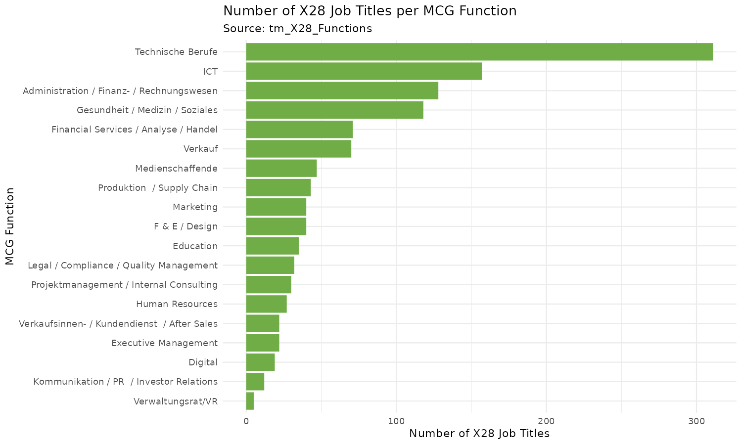
Figure 1 – Distribution of x28 job titles across the 19 MCG functions
Technische Berufe and ICT together account for over 37 % of all mappable job titles, reflecting Switzerland’s industrial and technology-sector composition. The distribution is heavily skewed, with Verwaltungsrat/VR having only 5 entries.

2.3 tm_tp_companies_sectors
Purpose: Assigns each company (identified by Kienbaum_ID = company_id) to one of 21 industry sectors in German, English, and French. This enables the sector-level aggregation needed for the dashboard visualisation.

Schema
Column | Data Type | Nullable | Description
company | Text | Yes | Company name (3 nulls; name not critical–ID is the key)
sector_sort | Integer | No | Sort order for the sector (used in dashboard ordering)
sector | Text | No | Sector name in German
company_id | Integer | No | Join key = Kienbaum_ID from tm_X28_Companies
last_updated | Text | No | Date of last record update
sector_EN | Text | No | Sector name in English
sector_FR | Text | No | Sector name in French
websites | Text | No | Company website (reference, not used in ETL)

Data Quality Findings
Issue | Count | Severity | ETL Handling
3 rows with null company name | 3 rows | Low | company_id is not null; name is non-critical for joins
26 Kienbaum_IDs with no sector entry | 26 IDs | Medium | Jobs from these companies will have no sector assigned; handle with LEFT JOIN + NULL check
14 sector company_ids not in Companies | 14 IDs | Low | Orphaned sector entries; no impact on ETL as join goes Companies → Sectors

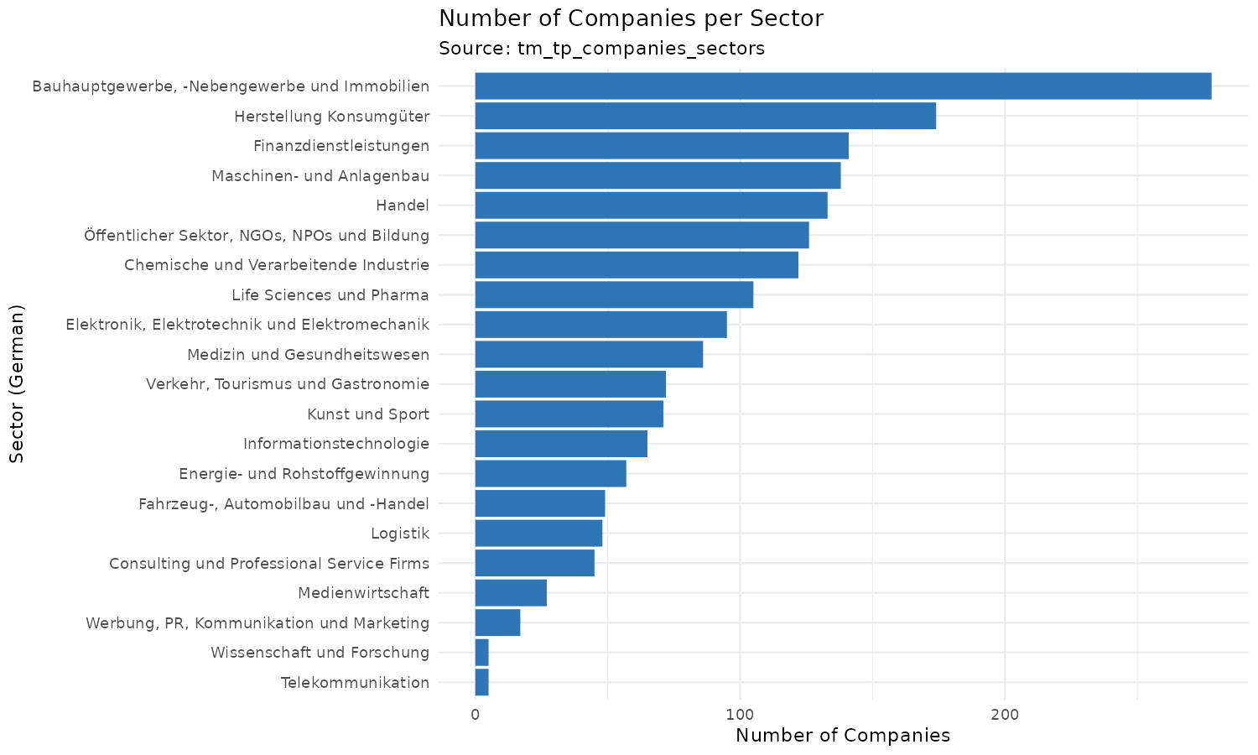
Figure 2 – Number of companies per sector (German labels)
Bauhauptgewerbe (construction & real estate) is the largest sector with 278 companies, followed by Herstellung Konsumgüter (consumer goods) with 174. The smallest sectors (Telekommunikation, Wissenschaft und Forschung) have only 5 companies each.

2.4 tm_tp_sectors_functions
Purpose: Defines which MCG functions are relevant for each sector. This is a cross-reference table that enables the ETL pipeline to filter or validate function-sector combinations and provides multilingual labels (DE / EN / FR) for the dashboard.

Schema
Column | Data Type | Nullable | Description
sector / sector_en / sector_fr | Text | Partially | Sector names in three languages (DE, EN, FR)
function / function_en / function_fr | Text | Partially | Function names in three languages
branche_order / _en / _fr | Text | Mostly Yes | Sort order (mostly null; ~302/322 rows)
tool_tip_text / _en / _fr | Text | Sometimes | Descriptive tooltip text for UI use

Data Quality Findings
Issue | Count | Severity | ETL Handling
20 rows with purely numeric sector/function values | 20 rows | High | These are separator/placeholder rows – filter out (WHERE sector NOT REGEXP '^[0-9]+$')
branche_order mostly null | 302/322 | Low | Column used only for sorting in UI; not needed in core ETL
16/19 functions match after trimws(); 3 mismatch | 3 funcs | Medium | Trim whitespace on both sides before joining with tm_X28_Functions
1 null row (header artefact) | 1 row | Low | Filter out rows with null sector or null function

Note on multilingual columns: This table is the only one providing English and French translations for both sectors and functions. While not required for the core ETL join, these columns are useful for international dashboard labels and should be loaded into the core layer as-is.

3. Missing Values Across All Tables
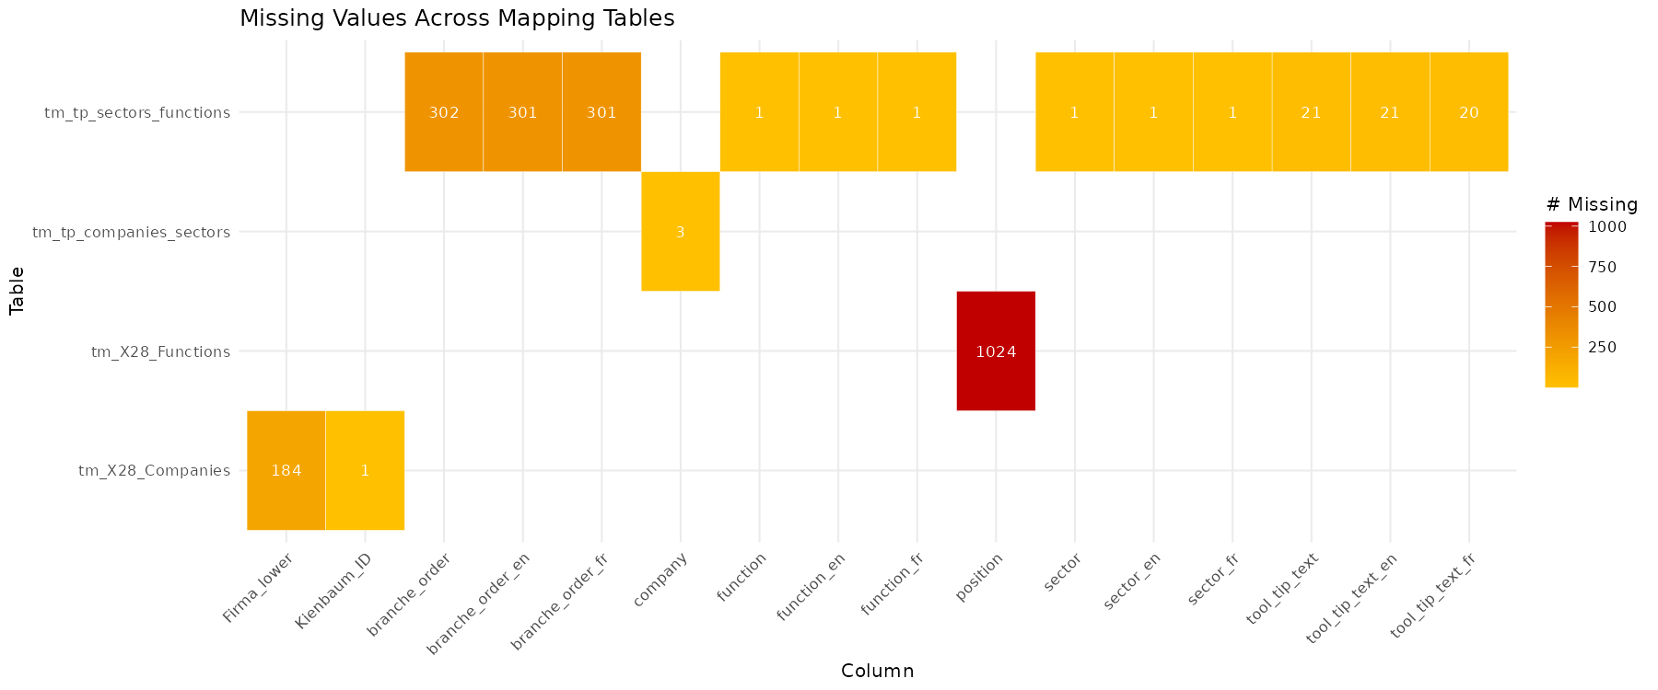
Figure 3 – Missing value counts by column and table (only columns with at least one null are shown)
The heatmap highlights that most missing values are concentrated in non-critical columns: the position column in tm_X28_Functions (1,024 nulls) and the branche_order columns in tm_tp_sectors_functions (~302 nulls each). These columns are either optional metadata or UI-only. The only critical nulls are the 184 missing Firma_lower values (affects case-insensitive lookup) and the single missing Kienbaum_ID (one unmappable company).

4. Join Key Analysis and Table Relationships
The four mapping tables form a chain that connects x28’s raw identifiers to the startup’s internal classification:

Join | Left Table → Right Table | Left Key | Right Key | Matched | Gaps
1 | XML company id → tm_X28_Companies | <company><id> | cmp_id | ~1,776 | 36 rows cmp_id=0; must cleanse first
2 | tm_X28_Companies → tm_tp_companies_sectors | Kienbaum_ID | company_id | 1,845 | 26 Companies unmapped; 14 Sectors orphaned
3 | tm_tp_companies_sectors → tm_tp_sectors_func | sector (DE) | sector (DE) | 21 / 21 | Full match – no gaps
4 | tm_tp_sectors_func → tm_X28_Functions | function | function | 16 / 19 | 3 mismatches due to whitespace; fix with TRIM()
5 | XML function id → tm_X28_Functions | <metadata> id | job_id_x28 | ~1,203 | 26 duplicate IDs; use DISTINCT or first-match

The join chain from XML to final sector and function labels is:
XML <company><id> → cmp_id (tm_X28_Companies) → Kienbaum_ID → company_id (tm_tp_companies_sectors) → sector label
XML <metadata FUNCTION id> → job_id_x28 (tm_X28_Functions) → MCG function label

5. Required Fields from the XML Source
Based on the exam specification and the mapping table analysis, the following fields must be extracted from each <job> element in the x28 XML files:
XML Field / Path | Type | Required For | Notes
<response><date> | Date | Weeks-open calculation | Extraction date at file level – set to 2020-07-08 in sample
<job><id> | Integer | Primary key / dedup | Unique x28 job ID
<job><title> | Text | Display / debug | Job title as free text
<job><created> | DateTime | Weeks-open calculation | CEIL(DATEDIFF(date, created) / 7)
<job><deleted> | Boolean | Filtering | Filter out deleted jobs before staging
<job><company><id> | Integer | Company lookup | Join key → cmp_id in tm_X28_Companies; cleanse before lookup
<job><metadata FUNCTION id> | Integer | Function lookup | Join key → job_id_x28 in tm_X28_Functions
<job><metadata INDUSTRY id> | Integer | Sector cross-check | Optional; sector is derived via company chain

6. Summary of Key Findings
Finding | Impact | Action in ETL
cmp_id = 0 in 36 company rows | High | Cleanse cmp_id before DB-Lookup (filter or replace with NULL)
96 duplicate cmp_id values (excl. 0) | High | Deduplicate before staging; use DISTINCT in lookup
184 missing Firma_lower values | Medium | Generate Firma_lower = LOWER(TRIM(Firma)) in HOP Calculator step
26 duplicate job_id_x28 | Medium | Use first-match strategy in lookup; document assumption
Whitespace in function names (3 cases) | Medium | Apply TRIM() in HOP before joining tm_X28_Functions to sectors table
20 garbage rows in sectors_functions | High | Filter WHERE sector NOT LIKE ‘%[0-9]%’ before loading to core
1 missing Kienbaum_ID (Brambles) | Low | Proceed with LEFT JOIN; NULL Kienbaum_ID will propagate as unclassified
26 Kienbaum_IDs not in sector table | Medium | LEFT JOIN ensures jobs still appear; sector will be NULL for these

II – Architecture

III - Visualization

