X28 Job Analysis: An ETL design with Apache HOP
Diez-Liebana Orejas, Ramiro
Van Helleputte, Cyriel
Ryan, Michael
Hochschule Luzern, School of Business
Modern Data Engineering - ETL03.F26
Dollfus, Christian
May 2026

I. Data Analysis

1. Overview of Provided Files
File | Role | Rows | Columns
tm_X28_Companies.xlsx | Maps x28 cmp_id → Kienbaum_ID and company name | 1,872 | 5
tm_X28_Functions.xlsx | Maps x28 job_id → MCG function (19 categories) | 1,229 | 4
tm_tp_companies_sectors.xlsx | Maps company (Kienbaum_ID) → sector | 1,859 | 8
tm_tp_sectors_functions.xlsx | Maps sector → allowed functions (multi-language) | 322 | 12

2. Detailed Table Analysis

2.1 tm_X28_Companies
Purpose: This is the primary company lookup table. It translates the x28-internal numeric company identifier (cmp_id) into the startup’s own Kienbaum_ID and provides the official company name (Firma) and website. It is used in a DB-Lookup step to enrich every job record from the XML.

Schema
Column | Data Type | Nullable | Description
Firma | Text | No | Official company name (used for matching with Firma field in XML)
Firma_lower | Text | Yes | Lowercase version of Firma for case-insensitive lookup
cmp_id | Integer | No | x28 internal company ID – primary join key to XML <company><id>
Kienbaum_ID | Float | Yes | Startup’s internal company ID (1 null; effectively integer)
Homepage | Text | No | Company website URL

Data Quality Findings
Issue | Count | Severity | ETL Handling
cmp_id = 0 (unknown/missing) | 36 rows | High | Rows with cmp_id = 0 cannot be joined to XML; filter out or flag
Duplicate cmp_id values | 96 rows | High | After cmp_id = 0 removal, check residual duplicates; use DISTINCT or dedup step
Missing Firma_lower | 184 rows | Medium | Only affects case-insensitive matching; ensure Firma is always populated
Duplicate Firma (company name) | 4 rows | Low | Review; likely data entry variants of the same company
Missing Kienbaum_ID | 1 row | Low | One entry (Brambles) cannot be mapped; flag in output
Key insight: The cmp_id = 0 entries are a structural defect – they represent companies that were added before the x28 ID was known. These 36 rows must be excluded from the lookup table or handled via a fallback (e.g., name-based matching) before loading into staging. The Firma_lower column is intended to support case-insensitive lookups but is missing for 184 newer entries (Kienbaum_ID ≥ 1,793), suggesting the column was not back-filled.

2.2 tm_X28_Functions
Purpose: Maps each of the ~1,200 x28 job titles to one of 19 standardised MCG functions (e.g., “Technische Berufe”, “ICT”, “Marketing”). This is used to normalise the granular job-title field from the XML into the startup’s functional taxonomy.

Schema
Column | Data Type | Nullable | Description
function | Text | No | MCG function category (19 unique values) – target classification
position | Text | Yes | Sub-position label; mostly null (1,024 / 1,229 rows)
job_id_x28 | Integer | No | x28 internal job-title ID – join key to XML <metadata> FUNCTION id
job_name_x28 | Text | No | German job title as delivered by x28

Data Quality Findings
Issue | Count | Severity | ETL Handling
Missing position | 1,024 rows | Low | Column is optional metadata; not needed for ETL join
Duplicate job_id_x28 | 26 rows | Medium | Same job ID appears under different functions; use first match or flag ambiguity
Duplicate job_name_x28 | 26 rows | Medium | Same name can belong to multiple functions (e.g., “Art Director” in Marketing and Medienschaffende)
Whitespace in function names | Several | Medium | Names contain double spaces (e.g., “Produktion / Supply Chain”); trim before join

Technische Berufe and ICT together account for over 37 % of all mappable job titles, reflecting Switzerland’s industrial and technology-sector composition. The distribution is heavily skewed, with Verwaltungsrat/VR having only 5 entries.

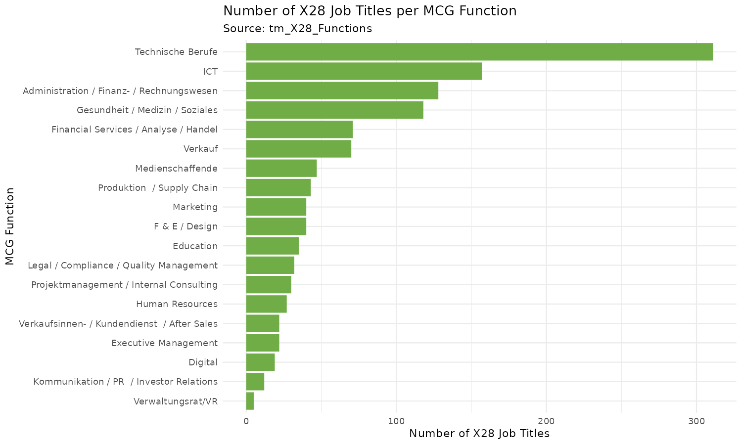
Figure 1 – Distribution of x28 job titles across the 19 MCG functions

2.3 tm_tp_companies_sectors
Purpose: Assigns each company (identified by Kienbaum_ID = company_id) to one of 21 industry sectors in German, English, and French. This enables the sector-level aggregation needed for the dashboard visualisation.

Schema
Column | Data Type | Nullable | Description
company | Text | Yes | Company name (3 nulls; name not critical–ID is the key)
sector_sort | Integer | No | Sort order for the sector (used in dashboard ordering)
sector | Text | No | Sector name in German
company_id | Integer | No | Join key = Kienbaum_ID from tm_X28_Companies
last_updated | Text | No | Date of last record update
sector_EN | Text | No | Sector name in English
sector_FR | Text | No | Sector name in French
websites | Text | No | Company website (reference, not used in ETL)

Data Quality Findings
Issue | Count | Severity | ETL Handling
3 rows with null company name | 3 rows | Low | company_id is not null; name is non-critical for joins
26 Kienbaum_IDs with no sector entry | 26 IDs | Medium | Jobs from these companies will have no sector assigned; handle with LEFT JOIN + NULL check
14 sector company_ids not in Companies | 14 IDs | Low | Orphaned sector entries; no impact on ETL as join goes Companies → Sectors

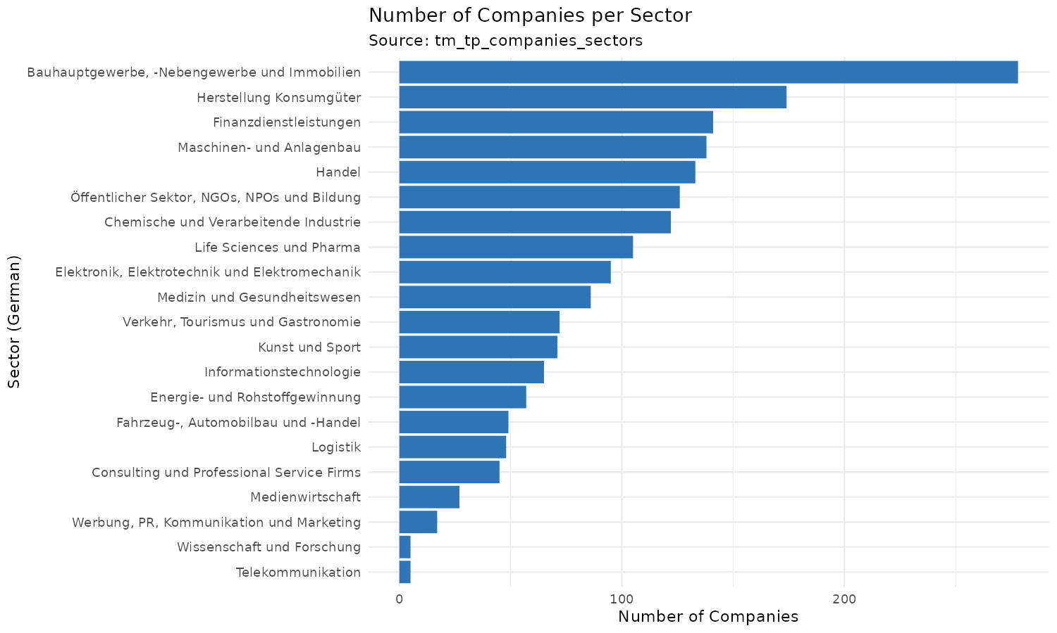
Figure 2 – Number of companies per sector (German labels)
Bauhauptgewerbe (construction & real estate) is the largest sector with 278 companies, followed by Herstellung Konsumgüter (consumer goods) with 174. The smallest sectors (Telekommunikation, Wissenschaft und Forschung) have only 5 companies each.

2.4 tm_tp_sectors_functions
Purpose: Defines which MCG functions are relevant for each sector. This is a cross-reference table that enables the ETL pipeline to filter or validate function-sector combinations and provides multilingual labels (DE / EN / FR) for the dashboard.

Schema
Column | Data Type | Nullable | Description
sector / sector_en / sector_fr | Text | Partially | Sector names in three languages (DE, EN, FR)
function / function_en / function_fr | Text | Partially | Function names in three languages
branche_order / _en / _fr | Text | Mostly Yes | Sort order (mostly null; ~302/322 rows)
tool_tip_text / _en / _fr | Text | Sometimes | Descriptive tooltip text for UI use

Data Quality Findings
Issue | Count | Severity | ETL Handling
20 rows with purely numeric sector/function values | 20 rows | High | These are separator/placeholder rows – filter out (WHERE sector NOT REGEXP '^[0-9]+$')
branche_order mostly null | 302/322 | Low | Column used only for sorting in UI; not needed in core ETL
16/19 functions match after trimws(); 3 mismatch | 3 funcs | Medium | Trim whitespace on both sides before joining with tm_X28_Functions
1 null row (header artefact) | 1 row | Low | Filter out rows with null sector or null function

Note on multilingual columns: This table is the only one providing English and French translations for both sectors and functions. While not required for the core ETL join, these columns are useful for international dashboard labels and should be loaded into the core layer as-is.

3. Missing Values Across All Tables
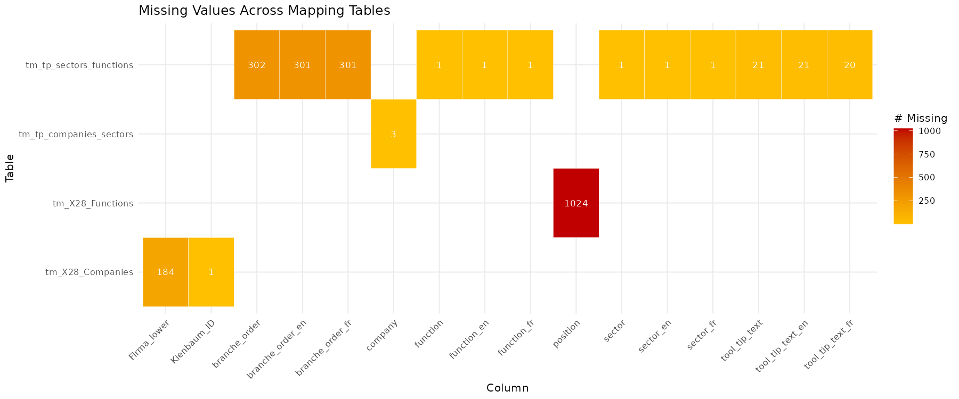
Figure 3 – Missing value counts by column and table (only columns with at least one null are shown)
The heatmap highlights that most missing values are concentrated in non-critical columns: the position column in tm_X28_Functions (1,024 nulls) and the branche_order columns in tm_tp_sectors_functions (~302 nulls each). These columns are either optional metadata or UI-only. The only critical nulls are the 184 missing Firma_lower values (affects case-insensitive lookup) and the single missing Kienbaum_ID (one unmappable company).

4. Join Key Analysis and Table Relationships
The four mapping tables form a chain that connects x28’s raw identifiers to the startup’s internal classification:

Join | Left Table → Right Table | Left Key | Right Key | Matched | Gaps
1 | XML company id → tm_X28_Companies | <company><id> | cmp_id | ~1,776 | 36 rows cmp_id=0; must cleanse first
2 | tm_X28_Companies → tm_tp_companies_sectors | Kienbaum_ID | company_id | 1,845 | 26 Companies unmapped; 14 Sectors orphaned
3 | tm_tp_companies_sectors → tm_tp_sectors_func | sector (DE) | sector (DE) | 21 / 21 | Full match – no gaps
4 | tm_tp_sectors_func → tm_X28_Functions | function | function | 16 / 19 | 3 mismatches due to whitespace; fix with TRIM()
5 | XML function id → tm_X28_Functions | <metadata> id | job_id_x28 | ~1,203 | 26 duplicate IDs; use DISTINCT or first-match

The join chain from XML to final sector and function labels is:
XML <company><id> → cmp_id (tm_X28_Companies) → Kienbaum_ID → company_id (tm_tp_companies_sectors) → sector label
XML <metadata FUNCTION id> → job_id_x28 (tm_X28_Functions) → MCG function label

5. Required Fields from the XML Source
Based on the exam specification and the mapping table analysis, the following fields must be extracted from each <job> element in the x28 XML files:
XML Field / Path | Type | Required For | Notes
<response><date> | Date | Weeks-open calculation | Extraction date at file level – set to 2020-07-08 in sample
<job><id> | Integer | Primary key / dedup | Unique x28 job ID
<job><title> | Text | Display / debug | Job title as free text
<job><created> | DateTime | Weeks-open calculation | CEIL(DATEDIFF(date, created) / 7)
<job><deleted> | Boolean | Filtering | Filter out deleted jobs before staging
<job><company><id> | Integer | Company lookup | Join key → cmp_id in tm_X28_Companies; cleanse before lookup
<job><metadata FUNCTION id> | Integer | Function lookup | Join key → job_id_x28 in tm_X28_Functions
<job><metadata INDUSTRY id> | Integer | Sector cross-check | Optional; sector is derived via company chain

6. Summary of Key Findings
Finding | Impact | Action in ETL
cmp_id = 0 in 36 company rows | High | Cleanse cmp_id before DB-Lookup (filter or replace with NULL)
96 duplicate cmp_id values (excl. 0) | High | Deduplicate before staging; use DISTINCT in lookup
184 missing Firma_lower values | Medium | Generate Firma_lower = LOWER(TRIM(Firma)) in HOP Calculator step
26 duplicate job_id_x28 | Medium | Use first-match strategy in lookup; document assumption
Whitespace in function names (3 cases) | Medium | Apply TRIM() in HOP before joining tm_X28_Functions to sectors table
20 garbage rows in sectors_functions | High | Filter WHERE sector NOT LIKE ‘%[0-9]%’ before loading to core
1 missing Kienbaum_ID (Brambles) | Low | Proceed with LEFT JOIN; NULL Kienbaum_ID will propagate as unclassified
26 Kienbaum_IDs not in sector table | Medium | LEFT JOIN ensures jobs still appear; sector will be NULL for these

II. Architecture
The pipeline runs in Apache HOP, and it uses three naming conventions: stg_ for raw input, core_ for transformed data, and tm_ for the final business layer. Source data is stored in the Exam1/data/ folder of the HOP project. All files sit in the same folder. This includes 67 XML files from x28, and the four Excel mapping tables.

Data Limitations
Stg_tm_x28_companies contained some rows with no company information (cmp_id = 0) and 96 duplicated company (cmp_id) values. A ROW_NUMBER() subquery keeps only one row per cmp_id. Jobs with no match get a NULL Kienbaum ID.

Stg_x28_job_meta stores multiple metadata entries per job. A subquery filters to type JOB only and picks one row per job. This prevents duplicates in the join.

Stg_tm_x28_functions has 26 duplicate job_id_x28 values. A ROW_NUMBER() subquery keeps the first match per ID.

All joins are LEFT JOINs. Jobs with no matching company, function, or sector still appear in the output with NULL values for those fields.

Design

With this in mind, we staged our pipelines in 4 levels:
- P01: Loading-Level
- P02: Data extraction
- P03: Data Transformation
- P04: Calculations, Business-added value.

P01: Load the mapping tables
Using Excel Input functions, P01 reads the four metadata files directly from Exam1/data/ and writes them to the Azure SQL staging layer. These are the reference tables used for all lookups.
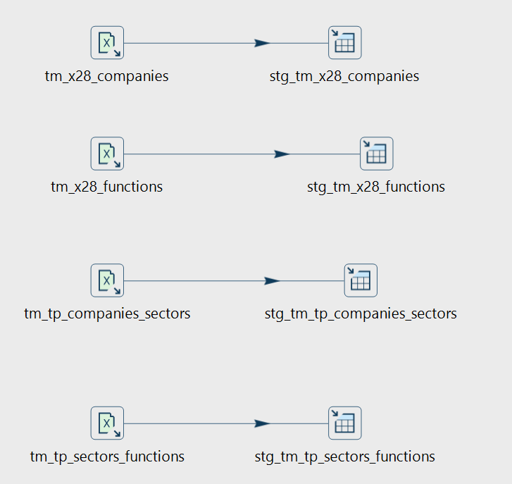
p01_load_metatables.hpl

P02: Extract the XML data
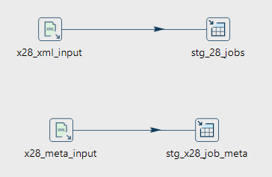
P02 reads 67 XML files from x28 and writes 13,200 job records to stg_x28_jobs and 46,169 metadata entries to stg_x28_job_meta. Each job contains multiple metadata entries of different types. Only entries of type JOB are used. These map to the MCG function via job_id_x28.
p02_extract.hpl

P03: Transform the data
P03 joins the staging tables, maps company IDs to Kienbaum IDs, maps job metadata to MCG functions, and calculates weeks open. The result is 13,200 rows in core_x28_jobs.


p03_transform_core.hpl

p04: The business layer
It reads from core_x28_jobs and writes the final dataset to tm_x28_jobs. This table is used for visualization.
p04_business_layer.hpl


p05: The Scheduled Workflow

To execute this linearly, we designed the workflow that wraps it all together and executes all pipelines sequentially. Once each step is met, it can run to the next one.

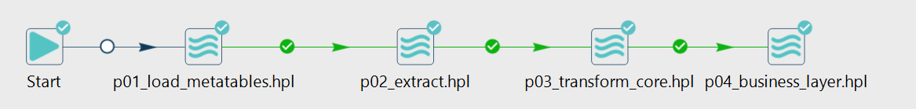

III. Visualization

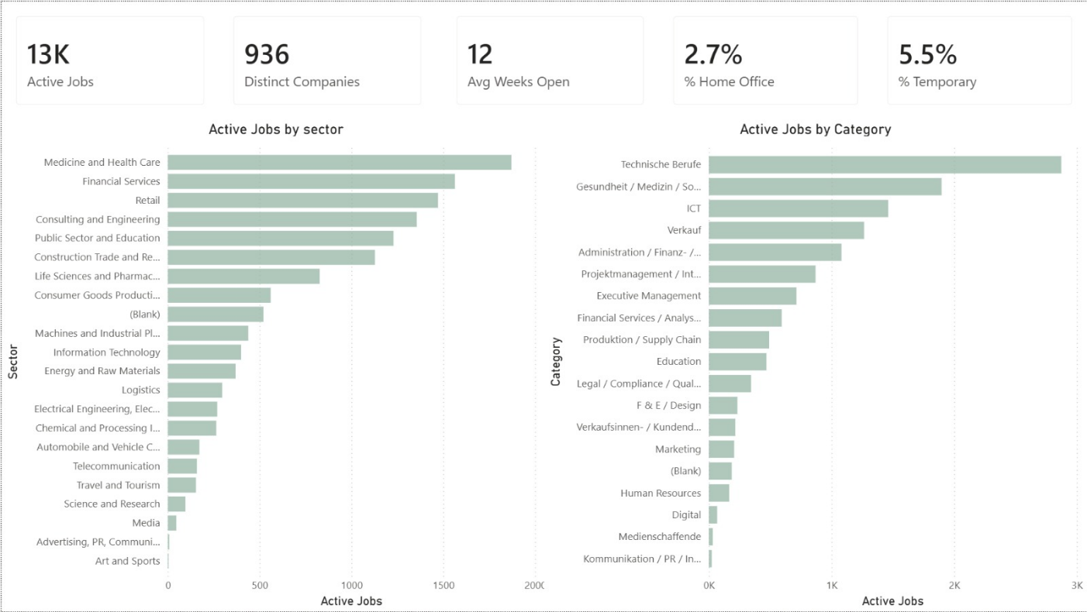
Figure 4 – Job Market Overview Dashboard

The main dashboard provides a high-level snapshot of the Swiss labour market as captured in the x28 data. The KPI tiles at the top summarise the dataset: 13,000 active jobs are distributed across 936 distinct companies, with an average vacancy duration of 12 weeks. Only 2.7 % of postings explicitly mention home-office arrangements, and 5.5 % are flagged as temporary positions.

The left-hand bar chart, Active Jobs by Sector, reveals a strong concentration of demand in service-oriented industries. Medicine and Health Care leads with roughly 1,900 active postings, closely followed by Financial Services (~1,600) and Retail (~1,500). Telecommunication, Travel and Tourism, Science and Research, Media, Advertising, and Art and Sports, each account for fewer than 200 postings, illustrating the dominance of a handful of macro-sectors in Switzerland's labour demand.

The right-hand chart, Active Jobs by Category, shows the breakdown across the 19 MCG functions. Technische Berufe (technical professions) is by far the largest category with roughly 2,900 jobs, confirming Switzerland's industrial and engineering profile. Gesundheit / Medizin / Soziales (~2,000) and ICT (~1,500) follow, while specialised functions such as Digital, Medienschaffende, and Kommunikation/PR remain marginal. The blank category (~250 jobs) represents postings whose function ID could not be resolved through tm_X28_Functions
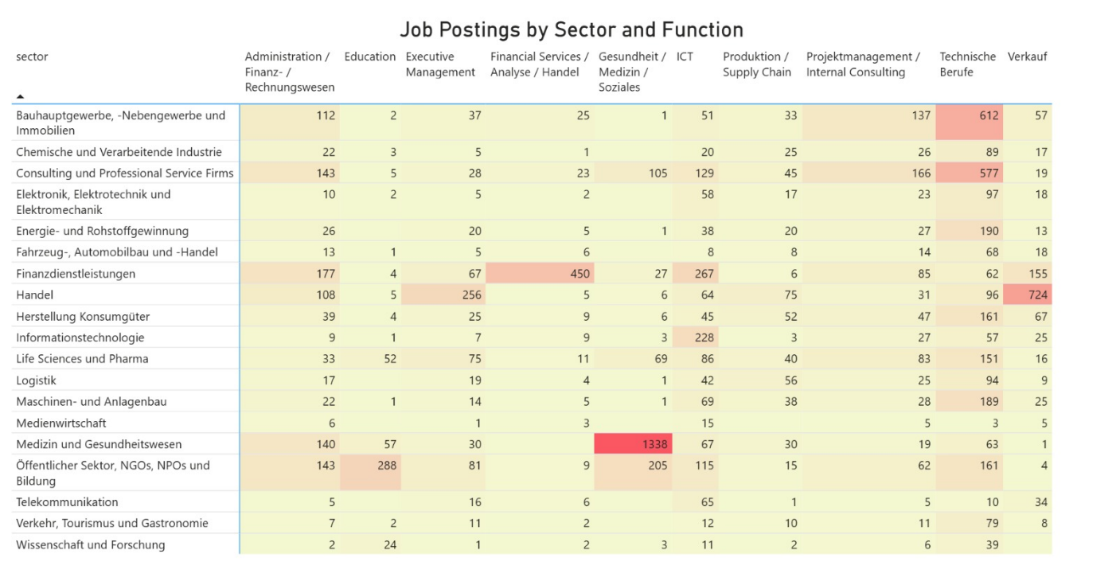
Figure 5 – Job Postings by Sector and Function (Heatmap)

This cross-tabulation matrix exposes the structural relationships between sectors (rows) and functions (columns), with colour intensity scaling from yellow (low) to red (high). Several patterns emerge:
- Medizin und Gesundheitswesen × Gesundheit / Medizin / Soziales dominates the matrix with 1,338 postings which is by far the largest single cell. This confirms the tight coupling between the healthcare sector and its core clinical function.
- Handel × Verkauf (724) and Bauhauptgewerbe × Technische Berufe (612) represent the second tier of strong sector-function alignments, each reflecting the natural skill demand of the underlying industry.
- Consulting und Professional Service Firms shows a broad horizontal distribution (Technische Berufe 577, Projektmanagement 166, Administration 143), consistent with the multidisciplinary nature of consulting work.

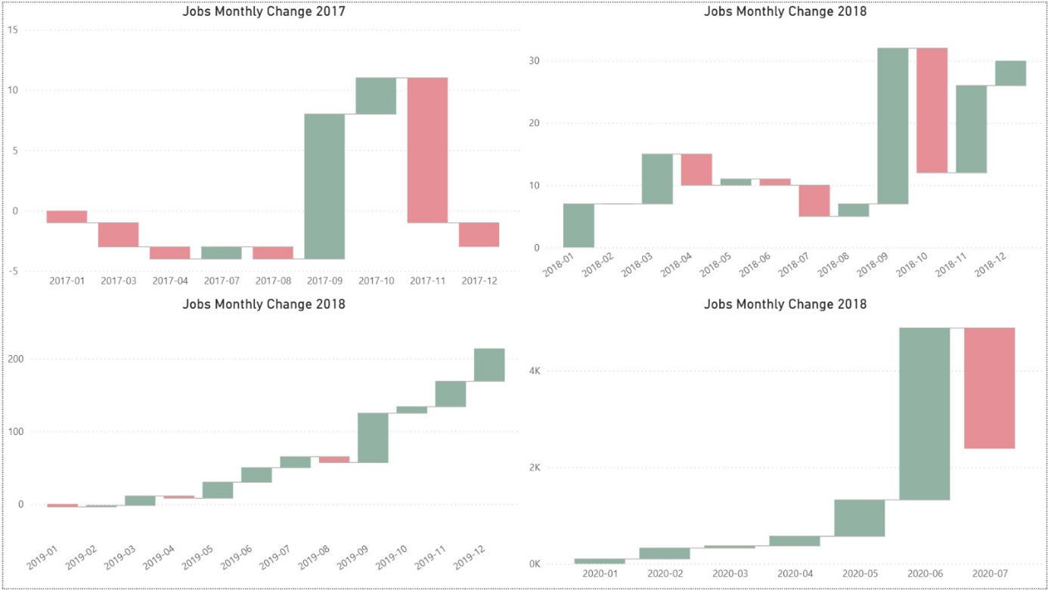
Figure 6 – Monthly Job Posting Changes (2017–2020)

The four waterfall charts trace the net monthly change in active job postings across the four years covered by the x28 dataset. Note the dramatic shift in y-axis scale between panels, from a range of ±15 jobs in 2017 to several thousand in 2020. This reveals the exponential growth of x28's coverage rather than a true labour-market expansion.
- 2017 shows minimal activity (±10 jobs per month), reflecting the early adoption phase of the data source.
- 2018 displays moderate growth with monthly swings of ±30 jobs and a notable acceleration in Q4.
- 2019 marks a clear inflection point: postings grow steadily through the year, reaching cumulative gains of over 200 jobs by December.
- 2020 shows explosive growth, with monthly net additions exceeding 4,000 postings between May and June, followed by a sharp drop of ~2,500 in July. This July decline coincides with the data extraction date (2020-07-08) and likely reflects an incomplete final month rather than a genuine market contraction.

