Initial Design

Given the (relatively) short timeline for this project, we are jumping right in with a complete, rough design. That doesn’t mean you can’t change direction over the next week, but time is limited and you need to make consistent forward progress.

You can work from the individual designs you already did or do something new. Everyone must contribute to the design.

**High level: Objectives & conflicts**

1. What is the player’s goal, and what do they need to do to achieve it?

Choices matter… Detective… Vigilante… turned based… 2d….

To resecure, kidnapped cat or something…

1. What are the most significant obstacles/conflicts to the player succeeding?

Battle Minions to then look for clues… levels to look for clues and stuff for battle… interrogation to people in the levels….

**More specific: The central system dynamics**

1. What is the most important player action? The most common?

Combat or searching for clues….

1. List the possible ways that the environment can respond to those actions (outcomes).

Clues allow progression in the story….

**Commit to a specific idea**

1. List 2-3 player experiences that will make the game fun and interesting. Be specific and player-focused!

Interrogation opens up interactives…

searching for password combinations….

Status effects during battle like throwing a gas to knock them out….

Weaken enemies in battle to interrogate similar to capture a Pokémon…

1. Draw out a sequence of screenshot sketches showing what a player would see during those critical gameplay experiences from question 5. Pay attention to what information is on screen (environment and UI elements). You have to commit to a certain visual perspective here (2d/3d, fixed or rotating camera).

Use your phone or a webcam to scan those sketches and add them to the doc.

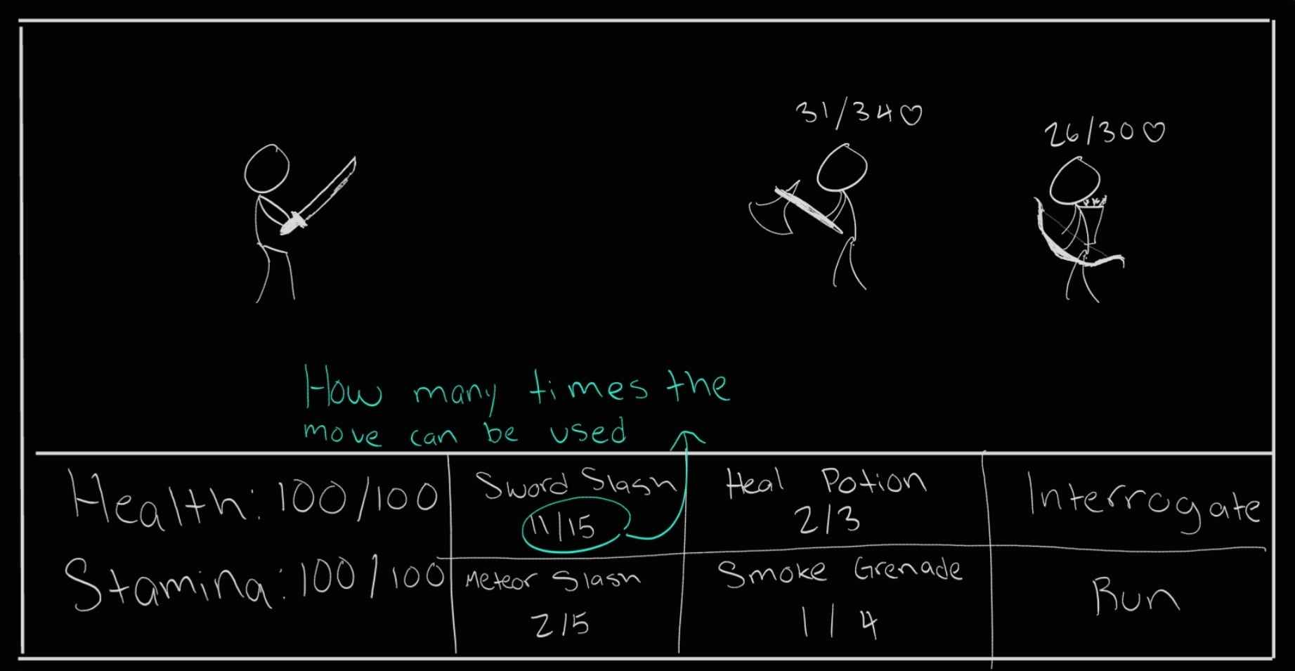

1. Write a 1-2 paragraph description that “sells” this concept to potential players. Try to capture what makes it uniquely interesting. Describe at least the premise, aesthetic, core gameplay and how you win or lose.’

A retired navy seal bored with his now normal life finally gets some action when his place is ransacked but only his dog was taken. The crime syndicate leaves a calling card, our hero must solve the mystery of who stole his dog, fighting his way through minions and interrogating enemies. With it’s old school noir aesthetic, 2d turned based game, and interactive environment to find clues on who and where the crime syndicate is.

1. Working title

City of Shadows: Seal’s Vengeance