Lab 3 Report
Inverse Kinematics
Name: Ramiro Rojas
Section: 0
Date: 10/16/2026

1. Numerical IK equations
TODO 1 Position error
position = target[:3, 3] - current[:3, 3]

TODO 2 Damped least squares
step = jacobian.T @ np.linalg.solve(system, error)

TODO 3 Joint update
q_proposed = q + alpha * delta_q

2. Offline IK results
Target A
converged: True
reason: converged
iterations: 14
final q [rad]: [ 0.19924 -0.7988 0.99875 -1.09713 -0.70111 0.29779]
position error [mm]: 0.817
orientation error [deg]: 0.088

Target B
converged: True
reason: converged
iterations: 17
final q [rad]: [-0.29899 -0.89984 1.09987 -1.39796 -1.20016 -0.1986 ]
position error [mm]: 0.817
orientation error [deg]: 0.152

3. Target A Webots result
Target: A
Desired tool position [m]: [0.662752 0.348085 0.277222]
Desired tool RPY [rad]: [-2.561988 0.399181 -2.210128]
Joint order: shoulder_pan_joint, shoulder_lift_joint, elbow_joint, wrist_1_joint, wrist_2_joint, wrist_3_joint
Initial q [rad]: [-4.464087e-06 4.335639e-06 1.230183e-06 -3.028271e-07 1.902101e-08
-1.905286e-08]
Converged: True Reason: converged
Iterations: 20
Solver position error [mm]: 0.597
Solver orientation error [deg]: 0.402
IK solution q [rad]: [ 0.199736 -0.799209 0.996694 -1.091273 -0.698857 0.300827]
Predicted tool position [m]: [0.662626 0.347941 0.277787]
Predicted tool RPY [rad]: [-2.56739 0.394454 -2.213609]
Webots measured q [rad]: [ 0.199736 -0.799163 0.996711 -1.091272 -0.698857 0.300827]
Webots tool position [m]: [0.662309 0.348903 0.277716]
Webots tool RPY [rad]: [-2.567442 0.394388 -2.213629]

Screenshot
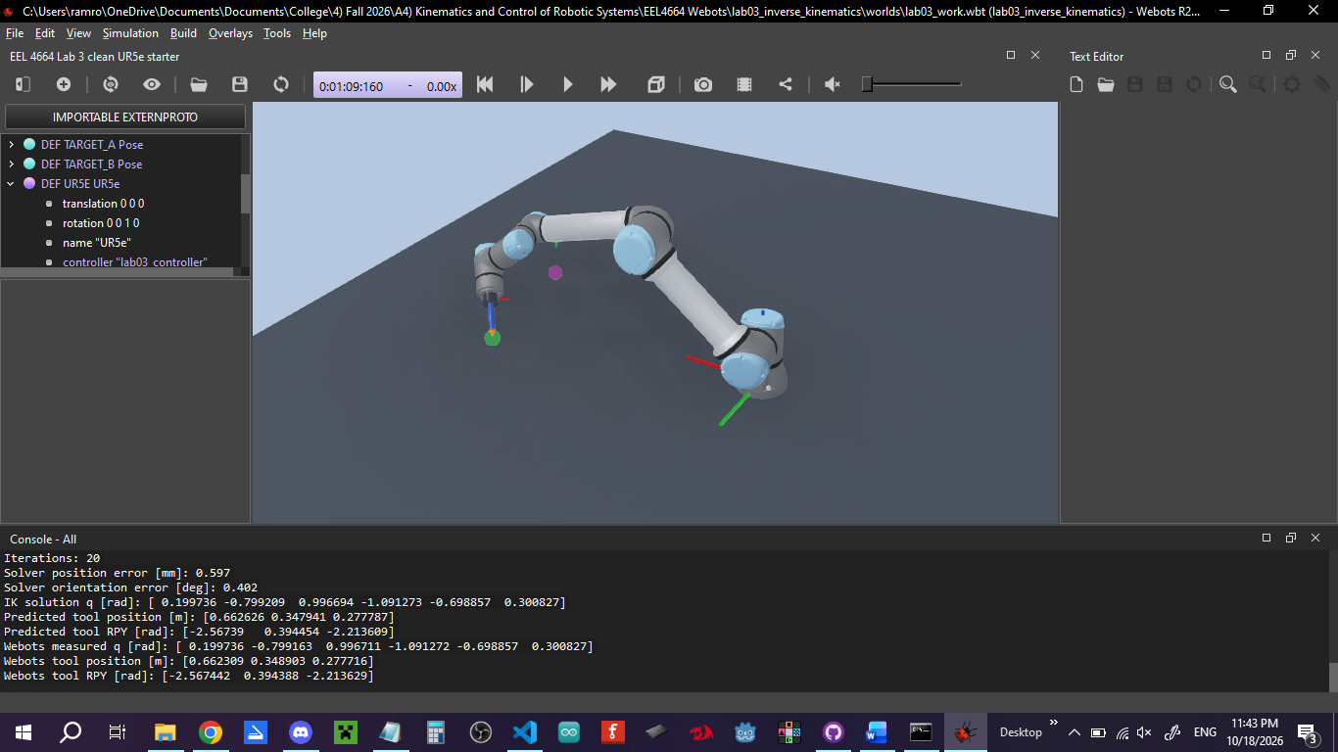
Both the predicted and measured tool position and tool RPY for Target A agree closely, only differing by a small decimal value.

4. Target B Webots result
Target: B
Desired tool position [m]: [ 0.726296 -0.047359 0.294847]
Desired tool RPY [rad]: [-1.890963 0.41478 -1.809042]
Joint order: shoulder_pan_joint, shoulder_lift_joint, elbow_joint, wrist_1_joint, wrist_2_joint, wrist_3_joint
Initial q [rad]: [-4.464087e-06 4.335639e-06 1.230183e-06 -3.028271e-07 1.902101e-08
-1.905286e-08]
Converged: True Reason: converged
Iterations: 23
Solver position error [mm]: 0.440
Solver orientation error [deg]: 0.499
IK solution q [rad]: [-0.299917 -0.899023 1.096938 -1.390946 -1.198835 -0.196802]
Predicted tool position [m]: [ 0.725994 -0.047091 0.295019]
Predicted tool RPY [rad]: [-1.899832 0.41525 -1.815735]
Webots measured q [rad]: [-0.299917 -0.898981 1.096955 -1.390944 -1.198835 -0.196802]
Webots tool position [m]: [ 0.726195 -0.046269 0.294883]
Webots tool RPY [rad]: [-1.899918 0.415246 -1.81577 ]

Screenshot
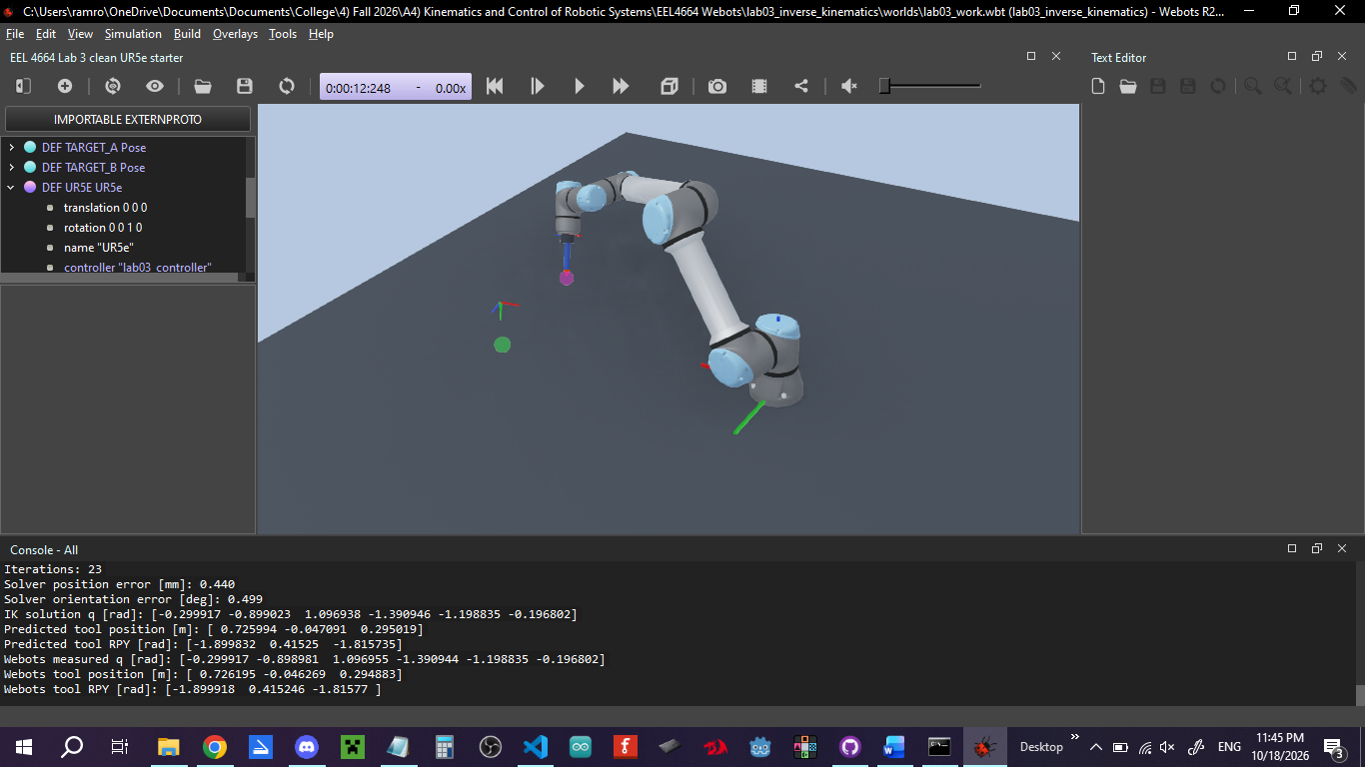
Both the predicted and measured tool position and tool RPY for Target B agree closely, only differing by a small decimal value.

5. Engineering question
During one IK iteration, what does the solver calculate by comparing the desired and current tool poses, and how does it use that result to update the joint angles?
During one IK iteration, the solver calculates the position error and orientation error by comparing the desired and current tool poses.

