Lab 4 Singularity Observation Report
  - EEL 4664 Robotics
Observe three straight stylus motions: a well-conditioned baseline, an approach to a straight-elbow singularity, and an approach to a shoulder singularity. Compare where the robot moves rapidly even though Cartesian speed remains constant.
Name: Ramiro Rojas
Section: 0
Date: 10/27/2026

Prediction
Before running Webots, predict which robot geometry and joint motion will identify the elbow and shoulder singularities in Trials 2 and 3.
________________________________________________________________________________
________________________________________________________________________________

Recorded Results
Copy the three values printed by the singularity_demo controller for each trial.
Quantity | Trial 1  Move away undamped | Trial 2  Approach elbow singularity | Trial 3  Approach shoulder singularity
Minimum singular value (sigma_min) | 0.196967 | 0.197003 | 0.090902
Condition number | 10.0 | 10.0 | 20.6
Peak commanded joint rate (rad/s) | 0.072 | 0.072 | 0.042
Interpret the recorded quantities as follows:
- Minimum singular value (sigma_min): larger is better. Zero means the Jacobian is singular; near zero means one Cartesian motion direction is almost lost.
- Condition number: smaller is better. One is ideal; a large value means the inverse is sensitive and can strongly amplify joint rates.
- Peak commanded joint rate: larger means faster joint motion. Compare it with the 3.00 rad/s Webots simulation limit.

Webots Evidence

Trial 1 Move Away Undamped Baseline
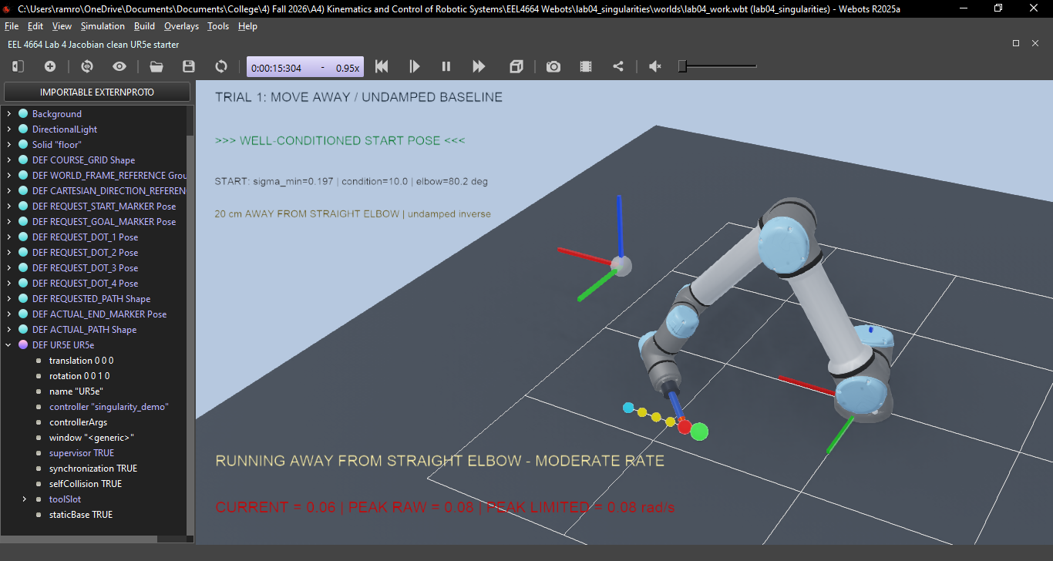

Trial 2 Approach Elbow Singularity Undamped
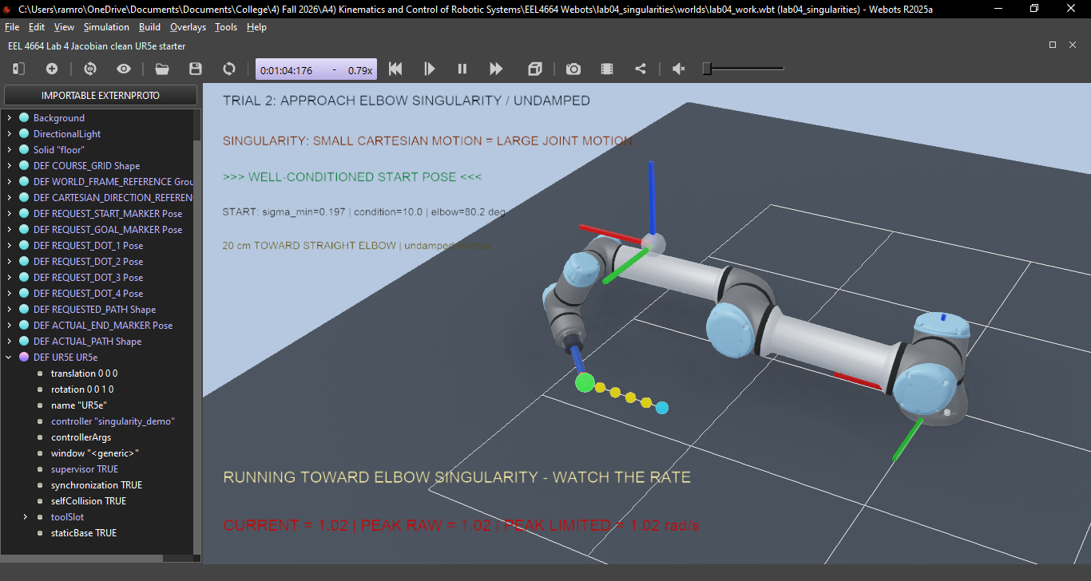

Trial 3 Approach Shoulder Singularity Undamped
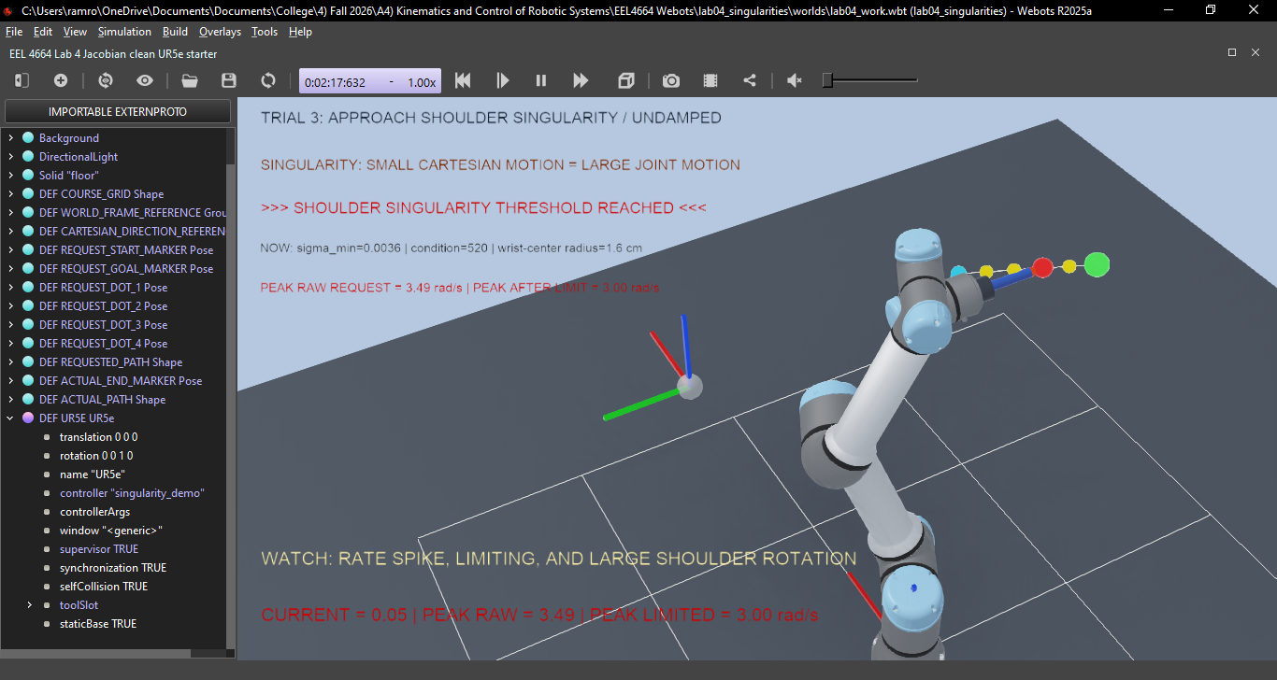

Joint Rate Comparison Plot
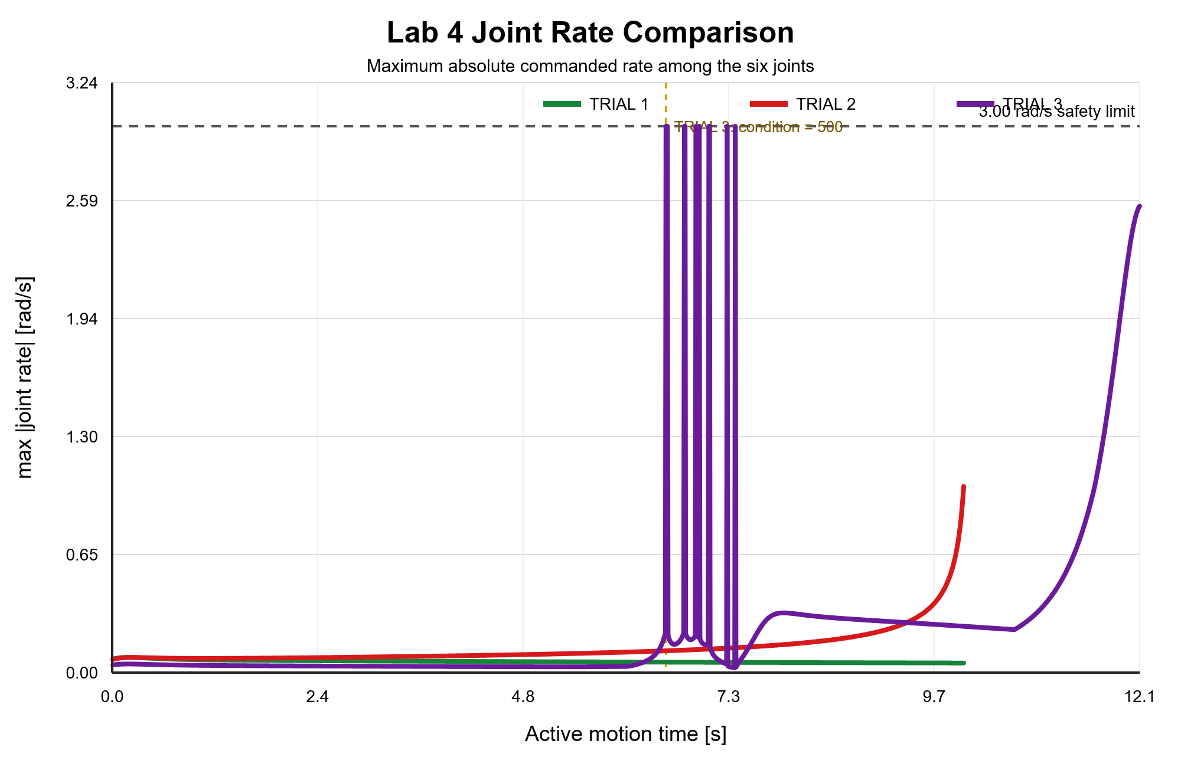

Questions

Why can a small requested Cartesian motion require very large joint motion near a singularity?
________________________________________________________________________________
________________________________________________________________________________
________________________________________________________________________________
________________________________________________________________________________

