EEL 4664
Lab 2 Report
UR5e Frames and Forward Kinematics
Student name  Ramiro Rojas | Course section  Section 0
Date
09/20/2026
Directions: Open this template in Microsoft Word. Before entering results, select File > Save As and create a personal copy named LastName_Lab02_Report.docx. Replace the prompt text with your results. Paste output as text and add screenshots with Insert > Pictures. Complete and submit your personal .docx copy.

1. Modified-DH entries and offline tests
Two completed matrix entries
row_2_column_1 = s_theta * c_alpha
row_3_column_4 = c_alpha * d
Zero-configuration test
[[ 1.000000e+00 0.000000e+00 0.000000e+00 8.172000e-01]
[ 0.000000e+00 6.123234e-17 -1.000000e+00 2.329000e-01]
[ 0.000000e+00 1.000000e+00 6.123234e-17 6.280000e-02]
[ 0.000000e+00 0.000000e+00 0.000000e+00 1.000000e+00]]
orthogonality = 0.0
det = 1.0
Nonsymmetric-configuration test
[[ 0.54974984 -0.63354676 0.54442044 0.66275216]
[ 0.73940191 0.06582515 -0.67003871 0.34808534]
[ 0.38866429 0.77089918 0.50463305 0.27722226]
[ 0. 0. 0. 1. ]]
orthogonality = 3.264366028275249e-16
det = 1.0000000000000002

Screenshot
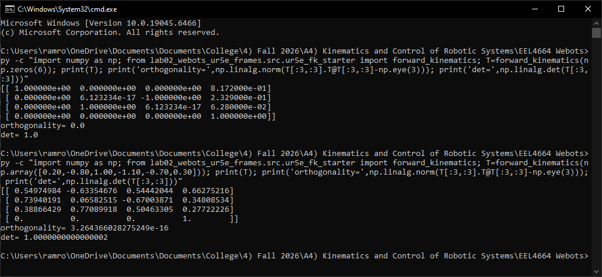

2. FK predictions before Webots
Run predict_fk_poses.py before running the Webots motion experiment.
FK prediction output for A, B, and C
Pose A
Position [m]: [0.638607 0.133379 0.452214]
RPY [rad]: [-1.641593e+00 7.943320e-04 -1.570853e+00]
Pose B
Position [m]: [0.662752 0.348085 0.277222]
RPY [rad]: [-2.561988 0.399181 -2.210128]
Pose C
Position [m]: [ 0.726296 -0.047359 0.294847]
RPY [rad]: [-1.890963 0.41478 -1.809042]
Screenshot
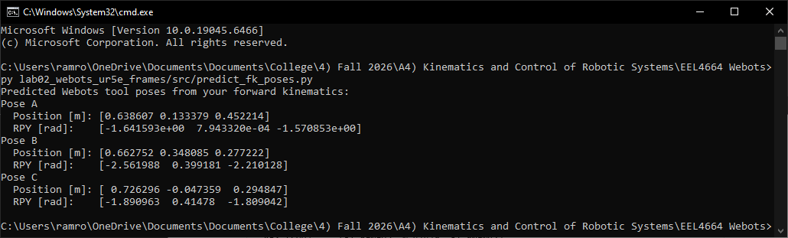

3. Webots motion and measurements
Webots output for A, B, and C
===== POSE A MEASUREMENT =====
Joint order: shoulder_pan_joint, shoulder_lift_joint, elbow_joint, wrist_1_joint, wrist_2_joint, wrist_3_joint
Measured q [rad]: [ 1.416890e-05 -1.199968e+00 1.200017e+00 -1.499998e+00 -1.570000e+00
-7.207035e-09]
Tool position [m]: [0.638689 0.134081 0.452088]
Tool RPY [rad]: [-1.641657e+00 7.871980e-04 -1.570852e+00]
Tool test point [m]: [0.629485 0.134183 0.322414]
===== POSE B MEASUREMENT =====
Joint order: shoulder_pan_joint, shoulder_lift_joint, elbow_joint, wrist_1_joint, wrist_2_joint, wrist_3_joint
Measured q [rad]: [ 0.2 -0.799955 1.000017 -1.099999 -0.7 0.3 ]
Tool position [m]: [0.662437 0.349048 0.277152]
Tool RPY [rad]: [-2.562041 0.399116 -2.210149]
Tool test point [m]: [0.591658 0.436151 0.211553]
===== POSE C MEASUREMENT =====
Joint order: shoulder_pan_joint, shoulder_lift_joint, elbow_joint, wrist_1_joint, wrist_2_joint, wrist_3_joint
Measured q [rad]: [-0.3 -0.899957 1.100017 -1.399999 -1.2 -0.2 ]
Tool position [m]: [ 0.7265 -0.046538 0.294712]
Tool RPY [rad]: [-1.891049 0.414778 -1.809077]
Tool test point [m]: [0.698468 0.011441 0.181784]

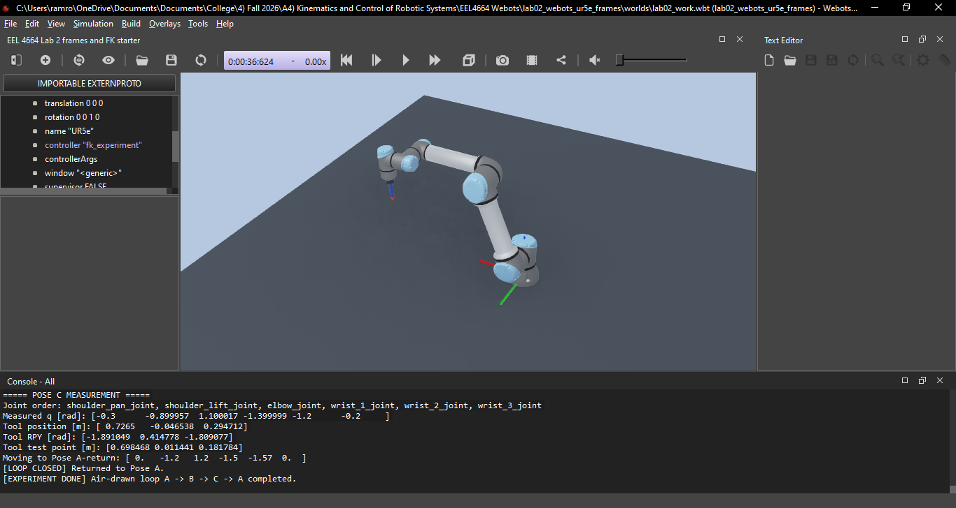

4. Qualitative comparison
Prediction versus Webots
For each pose, compare the predicted tool position [x, y, z] and predicted tool RPY [roll, pitch, yaw] from Step 5 with the Webots-measured tool position and tool RPY from Step 6.
Pose A: Both the predicted and Webots-measured tool position and tool RPY for Pose A agree closely, only differing by a small decimal value.
Pose B: Both the predicted and Webots-measured tool position and tool RPY for Pose B agree closely, only differing by a small decimal value.
Pose C: Both the predicted and Webots-measured tool position and tool RPY for Pose C agree closely, only differing by a small decimal value.
RPY means roll, pitch, and yaw: the three angles used here to describe tool orientation about the x-, y-, and z-axes. Write one or two sentences for each pose. No error formula is required.
Webots screenshot

Before submitting
Check your report
Check that your name, output, screenshots, and explanation are included. Save the file as .docx.

