Handler: Receives the request and and checks if it is correctly formatted ( and there’s no missing data).
Bussiness logic:
It’s desired for the handler and the bussiness logic to have as little relationship as possible. To insolate we use interfaces (exposed by the bussiness logic).
Each code (or part of a program) only should have one responsibility, for changes to be easily made.
Platfotm: Knows nothing about bussiness logic.
Folder structure:
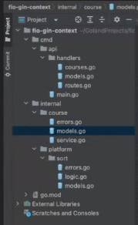
Course: Orders the courses and returns them
Platform: Has sort, which sorts (doesn’t know about about the courses, it only sorts names)

