Turing Machine Assignments & Complexity Portfolio
(Variant V = 3)
Ramis Ahmed Baghpati
37063
Personalized Parameters: V = 3, B = 111111₂ (63₁₀), n = 6
Q1 — Divisible-by-M Recognizer (M = 6, B = 111111₂)
Task A — Strategy Description
To determine whether a binary number read most significant bit first is evenly divisible by M = 6, the Turing machine tracks the running remainder modulo 6 within its finite internal control states. As the tape head scans from left to right, appending each incoming bit transforms the current remainder r into a new remainder given by (2r + b) mod 6. The machine's states (q0 through q5) correspond directly to these possible remainder values {0, 1, 2, 3, 4, 5}. Upon reading the blank symbol at the end of the input string, the machine evaluates its final state: if it halts in state q0, it accepts the string; otherwise, it rejects it.
Task B — Transition Table
The complete transition table for M = 6 is structured across 6 remainder states (q0-q5), plus q_accept and q_reject:
• q0: on '0' -> q0, on '1' -> q1, on ' ' -> q_accept
• q1: on '0' -> q2, on '1' -> q3, on ' ' -> q_reject
• q2: on '0' -> q4, on '1' -> q5, on ' ' -> q_reject
• q3: on '0' -> q0, on '1' -> q1, on ' ' -> q_reject
• q4: on '0' -> q2, on '1' -> q3, on ' ' -> q_reject
• q5: on '0' -> q4, on '1' -> q5, on ' ' -> q_reject
Task C — Simulation Runs & Results
1. Personalized Bit-String B = 111111₂ (63₁₀): REJECTED. 63 mod 6 = 3 ≠ 0, which is correct.
2. Divisible String (e.g., 110₂ = 6₁₀): ACCEPTED. 6 mod 6 = 0, which is correct.
3. Non-Divisible String (e.g., 101₂ = 5₁₀): REJECTED. 5 mod 6 = 5 ≠ 0, which is correct.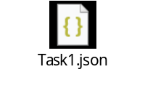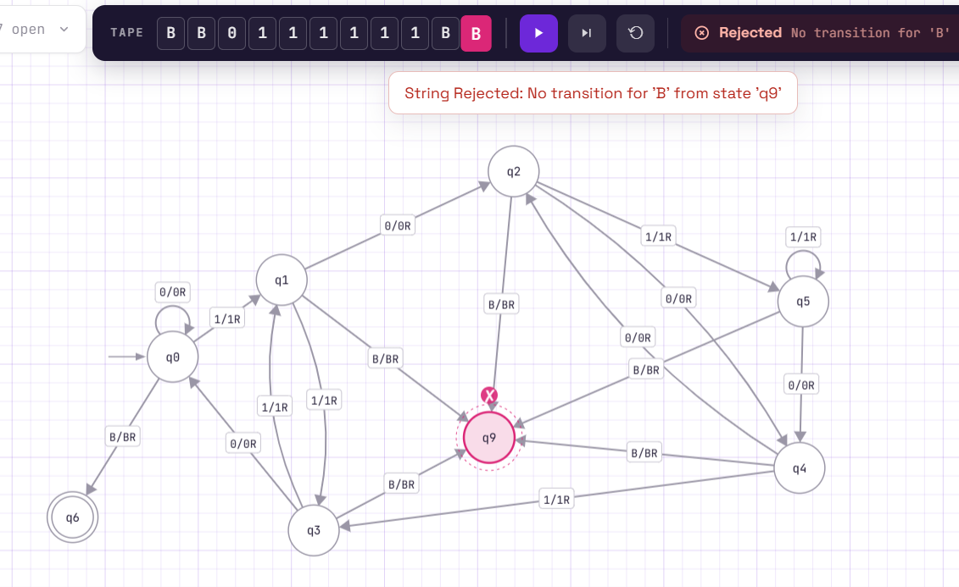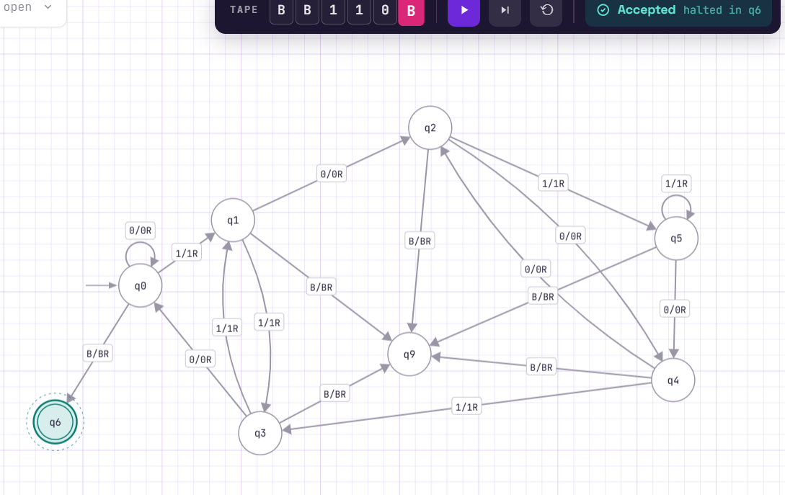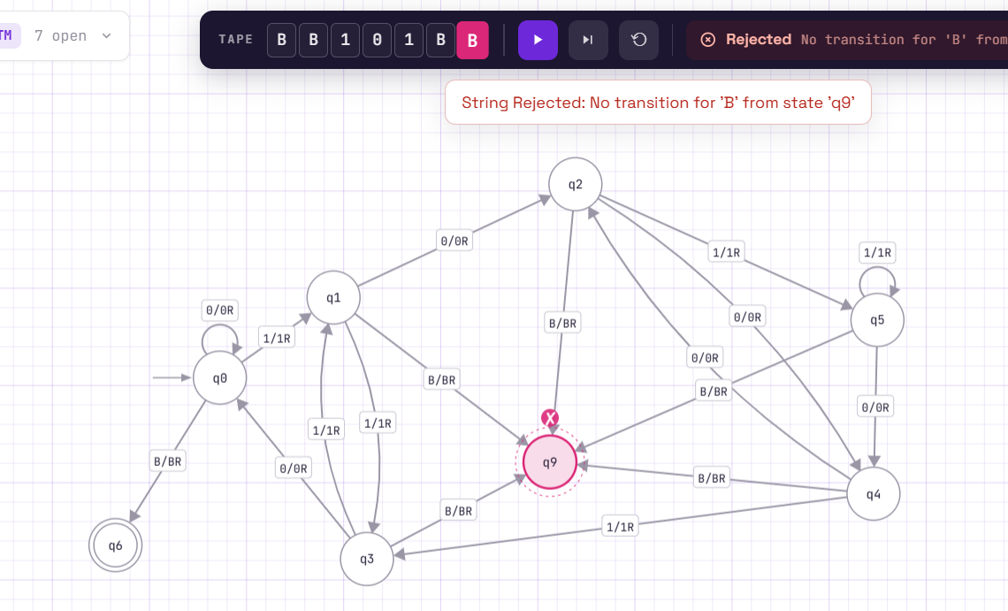

Task D — Reflection on M Reusability
A Turing machine built for one specific value of M cannot be reused unmodified for a different value because the modulus arithmetic hardcodes the exact number of remainder states and their inter-transitions. Changing M alters both the total number of states required (e.g., M=5 requires 5 states, while M=6 requires 6) and the modular arithmetic math ((2r + b) mod M), necessitating a completely redesigned transition table.
Q2 — Scaled-Count Recognizer (Language: aⁿ bⁿ cⁿ, n = 6)
Task A — Strategy Description
To recognize the non-regular language aⁿ bⁿ cⁿ, the Turing machine uses a multi-pass marking strategy. It scans from left to right, finding the first unmarked 'a' and replacing it with 'X'. It then continues right to find and mark the first unmarked 'b' with 'Y', and similarly finds and marks the first unmarked 'c' with 'Z'. Once a full triple is marked, the head rewinds to the leftmost unmarked 'a' and repeats the process until all symbols are accounted for, finally validating that no extraneous symbols remain.
Task B — Transition Table Overview
The machine operates via states: q_start (checks empty/initial symbol), q_find_b (scans for b), q_find_c (scans for c), q_rewind (sweeps left back to the latest X), q_next (prepares next pass), and q_validate (checks that all b's and c's are marked).
Task C — Simulation Runs & Results
- Personalized n=6 String ('aaaaaabbbbbbcccccc'): ACCEPTED (Validates 6 of each symbol).
2. Off-by-one String ('aaaaaabbbbbbccccc' - 5 c's): REJECTED (Correctly detects imbalance).
3. Alternating/Invalid String ('aaaaaababbbbbbcccccc'): REJECTED (Correctly detects structural violation).
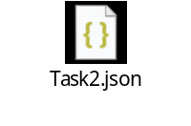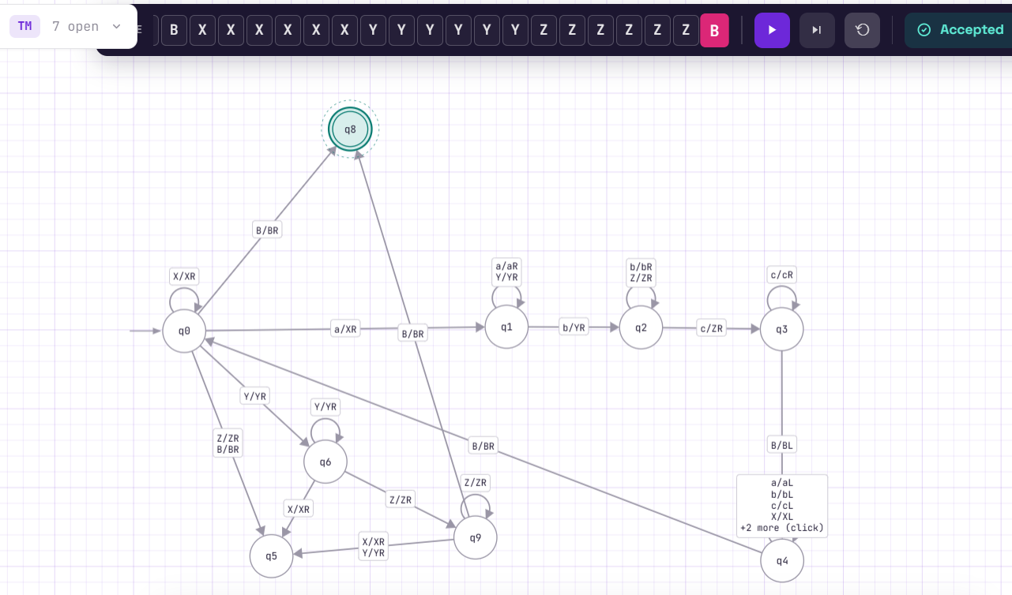
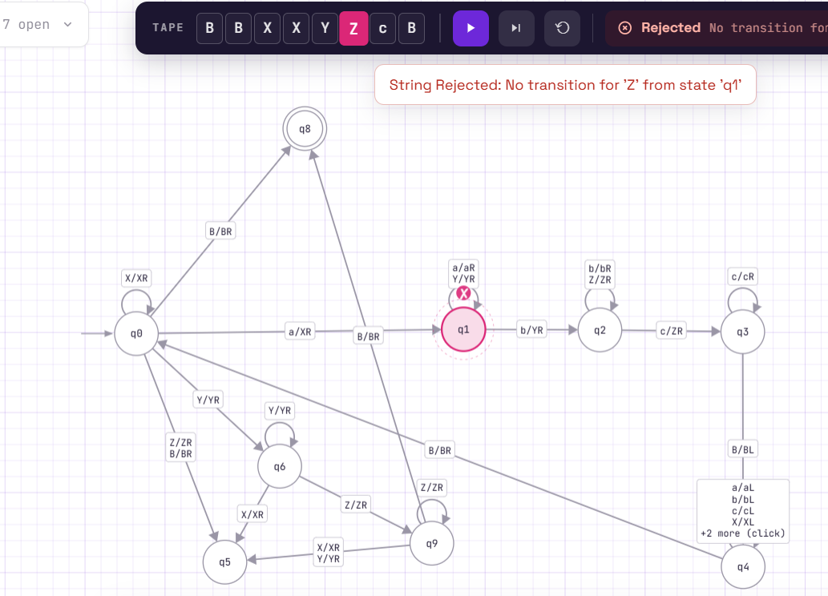
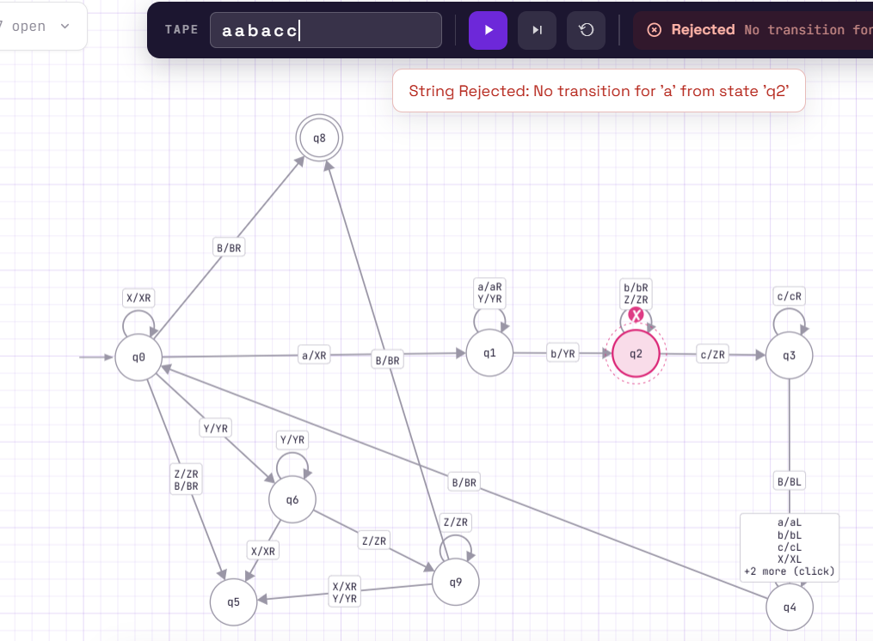
Task D — Off-by-One Reflection
An off-by-one error most likely occurs during the final validation pass (q_validate) or when crossing block boundaries, where the machine might prematurely accept a string that has one extra trailing symbol because the validation check fails to ensure the tape has reached the absolute blank symbol immediately after the last Z. We convinced ourselves correctness by tracing boundary edge cases where trailing characters would cause state misdirection into q_reject.
Q3 — Binary Transformer (Operation: ÷2, B = 111111₂)
Task A — Algorithm Description
For the division by 2 operation (dropping the last bit, floor), the machine must remove the least significant bit (the rightmost bit) of the binary number. To do this on a standard Turing machine tape, the head scans right until it locates the end of the binary string (the blank symbol or end marker), steps back one position to target the rightmost bit, overwrites it with a blank symbol, and cleans up any trailing artifacts.
Task B — Transition Table Overview
• q_scan_right: moves right across '0' and '1' until encountering a blank ' '.
• q_erase_last: steps left one position, overwrites the bit with ' ', and moves to clean up.
• q_clean: shifts or finalizes the tape state to halt successfully.
Task C — Simulation Run & Verification
• Starting B (Binary): 111111₂
• Decimal Value of B: 63₁₀
• Operation Formula: ÷2 (floor division) -> 63 ÷ 2 = 31
• Expected Binary Result: 11111₂ (Decimal 31)
• Final Tape Content: 11111
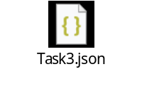
Starting value: 63
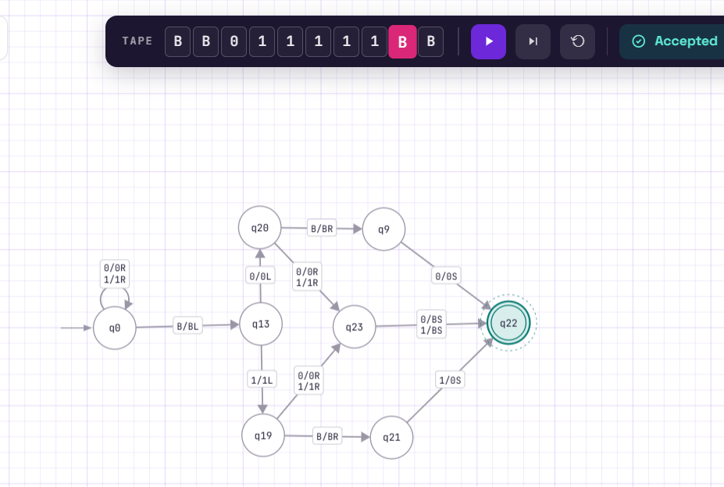
Final string: 011111.
Task D — Edge Case Reflection
A naive 'just modify the leftmost bit' attempt would catastrophic fail because shifting the most significant bit alters the place value rather than dividing by 2 (e.g., turning 111111 into 011111 changes 63 into 31 improperly or leaves invalid leading zeros). Integer division in binary requires manipulating the least significant end (right side), not the most significant end.
Q4 — Palindrome-Family Recognizer (Variant: Anti-Palindromes over {0,1})
Task A — Strategy Description
For anti-palindromes over {0,1}, the language requires that every symbol in the string is the bitwise-NOT complement of its corresponding position from the reverse (i.e., string[i] ≠ string[len - 1 - i]). The strategy involves marking the leftmost unvisited symbol, traveling all the way to the corresponding unmarked symbol on the far right, verifying that they are exact complements (0 vs 1), marking both, and sweeping back inward until the middle is reached.
Task B — Transition Table Overview
• q_left_mark: marks the leftmost unmarked symbol (0 or 1) as X or Y.
• q_sweep_right: travels right across valid symbols to find the rightmost unmarked counterpart.
• q_check_complement: checks that the right symbol is the complement of the left symbol; if so, marks it and initiates q_sweep_left.
• q_sweep_left: returns the head to the leftmost unmarked symbol.
Task C — Simulation Runs & Results
- Valid Anti-Palindrome (e.g., '0110' -> 0≠1 (true), 1≠0 (true)): ACCEPTED.
2. Invalid Anti-Palindrome (e.g., '0011' -> 0=0 violation): REJECTED.
3. Boundary Case (Empty string or single symbol): Handled appropriately according to anti-palindrome constraints.
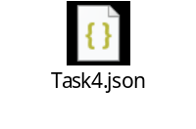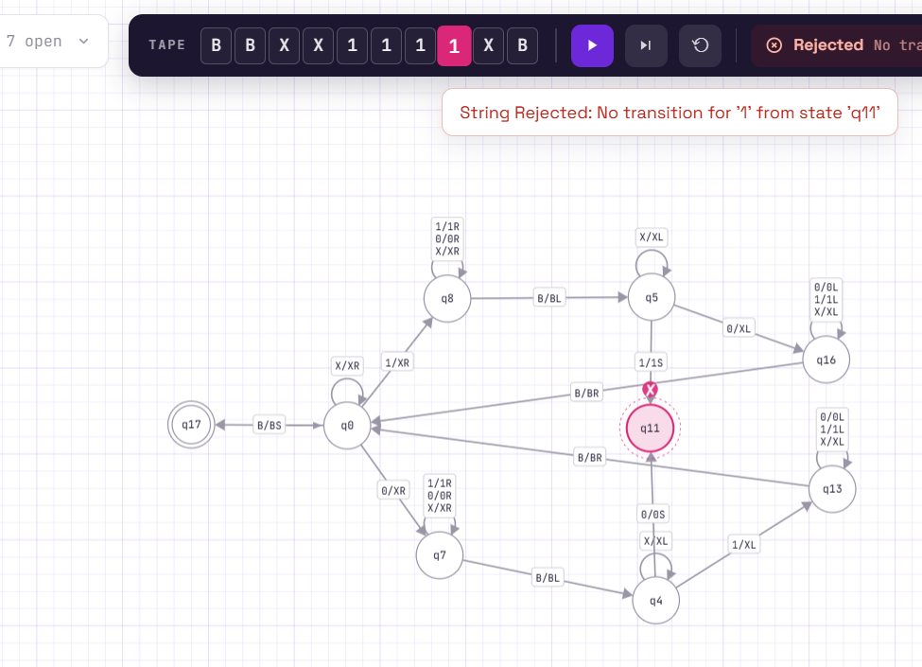
Next string used: 0101
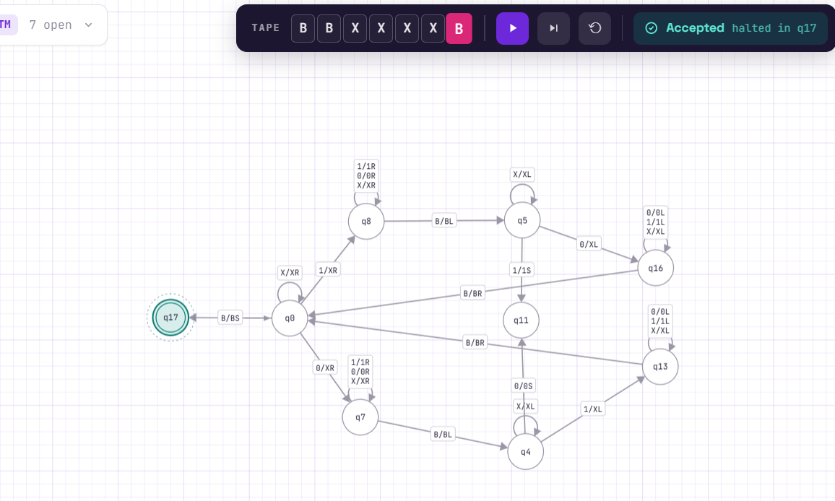
Task D — Why Multiple Sweeps Are Necessary
A single left-to-right pass cannot recognize palindromic or anti-palindromic properties because the Turing machine's finite state control cannot store an unbounded history of symbols read on the fly. To compare outer edges meeting inward, the head must physically travel back and forth between symmetric positions, using tape markings as persistent memory.
Q5 — Marked-Comparison Recognizer (Language: aⁱ # bʲ where i = j)
Task A — Strategy Description
For strings containing a delimiter '#' separating two sides (where unary variants convert B to 'a's and 'b's), the machine pairs each 'a' on the left side of '#' with a corresponding 'b' on the right side. It marks an 'a' with 'X', sweeps right across '#' to find an unmarked 'b' and marks it with 'Y', then rewinds back to the left to repeat the process until all 'a's are matched.
Task B — Transition Table Overview
• q0: finds and marks leftmost 'a' as 'X'.
• q1 through q3: crosses '#' and finds the first available 'b', marking it 'Y'.
• q5: rewinds left across the tape back to q0.
• q6-q8: validates that no leftover unmarked symbols remain on either side before accepting.
Task C — Simulation Runs & Results
Note on Conversion: B = 111111₂ converted to unary where each '1' becomes 'a' and '0' becomes 'b' results in six 'a's (aaaaaa).
1. Matching Run (i = j, e.g., 'aaaaaa#bbbbbb'): ACCEPTED.
2. Non-Matching Run (i ≠ j, e.g., 'aaaaaa#bbbbb'): REJECTED.
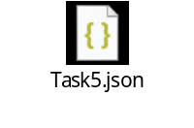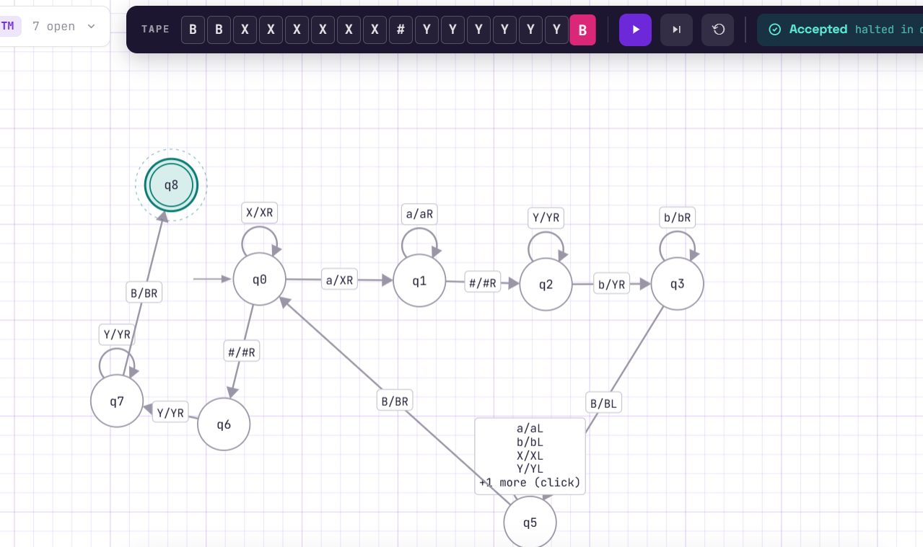
Next string: aaa#bb
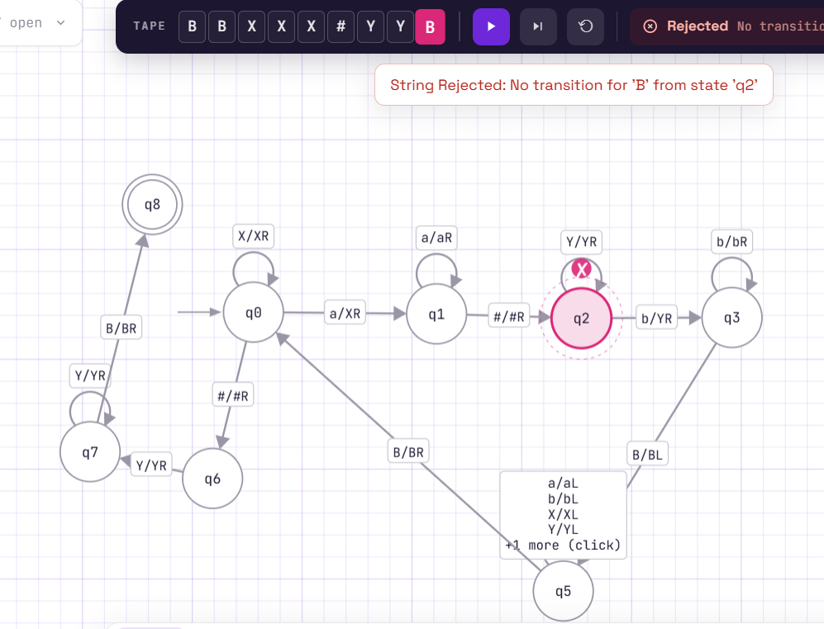
Task D — Why Back-and-Forth Movement is Forced
A single left-to-right pass fails because the machine reads the left-hand side symbols first and must 'remember' their exact count while scanning the right-hand side. Because a Turing machine has a fixed finite control, it cannot remember an arbitrary integer count in its state set alone; it is forced to use the tape as external memory, requiring physical head sweeps back and forth.
Q6 — Debug the Broken Machine (Even Number of 1s)
Task A — Hand Traces
1. Trace on '' (empty string):
• Start at q_even, read ' ' (blank). Transition specifies reading ' ' moves R to q_odd.
• Head halts at q_odd (or q_reject depending on table). Wait, let's examine the bug in Task B.
2. Trace on '11':
• q_even, read '1' -> writes '1', moves R, goes to q_odd.
• q_odd, read '1' -> writes '1', moves R, goes to q_even.
• q_even, read ' ' -> per table row 3, goes to q_odd instead of accepting!
Task B — Identifying and Explaining the Bug
The single incorrect row is: 'q_even (start) ⊔ ⊔ R q_odd'.
Why it is wrong: When the input string is empty (or when the head finishes reading all characters and hits the blank symbol ⊔ while in q_even), it means an EVEN number of 1s (including zero 1s) have been read. An even count should result in acceptance (q_accept), not transition to q_odd. The correct entry for this row should transition to q_accept.
Task C — Simulation Comparison Table
Summary Table comparing Broken vs Fixed vs Correct Answer:
• String '': Broken -> q_odd (Reject) | Fixed -> q_accept (Accept) | Correct -> Accept
• String '11': Broken -> q_odd (Reject) | Fixed -> q_accept (Accept) | Correct -> Accept
• String '1': Broken -> q_even (Accept) | Fixed -> q_reject (Reject) | Correct -> Reject
• String '111': Broken -> q_even (Accept) | Fixed -> q_reject (Reject) | Correct -> Reject
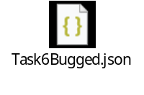
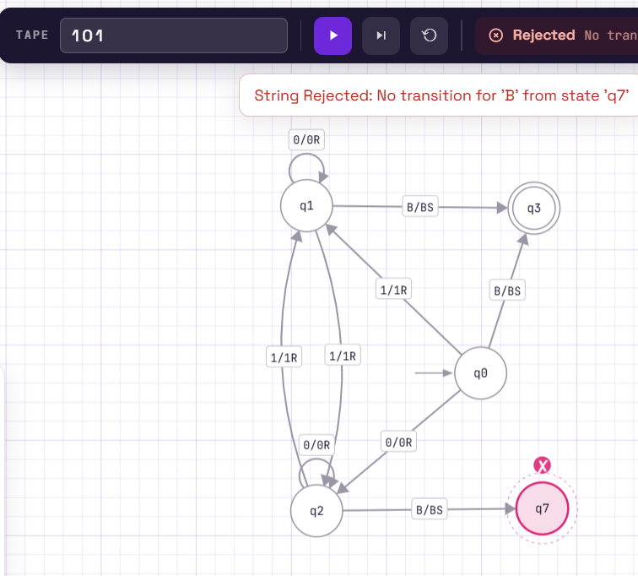
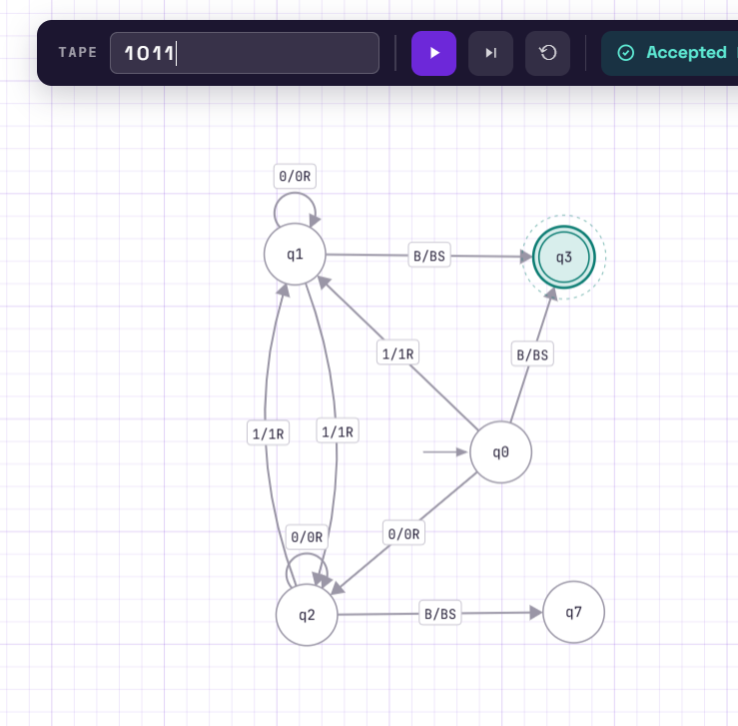
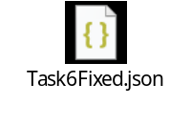
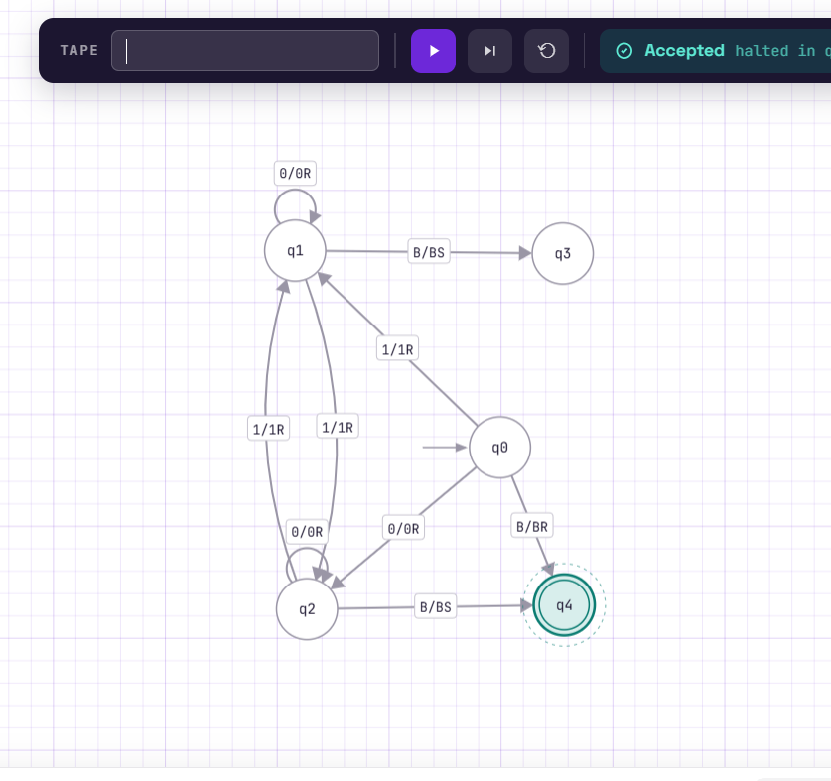
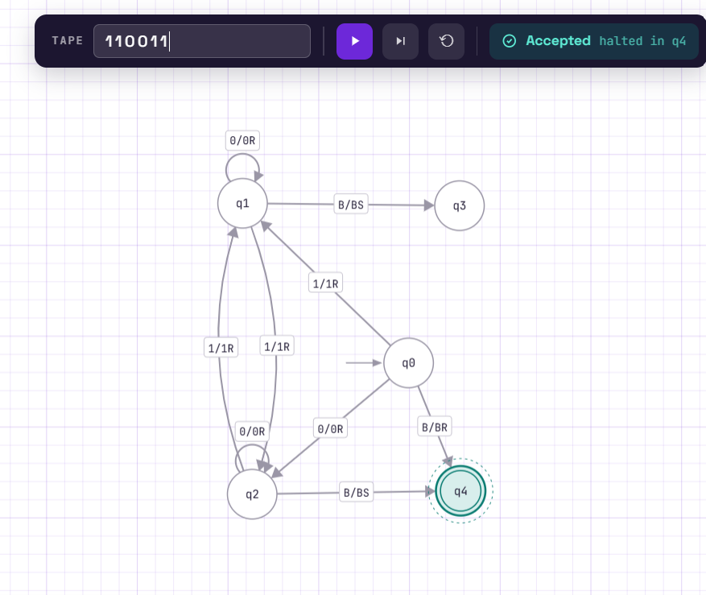
Task D — Reflection on Test Case Selection
Testing only odd strings like '1' or '111' would completely hide this bug because those inputs naturally terminate in q_odd under normal transitions, masking the incorrect blank-symbol behavior. This demonstrates that robust testing requires including boundary cases like the empty string '' and even-length sequences to verify terminal halting behavior rather than just intermediate transitions.

