SYSTEM REQUIREMENTS SPECIFICATION (SRS)

FOR

***[Scholl Management System]***

Platform Version No.: 1.0

Document Version No.: 1.0

Template Version No.: 1.1

**Template Revision History**

|  |  |  |  |  |
| --- | --- | --- | --- | --- |
| Version  No. | Version Date | Changes/Description | Prepared By | Reviewed/  Approved By |
| 01. | 29 June 2022 | Initial Drop | Ramisa Anjum Oishi |  |
|  |  |  |  |  |
|  |  |  |  |  |
|  |  |  |  |  |

*Users should not delete the content

**Document Revision History**

|  |  |  |  |  |
| --- | --- | --- | --- | --- |
| Version  No. | Version Date | Changes/Description | Prepared By | Reviewed/  Approved By |
| 01. | 29 June 2022 | Initial | Ramisa Anjum Oishi |  |
|  |  |  |  |  |
|  |  |  |  |  |

Index

**Introduction                                                                                                                                  4**

**Purpose                                                                                                                                        4**

**System Overview                                                                                                                         5**

**Diagram**

**Use Case Diagram                                                                                                                     5**

**The Flow Chart Diagram                                                                                                                  7**

**User Stories                                                                                                                                8**

**Use Cases                                                                                                                                   11**

Introduction

The purpose of this document is to outline the system requirements for the ***School Management System*** in a technology ambiguous manner. It intends to outline the users, features, and goals of the management of the school. A school management system may integrate only with students and teachers but the aim behind this project is to boost the traditional school management environment with the possible related users like students, teachers, guardians, admins and principle. This document covers expected users, user stories, process diagrams, detailed use cases, detail-oriented UI designs/mock-ups, and functional and technical requirements of the system. It is also expected to be used to clarify the requirements of this system and to help make a technology selection.

Purpose

This document will be used for the system design & development of the platform for the School Management System. The Platform, will introduce a web-based solution and service for their school management and will develop an initial level web-based application for this project which will be integrated with the core platform.

System Overview

The project is about The School Management System where the client wants his school management to be automated by a web-based solution. In this system there will be six type of users who will interacting with the system in daily basis. The users are Admin, Student, Accountant, Teacher, Guardian and Principle. In the system the Admin will be responsible for creating the accounts of student’s teachers and accountant. The teachers will take attendance throughout the system, can upload students result sheet, search students by their id, can see the payment status of the students. The students and guardians can also see the attendance sheet of a particular month. Guardians can pay through the system online payment platform. Accountant can check student’s payment statement then update it if anyone want to pay physically. Principle can post notice through the system. However, with the overall expectation of the client is to update the school management system from traditional level to automated level. The client does not want the traditional system like notice board, paper work on accounts, paper work on attendance and all. The system has been constructing by considering the clients requirement that he wants a web-based automated solution for his school management system.

**Diagram: The use case**

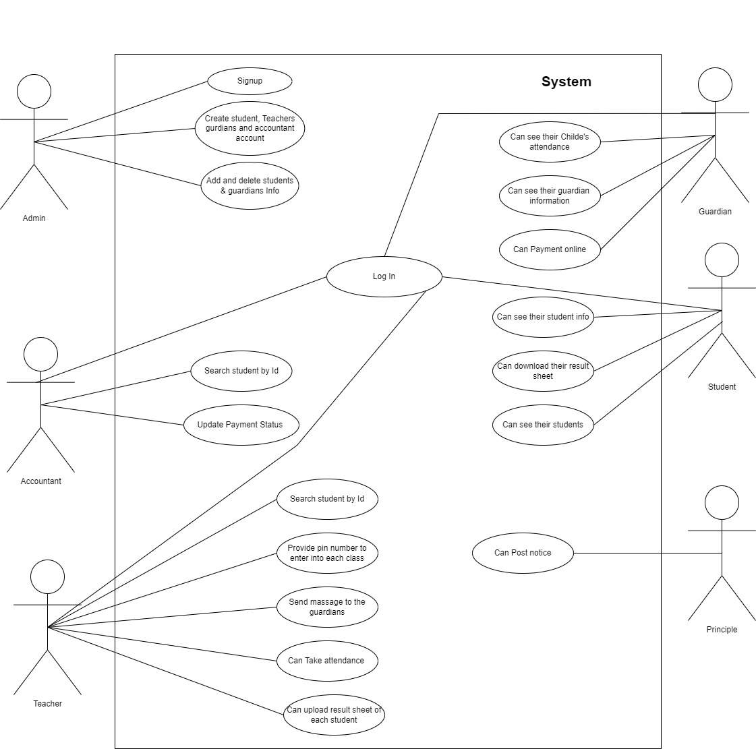

**The Flow chart:**

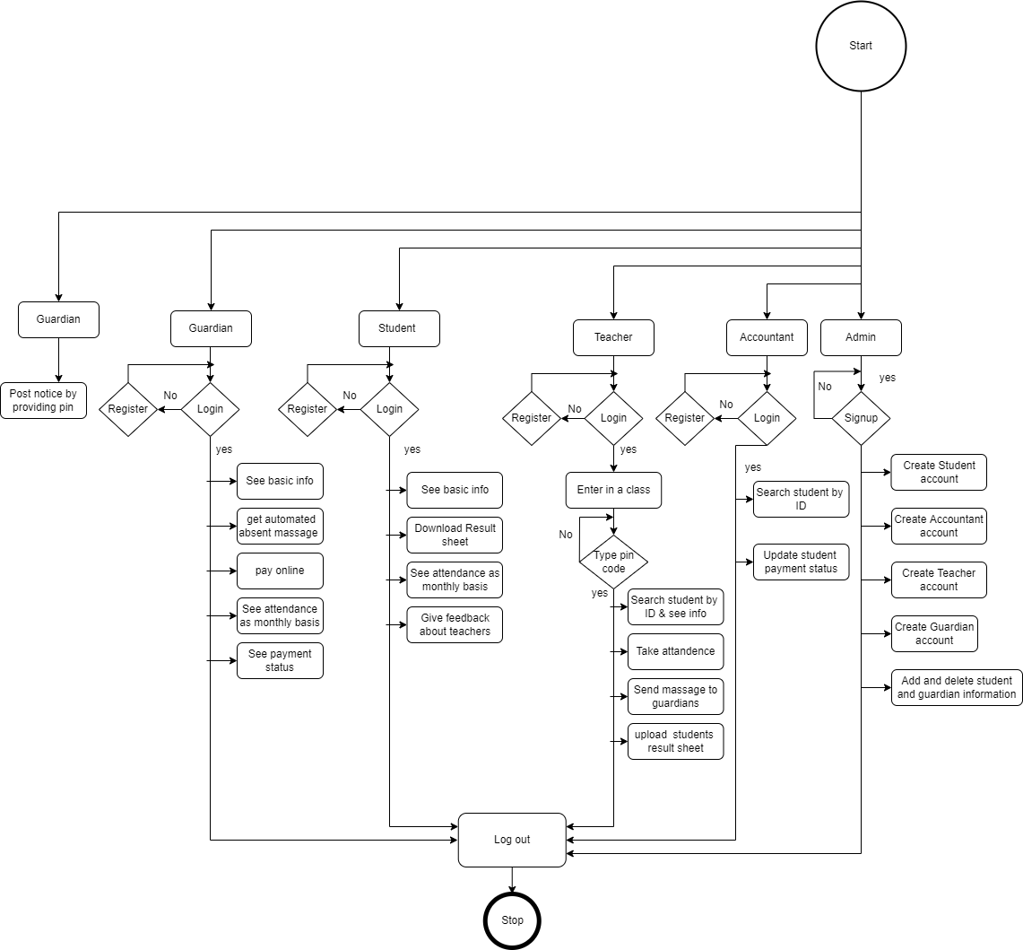

**­**

User Stories

|  |  |  |  |
| --- | --- | --- | --- |
| As a | Sl No. | I want to | So that I can |
| Admin  Accountant  Teacher  Student |  | There should be an admin panel also an admin login | manage the whole system. |
|  | Admin will able to create their account only with the official mail that has been provided to them | Only the official employee has the rights to opens an account |
|  | Admin can add and remove student’s information from the system | Track down the current student’s information |
|  | Only admin is able to create student, guardians and teachers account | the complication with those user’s login could not be happen |
|  | The accountant account should be created by admins with a specific id and pass word | The accountants can not change the password or create any new accountant account as the security purpose |
|  | There should be a section where login as admin has to be clicked | The system can understand the type of user login |
|  | Search students by id | To see and update the payment status |
|  | The payment receipt should be printed prom the system | Provide receipt who will clear the payment in offline |
|  | There should be a section where login as Teacher has to be clicked | The system can understand the type of user login |
|  | After login to the system all the class standers of the Scholl have to be shown | The class teacher can go to the particular class standard |
|  | After click into the particular class all the available sections will show up | The class teachers of different sections can enter into the particular section. |
|  | Teacher will click into the assigned section and they need to type a 6-digit pin number to get into the section | No other teacher from the other section can access each other assigned section |
|  | Teachers will set the 6-digit password by their own and can also change it or remove it. | Only they can know about the pin number |
|  | To Take attendance the date and the month should be selected. | The track down for every day’s attendance is easy. |
|  | Search the students by their id | To watch the information and also payment status, result sheet and attendee sheet of each month |
|  | Teachers can see their attendance sheet with dates and the attendance days should be marked green and absent days marked red | Easily understand the total present and absent days. |
|  | Can upload their result sheet | Students can able to download them. |
|  | Teachers can send massage to guardians through the system | To inform them about the results or any other information. |
|  | To set the 6 digits pin it has to be typed twice and to change or remove the pin, the existing one has to be required | Change or remove anytime |
|  | There should be a section where login as student has to be clicked | The system can understand the type of user login |
|  | See the basic information  Like name roll number guardian name, phone number & photo | Identify themselves |
|  | Can download the result sheet | There is no need to go into Scholl to collect it |
|  |  | Student can select month to see the attendance where the dates marked green for present and red for absent | Track their own attendance days |
| Guardian  Principle |  | Give feedback about the teachers | The officials should know about the teacher’s behavior with the students |
|  | Download their class routine | There is no need to print it in traditional ways |
|  | There should be a section where login as student has to be clicked | The system can understand the type of user login |
|  | See the basic information  Like name roll number guardian name, phone number & photo | Identify themselves |
|  | Can download the result sheet | There is no need to go into Scholl to collect it |
|  | Pay the school fees through mobile banking | Able to pay from anywhere |
|  | can select month to see the attendance where the dates marked green for present and red for absent | Track their own attendance days |
|  | Can see the students due or done payment status | Notified about the payment status |
|  |  |  |
|  | Can post notice to the system’s notice section | To notify about the school decisions to the teachers’ students. |
|  | There should be a button ca post notice | Another web page can load to post the notice |
|  | After click into the post notice button a password should be required | No other can post notice expect the principle |
|  | To set the password it has to be typed twice and to change or remove the it, the existing one has to be required | Change or remove anytime |
|  |  |  |
|  |  |  |
|  |  |  |
|  |  |  |
|  |  |  |
|  |  |  |  |
|  |  |  |  |

Use Cases

Web Admin Panel Login

|  |  |  |  |
| --- | --- | --- | --- |
|  | | | |
| **Use Case ID** | **1** | | |
| **BRS Code** |  | **SRS Code** | **1.0** |
| **Use Case Name** | **Login** | | |
| **Created By** | BA | **Last Updated By** |  |
| **Date Created** | 29-06-2022 | **Date Last Updated** |  |
| **Requirement Source** | Clint interview (Admin) | | |
| **Actors** | Admin User | | |
| **Description** | This use case describes the login process of this application. Users will be able to log in the web application via application browser. Admin user will able to login to the system with the email ID and predefined password.  After Successful login, users will be able to see the homepage of this web admin panel. | | |
| **Preconditions** | Admin Users should browse the URL and an admin account must be registered. | | |
| **Postconditions:** | The Application will show the Homepage of this portal. | | |
| **Normal Course:** | The user will be able to login and also browse the homepage of admin panel to perform the actions that was mentioned in user stories also a registered account is needed to login to the system.  The admin should click login **as admin**.  Input:   * Type the admin panel **URL** on the web browser * Enter **Email ID** * Enter **Password**   Select:   * Click on **Login** * Click on **forgot password** | | |
| **Alternative Courses:** | N/A | | |
| **Exceptions:** | N/A | | |
| **Include:** | N/A | | |
| **Priority:** | High | | |
| **Frequency of Use:** | Once Per Visit | | |
| **Business Rules** | The user is only able to open an admin account with the organizational provided mail. | | |
| **Special Requirements:** | N/A | | |
| **Assumptions:** | N/A | | |
| **Notes and Issues:** |  | | |

Web Accountant Panel Login

|  |  |  |  |
| --- | --- | --- | --- |
|  | | | |
| **Use Case ID** | **2** | | |
| **BRS Code** |  | **SRS Code** | **1.0** |
| **Use Case Name** | **Login** | | |
| **Created By** | BA | **Last Updated By** |  |
| **Date Created** | 29-06-2022 | **Date Last Updated** |  |
| **Requirement Source** | Clint interview (Admin) | | |
| **Actors** | Accountant User | | |
| **Description** | This use case describes the login process of this application. Users will be able to log in the web application via application browser. Accountant user will able to login to the system with predefined id and password.  After Successful login, users will be able to see the homepage of this web Accountant panel. | | |
| **Preconditions** | Admin Users should browse the URL and an Accountant account must be registered. | | |
| **Postconditions:** | The Application will show the Homepage of this portal. | | |
| **Normal Course:** | The user will be able to login also browse the homepage of accountant panel to perform the actions that was mentioned in user stories also a registered account is needed to login to the system. The accountant has to select login **as accountant.**  Input:   * Type the admin panel **URL** on the web browser * Enter **User ID** * Enter **Password**   Select:   * Click on **Login** | | |
| **Alternative Courses:** | N/A | | |
| **Exceptions:** | N/A | | |
| **Include:** | N/A | | |
| **Priority:** | High | | |
| **Frequency of Use:** | Once Per Visit | | |
| **Business Rules** | The account should be created by the admin only and the id should include only ‘**character’** and ‘**intege**r’ value | | |
| **Special Requirements:** | N/A | | |
| **Assumptions:** | N/A | | |
| **Notes and Issues:** |  | | |

Web Teacher Panel Login

|  |  |  |  |
| --- | --- | --- | --- |
|  | | | |
| **Use Case ID** | **3** | | |
| **BRS Code** |  | **SRS Code** | **1.0** |
| **Use Case Name** | **Login** | | |
| **Created By** | BA | **Last Updated By** |  |
| **Date Created** | 29-06-2022 | **Date Last Updated** |  |
| **Requirement Source** | Clint interview (Admin) | | |
| **Actors** | Teacher User | | |
| **Description** | This use case describes the login process of this application. Users will be able to log in the web application via application browser. The user Teacher will able to login to the system with predefined id and password.  After Successful login, users will be able to see the homepage of this web Teacher panel. | | |
| **Preconditions** | Teacher Users should browse the URL and a teacher account must be registered. | | |
| **Postconditions:** | The Application will show the Homepage of this portal. | | |
| **Normal Course:** | The user will be able to login also browse the homepage of Teacher panel to perform the actions that was mentioned in user stories also a registered account is needed to login to the system. The Teacher has to select login **as Teacher.**  Input:   * Type the admin panel **URL** on the web browser * Enter **User ID** * Enter **Password**   Select:   * Click on **Login** | | |
| **Alternative Courses:** | N/A | | |
| **Exceptions:** | N/A | | |
| **Include:** | N/A | | |
| **Priority:** | High | | |
| **Frequency of Use:** | Once Per Visit | | |
| **Business Rules** | The account should be created by the admin only and the id should include only **“Character”** and **“integer”** value | | |
| **Special Requirements:** | N/A | | |
| **Assumptions:** | N/A | | |
| **Notes and Issues:** |  | | |

Web Student Panel Login

|  |  |  |  |
| --- | --- | --- | --- |
|  | | | |
| **Use Case ID** | **4** | | |
| **BRS Code** |  | **SRS Code** | **1.0** |
| **Use Case Name** | **Login** | | |
| **Created By** | BA | **Last Updated By** |  |
| **Date Created** | 29-06-2022 | **Date Last Updated** |  |
| **Requirement Source** | Clint interview (Admin) & (Students) | | |
| **Actors** | Student User | | |
| **Description** | This use case describes the login process of this application. Users will be able to log in the web application via application browser. The user Student will able to login to the system with predefined id and password.  After Successful login, users will be able to see the homepage of this web Student panel. | | |
| **Preconditions** | Student Users should browse the URL and a student account must be registered. | | |
| **Postconditions:** | The Application will show the Homepage of this portal. | | |
| **Normal Course:** | The user will be able to login also browse the homepage of Teacher panel to perform the actions that was mentioned in user stories also a registered account is needed to login to the system. The Student has to select login **as Student.**  Input:   * Type the admin panel **URL** on the web browser * Enter **User ID** * Enter **Password**   Select:   * Click on **Login** | | |
| **Alternative Courses:** | N/A | | |
| **Exceptions:** | N/A | | |
| **Include:** | N/A | | |
| **Priority:** | High | | |
| **Frequency of Use:** | Once Per Visit | | |
| **Business Rules** | The account should be created by the admin only and the id should include only **“-”** and **“integer”** value | | |
| **Special Requirements:** | N/A | | |
| **Assumptions:** | N/A | | |
| **Notes and Issues:** |  | | |

Web Student Panel Login

|  |  |  |  |
| --- | --- | --- | --- |
|  | | | |
| **Use Case ID** | **4** | | |
| **BRS Code** |  | **SRS Code** | **1.0** |
| **Use Case Name** | **Login** | | |
| **Created By** | BA | **Last Updated By** |  |
| **Date Created** | 29-06-2022 | **Date Last Updated** |  |
| **Requirement Source** | Clint interview (Admin) & (Students) | | |
| **Actors** | Student User | | |
| **Description** | This use case describes the login process of this application. Users will be able to log in the web application via application browser. The user Student will able to login to the system with predefined id and password.  After Successful login, users will be able to see the homepage of this web Student panel. | | |
| **Preconditions** | Student Users should browse the URL and a student account must be registered. | | |
| **Postconditions:** | The Application will show the Homepage of this portal. | | |
| **Normal Course:** | The user will be able to login also browse the homepage of student panel to perform the actions that was mentioned in user stories also a registered account is needed to login to the system. The Student has to select login **as Student.**  Input:   * Type the admin panel **URL** on the web browser * Enter **User ID** * Enter **Password**   Select:   * Click on **Login** | | |
| **Alternative Courses:** | N/A | | |
| **Exceptions:** | N/A | | |
| **Include:** | N/A | | |
| **Priority:** | High | | |
| **Frequency of Use:** | Once Per Visit | | |
| **Business Rules** | The account should be created by the admin only and the id should include only **“-”** and **“integer”** value | | |
| **Special Requirements:** | N/A | | |
| **Assumptions:** | N/A | | |
| **Notes and Issues:** |  | | |

Web Guardian Panel Login

|  |  |  |  |
| --- | --- | --- | --- |
|  | | | |
| **Use Case ID** | **5** | | |
| **BRS Code** |  | **SRS Code** | **1.0** |
| **Use Case Name** | **Login** | | |
| **Created By** | BA | **Last Updated By** |  |
| **Date Created** | 29-06-2022 | **Date Last Updated** |  |
| **Requirement Source** | Clint interview (Admin) | | |
| **Actors** | Guardian User | | |
| **Description** | This use case describes the login process of this application. Users will be able to log in the web application via application browser. The user Guardian will able to login to the system with predefined id and password.  After Successful login, users will be able to see the homepage of this web Guardian panel. | | |
| **Preconditions** | Guardian Users should browse the URL and a student account must be registered. | | |
| **Postconditions:** | The Application will show the Homepage of this portal. | | |
| **Normal Course:** | The user will be able to login also browse the homepage of Guardian panel to perform the actions that was mentioned in user stories also a registered account is needed to login to the system. The Student has to select login **as Guardian**  Input:   * Type the admin panel **URL** on the web browser * Enter **User ID** * Enter **Password**   Select:   * Click on **Login** | | |
| **Alternative Courses:** | N/A | | |
| **Exceptions:** | N/A | | |
| **Include:** | N/A | | |
| **Priority:** | High | | |
| **Frequency of Use:** | Once Per Visit | | |
| **Business Rules** | The account should be created by the admin only and the id should include only **“character”** and **“integer”** value | | |
| **Special Requirements:** | N/A | | |
| **Assumptions:** | N/A | | |
| **Notes and Issues:** | **The online payment section will be intricated with web based mobile banking.** | | |

Web Guardian Panel Login

|  |  |  |  |
| --- | --- | --- | --- |
|  | | | |
| **Use Case ID** | **5** | | |
| **BRS Code** |  | **SRS Code** | **1.0** |
| **Use Case Name** | **Login** | | |
| **Created By** | BA | **Last Updated By** |  |
| **Date Created** | 29-06-2022 | **Date Last Updated** |  |
| **Requirement Source** | Clint interview (Admin) | | |
| **Actors** | Guardian User | | |
| **Description** | This use case describes the login process of this application. Users will be able to log in the web application via application browser. The user Guardian will able to login to the system with predefined id and password.  After Successful login, users will be able to see the homepage of this web Guardian panel. | | |
| **Preconditions** | Guardian Users should browse the URL and a student account must be registered. | | |
| **Postconditions:** | The Application will show the Homepage of this portal. | | |
| **Normal Course:** | The user will be able to login also browse the homepage of Guardian panel to perform the actions that was mentioned in user stories also a registered account is needed to login to the system. The Student has to select login **as Guardian**  Input:   * Type the admin panel **URL** on the web browser * Enter **User ID** * Enter **Password**   Select:   * Click on **Login** * Cash on Delivery * Bkash * Nagad * Rocket | | |
| **Alternative Courses:** | N/A | | |
| **Exceptions:** | N/A | | |
| **Include:** | N/A | | |
| **Priority:** | High | | |
| **Frequency of Use:** | Once Per Visit | | |
| **Business Rules** | The account should be created by the admin only and the id should include only **“character”** and **“integer”** value | | |
| **Special Requirements:** | N/A | | |
| **Assumptions:** | N/A | | |
| **Notes and Issues:** | **The online payment section will be intricated with web based mobile banking.** | | |