Name: Ramisa Nawar
Student ID: 104388441
Lab02 Task2_1
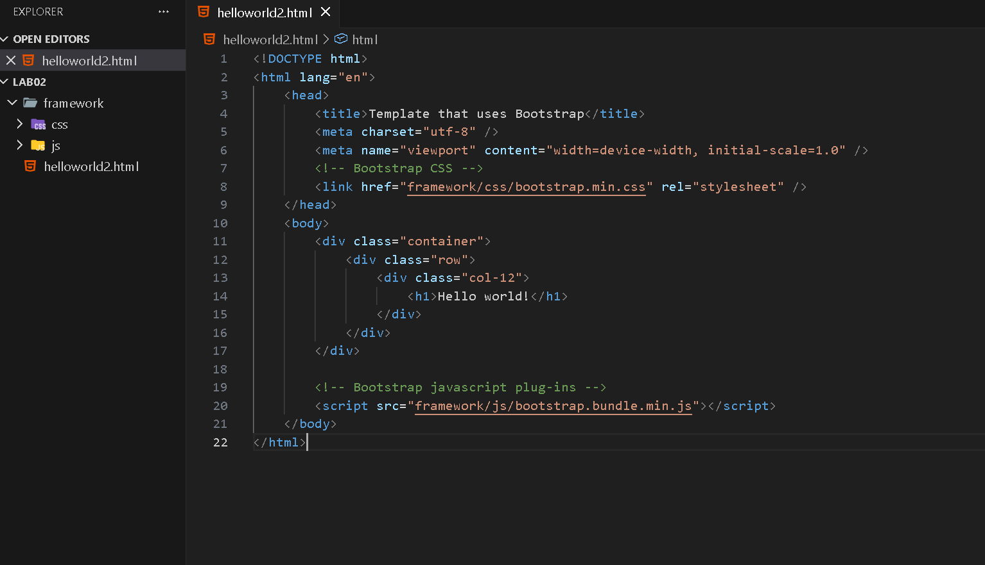
1. Is the font type in helloworld2.html similar to helloworld.html (you created in the first week)?
Ans: No, the font type is different from the helloworld.html in Lab01, which is a plain HTML without Bootstrap. The helloworld2.html uses a sans-serif font stack, which is applied by Bootstrap globally via its CSS reset. The file from the first week used the browser default font.
2. What happens if you remove <div class="container"></div>?
If the <div class="container"></div> wrapper is removed, the content loses Bootstrap’s responsive fixed-width layout. The “Hello World!” heading would stretch to fill the entire width of the browser viewport.
3. What is the purpose of <div class="container"></div>?
The <div class="container"></div> is a Bootstrap layout class that provides a responsive, fixed-width container. It centers the content horizontally on the page and adds appropriate left/right padding. It also responds to different screen sizes by adjusting its maximum width at defined breakpoints.

