National University of Computer and Emerging Sciences

Auto Stitch



Supervisor
Dr. Usman Ahmad

Co-Supervisor
Dr. Muhammad Usama

FYP TEAM
Ramis Ali | 22F-3703
Hafsa Tanveer | 22F-3576
Muhammad Faizan | 22F-3898
Anti-Plagiarism Declaration

This is to declare that the above publication produced under the:
Title: Auto Stitch

Is the sole contribution of the author(s) and no part hereof has been reproduced on its basis (cut and paste) which can be considered as Plagiarism. All referenced parts have been used to support the idea and have been cited properly.

We will be responsible and liable for any consequence if violation of this Declaration is determined.

Date: ______________

Student 1
Name: Ramis Ali

Signature: ___________________

Student 2
Name: Hafsa Tanveer

Signature: ___________________

Student 3
Name: Muhammad Faizan

Signature: ___________________
Intellectual Property Rights Declaration

We hereby declare that the work carried out under the title "Auto Stitch" to partially fulfill the requirements of BS FYP is the exclusive property of the National University of Computer and Emerging Sciences and is safeguarded under the intellectual property rights laws and conventions. It can only be used or considered for purposes such as extension for further improvement, product development, and adoption for commercial/organizational usage, with the explicit permission of the University. The above statement is applicable to all students and faculty involved in the project.

Date: ______________

Student 1
Name: Ramis Ali

Signature: __________________

Student 2
Name: Hafsa Tanveer

Signature: __________________

Student 3
Name: Muhammad Faizan

Signature: __________________

Supervisor: Dr. Usman Ahmad

Signature: __________________

Acknowledgement

We begin by expressing our deepest gratitude to Almighty Allah, whose countless blessings and guidance have enabled us to pursue this academic journey and undertake this project. We are thankful for being granted the strength, patience, and determination to contribute towards solving a meaningful problem through this work.

We would also like to extend our sincere appreciation to our institution, FAST-NUCES, for providing us with the knowledge, resources, and learning environment that made this project possible. The academic and personal growth we have achieved here will remain valuable in both our professional careers and personal lives.

Finally, we are grateful to our faculty and mentors, Dr. Usman Ahmad and Dr. Muhammad Usama, for their encouragement, constructive feedback, and continuous support throughout the course of this project. Their guidance has been instrumental in shaping our work and motivating us to strive for excellence.

Abstract

Auto Stitch is a full-stack, AI-powered, multi-boutique fashion marketplace specifically designed for the Pakistani market. It delivers virtual try-on, part-level outfit customization, and intelligent shopping assistance within a single privacy-aware platform. Users can explore products from multiple boutiques, request custom modifications targeting specific garment regions such as neckline, sleeves, or hemline using reference images, receive competitive price bids from boutiques, and preview outfits on their own body using an AI-based virtual try-on pipeline. The pipeline follows a four-stage asynchronous process using pre-trained models: pose estimation using MediaPipe and HRNet, human parsing using SCHP, garment warping using PF-AFN, and generative refinement using LaDI-VTON. The platform offers personalized recommendations powered by FashionCLIP (built on CLIP) embeddings stored in PostgreSQL with pgvector, a RAG-enabled chatbot using LangChain with GPT-3.5-turbo, secure payment integration via Stripe (sandbox/test mode), and a comprehensive admin dashboard for managing listings, orders, bids, and quality control. User privacy is enforced through explicit consent-based image handling, ephemeral S3 processing, and encrypted storage using AWS SSE-KMS, with privacy principles aligned to Pakistan's Personal Data Protection Bill (PDPB). The system is built on a modular microservice architecture connecting a React frontend, Node.js/Express API server, FastAPI ML microservices, Celery + Redis async task queue, PostgreSQL and MongoDB databases, and AWS S3 object storage, all containerized with Docker and deployed via GitHub Actions CI/CD pipelines.
Table of Contents
1. Introduction 11
2. Vision Document 12
2.1. Problem Statement 12
2.2. Business Opportunities 13
2.3. Objectives 13
2.4. Scope 14
2.5. Constraints 14
2.6. Stakeholder and User Description 15
2.6.1. Market Demographics 15
2.6.2. Customer/User Environment 15
2.6.3 Stakeholder Profiles 15
2.6.3.1. Supervisor Team 15
2.6.3.2. Development Team 16
2.6.3.3. End Users (Customers) 17
2.6.3.4. Boutique Owners 17
2.6.3.5. Admin 18
2.6.4. Stakeholder Summary 18
3. Software Requirements Specification 19
3.1. System Features 19
3.2. Functional Requirements 19
3.2.1. User Account Management 19
3.2.2. Product Browsing & Search 19
3.2.3. AI Virtual Try-On 20
3.2.4. Garment Customization 20
3.2.5. Boutique Bidding System 20
3.2.6. Product & Catalogue Management 20
3.2.7. Order Management 20
3.2.8. Payments (Stripe Sandbox) 21
3.2.9. Recommendations Engine 21
3.2.10. RAG Chatbot 21
3.2.11. Admin Moderation & Dashboard 21
3.2.12. Notifications 21
3.2.13. Analytics Dashboard 22
3.3. Non-Functional Requirements 22
3.3.1. Performance Requirements 22
3.3.2. Safety Requirements 22
3.3.3. Security Requirements 22
3.3.4. Software Quality Attributes 23
3.3.4.1. Maintainability 23
3.3.4.2. Scalability 23
3.3.4.3. Testability 23
3.3.4.4. Reliability 23
3.3.4.5. Usability 24
3.3.4.6. Portability 24
3.3.4.7. Privacy 24
4. Design Artifacts 25
4.1. Architecture Diagram 25
4.2. Use Case Diagram 26
4.3. High Level Use Cases 27
4.3.1. Register / Login 27
4.3.2. AI Virtual Try-On 27
4.3.3. Request Garment Customization 28
4.3.4. Submit Bid on Customization Request 28
4.3.5. Place Order & Checkout 28
4.3.6. Place / Manage Bids 29
4.3.7. View Recommendations 29
4.3.8. Use Chatbot 29
4.4. Expanded Level Use Cases 30
UC 01: Register / Login 30
UC 02: AI Virtual Try-On 32
UC 03: Request Garment Customization 34
UC 04: Submit Bid on Customization Request 35
UC 05: Place Order & Checkout 37
UC 06: Place / Manage Bids 38
UC 07: View Recommendations 40
UC 08: Use Chatbot 41
4.5. System Sequence Diagrams 43
4.5.1. Register / Login 43
4.5.2. AI Virtual Try-On 44
4.5.3. Request Garment Customization 45
4.5.4. Submit Bid on Customization Request 46
4.5.5. Place Order & Checkout 47
4.5.6. Place / Manage Bids 48
4.5.7. View Recommendations 49
4.5.8. Use Chatbot 50
4.6. Domain Model 51
4.7. Package Diagram 52
4.8. Activity Diagram 53
4.8.1. Customer 53
4.8.2. Boutique Owner 54
4.8.3. Admin 55
4.9. DFD Diagram 56
4.9.1. Context Level 56
4.9.2. Level - 0 57
4.9.3. Level-1 58
4.9.3.1. p1: Auth and Accounts 58
4.9.3.2. p2: Catalogue and Search 59
4.9.3.3. p3: AI Virtual Try-On 60
4.9.3.4. p4: Garment Customization 61
4.9.3.5. p5: Boutique Bidding 62
4.9.3.6. p6: Orders and Payments 63
4.9.3.7. p7: Recommendations and Chatbot 64
4.9.3.8. p8: Admin and Analytics 65
4.10. Component Diagram 66
4.11. Deployment Diagram 67
4.12. Entity Relationship Diagram 68
5. References 69

List of Tables

Table 1: Problem Statement
Table 2: Supervisor Team
Table 3: Development Team
Table 4: End Users (Customers)
Table 5: Boutique Owners
Table 6: Admin
Table 7: Stakeholder Summary
Table 8: Register / Login (High Level)
Table 9: AI Virtual Try-On (High Level)
Table 10: Request Garment Customization (High Level)
Table 11: Submit Bid on Customization Request (High Level)
Table 12: Place Order & Checkout (High Level)
Table 13: Place / Manage Bids (High Level)
Table 14: View Recommendations (High Level)
Table 15: Use Chatbot (High Level)
Table 16: EUC - Register / Login
Table 17: EUC - AI Virtual Try-On
Table 18: EUC - Request Garment Customization
Table 19: EUC - Submit Bid on Customization Request
Table 20: EUC - Place Order & Checkout
Table 21: EUC - Place / Manage Bids
Table 22: EUC - View Recommendations
Table 23: EUC - Use Chatbot

List of Figures

Figure 1: Architecture Diagram
Figure 2: Use Case Diagram
Figure 3: SSD - Register / Login
Figure 4: SSD - AI Virtual Try-On
Figure 5: SSD - Request Garment Customization
Figure 6: SSD - Submit Bid on Customization Request
Figure 7: SSD - Place Order & Checkout
Figure 8: SSD - Place / Manage Bids
Figure 9: SSD - View Recommendations
Figure 10: SSD - Use Chatbot
Figure 11: Domain Model
Figure 12: Package Diagram
Figure 13: Activity Diagram - Customer
Figure 14: Activity Diagram - Boutique Owner
Figure 15: Activity Diagram - Admin
Figure 16: DFD - Context Level
Figure 17: DFD - Level 0
Figure 18: DFD - Level 1-P1 Auth and Accounts
Figure 19: DFD - Level 1- P2 Catalogue and Search
Figure 20: DFD - Level 1- P3 AI Virtual Try-On
Figure 21: DFD - Level 1- P4 Garment Customization
Figure 22: DFD - Level 1- P5 Boutique Bidding
Figure 23: DFD - Level 1- P6 Orders and Payments
Figure 24: DFD - Level 1- P7 Recommendations and Chatbot
Figure 25: DFD - Level 1- P8 Admin and Analytics
Figure 26: Component Diagram
Figure 27: Deployment Diagram
Figure 28: Entity Relationship Diagram

1. Introduction
Auto Stitch is an AI-powered, multi-boutique fashion marketplace designed for Pakistan's growing e-commerce market, where existing platforms offer only basic catalogue listings without AI augmentation leading to high product return rates (15-40%), low customer confidence, and limited boutique visibility. The platform addresses this gap by integrating a four-stage virtual try-on pipeline (MediaPipe/HRNet, SCHP, PF-AFN, LaDI-VTON), part-level garment customization via ControlNet and InstructPix2Pix, FashionCLIP-based personalized recommendations, a RAG chatbot (LangChain + GPT-3.5-turbo), boutique bidding, Stripe sandbox payments, and privacy-first design -- all within a modular microservice architecture built on React, Node.js/Express, FastAPI + PyTorch, PostgreSQL + MongoDB, AWS S3, Celery + Redis, and Docker, serving Customer, Boutique Owner, and Administrator roles. This SRS document defines the complete software requirements, use cases, and design artifacts for the Auto Stitch platform as scoped for a three-person FYP team at FAST-NUCES.

2. Vision Document
In this section, project vision is discussed in detail.

2.1. Problem Statement

Category | Description
Problem | • Pakistani fashion consumers cannot virtually try on clothes, request targeted garment modifications, or discover multiple boutiques through a single AI-powered platform.  • Existing platforms offer only single-brand, catalogue-based experiences without AI augmentation.  • Boutique owners lack digital storefronts with AI capabilities.  • No affordable virtual try-on or customization solutions in Pakistan's boutique market.
Affects | • Online fashion shoppers in Pakistan (ages 18-45).  • Small-to-medium boutique owners and independent designers who lack digital storefronts with AI capabilities.  • Customers lose trust in online purchases due to fit uncertainty.  • Boutiques face increased return costs and missed sales opportunities.
Impact | • High product return rates (15-40%).  • Low consumer confidence in online purchases.  • Limited boutique visibility and inability to offer personalized or customized garments at scale.  • Fragmented shopping experiences across multiple platforms.  • Inhibits the growth of local e-commerce and fashion digitization.
Solution | • Auto Stitch -- an AI-powered, multi-boutique fashion marketplace providing:  • Virtual try-on via a 4-stage AI pipeline (MediaPipe/HRNet, SCHP, PF-AFN, LaDI-VTON).  • Part-level garment customization via ControlNet + InstructPix2Pix.  • Competitive boutique bidding on customization requests.  • FashionCLIP-based personalized recommendations.  • RAG chatbot (LangChain + GPT-3.5-turbo) for shopping assistance.  • Privacy-aware image processing aligned with PDPB principles.  • Stripe sandbox payments, all within a unified web platform.
Table 1: Problem Statement

2.2. Business Opportunities
The initiative presents several promising business opportunities:
- Market Gap: Pakistan's fashion e-commerce market is expanding rapidly, but existing platforms such as Khaadi, Sapphire, and Gul Ahmed offer only single-brand, catalogue-based experiences without AI augmentation.
- Boutique Owners: Gain a digital storefront with AI-enhanced product presentation and customization workflow support.
- Customers: Benefit from virtual try-on to visualize outfits before purchasing, reducing return rates.
- Bidding System: Introduces competitive pricing for custom orders, creating a unique value proposition not available on any current Pakistani platform.
- Recommendations & Chatbot: FashionCLIP embeddings and a RAG chatbot increase engagement and average order value.
- Revenue Model: Boutique subscription tiers, per-transaction commission fees, and premium feature access.
- Target Market: Pakistan's smartphone-savvy, fashion-conscious demographic (ages 18-45), with potential expansion to South Asian markets.

2.3. Objectives
Following are the objectives of the Auto Stitch platform:
- Enable customers to virtually try on garments using a four-stage AI pipeline (MediaPipe/HRNet, SCHP, PF-AFN, LaDI-VTON) with pre-trained weights only.
- Provide part-level garment customization (neckline, sleeves, hemline, embroidery) via ControlNet and InstructPix2Pix using customer-uploaded reference images.
- Implement a boutique bidding system where multiple boutiques compete on customization requests with price, timeline, and portfolio submissions.
- Deliver FashionCLIP-based personalized recommendations using 512-dim embeddings indexed with pgvector HNSW, with a cold-start popularity fallback.
- Deploy a RAG-enabled chatbot (LangChain + GPT-3.5-turbo) for natural-language product queries and shopping assistance.
- Process payments securely through Stripe in sandbox/test mode.
- Enforce privacy-first design: explicit consent-based image handling, ephemeral S3 storage (1-hour TTL), face masking during ML inference, and PDPB principles-level alignment.
- Provide role-based dashboards for Customers, Boutique Owners, and Administrators with real-time notifications.
- Containerize all services with Docker and automate deployment via GitHub Actions CI/CD pipelines.
- Build a scalable microservice architecture using Node.js/Express (API), FastAPI + PyTorch (ML), PostgreSQL + MongoDB (databases), Celery + Redis (async queue), and AWS S3 (storage).

2.4. Scope
Auto Stitch is scoped as a three-person Final Year Project (FYP) deliverable. The following boundaries apply:
In Scope:
- Multi-boutique product catalogue with CRUD operations for boutique owners.
- AI virtual try-on using four pre-trained models (no fine-tuning or dataset collection).
- Part-level customization using ControlNet + InstructPix2Pix with reference-image uploads.
- Boutique bidding workflow for customization requests.
- FashionCLIP recommendation engine with pgvector similarity search.
- RAG chatbot using LangChain + GPT-3.5-turbo.
- Stripe sandbox payment integration (test mode only).
- Role-based access for Customer, Boutique Owner, and Administrator.
- Docker containerization and GitHub Actions CI/CD.
- PDPB principles-level privacy alignment (not full legal compliance).

Out of Scope (Deferred to Future Work):
- Fine-tuning or retraining any AI/ML model.
- JazzCash / EasyPaisa payment integration (requires business registration).
- Self-hosted Llama 3 chatbot (GPU cost prohibitive for students).
- Amazon Rekognition for nudity detection (AWS spending constraints).
- Kubernetes auto-scaling and Kafka event streaming.
- 3D garment rendering and body-scan try-on.
- Installment payment plans with automated retry logic.
- Full legal PDPB compliance audit.

2.5. Constraints
- Compute Budget: The team operates on student-level AWS credits; GPU-intensive inference (try-on, customization) must use pre-trained weights and batch processing via Celery to stay within limits.
- Team Size: Three developers (Ramis Ali, Hafsa Tanveer, Muhammad Faizan) must implement frontend, backend, ML services, and DevOps within two semesters.
- Payment Gateway: Stripe sandbox/test mode is the only payment integration; live payment processing and local gateways (JazzCash/EasyPaisa) are deferred.
- Privacy Regulation: Pakistan's PDPB is still evolving; the system aligns with its principles (consent, minimization, encryption) but does not claim full legal compliance.
- Model Licensing: All ML models (LaDI-VTON, PF-AFN, SCHP, HRNet, ControlNet, InstructPix2Pix, FashionCLIP) are used under their respective open-source licenses with pre-trained weights only.
- Network Dependency: AI inference requires server-side GPU access; offline mode is not supported.
- Browser Compatibility: The React frontend targets modern evergreen browsers (Chrome, Firefox, Edge, Safari) with no IE11 support.

2.6. Stakeholder and User Description

2.6.1. Market Demographics
Auto Stitch targets Pakistan's fashion e-commerce market, primarily serving fashion-conscious consumers aged 18-45 in urban and semi-urban areas with smartphone access and online shopping experience, alongside small-to-medium boutique owners and tailors in cities such as Lahore, Karachi, Islamabad, and Faisalabad seeking digital storefronts. Pakistan's textile and fashion industry is valued at over USD 15 billion with e-commerce adoption growing at approximately 30% year-over-year, supported by over 100 million smartphone users and expanding 4G/broadband access -- making web-based platforms highly viable.

2.6.2. Customer/User Environment
Users access Auto Stitch through a responsive React SPA on desktop and mobile browsers, authenticating via email/password with JWT tokens or Google and Facebook OAuth 2.0 social login. Customers upload full-body photos for virtual try-on and reference images for customization directly through the browser; all uploads are stored in AWS S3 with SSE-KMS encryption and a 1-hour ephemeral TTL for processing artifacts. All ML inference runs server-side on GPU-enabled containers, with customers receiving processed results asynchronously through in-app notifications. Payments are handled via Stripe checkout in sandbox/test mode, with no real money processed during the FYP phase.

2.6.3 Stakeholder Profiles

2.6.3.1. Supervisor Team

Representatives | Dr. Usman Ahmad (Supervisor), Dr. Muhammad Usama (Co-Supervisor)
Description | Supervises development and ensures technical accuracy and FYP compliance.
Type | Technical Stakeholders
Responsibilities | 1. Guide the development team on system architecture and AI pipeline design.  2. Ensure project completion on time.  3. Verify alignment with objectives and academic standards.  4. Evaluate documentation, prototypes, and semester deliverables.  5. Review weekly progress and provide feedback on research methodology.
Success Criteria | The team delivers a functional prototype demonstrating all in-scope features with proper documentation. AI components function correctly with pre-trained models. Timely completion of committed features and supervisor approval.
Involvement | Requirement review and project evaluation.
Comments/Issues | None
Table 2: Supervisor Team

2.6.3.2. Development Team

Representatives | Ramis Ali (22F-3703), Hafsa Tanveer (22F-3576), Muhammad Faizan (22F-3898)
Description | Responsible for the complete development, documentation, and deployment of the system.
Type | Technical Stakeholders
Responsibilities | 1. Research AI models and implement virtual try-on pipeline.  2. Design and develop React frontend, Node.js/Express backend, and FastAPI ML microservices.  3. Prepare system documentation (SRS, design artifacts).  4. Conduct testing, integration, and Docker containerization.  5. Set up CI/CD pipelines via GitHub Actions.
Success Criteria | Fully functional prototype demonstrating virtual try-on, customization, bidding, recommendations, and chatbot. Complete platform deployed with Docker, passing CI/CD pipeline, all functional requirements demonstrated.
Involvement | Full involvement throughout FYP cycle.
Comments/Issues | None
Table 3: Development Team

2.6.3.3. End Users (Customers)

Representatives | Fashion-conscious consumers (ages 18-45) in Pakistan
Description | End users who browse products, use virtual try-on, request customizations, place bids, make purchases, and receive recommendations.
Type | External Stakeholders
Responsibilities | Use the platform ethically and provide feedback.
Involvement | Moderate
Comments/Issues | None
Table 4: End Users (Customers)

2.6.3.4. Boutique Owners

Representatives | Small-to-medium boutique owners and tailors in Pakistan
Description | Manage product catalogues, respond to customization bids, fulfill orders, track sales analytics, and build brand presence on the platform.
Type | External Stakeholders
Responsibilities | 1. Upload and manage product listings.  2. Respond to customization bids with price and timeline.  3. Fulfill orders and update order statuses.  4. Monitor analytics dashboard.
Involvement | Continuous
Comments/Issues | None
Table 5: Boutique Owners

2.6.3.5. Admin

Representatives | System Administrator
Description | Moderates listings, manages users and boutiques, reviews flagged content, and monitors platform health via admin dashboard.
Type | Internal Stakeholder
Responsibilities | 1. Approve or reject product listings.  2. Manage user accounts and access levels.  3. Review flagged content and analytics.  4. Monitor privacy requests and platform health.
Involvement | Continuous
Comments/Issues | None
Table 6: Admin

2.6.4. Stakeholder Summary

Name | Description | Responsibility
Development Team | Responsible for system design and development. | Research, coding, testing, deployment.
Supervisor Team | Provides technical supervision and academic oversight. | Evaluate, guide, and validate.
Customers | End users using try-on, customization, and shopping features. | Utilize system ethically, provide feedback.
Boutique Owners | Boutique managers managing inventory and fulfilling orders. | Manage listings, respond to bids, fulfill orders.
Admin | System administrator managing platform operations. | Approve listings, moderate content, monitor platform health.

Table 7: Stakeholder Summary

3. Software Requirements Specification
In this section, features and requirements of the system are explained.

3.1. System Features
- User Registration & Authentication (email/password, Google/Facebook OAuth 2.0, JWT, TOTP 2FA)
- Product Browsing & Multi-faceted Search (Elasticsearch, category, price, boutique, keyword)
- AI Virtual Try-On (4-stage pipeline: pose estimation, parsing, warping, refinement)
- Part-Level Garment Customization (ControlNet + InstructPix2Pix with reference images)
- Boutique Bidding System (customization requests with competitive bids)
- Product & Catalogue Management (boutique CRUD, image uploads, inventory)
- Order Management (cart, checkout, order tracking, status updates, coupon engine, refund workflow)
- Payment Processing (Stripe sandbox/test mode, full & installment checkout)
- Personalized Recommendations (FashionCLIP embeddings, pgvector HNSW)
- RAG Chatbot (LangChain + GPT-3.5-turbo for product Q&A)
- Admin Moderation & Dashboard (user management, listing approval, flagged content)
- Real-Time Notifications (in-app via Socket.IO, email via SendGrid, browser push via Web Push API)
- Analytics Dashboard (sales metrics, user engagement, boutique performance)

3.2. Functional Requirements

3.2.1. User Account Management
The system shall allow users to register with email/password or via Google and Facebook OAuth 2.0, with input validation and JWT-based authentication (15-min access tokens, 7-day refresh tokens). RBAC enforces three roles: Customer, Boutique Owner, and Administrator. Users may update profiles, reset passwords via email, and optionally enable TOTP 2FA (mandatory for Administrators). Accounts are locked after 5 failed login attempts with exponential backoff, refresh tokens rotate on every use, and per-user consent flags in MongoDB govern image processing and retention behaviour.

3.2.2. Product Browsing & Search
The system shall display a paginated product catalogue with filtering by category, price, boutique, color, size, and material, and support full-text keyword search via Elasticsearch with automatic index sync on every product change. Product detail pages include multiple images, size charts, customization options, boutique information, and customer reviews. Customers can maintain a wishlist, view FashionCLIP-based related products, and perform cross-modal (text-to-image and image-to-image) search using pgvector similarity queries.

3.2.3. AI Virtual Try-On
The system shall allow authenticated customers to upload a full-body photo (JPEG/PNG, max 10 MB) after providing explicit consent, and enqueue a try-on job via Celery + Redis. The four-stage pipeline extracts body pose keypoints (MediaPipe/HRNet), segments body regions (SCHP), warps the garment to fit the body shape (PF-AFN), and synthesizes the final composite try-on image (LaDI-VTON) with face masking applied throughout. Results are stored in AWS S3 with SSE-KMS encryption and a 1-hour ephemeral TTL. The user is notified on completion, can cancel in-progress jobs, and post-try-on feedback (1-5 stars) is collected for future model improvement.

3.2.4. Garment Customization
The system shall allow customers to initiate a part-level customization request by selecting target regions (neckline, sleeves, hemline, embroidery) and uploading reference images (JPEG/PNG, max 5 MB each). ControlNet applies structural conditioning and InstructPix2Pix handles texture and style transfer asynchronously via Celery. Customers review the generated preview alongside the original and either submit it as a formal request to boutiques or discard it. Each revision stores full provenance metadata, and a Socket.IO messaging channel facilitates direct communication between customer and boutique.

3.2.5. Boutique Bidding System
The system shall allow customers to broadcast approved customization requests to all boutiques in the relevant category. Boutique owners submit bids with a quoted price, estimated timeline, and optional portfolio samples. Customers compare bids in a sorted view, accept one to create a confirmed order, or reject/let requests expire after 72 hours. Boutique reputation scores (0.0-5.0) are computed from ratings, completion rate, on-time delivery, and bid acceptance rate. Bid status updates are communicated in real time, and undelivered accepted orders trigger an admin-mediated dispute and refund workflow.

3.2.6. Product & Catalogue Management
The system shall allow boutique owners to create, update, and delete product listings with up to 8 images stored in AWS S3 via CloudFront CDN, and support bulk CSV import. FashionCLIP embeddings (512-dim) are auto-generated for new product images and stored in PostgreSQL with pgvector. New listings enter an admin moderation queue before becoming publicly visible. Boutique onboarding requires KYC documents (CNIC, business registration certificate), and shipping zone configuration supports integration hooks for TCS, Leopards Courier, and Pakistan Post rate APIs.

3.2.7. Order Management
The system shall support a full cart-to-delivery workflow with server-side validated totals, a coupon engine, and database advisory locks to prevent overselling. Order statuses progress through Placed, Accepted, In Production, Ready to Ship, Shipped, Delivered, Cancelled, Dispute, Refund Requested, and Refunded, with invalid transitions returning HTTP 400. Customers can cancel orders, view order history, and initiate return/refund requests with evidence images. Boutique owners update statuses with optional tracking information, and customers receive in-app and email notifications at each stage.

3.2.8. Payments (Stripe Sandbox)
The system shall integrate Stripe Checkout in sandbox/test mode, supporting test card payments, webhook event handling for payment confirmation, failure, and refunds, and a 3-installment checkout plan (33%/33%/34% at 0/30/60 days) scheduled via node-cron. All payment API calls include idempotency keys, webhook signatures are verified via HMAC, and transaction records are stored in PostgreSQL with Stripe payment intent IDs. No real money is processed during the FYP phase.

3.2.9. Recommendations Engine
The system shall generate personalized product recommendations using 512-dim FashionCLIP embeddings stored in PostgreSQL with pgvector HNSW indexing for sub-100ms nearest-neighbor queries. User preference vectors are built from browsing history, wishlist items, and past purchases, with a popularity-based cold-start fallback for new users. Real-time session signals (views, wishlist additions, dwell time) are tracked in Redis for dynamic re-ranking, and embedding upserts are triggered by Celery on product updates with nightly consistency checks.

3.2.10. RAG Chatbot
The system shall provide a floating chatbot widget powered by LangChain and GPT-3.5-turbo, using product catalogue data as the RAG knowledge base. It supports multi-turn conversation context, clickable product links in responses, and rate limiting at 30 queries per user per hour. When retrieval confidence drops below 0.6, a fallback message is returned. The chatbot never directly executes sensitive actions; all confirmed intents are routed through signed backend API calls using the user's JWT session. Conversation history is limited to the 10 most recent turns and stored in MongoDB.

3.2.11. Admin Moderation & Dashboard
The system shall provide administrators with an exclusive dashboard for approving or rejecting product listings, managing user and boutique accounts, reviewing flagged content, and monitoring platform-wide metrics (total users, active boutiques, total orders, pending moderation items). The moderation queue operates under a 24-hour SLA with visual escalation indicators, supporting bulk approve/reject actions with templated rejection messages. All administrative actions are recorded in immutable audit logs with full before/after state, IP address, and user agent metadata.

3.2.12. Notifications
The system shall deliver in-app notifications via Socket.IO for order updates, bid responses, try-on completion, and customization results, and email notifications via SendGrid for account and payment events, with browser push support via the Web Push API. Notification events are published through Redis Pub/Sub with per-user preference filtering before dispatch, and failed deliveries are re-queued with exponential backoff up to 5 retries with a 30-minute maximum delay.

3.2.13. Analytics Dashboard
The system shall provide boutique owners with sales analytics (revenue, order count, average order value, top-selling products) and customer engagement metrics, and administrators with platform-wide analytics including user and boutique growth, transaction volume, AI feature usage, and boutique performance rankings. Data is visualized with charts on the frontend and exportable as CSV, with all export endpoints rate-limited and PII masked for boutique-facing exports. Materialized PostgreSQL views compute MAU/DAU, AOV, and conversion rates hourly, and Prometheus/Grafana monitor AI pipeline health metrics.

3.3. Non-Functional Requirements

3.3.1. Performance Requirements
- The API server shall respond to standard CRUD requests within 200 ms under normal load (up to 100 concurrent users).
- FashionCLIP recommendation queries using pgvector HNSW index shall return results within 100 ms.
- AI virtual try-on pipeline (all four stages) shall complete within 60 seconds per request on a single GPU instance.
- Garment customization (ControlNet + InstructPix2Pix) shall complete within 45 seconds per request.
- The chatbot (GPT-3.5-turbo) shall return responses within 5 seconds per query.
- Product catalogue pages shall load within 2 seconds on a 4G mobile connection.
- The system shall support at least 100 concurrent users during the FYP demonstration phase.

3.3.2. Safety Requirements
- The system shall require explicit user consent before processing any uploaded images through AI models.
- The system shall apply face masking during ML inference to prevent facial data from being used in garment-related processing.
- Processing artifacts and ephemeral images shall be automatically deleted from S3 after a 1-hour TTL.
- The system shall validate all uploaded images for file type (JPEG/PNG only) and size limits (10 MB for try-on, 5 MB for customization references) to prevent malicious uploads.
- The system shall implement rate limiting (Redis-backed) on API endpoints to prevent abuse and denial-of-service: 100 requests/min for standard endpoints and 10 requests/min for AI inference endpoints.

3.3.3. Security Requirements
- All API communication shall use HTTPS/TLS encryption.
- User passwords shall be hashed using bcrypt with a minimum cost factor of 10.
- Authentication shall use JWT tokens with short-lived access tokens (15 min) and longer refresh tokens (7 days), with secure httpOnly cookie storage.
- All user inputs shall be validated and sanitized using Zod schema validation on the backend to prevent injection attacks (OWASP A03).
- AWS S3 objects shall be encrypted at rest using SSE-KMS (Server-Side Encryption with Key Management Service).
- Role-based access control (RBAC) shall be enforced on all API endpoints; unauthorized access attempts shall return HTTP 403.
- Nginx reverse proxy shall serve as the API gateway with rate limiting and request size restrictions.
- Database connections shall use parameterized queries to prevent SQL injection.
- CORS policy shall restrict API access to the registered frontend origin only.
- Administrative actions shall be recorded in an immutable audit log in PostgreSQL.
- The application shall implement CSRF protection (double-submit cookie pattern via csrf-csrf) on all state-changing endpoints.
- The Node.js API server shall apply Helmet.js security headers on all responses.
- All payment gateway webhook payloads shall be verified via HMAC signature validation before processing.
- Idempotency keys shall be included on all payment and order creation API calls to prevent duplicate transactions.

3.3.4. Software Quality Attributes

3.3.4.1. Maintainability
The codebase shall follow a modular microservice architecture with clear service boundaries (React frontend, Node.js API, FastAPI ML services) to enable independent development and deployment.

3.3.4.2. Scalability
The system shall be containerized with Docker to allow horizontal scaling of individual services in future deployments (auto-scaling deferred to future work).

3.3.4.3. Testability
The system shall achieve a minimum of 70% unit test coverage on backend API routes and ML service endpoints, with integration tests for critical workflows (registration, try-on, order placement).

3.3.4.4. Reliability
The Celery + Redis task queue shall implement retry logic with exponential backoff for failed AI processing jobs (max 3 retries).

3.3.4.5. Usability
The React frontend shall follow responsive design principles, providing usable interfaces on screen widths from 320px (mobile) to 1920px (desktop).

3.3.4.6. Portability
All services shall be containerized with Docker and orchestrated via Docker Compose, ensuring consistent deployment across development, staging, and production environments.

3.3.4.7. Privacy
The system shall align with PDPB principles including purpose limitation, data minimization, storage limitation, and user consent, as documented in the Privacy Impact Assessment.

4. Design Artifacts
In this section, design artifacts including architecture diagrams, use case models, sequence diagrams, domain models, and deployment diagrams are presented.

4.1. Architecture Diagram
The following diagram illustrates the high-level system architecture of the Auto Stitch platform.

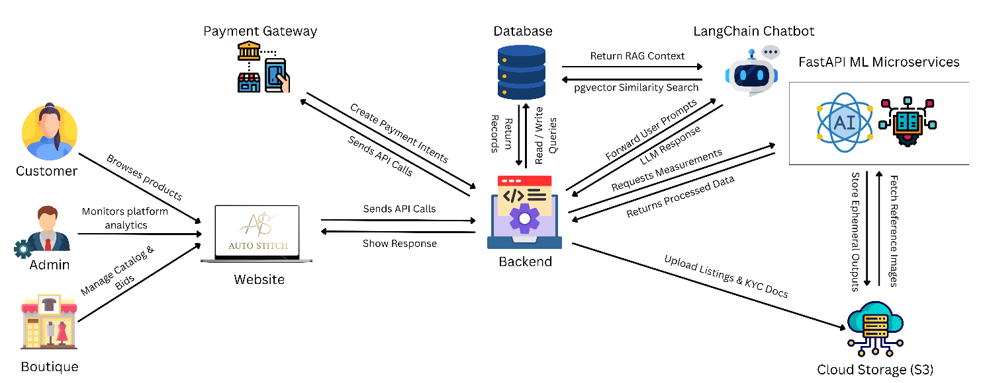
Figure 1: Architecture Diagram

4.2. Use Case Diagram
The use case diagram identifies all actors and their interactions with system features.

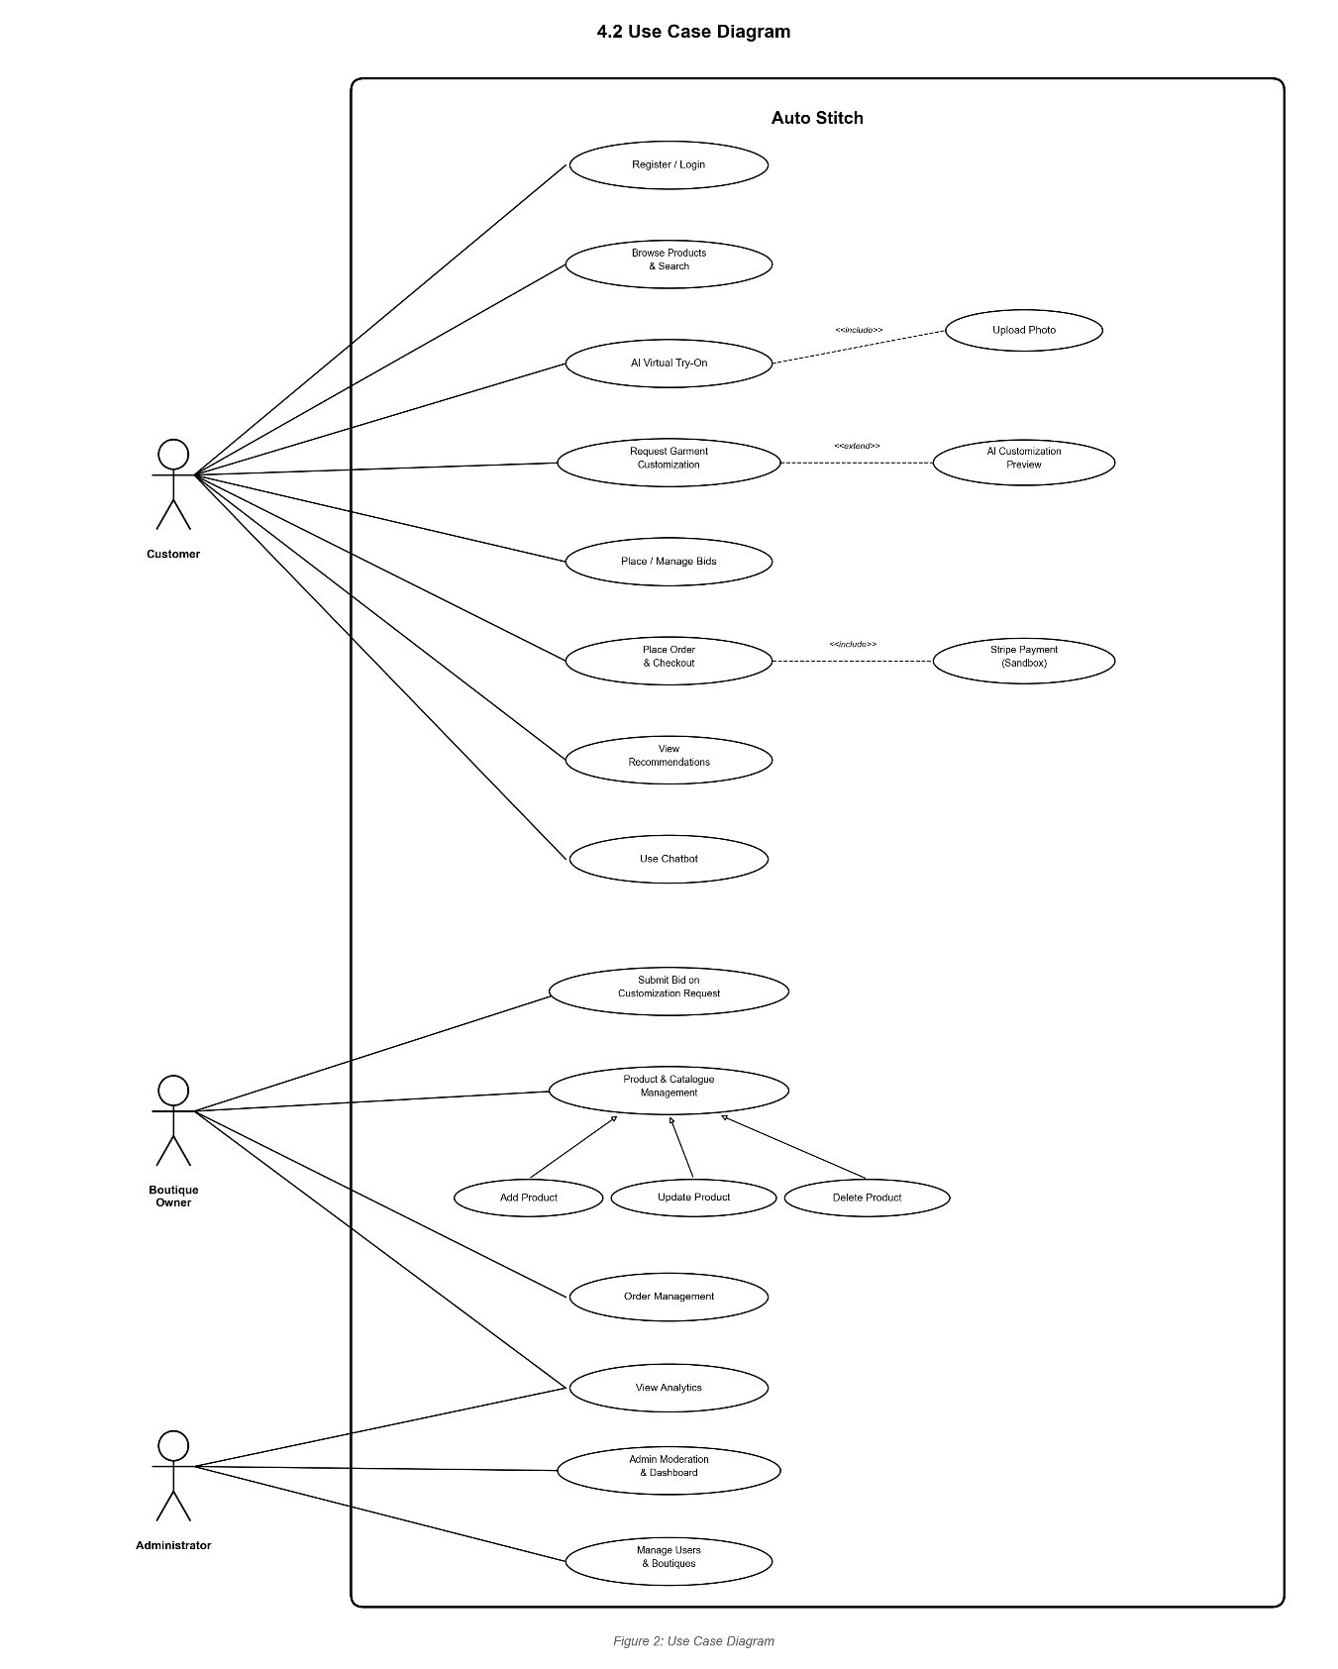
Figure 2: Use Case Diagram

4.3. High Level Use Cases
The following tables provide a brief overview of each use case before the detailed expanded descriptions.

4.3.1. Register / Login

Field | Details
Use Case Name | Register / Login
Use Case ID | UC-01
Actor | Customer, Boutique Owner, Administrator
Description | Allow users to register using email/password or Google/Facebook OAuth 2.0, or log into the platform with existing credentials.

Table 8: Register / Login

4.3.2. AI Virtual Try-On

Field | Details
Use Case Name | AI Virtual Try-On
Use Case ID | UC-02
Actor | Customer
Description | Enable customers to upload a full-body photo and visualize how garments fit using the four-stage AI pipeline (pose estimation, parsing, warping, refinement).

Table 9: AI Virtual Try-On

4.3.3. Request Garment Customization

Field | Details
Use Case Name | Request Garment Customization
Use Case ID | UC-03
Actor | Customer
Description | Allow customers to select garment regions for modification and upload reference images to receive AI-generated customization previews.

Table 10: Request Garment Customization

4.3.4. Submit Bid on Customization Request

Field | Details
Use Case Name | Submit Bid on Customization Request
Use Case ID | UC-04
Actor | Boutique Owner
Description | Allow boutique owners to review customization requests and submit competitive bids with price, timeline, and portfolio samples.

Table 11: Submit Bid on Customization Request

4.3.5. Place Order & Checkout

Field | Details
Use Case Name | Place Order & Checkout
Use Case ID | UC-05
Actor | Customer
Description | Allow customers to add items to cart, proceed through checkout, pay via Stripe (sandbox), and receive order confirmation.

Table 12: Place Order & Checkout

4.3.6. Place / Manage Bids

Field | Details
Use Case Name | Place / Manage Bids
Use Case ID | UC-06
Actor | Customer
Description | Allow customers to submit approved customization requests to boutiques, receive competitive bids, compare them, and accept or reject proposals.

Table 13: Place / Manage Bids

4.3.7. View Recommendations

Field | Details
Use Case Name | View Recommendations
Use Case ID | UC-07
Actor | Customer
Description | Display personalized product recommendations generated by FashionCLIP embeddings with popularity-based cold-start fallback.

Table 14: View Recommendations

4.3.8. Use Chatbot

Field | Details
Use Case Name | Use Chatbot
Use Case ID | UC-08
Actor | Customer
Description | Provide AI-powered chatbot for natural-language product queries, styling advice, and shopping assistance via RAG + GPT-3.5-turbo.

Table 15: Use Chatbot

4.4. Expanded Level Use Cases
The following tables provide comprehensive details for each use case, including scenarios, exceptions, and quality attributes.

UC 01: Register / Login

Designation | UC-01
Name | Register / Login
Authors | Ramis Ali (22F-3703), Hafsa Tanveer (22F-3576), Muhammad Faizan (22F-3898)
Priority | High
Criticality | Critical
Source | Customer Requirements, System Specifications
Person Responsible | Development Team
Description | This use case enables new users to register an account using email/password or Google/Facebook OAuth 2.0, and allows existing users to log in to access the platform. The system supports RBAC for Customer, Boutique Owner, and Administrator roles with JWT-based authentication.
Trigger Event | User navigates to the registration/login page
Actors | Primary: Customer, Boutique Owner, Administrator Secondary: Authentication System (JWT, OAuth 2.0 providers)
Pre-Condition | 1. User has a valid email address, Google account, or Facebook account 2. The system is accessible via modern web browser 3. Stable internet connection available 4. OAuth provider APIs are reachable (for social login)
Post-Condition | 1. User account is created in the database (for registration) 2. JWT access and refresh tokens issued and stored in httpOnly cookies 3. User is redirected to role-appropriate dashboard/homepage 4. Consent flags initialized in MongoDB for new accounts
Result | User is authenticated and can access role-specific platform features
Main Scenario | Step 1: User opens the Auto Stitch web application in their browser Step 2: User navigates to the registration/login page Step 3: User selects registration method (email, Google, or Facebook) Step 4: For email: user enters full name, email address, and password Step 5: System validates input using Zod schema (format, strength, unique) Step 6: System hashes password with bcrypt (cost factor 10) and stores Step 7: For OAuth: system redirects to Google/Facebook consent screen Step 8: Upon OAuth approval, system creates account from provider profile Step 9: System assigns default role (Customer) or role based on signup flow Step 10: System generates JWT access token (15-min) and refresh token (7-day) Step 11: Tokens are stored in secure httpOnly cookies Step 12: System initializes per-user consent flags in MongoDB Step 13: User is redirected to the role-appropriate dashboard/homepage Step 14: System displays welcome message with onboarding guidance
Alternative Scenarios | Alt 1: Existing User Login - User enters email and password on login form - System verifies credentials against stored bcrypt hash - If TOTP 2FA is enabled, system prompts for 6-digit code - Upon successful verification, JWT tokens are issued - User is redirected to dashboard Alt 2: Email Already Registered - System detects duplicate email in database - System displays error message and suggests login or password reset Alt 3: Password Reset Flow - User clicks "Forgot Password" - User enters registered email - System sends reset link via email (SendGrid) - User clicks link and enters new password - System updates password hash and confirms
Exception Scenarios | Exc 1: Database Connection Failure - System displays "Service temporarily unavailable" error - User advised to retry after a few minutes Exc 2: Google/Facebook API Unavailable - System suggests email-based registration as alternative Exc 3: Account Lockout - After 5 failed login attempts, account is locked - Exponential backoff applied to prevent brute force Exc 4: Invalid OAuth Token - User shown "Authentication failed" message
Qualities | Usability: Intuitive registration with clear validation messages Security: Bcrypt hashing, JWT with short-lived tokens, TOTP 2FA support Performance: Login/registration completes within 2 seconds Privacy: Minimal data collection; consent flags set on registration Reliability: 99.5% uptime target for authentication services

Table 16: EUC - Register / Login

UC 02: AI Virtual Try-On

Designation | UC-02
Name | AI Virtual Try-On
Authors | Ramis Ali (22F-3703), Hafsa Tanveer (22F-3576), Muhammad Faizan (22F-3898)
Priority | High
Criticality | Critical
Source | Customer Requirements, Market Demand
Person Responsible | Development Team
Description | This use case enables authenticated customers to upload a full-body photo and select a garment to generate a virtual try-on image using the four-stage AI pipeline. The pipeline processes pose estimation, body parsing, garment warping, and generative refinement with face masking applied throughout.
Trigger Event | Customer clicks "Try On" button on a product page
Actors | Primary: Customer Secondary: AI Virtual Try-On Pipeline (ML microservices)
Pre-Condition | 1. Customer is authenticated with valid JWT session 2. A product with a garment image is selected 3. Customer has or will upload a full-body photo (JPEG/PNG, max 10 MB) 4. GPU-enabled ML service is available 5. Stable internet connection available
Post-Condition | 1. Try-on result image generated and stored in S3 (SSE-KMS, 1-hour TTL) 2. Face masking applied throughout inference pipeline 3. Customer notified of completion via in-app notification 4. Processing artifacts scheduled for deletion after TTL
Result | Customer can view the virtual try-on composite image showing the selected garment on their body, alongside the original product image
Main Scenario | Step 1: Customer browses products and selects a garment Step 2: Customer clicks "Try On" button on the product detail page Step 3: System displays privacy notice explaining image processing Step 4: System requests explicit consent for AI image processing Step 5: Customer grants consent via checkbox and confirmation button Step 6: Customer uploads full-body photo (JPEG/PNG, max 10 MB) Step 7: System validates image file type, size, and body detection Step 8: System enqueues try-on job to Celery + Redis async task queue Step 9: System displays progress indicator with estimated wait time Step 10: Pipeline Stage 1 - MediaPipe/HRNet extracts body pose keypoints Step 11: Pipeline Stage 2 - SCHP segments body regions (with face masking) Step 12: Pipeline Stage 3 - PF-AFN warps garment to fit the body shape Step 13: Pipeline Stage 4 - LaDI-VTON generates final composite image Step 14: Result stored in AWS S3 with SSE-KMS encryption (1-hour TTL) Step 15: Customer receives in-app notification of completion Step 16: Customer views try-on result alongside original product image Step 17: System prompts for feedback rating (1-5 stars) Step 18: Customer can save result, share via pre-signed URL, or try another
Alternative Scenarios | Alt 1: Image Validation Failure - System detects invalid file type or exceeds size limit - System displays error with guidance; customer uploads valid photo Alt 2: Customer Denies Consent - Try-on is cancelled; customer returns to product page Alt 3: Cancel In-Progress Job - Customer clicks "Cancel" during processing - System sends cancellation signal to Celery task - Processing artifacts are cleaned up from S3 Alt 4: Reuse Previously Uploaded Photo - Customer selects existing saved photo (with consent)
Exception Scenarios | Exc 1: GPU Service Unavailable - Customer notified of delay; job re-queued with exponential backoff Exc 2: Pipeline Stage Failure - System retries up to 3 times with exponential backoff Exc 3: Body Detection Failure - Guidance provided: proper lighting, full-body visibility Exc 4: S3 Storage Failure - Error logged and admin notified; customer informed to retry Exc 5: Network Latency - Upload progress bar displayed with retry option
Qualities | Realism: High-fidelity garment rendering using state-of-the-art models Privacy: Face masking, ephemeral S3 storage, explicit consent required Performance: Complete pipeline within 60 seconds on single GPU instance Reliability: 3-retry mechanism with exponential backoff Security: SSE-KMS encryption for all stored images; 1-hour auto-deletion

Table 17: EUC - AI Virtual Try-On

UC 03: Request Garment Customization

Designation | UC-03
Name | Request Garment Customization
Authors | Ramis Ali (22F-3703), Hafsa Tanveer (22F-3576), Muhammad Faizan (22F-3898)
Priority | High
Criticality | High
Source | Customer Requirements, Business Objectives
Person Responsible | Development Team
Description | This use case enables customers to select garment regions for modification, upload reference images, and receive an AI-generated customization preview using ControlNet and InstructPix2Pix. Approved previews can be submitted as formal requests to boutiques for bidding.
Trigger Event | Customer clicks "Customize" button on a product page
Actors | Primary: Customer Secondary: AI Customization Pipeline (ControlNet, InstructPix2Pix)
Pre-Condition | 1. Customer is authenticated with valid JWT session 2. A product is selected on the product detail page 3. Customer has reference images (JPEG/PNG, max 5 MB each) 4. ML customization service is available
Post-Condition | 1. Customization preview generated and displayed to customer 2. If approved, formal customization request created 3. Request broadcast to eligible boutiques in the relevant category 4. Full provenance metadata stored for each revision
Result | Customer receives an AI-generated preview and can submit it as a formal request for boutique bidding
Main Scenario | Step 1: Customer clicks "Customize" on the product detail page Step 2: System displays available customization regions for the garment Step 3: Customer selects target regions (neckline, sleeves, hemline, etc.) Step 4: Customer uploads reference images (JPEG/PNG, max 5 MB each) Step 5: Customer optionally adds text description of desired changes Step 6: System validates uploaded images for format and size Step 7: System enqueues customization job to Celery + Redis Step 8: System displays processing indicator with estimated wait time Step 9: ControlNet applies structural conditioning to target regions Step 10: InstructPix2Pix transfers texture and style from reference images Step 11: System generates customization preview and notifies customer Step 12: Customer views preview alongside original garment (side-by-side) Step 13: Customer approves preview and clicks "Submit to Boutiques" Step 14: System creates formal customization request with full metadata Step 15: System broadcasts request to all eligible boutiques
Alternative Scenarios | Alt 1: Reference Image Invalid - System rejects with guidance; customer uploads corrected images Alt 2: Customer Discards Preview - Customer adjusts regions/references and re-submits for new preview Alt 3: Direct Boutique Communication - Customer opens Socket.IO messaging channel to communicate requirements
Exception Scenarios | Exc 1: ML Service Failure - System retries with exponential backoff (max 3 retries) Exc 2: No Eligible Boutiques - Customer notified; request saved for future broadcast Exc 3: Reference Image Quality Issue - System warns about potential quality limitations
Qualities | Accuracy: High-fidelity structural and texture transfer via ControlNet Usability: Side-by-side preview with clear approve/discard options Performance: Customization completes within 45 seconds per request Traceability: Full provenance metadata stored for every revision Communication: Real-time Socket.IO channel for customer-boutique chat

Table 18: EUC - Request Garment Customization

UC 04: Submit Bid on Customization Request

Designation | UC-04
Name | Submit Bid on Customization Request
Authors | Ramis Ali (22F-3703), Hafsa Tanveer (22F-3576), Muhammad Faizan (22F-3898)
Priority | High
Criticality | High
Source | Business Requirements, Boutique Owner Requirements
Person Responsible | Development Team
Description | Boutique owners review customization requests and submit competitive bids with price, timeline, and optional portfolio samples. Reputation scores are visible to customers during comparison.
Trigger Event | Boutique owner receives notification of a new customization request
Actors | Primary: Boutique Owner Secondary: Customer (receives bid notification)
Pre-Condition | 1. Boutique owner is authenticated with valid JWT session 2. A customization request exists in the owner's relevant category 3. Request has not expired (within 72-hour window) 4. Boutique has completed KYC verification
Post-Condition | 1. Bid recorded with price, timeline, and portfolio 2. Customer notified of the new bid 3. Bid status set to "pending" 4. Boutique reputation score attached to bid
Result | Bid is visible to customer alongside other competing bids
Main Scenario | Step 1: Owner receives in-app notification of new request Step 2: Owner navigates to customization requests dashboard Step 3: Owner views request details and AI-generated preview Step 4: Owner assesses feasibility based on their capabilities Step 5: Owner clicks "Submit Bid" and enters quoted price Step 6: Owner enters estimated delivery timeline Step 7: Owner optionally uploads portfolio images of similar work Step 8: Owner optionally adds notes or special conditions Step 9: System validates and records the bid Step 10: System notifies the customer of the new bid
Alternative Scenarios | Alt 1: Request Already Expired - System informs owner the 72-hour window has passed Alt 2: Owner Decides Not to Bid - No action required; request remains open for others Alt 3: Update Existing Bid - Owner edits price, timeline, or portfolio before acceptance
Exception Scenarios | Exc 1: Database Error - Owner shown retry message; bid data preserved locally Exc 2: Concurrent Bid Conflict - Customer accepts another bid while owner is composing - System informs owner; bid form closed gracefully
Qualities | Responsiveness: Bid submission within 2 seconds Fairness: Equal notification timing for all boutiques Transparency: Reputation scores visible for decision-making Flexibility: Bids updatable before customer acceptance

Table 19: EUC - Submit Bid on Customization Request

UC 05: Place Order & Checkout

Designation | UC-05
Name | Place Order & Checkout
Authors | Ramis Ali (22F-3703), Hafsa Tanveer (22F-3576), Muhammad Faizan (22F-3898)
Priority | High
Criticality | Critical
Source | Customer Requirements, Business Requirements
Person Responsible | Development Team
Description | Customers add items to cart, proceed through checkout, pay via Stripe (sandbox/test mode), and receive order confirmation with tracking details. Supports full and installment payment with idempotency protection.
Trigger Event | Customer clicks "Proceed to Checkout" from shopping cart
Actors | Primary: Customer Secondary: Stripe Payment Gateway, Boutique Owner
Pre-Condition | 1. Customer is authenticated with valid JWT session 2. Cart contains at least one item with available inventory 3. Stripe sandbox is configured and operational 4. Delivery address available or will be entered
Post-Condition | 1. Order record created with unique tracking ID, status "Placed" 2. Payment record stored with Stripe payment intent ID 3. Inventory decremented with database advisory locks 4. Customer and boutique owner receive confirmation notifications
Result | Order is placed and confirmed; boutique owner notified for fulfillment
Main Scenario | Step 1: Customer reviews cart items with quantities, sizes, and totals Step 2: System validates server-side totals and inventory availability Step 3: Customer optionally applies coupon code Step 4: Customer enters or selects delivery address Step 5: Customer selects payment method (full or 3 installments) Step 6: Customer proceeds to Stripe Checkout page Step 7: Customer enters test card details and confirms payment Step 8: Stripe processes payment with idempotency key Step 9: Stripe webhook confirms payment success to backend Step 10: System verifies webhook signature via HMAC Step 11: System creates order record with tracking ID in PostgreSQL Step 12: System decrements inventory using database advisory locks Step 13: System sends confirmation notifications to both parties
Alternative Scenarios | Alt 1: Payment Failure - Stripe returns decline; customer retries with different card Alt 2: Cart Item Out of Stock - System alerts customer; recalculates totals after removal Alt 3: Installment Payment Plan - Schedule: 33%/33%/34% at 0/30/60 days via node-cron Alt 4: Coupon Applied - System validates, applies discount, displays updated totals
Exception Scenarios | Exc 1: Stripe API Unavailable - Customer informed to retry later; cart preserved Exc 2: Webhook Delivery Failure - System retries with exponential backoff Exc 3: Duplicate Transaction Prevention - Idempotency key prevents duplicate charges Exc 4: Inventory Race Condition - Database advisory locks ensure single-winner; second customer notified
Qualities | Security: HMAC webhook verification, idempotency keys Reliability: Advisory locks prevent overselling Performance: Checkout within 3 seconds (excluding Stripe redirect) Integrity: Server-side validation prevents cart manipulation Auditability: Full payment trail with Stripe intent IDs

Table 20: EUC - Place Order & Checkout

UC 06: Place / Manage Bids

Designation | UC-06
Name | Place / Manage Bids
Authors | Ramis Ali (22F-3703), Hafsa Tanveer (22F-3576), Muhammad Faizan (22F-3898)
Priority | High
Criticality | High
Source | Customer Requirements, Business Objectives
Person Responsible | Development Team
Description | Customers submit approved customization requests to boutiques, receive competitive bids, compare them based on price, timeline, and reputation, and accept or reject proposals. Accepted bids convert to confirmed orders.
Trigger Event | Customer approves customization preview and clicks "Submit to Boutiques"
Actors | Primary: Customer Secondary: Boutique Owners (bid submitters)
Pre-Condition | 1. Customer is authenticated with valid JWT session 2. A customization preview has been approved 3. At least one boutique exists in the relevant category
Post-Condition | 1. One bid accepted and converted to confirmed order 2. All other bids auto-closed with "not_selected" status 3. Losing boutiques notified of outcome
Result | Customer selects best bid; confirmed order created with winning boutique
Main Scenario | Step 1: Customer approves customization preview Step 2: Customer clicks "Submit to Boutiques" Step 3: Customer optionally specifies budget hint and notes Step 4: System broadcasts request to all eligible boutiques Step 5: Customer views incoming bids in real-time comparison view Step 6: Bids sorted by price and boutique reputation score (0.0-5.0) Step 7: Customer reviews bid details: price, timeline, portfolio Step 8: Customer clicks boutique profile to view ratings and history Step 9: Customer accepts one bid Step 10: System auto-closes all other bids; notifies losing boutiques Step 11: Accepted bid converted into confirmed order
Alternative Scenarios | Alt 1: No Bids Received Within 72 Hours - Request expires; customer notified and may resubmit Alt 2: Customer Rejects All Bids - Request closed; all boutiques notified Alt 3: Expiry Warning and Extension - 12-hour warning sent; customer may extend by 24 hours
Exception Scenarios | Exc 1: Network Error During Bid Submission - System retries submission automatically Exc 2: Concurrent Acceptance Conflict - Single-winner constraint enforced via database lock Exc 3: Boutique Withdraws Bid - Customer notified; bid removed from comparison view
Qualities | Fairness: Equal notification timing for all boutiques Transparency: Reputation scores and complete bid details visible Responsiveness: Real-time bid updates via Socket.IO Reliability: Single-winner constraint enforced at database level

Table 21: EUC - Place / Manage Bids

UC 07: View Recommendations

Designation | UC-07
Name | View Recommendations
Authors | Ramis Ali (22F-3703), Hafsa Tanveer (22F-3576), Muhammad Faizan (22F-3898)
Priority | Medium
Criticality | High
Source | Customer Requirements, Business Objectives
Person Responsible | Development Team
Description | Customers view personalized product recommendations generated by FashionCLIP embeddings with pgvector HNSW nearest-neighbor search. New users receive popularity-based cold-start fallback. Session signals dynamically re-rank results.
Trigger Event | Customer navigates to homepage or "For You" section
Actors | Primary: Customer Secondary: Recommendation Engine (FashionCLIP, pgvector)
Pre-Condition | 1. Customer is authenticated with valid JWT session 2. Products with FashionCLIP embeddings exist in the catalogue 3. pgvector HNSW index is operational 4. Redis is available for session signal tracking
Post-Condition | 1. Personalized recommendations displayed to customer 2. Click-through rates logged with A/B cohort flags 3. Session signals updated for future re-ranking
Result | Customer sees curated products matching their preferences and behavior
Main Scenario | Step 1: Customer navigates to the homepage or "For You" section Step 2: System retrieves browsing history, wishlist, and purchase data Step 3: System builds user preference vector from combined data Step 4: System queries pgvector HNSW index for nearest neighbors Step 5: Real-time session signals from Redis re-rank candidates Step 6: System applies diversity filter to avoid repetitive results Step 7: System displays recommended products with thumbnails and prices Step 8: Customer browses and clicks products of interest Step 9: System logs click-through and engagement for A/B testing Step 10: Recommendation carousel refreshes as customer browses
Alternative Scenarios | Alt 1: Cold-Start User (Insufficient History) - System shows popularity-based feed (top-selling, past 7 days) - Gradually shifts to personalized as user interacts Alt 2: Cross-Modal Search (Text-to-Image) - FashionCLIP text encoder + pgvector nearest image embeddings Alt 3: Cross-Modal Search (Image-to-Image) - FashionCLIP image encoder + pgvector nearest product embeddings
Exception Scenarios | Exc 1: Embedding Service Unavailable - Trending products shown as fallback; admin notified Exc 2: Redis Unavailable - Real-time re-ranking skipped; static results served Exc 3: Empty Catalogue - "No recommendations available yet" displayed
Qualities | Personalization: Tailored to individual browsing and purchase patterns Performance: Sub-100ms nearest-neighbor queries via pgvector HNSW Intelligence: Adaptive re-ranking based on real-time session signals Fallback: Graceful degradation with popularity-based cold-start Measurability: A/B testing framework with click-through tracking

Table 22: EUC - View Recommendations

UC 08: Use Chatbot
Designation | UC-08
Name | Use Chatbot
Authors | Ramis Ali (22F-3703), Hafsa Tanveer (22F-3576), Muhammad Faizan (22F-3898)
Priority | Medium
Criticality | High
Source | Customer Requirements, Market Demand
Person Responsible | Development Team
Description | Customers interact with the RAG-enabled chatbot (LangChain + GPT-3.5-turbo) for natural-language product queries, styling advice, and recommendations. Multi-turn context maintained; clickable product links embedded.
Trigger Event | Customer clicks the floating chatbot widget on any page
Actors | Primary: Customer Secondary: RAG Chatbot System (LangChain, GPT-3.5-turbo, pgvector)
Pre-Condition | 1. Customer is on the platform (auth optional for basic queries) 2. GPT-3.5-turbo API available and within rate limits 3. Product catalogue indexed in pgvector for RAG retrieval 4. Customer has not exceeded 30 queries/hour rate limit
Post-Condition | 1. Customer receives product info with embedded links 2. Conversation history stored in MongoDB (10 recent turns) 3. No sensitive actions executed directly by chatbot
Result | Conversational AI assistance for product discovery and shopping queries
Main Scenario | Step 1: Customer clicks the floating chatbot widget Step 2: Chatbot displays welcome message and suggested queries Step 3: Customer types natural-language query Step 4: LangChain retrieves relevant products from pgvector embeddings Step 5: System also retrieves sizing/FAQ docs for context Step 6: GPT-3.5-turbo generates conversational response Step 7: Response includes embedded clickable product links Step 8: Customer views response in chatbot panel Step 9: Customer clicks product link to view detail page Step 10: Multi-turn context maintained for up to 10 prior turns Step 11: Customer continues conversation or closes widget
Alternative Scenarios | Alt 1: Low Retrieval Confidence (< 0.6) - Fallback: "Please contact the boutique directly for assistance" Alt 2: Sensitive Action Request - Chatbot does NOT execute directly - Intent routed to signed backend API via JWT session Alt 3: Unauthenticated User - Basic product info only; prompts login for personalized queries Alt 4: Styling Advice Request - Chatbot suggests complementary pieces and styling tips with links
Exception Scenarios | Exc 1: GPT-3.5-turbo API Unavailable - "Chatbot temporarily unavailable" message displayed Exc 2: Rate Limit Exceeded (30/hr) - Customer informed; advised to try again after cooldown Exc 3: MongoDB Connection Failure - Chatbot continues without multi-turn context Exc 4: Empty Search Results - Chatbot suggests broadening search terms
Qualities | Intelligence: Context-aware multi-turn conversations via LangChain Responsiveness: Responses within 5 seconds per query Security: No direct execution of sensitive actions; JWT-routed intents Usability: Floating widget accessible from any page Reliability: Graceful fallback when confidence low or API unavailable

Table 23: EUC - Use Chatbot

4.5. System Sequence Diagrams
The following system sequence diagrams illustrate the interaction between actors and the system for each use case.

4.5.1. Register / Login

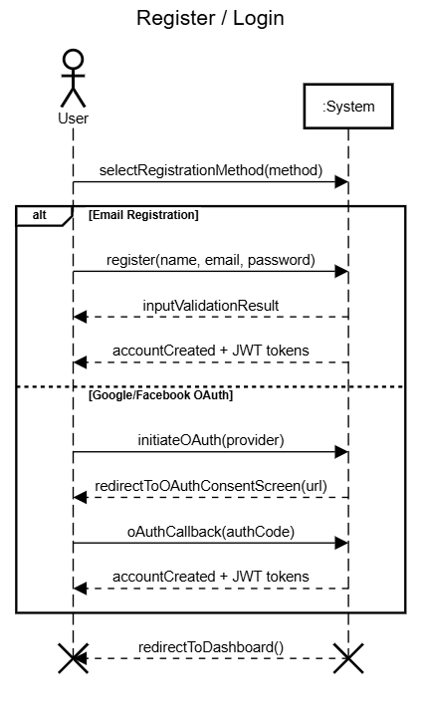

Figure 3: SSD - Register / Login

4.5.2. AI Virtual Try-On

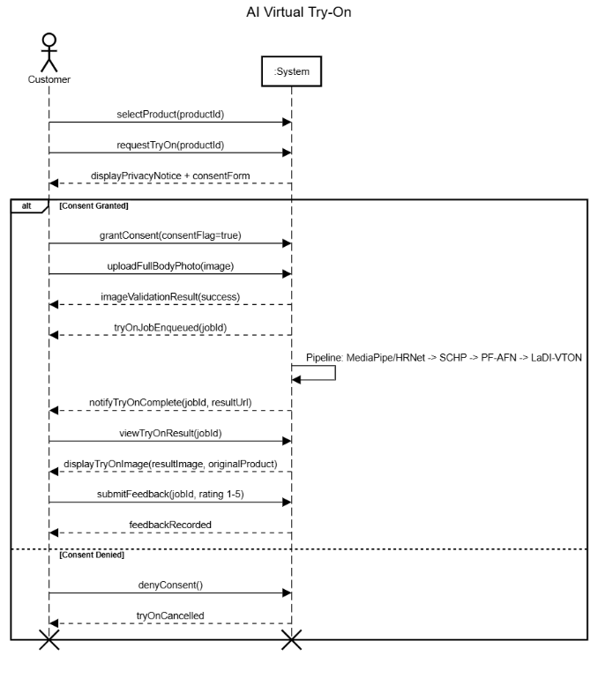
Figure 4: SSD - AI Virtual Try-On

4.5.3. Request Garment Customization

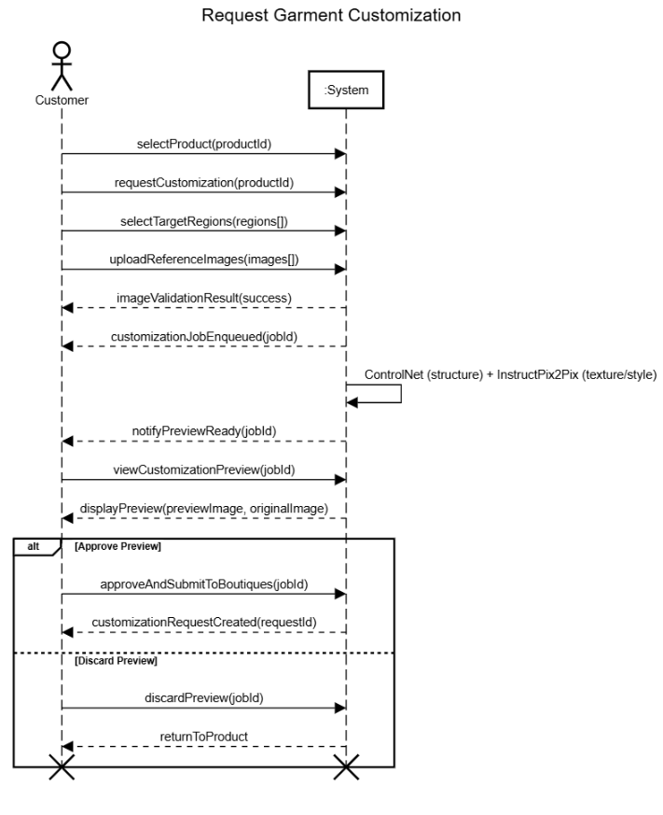
Figure 5: SSD - Request Garment Customization

4.5.4. Submit Bid on Customization Request

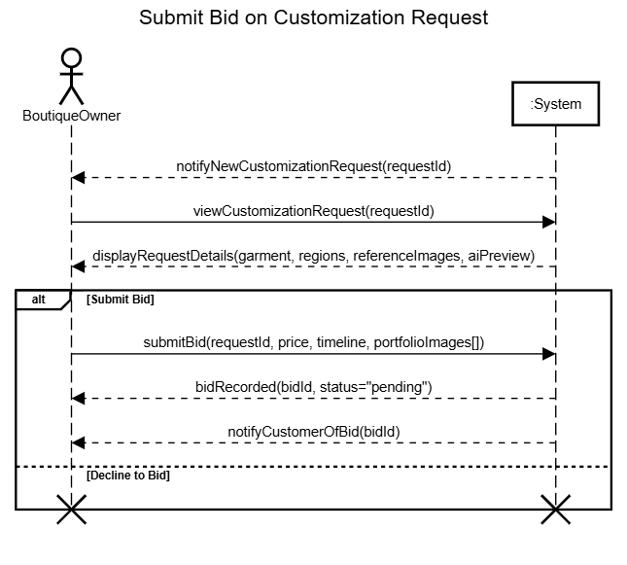
Figure 6: SSD - Submit Bid on Customization Request

4.5.5. Place Order & Checkout

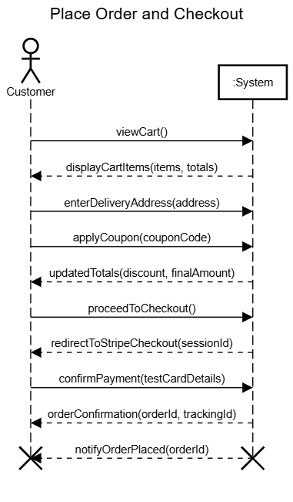
Figure 7: SSD - Place Order & Checkout

4.5.6. Place / Manage Bids

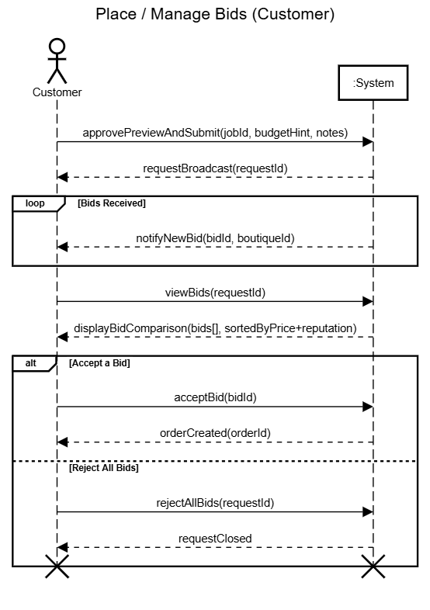
Figure 8: SSD - Place / Manage Bids

4.5.7. View Recommendations

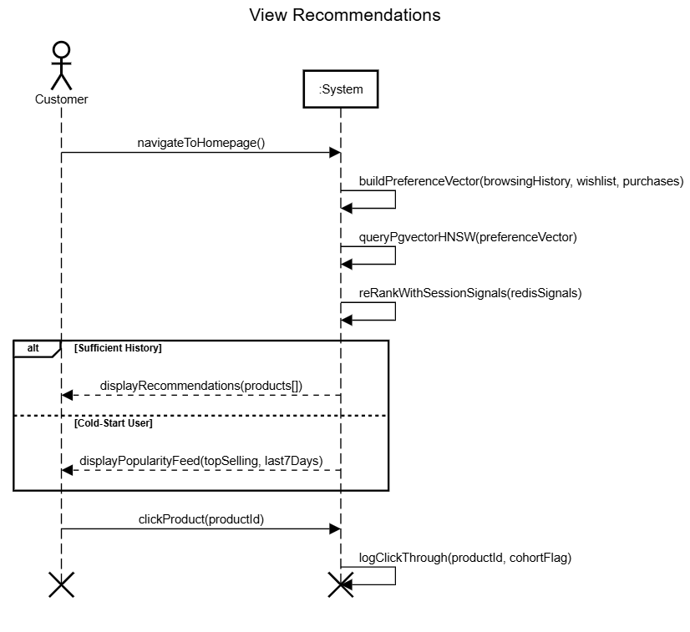
Figure 9: SSD - View Recommendations

4.5.8. Use Chatbot

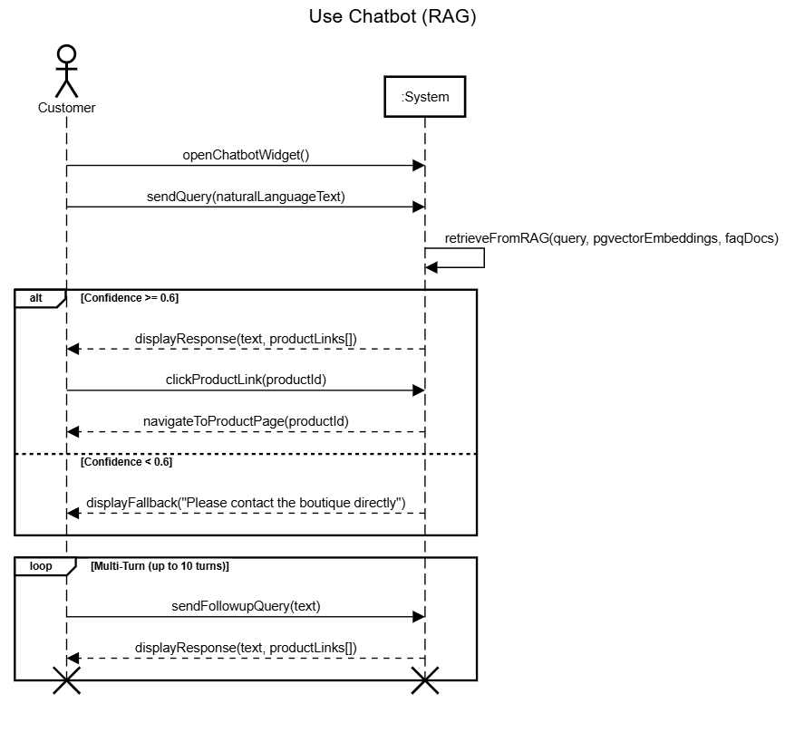
Figure 10: SSD - Use Chatbot

4.6. Domain Model
The domain model represents the key entities, their attributes, and relationships within the Auto Stitch system.
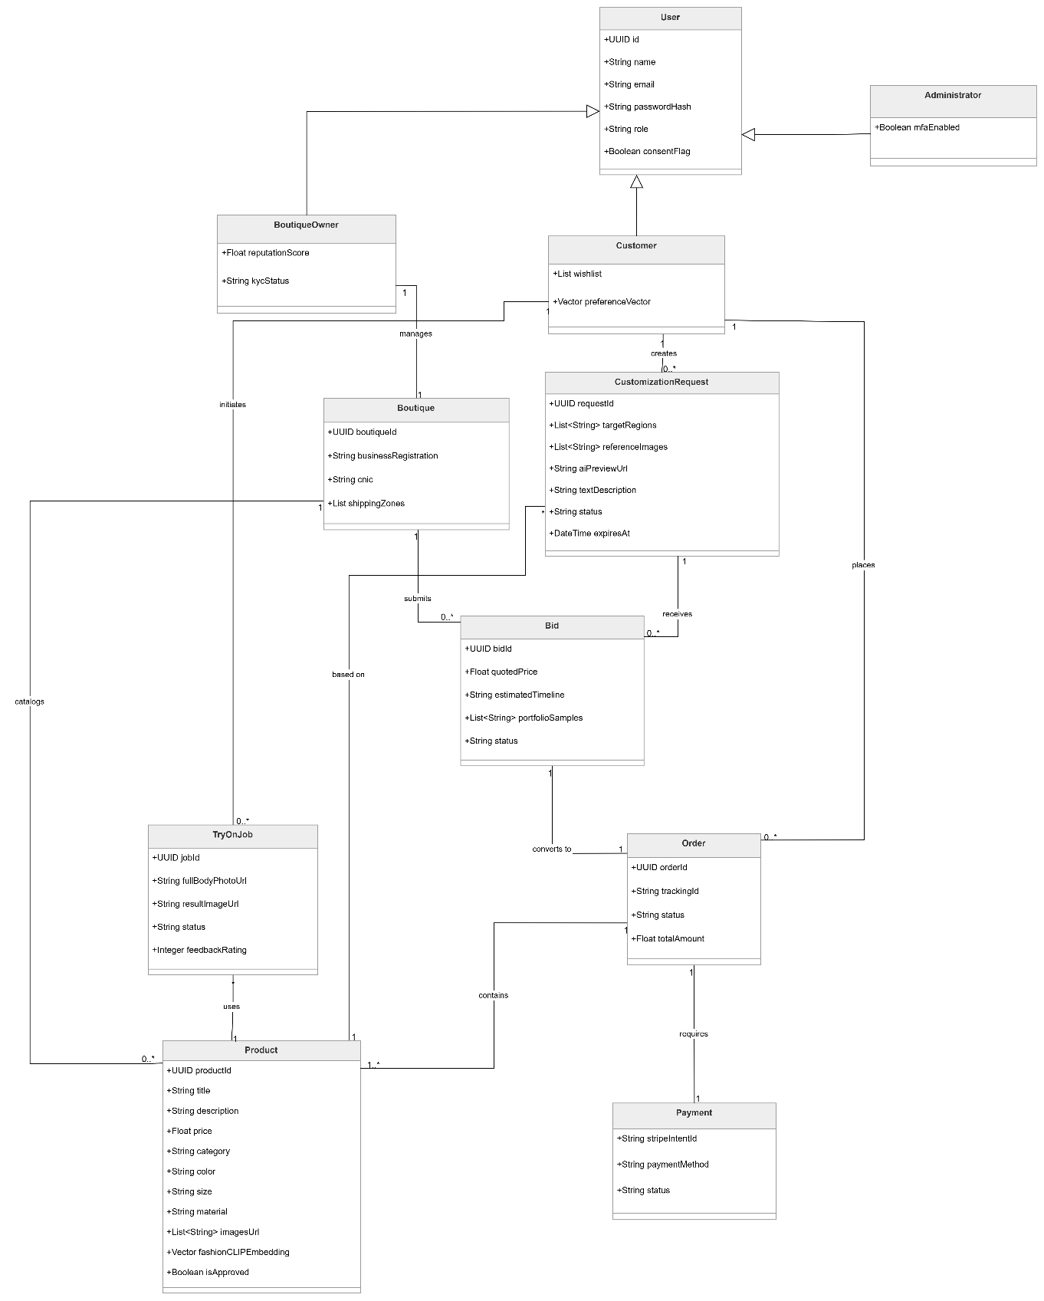

Figure 11: Domain Model

4.7. Package Diagram
The package diagram shows the high-level modular decomposition of the Auto Stitch system into logical packages.

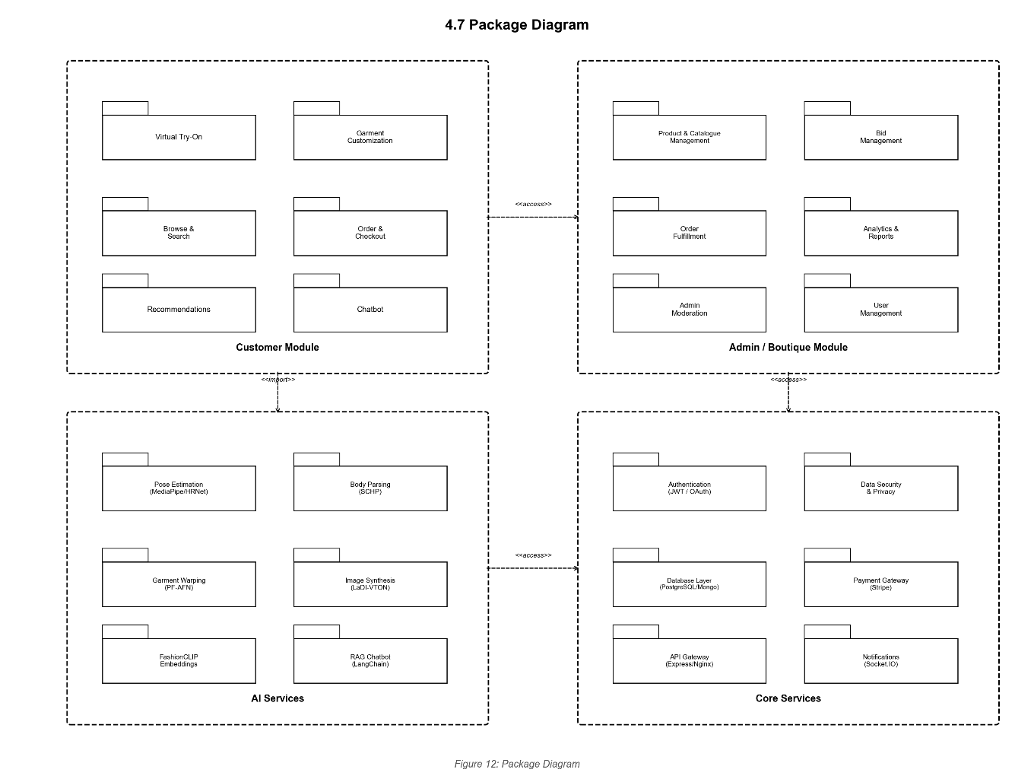

Figure 12: Package Diagram

4.8. Activity Diagram
Activity diagrams depict the workflow and decision logic for each actor’s role in the system.

4.8.1. Customer

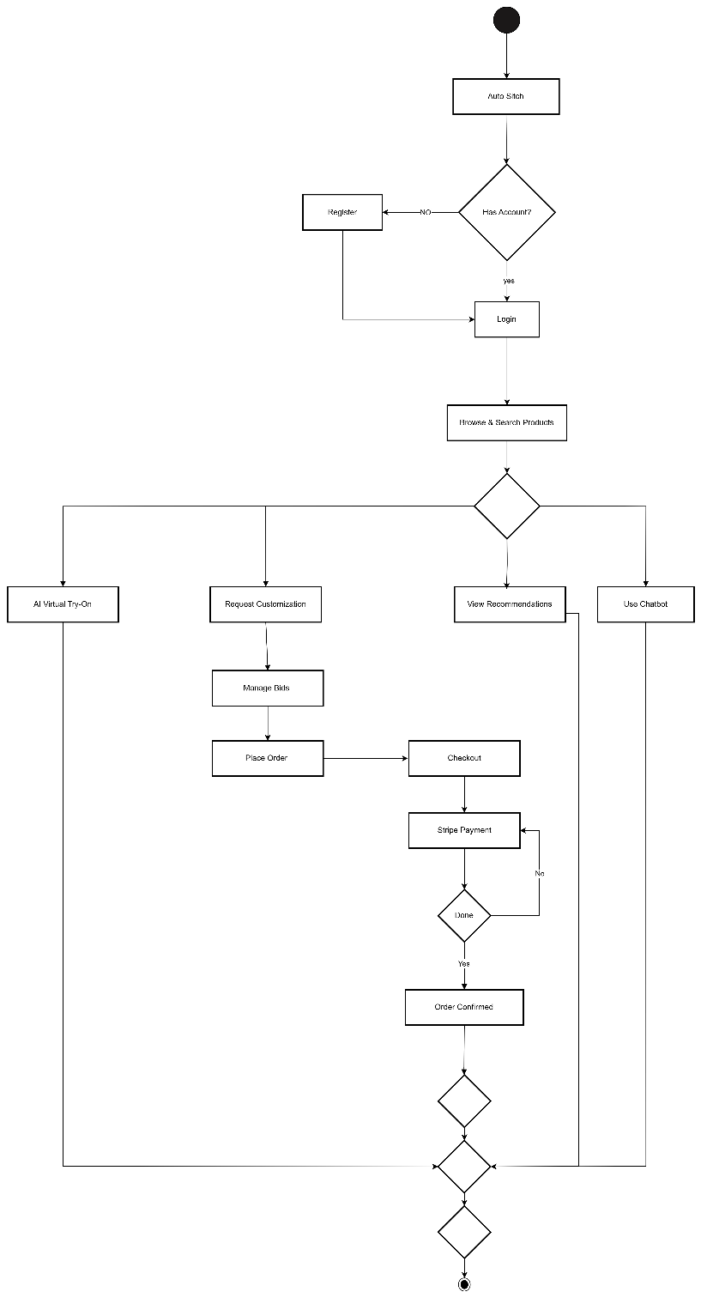

Figure 13: Activity Diagram - Customer

4.8.2. Boutique Owner

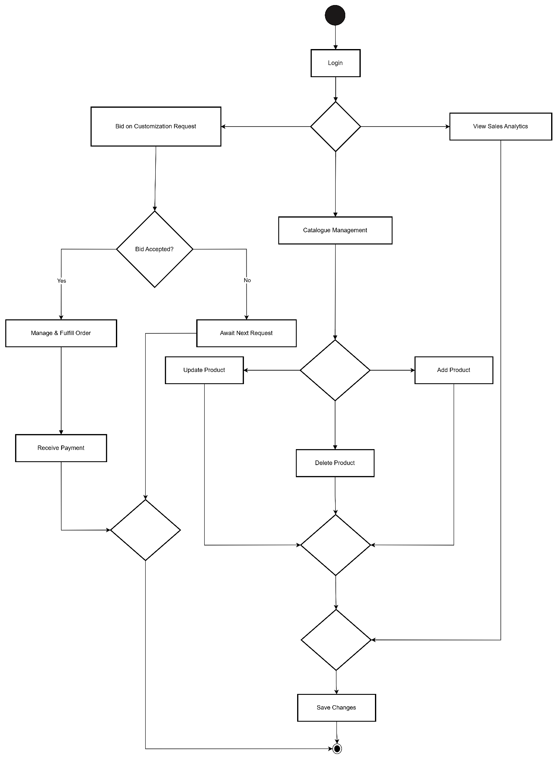
Figure 14: Activity Diagram - Boutique Owner

4.8.3. Admin

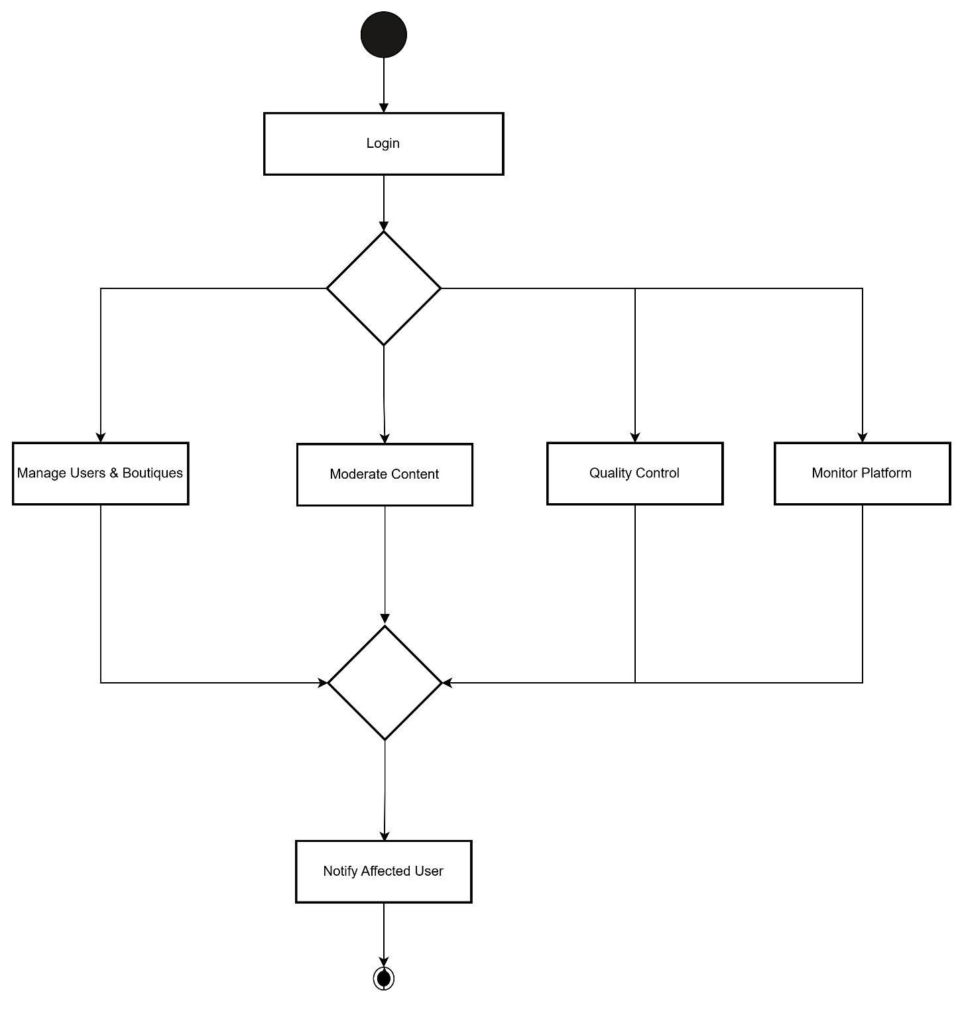
Figure 15: Activity Diagram – Admin

4.9. DFD Diagram
Data flow diagrams show how data moves through the system at varying levels of abstraction.

4.9.1. Context Level

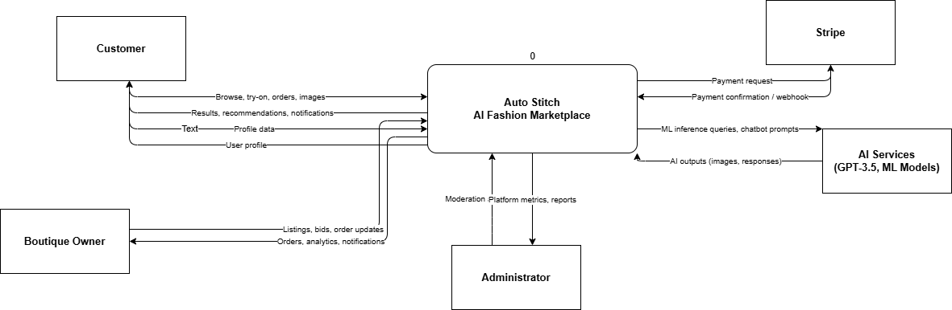

Figure 16: DFD - Context Level

4.9.2. Level - 0

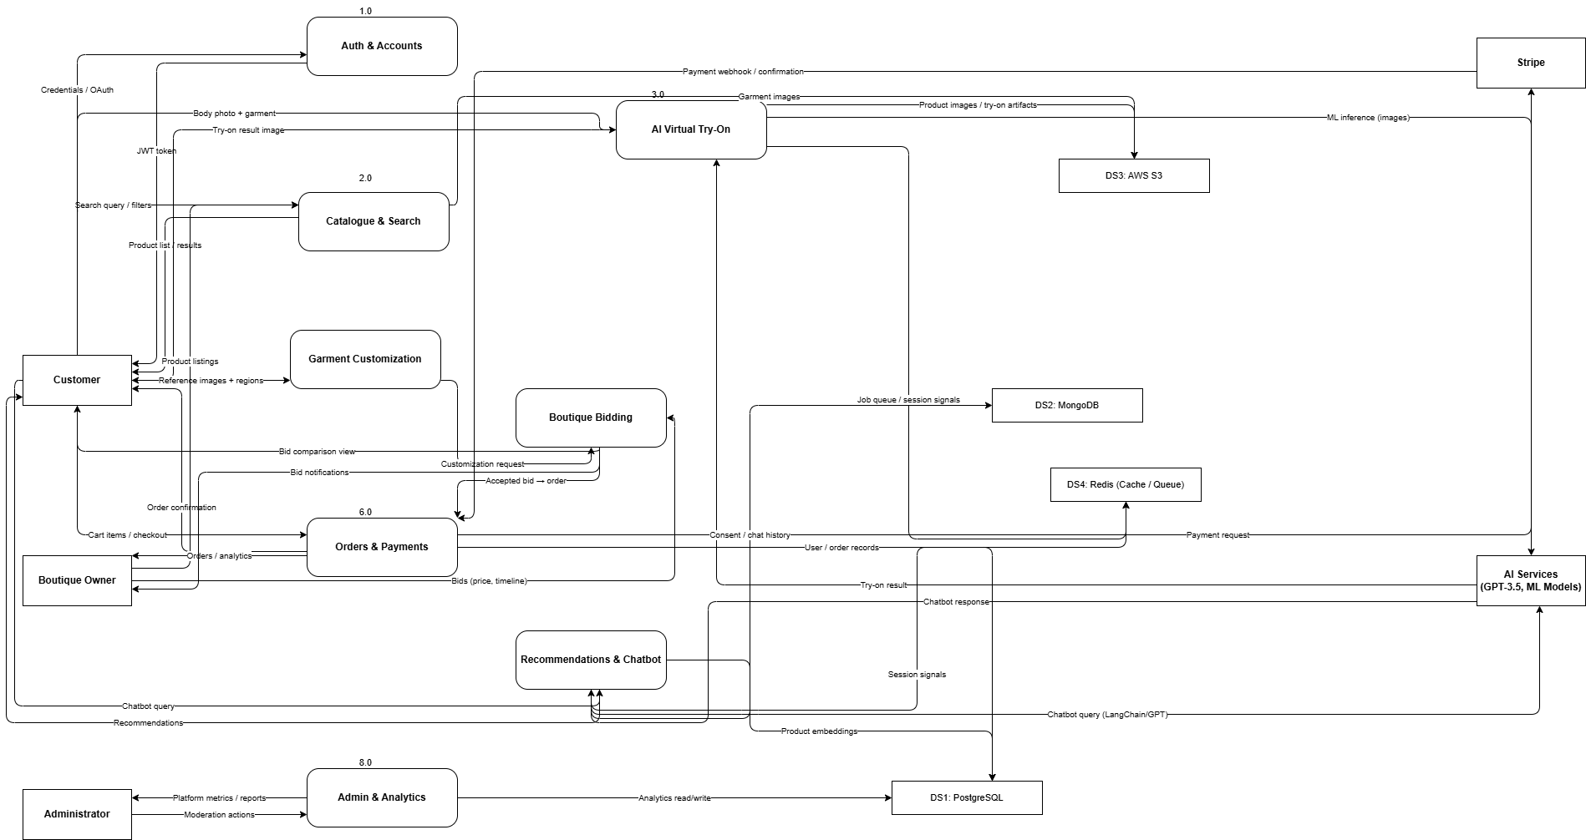

Figure 17: DFD - Level 0

4.9.3. Level-1

4.9.3.1. p1: Auth and Accounts

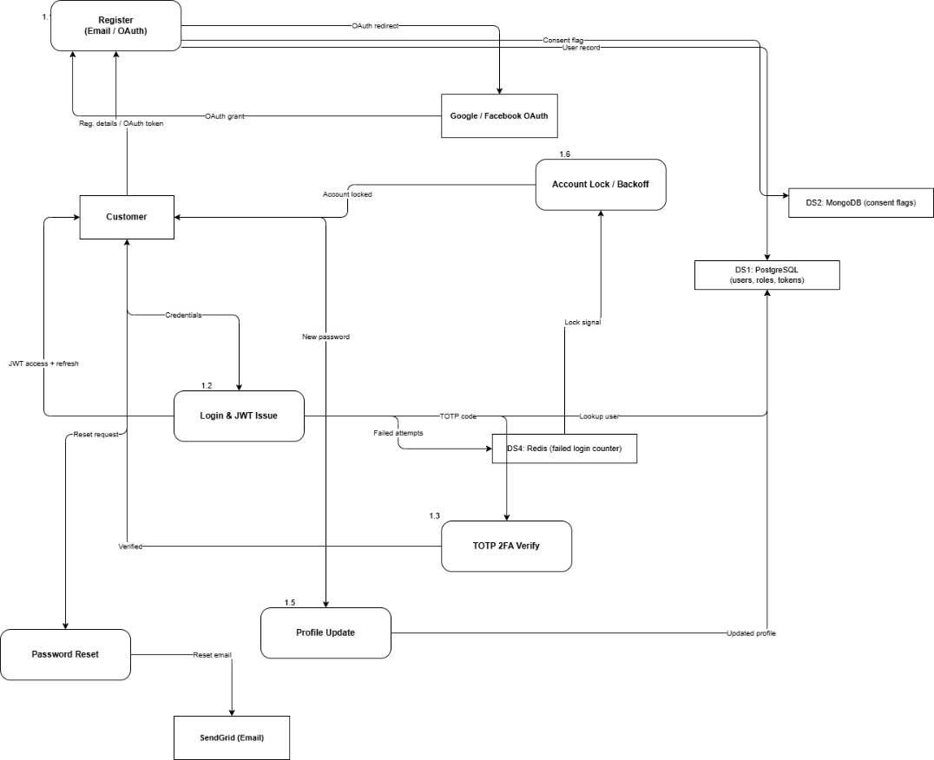

Figure 18: DFD - Level 1(p1: Auth and Accounts)

4.9.3.2. p2: Catalogue and Search

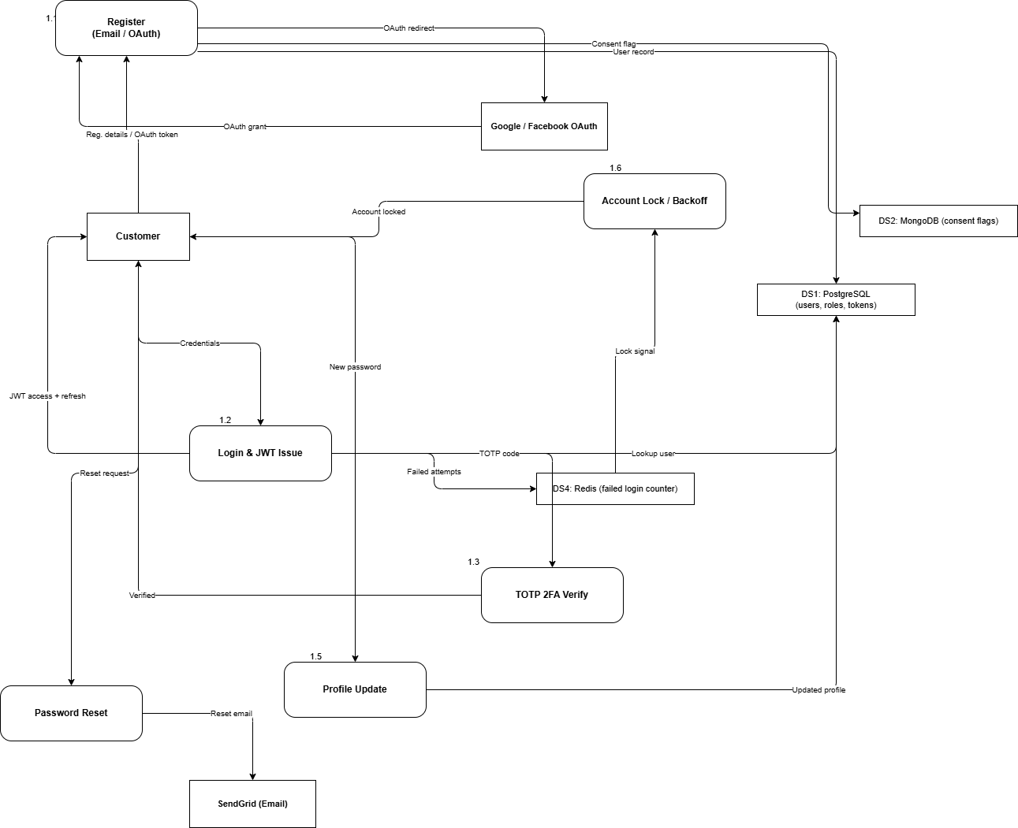

Figure 19: DFD - Level 1(p2: Catalogue and Search)

4.9.3.3. p3: AI Virtual Try-On

Figure 20: DFD - Level 1(p3: AI Virtual Try-On)

4.9.3.4. p4: Garment Customization

Figure 21: DFD - Level 1(p4: Garment Customization)

4.9.3.5. p5: Boutique Bidding

Figure 22: DFD - Level 1(p5: Boutique Bidding)

4.9.3.6. p6: Orders and Payments

Figure 23: DFD - Level 1(p6: Orders and Payments)

4.9.3.7. p7: Recommendations and Chatbot

Figure 24: DFD - Level 1(p7: Recommendations and Chatbot)

4.9.3.8. p8: Admin and Analytics

Figure 25: DFD - Level 1(p8: Admin and Analytics)

4.10. Component Diagram
The component diagram illustrates the physical software components and their dependencies.

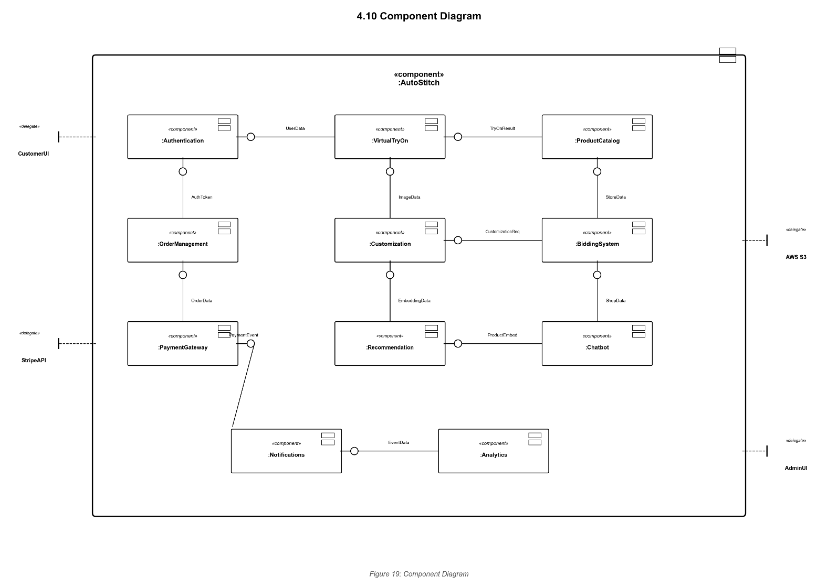Figure 26: Component Diagram

4.11. Deployment Diagram
The deployment diagram shows the physical infrastructure and runtime deployment topology.

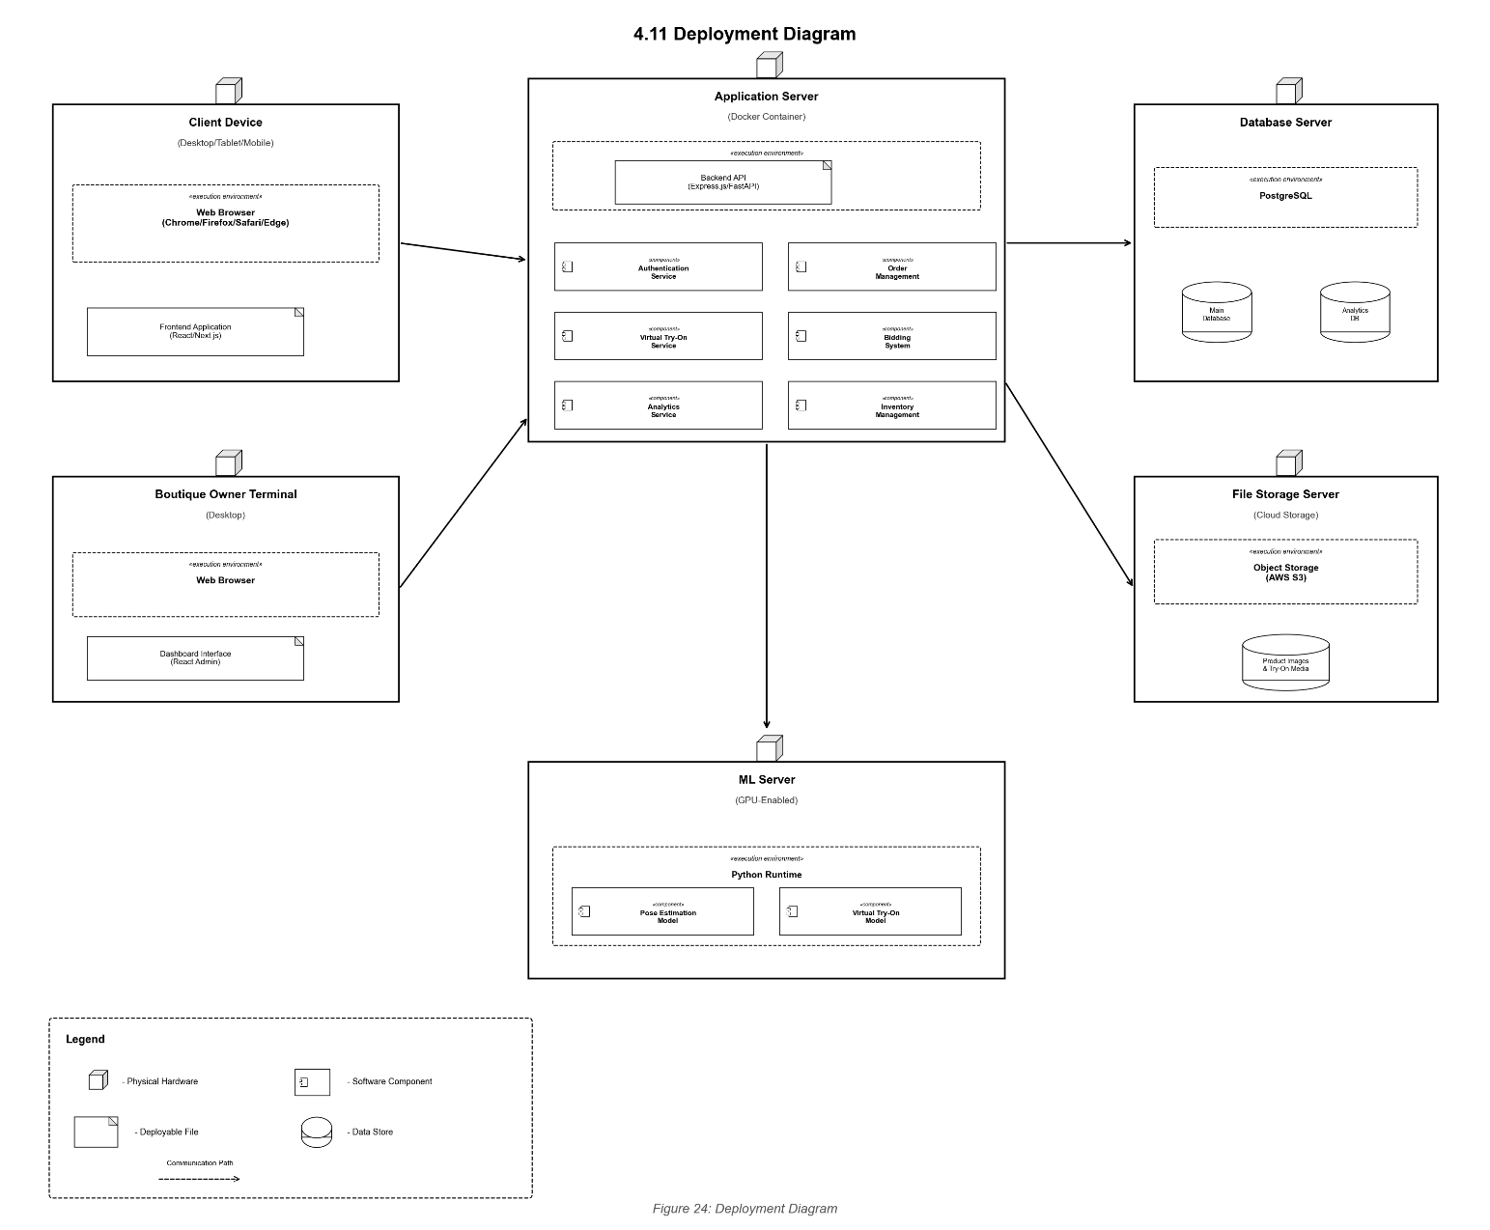

Figure 27: Deployment Diagram

4.12. Entity Relationship Diagram
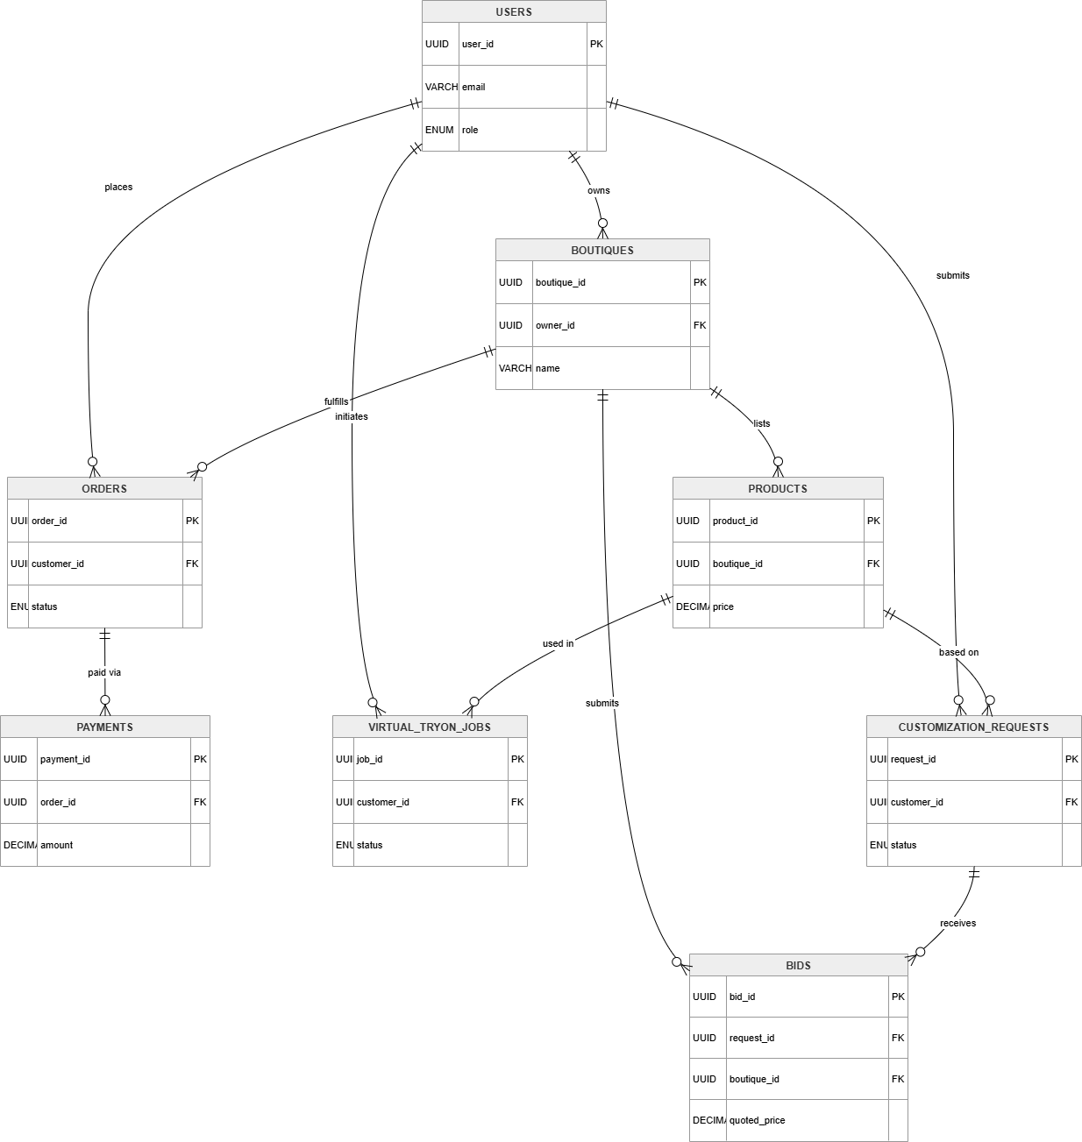

Figure 28: Entity Relation Diagram

5. References
[1] Y. Ge et al., "LaDI-VTON: Latent Diffusion Textual-Inversion for Virtual Try-ON," in Proc. ACM Multimedia (MM), 2023.
[2] T. Ge et al., "Parser-Free Virtual Try-on via Distilling Appearance Flows," in Proc. IEEE/CVF Conf. Comput. Vis. Pattern Recognit. (CVPR), 2021.
[3] P. Li et al., "Self-Correction for Human Parsing (SCHP)," IEEE Trans. Pattern Anal. Mach. Intell. (TPAMI), 2020.
[4] K. Sun et al., "Deep High-Resolution Representation Learning (HRNet)," in Proc. IEEE/CVF Conf. Comput. Vis. Pattern Recognit. (CVPR), 2019.
[5] A. Radford et al., "Learning Transferable Visual Models From Natural Language Supervision (CLIP)," in Proc. Int. Conf. Mach. Learn. (ICML), 2021.
[6] J. Biancofiore et al., "FashionCLIP: Connecting Language and Images for Product Representations," arXiv preprint, 2022.
[7] L. Zhang et al., "Adding Conditional Control to Text-to-Image Diffusion Models (ControlNet)," in Proc. IEEE/CVF Int. Conf. Comput. Vis. (ICCV), 2023.
[8] T. Brooks et al., "InstructPix2Pix: Learning to Follow Image Editing Instructions," in Proc. IEEE/CVF Conf. Comput. Vis. Pattern Recognit. (CVPR), 2023.
[9] P. Lewis et al., "Retrieval-Augmented Generation for Knowledge-Intensive NLP Tasks," in Adv. Neural Inf. Process. Syst. (NeurIPS), 2020.
[10] Google, "MediaPipe Pose," 2023. [Online]. Available: https://mediapipe.dev
[11] OpenAI, "GPT-3.5-turbo," 2023. [Online]. Available: https://platform.openai.com/docs
[12] LangChain, "LangChain Documentation," 2024. [Online]. Available: https://docs.langchain.com
[13] pgvector, "Open-source vector similarity search for Postgres," 2024. [Online]. Available: https://github.com/pgvector/pgvector
[14] Stripe, "Stripe Payments Documentation," 2024. [Online]. Available: https://stripe.com/docs [15] Amazon Web Services, "Amazon S3 Server-Side Encryption with AWS KMS," 2024. [Online]. Available: https://docs.aws.amazon.com/s3
[16] Docker Inc., "Docker Documentation," 2024. [Online]. Available: https://docs.docker.com
[17] Redis, "Redis Documentation," 2024. [Online]. Available: https://redis.io/docs
[18] Elasticsearch B.V., "Elasticsearch Documentation," 2024. [Online]. Available: https://www.elastic.co/guide
[19] Government of Pakistan, "Personal Data Protection Bill (PDPB)," National Assembly of Pakistan, 2023.
[20] OWASP Foundation, "OWASP Top Ten," 2021. [Online]. Available: https://owasp.org/www-project-top-ten

