$$Statistics-8$$

$$1) Data types$$

$$2) Categorical and Numerical$$

$$3) Qualitative and Quantitative$$

$$4) Continuoues and discrete type$$

$$5) Levels of data$$

$$6) Nominal level$$

$$7) Ordinal level$$

$$8) intervel level: It does not have true zero point$$

$$9) Ratio level:It has zero point$$

$$10) Population and sample$$

$$11) Inferential statistics:Will work on sample and estimate on population$$

$$12) Descriptive statiscs:Analyse the data (analyse the population)$$

$$13) Frequency table$$

$$14) Bar chart$$

$$15) Relative frequency table$$

$$16) pie chart$$

$$17) frequency distribution table$$

$$18) histogram$$

$$19) Distribution plot$$

$$20) How to find the interval$$

$$21) How to choose class width$$

$$22) Central tendency$$

$$22) Mean-mode-Median$$

$$23) Median vs Mean \\ 24) Postive skew :Right side skew:Mean>Median>Mode$$

$$25) Negative skew :Left side skew:Mean<Median<Mode$$

$$26) No skew:Normal distribution:Mean=Median=Mode$$

$$27) Data dispersion$$

$$28) Range$$

$$29) Mean deviation$$

$$30) Absolute mean deviation$$

$$31) Variance$$

$$32) Standard deviation$$

$$33) Covariance$$

$$34) Correlation$$

$$35) Covariance matrix$$

$$36) Normal distribution$$

$$37) Asymptodes$$

$$38) Normal distribution equation$$

$$39) Transformation methods$$

$$Emperical Rule: (68-95-99.7)$$

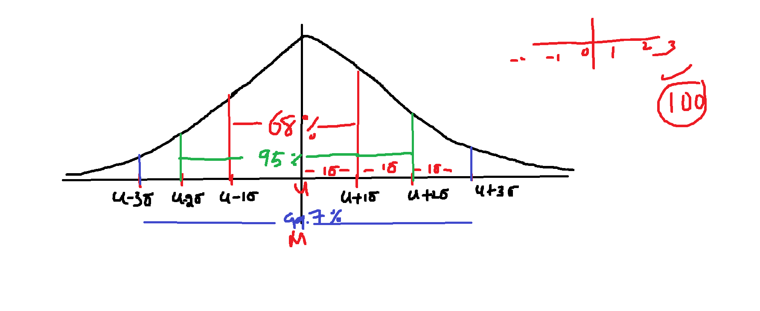

$$\left(68-95-99.7\right)$$

$$Standrad deviation=σ$$

$$population mean= μ$$

$$If a data follows Normal distribution$$

$$there are 68\% of data will cover between : u-1σ to u+1σ$$

$$there are 95\% of data will cover between : u-2σ to u+2σ$$

$$there are 99.7\% of data will cover between : u-3σ to u+3σ$$

$$the maximum data coverage will happens between-3σ to+3σ only$$

$$It is not derivation , It is an experiment$$

$$How much data coverage based on area under the curve$$

$$For the normal distribution equation calculate area under the curve then after repeatition of tests$$

$$we got the Emperical Rule$$

$$How can we apply in real time:$$

$$Assume that the statement is like this$$

$$In india the petrol rates on of average 100rs, and It is varies state by state by 2rs$$

$$Explain me the above statement in the Emperical rule$$

$$μ=100 σ=2$$

$$Assume that in india petrol rates are on of average 100rs , it will be vary state to state by 2rs$$

$$u=100 ; σ=2$$

$$u-1σ to u+1σ : 100-1*2 to 100+1*2=100-2 to 100+2 = 98 to 102$$

$$u-2σ to u+2σ :100-2*2 to 100+2*2=100-4 to 100+4 = 96 to 104$$

$$u-3σ to u+3σ :100-3*2 to 100+3*2=100-6 to 100+6 = 94 to 106$$

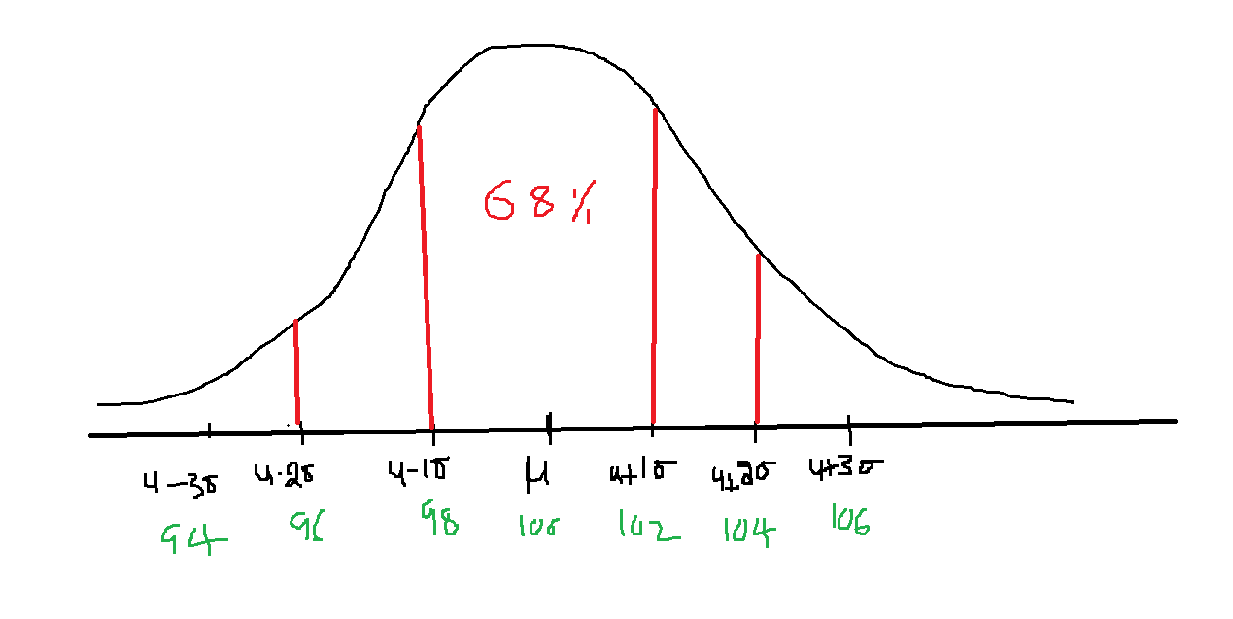

$In India 68\% states have petrol rates between 98rs to 102rs$

$In India 95\% states have petrol rates between 96rs to 104rs$

$In India 99.7\% states have petrol rates between 94rs to 106rs$

$which means the minimum petrol rates in india is 94rs$

$the maximum petrol rates is 106rs$

$$Chebyshev Inequality$$

$$Chebysheb inequlaity is applicable for Data not follows Normal distribution$$

$$Generally the data percentage formula for Normal distribution like below$$

$$u±k*σ here k=1 , k=2 and k=3$$

$$but for chebyshev the formulae like below$$

$$u±k*σ , k indicates how many standard deviations$$

$$Case-1$$

$$k=2 : for 2 standard deviations$$

$$u±k*σ data percentage=1-\frac{1}{k^{2}}$$

$$u±2*σ data percentage=1-\frac{1}{k^{2}}=1-\frac{1}{2^{2}}=1-\frac{1}{4}=\frac{3}{4}=75\%$$

$$Case-2$$

$$k=3 : for 3 standard deviations$$

$$u±k*σ data percentage=1-\frac{1}{k^{2}}$$

$$u±3*σ data percentage=1-\frac{1}{k^{2}}=1-\frac{1}{3^{2}}=1-\frac{1}{9}=\frac{8}{9}=88.8\%$$

$$Case-1$$

$$k=1 : for 1 standard deviations$$

$$u±k*σ data percentage=1-\frac{1}{k^{2}}$$

$$u±1*σ data percentage=1-\frac{1}{1^{2}}=1-\frac{1}{1^{2}}=1-1=0$$

|  |  |
| --- | --- |
| Normal(Emerical) | Chebyshev ($1-\frac{1}{k^{2}}$) |
| $$u-1σ to u+1σ=68$$ | $$u-1σ to u+1σ:Not valid= 1-\frac{1}{1^{2}}=0$$ |
| $$u-2σ to u+2σ=95$$ | $$u-2σ to u+2σ=75\%$$ |
| $$u-3σ to u+3σ=99.7$$ | $$u-3σ to u+3σ=1-\frac{1}{3^{2}}=\frac{8}{9}≅90\%$$ |