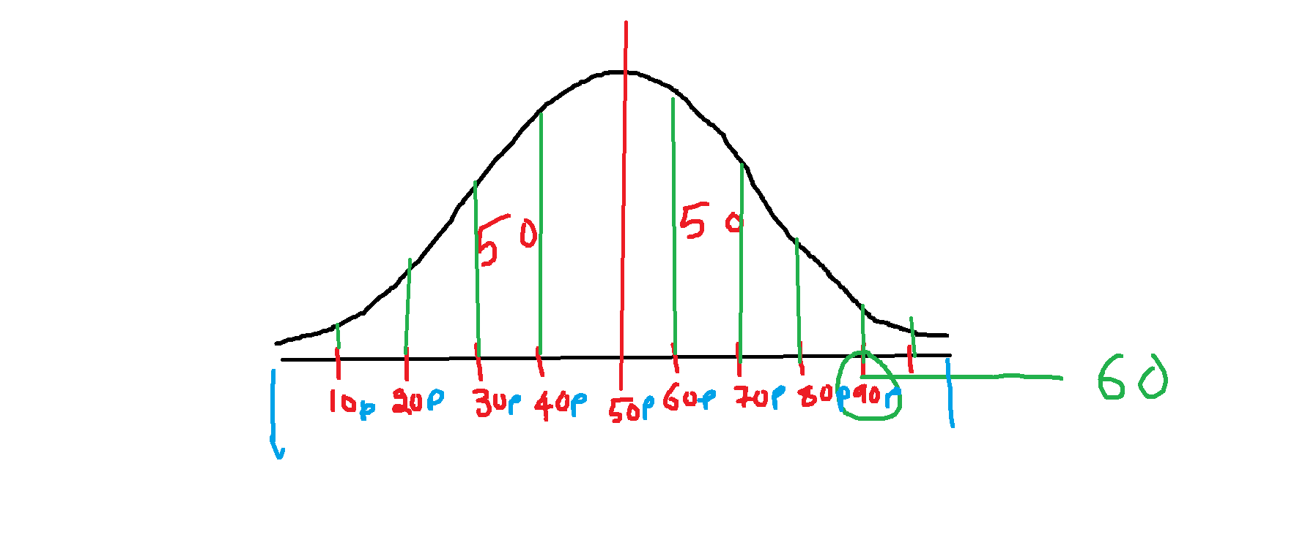

**$2,038 $1,758 $1,721 $1,637 $2,097**

**$2,047 $2,205 $1,787 $2,287 $1,940**

**$2,311 $2,054 $2,406 $1,471 $1,460**

