AOOP – WEEK1 2520030045
- Create a class Student with student ID, name and age. Create three student objects and display their details.
class Student {
int studentId;
String name;
int age;

void display() {
System.out.println("Student ID: " + studentId);
System.out.println("Name: " + name);
System.out.println("Age: " + age);
}

public static void main(String[] args) {
Student s1 = new Student();
s1.studentId = 101;
s1.name = "Teja";
s1.age = 20;

Student s2 = new Student();
s2.studentId = 102;
s2.name = "Ravi";
s2.age = 21;

Student s3 = new Student();
s3.studentId = 103;
s3.name = "Priya";
s3.age = 19;

s1.display();
s2.display();
s3.display();
}
}

OUTPUT-
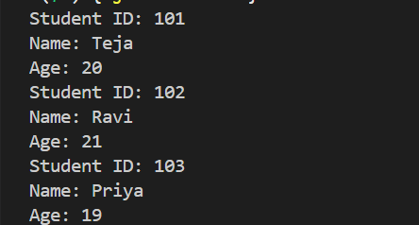
2. Create an Employee class with employee ID, name and salary. Initialize the values using a constructor and display employee details
class Employee {
int empId;
String name;
double salary;

Employee(int id, String n, double s) {
empId = id;
name = n;
salary = s;
}

void display() {
System.out.println("Employee ID: " + empId);
System.out.println("Name: " + name);
System.out.println("Salary: " + salary);
}

public static void main(String[] args) {
Employee e1 = new Employee(101, "Teja", 30000);
e1.display();
}
}

OUTPUT-
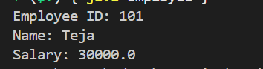

3. Create a BankAccount class with account number and balance. Implement deposit and withdrawal methods.
class BankAccount {
int accountNumber;
double balance;

BankAccount(int acc, double bal) {
accountNumber = acc;
balance = bal;
}

void deposit(double amount) {
balance = balance + amount;
System.out.println("Deposited: " + amount);
}

void withdraw(double amount) {
if (amount <= balance) {
balance = balance - amount;
System.out.println("Withdrawn: " + amount);
} else {
System.out.println("Insufficient Balance");
}
}

void display() {
System.out.println("Account Number: " + accountNumber);
System.out.println("Balance: " + balance);
}

public static void main(String[] args) {
BankAccount b = new BankAccount(12345, 5000);

b.deposit(2000);
b.withdraw(1000);
b.display();
}
}

OUTPUT-

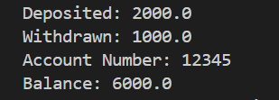

4. Create a Rectangle class with length and width. Calculate and display its area and perimeter.
class Rectangle {
double length, width;

Rectangle(double l, double w) {
length = l;
width = w;
}

void calculate() {
double area = length * width;
double perimeter = 2 * (length + width);

System.out.println("Area: " + area);
System.out.println("Perimeter: " + perimeter);
}

public static void main(String[] args) {
Rectangle r = new Rectangle(10, 5);
r.calculate();
}
}

OUTPUT –

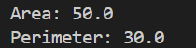

5. Create a Book class with ISBN, title and price. Initialize the values using a parameterized constructor.
class Book {
int ISBN;
String title;
double price;

Book(int i, String t, double p) {
ISBN = i;
title = t;
price = p;
}

void display() {
System.out.println("ISBN: " + ISBN);
System.out.println("Title: " + title);
System.out.println("Price: " + price);
}

public static void main(String[] args) {
Book b = new Book(101, "Java Programming", 500);
b.display();
}
}

OUTPUT –
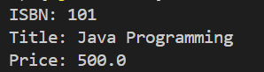

Github link – https://github.com/Ramisettysamshritha/AOOP_SKILL

