“Linux File Descriptor and File I/O Management System”
A Project Report Submitted in the partial fulfillment of the requirements for the award of the degree of

BACHELOR OF TECHNOLOGY
In

DEPARTMENT OF COMPUTER SCIENCE ENGINNERING

By

RAMISETTY SAMSHRITHA 2520030045

GUNDLA LAXMI SRI 2520030264

Under the Esteemed Guidance of

Dr. Hema Kolla
Assistant Professor
Department of Computer Science and Engineering




K L (Deemed to be) University DEPARTMENT OF COMPUTER SCIENCE ENGINEERING
&

DEPARTMENT OF COMPUTER SCIENCE AND INFORMATION TECHNOL

Declaration

The Project Report entitled “Linux File Descriptor and File I/O Management System” is a record of Bonafide work of RAMISETTY SAMSHRITHA - 2520030045, GUNDLA LAXMI SRI - 2520030264 submitted in
partial fulfillment for the award of B. Tech in Computer Science and Engineering (or) Computer Science and Information Technology to the K L University. The results embodied in this report have not been copied from any other departments/University/Institute.

RAMISETTY SAMSHRITHA 2520030045

GUNDLA LAXMI SRI 2520030264

K L (Deemed to be) University

DEPARTMENT OF COMPUTER SCIENCE ENGINEERING

CERTIFICATE

This is certify that the mini project based report entitled “Linux File Descriptor and File I/O Management System” is a bonafide work done and submitted by Ramisetty Samshritha – 2520030045, Gundla Laxmi Sri – 2520030264 ,
in partial fulfillment of the requirements for the award of the degree of BACHELOR OF TECHNOLOGY in Department of Computer Science Engineering, K L (Deemed to be University), during the academic year 2026-2027.

Signature of the Guide

Signature of the Course Coordinator Signature of the HOD

ACKNOWLEDGEMENT
The success in this project would not have been possible but for the timely help and guidance rendered by many people. Our wish to express my sincere thanks to all those who has assisted us in one way or the other for the completion of my project.

Our greatest appreciation to my Course Coordinator Dr. Hema Kolla, and my guide Dr. Hema Kolla, Department of Computer Science which cannot be expressed in words for his/her tremendous support, encouragement and guidance for this project.

We express our gratitude to Dr. P Venkateshwara Roa (CSE), Head of the Department for Computer Science Engineering for providing us with adequate facilities, ways and means by which we are able to complete this project-based Lab.

We thank all the members of teaching and non-teaching staff members, and also who have assisted me directly or indirectly for successful completion of this project. Finally, I sincerely thank my parents, friends and classmates for their kind help and cooperation during my work.

RAMISETTY SAMSHRITHA 2520030045

GUNDLA LAXMI SRI 2520030264

Abstract

File management is one of the most important services provided by an operating system, yet many learners use only high-level library functions and never see how a program actually communicates with the kernel. To address this, our project presents the Linux File Descriptor and File I/O Management System, a terminal-based application developed in C on Ubuntu Linux. Our core aim was to demonstrate low-level file management using Linux system calls and file descriptors in a simple, menu-driven program that anyone can run and study.

The application is structured around seven operation modules selected from a menu: creating a file, writing to a file, reading a file, appending to a file, copying a file, deleting a file and viewing the files of the working directory. Each module opens the file with the flags that suit the task through open(), checks the returned descriptor, transfers data with read() or write(), and releases the descriptor with close(); deletion is performed with unlink() and listing with opendir() and readdir(). Proper descriptor handling and error checking ensure that failures such as a missing file are reported to the user instead of failing silently.

The project connects theory with practice by showing the file descriptor table, open flags such as O_CREAT, O_TRUNC and O_APPEND, blocking system calls and the user/kernel boundary in working code. The program uses small fixed-size buffers, needs no dynamic memory and no external libraries, and was compiled and tested on Ubuntu Linux with GCC, with all menu operations producing the expected results. In summary, this project delivers a compact, reliable and easily understood demonstration of practical Operating Systems and Systems Programming concepts for efficient and dependable file management.

Index

S. No. | Chapter | Topics / Subtopics | Page No.
 | Acknowledgement |  | i
 | Abstract |  | ii
1 | Introduction |  | 8–10
 |  | 1.1 Background of the Project
 |  | 1.2 Problem Statement
 |  | 1.3 Scope of the Project
 |  | 1.4 Objectives of the Project
 |  | 1.5 Importance of the Application
 |  | 1.6 Target Users / Audience
2 | OS Concepts and Background Study |  | 11–14
 |  | 2.1 Operating System Concepts Related to the Project
 |  | 2.2 Existing Methods / Algorithms
 |  | 2.3 Proposed Approach
 |  | 2.4 Advantages of the Proposed Approach
3 | System Requirements |  | 15–16
 |  | 3.1 Hardware Requirements
 |  | 3.2 Software Requirements
 |  | 3.3 Operating System Environment – Ubuntu / WSL
 |  | 3.4 Development Tools and Compilers
4 | Technology and Tools Used |  | 17–19
 |  | 4.1 C / C++ Programming
 |  | 4.2 GCC Compiler
 |  | 4.3 Linux System Calls
 |  | 4.4 POSIX Threads / Synchronization
 |  | 4.5 Linux Commands and Utilities
 |  | 4.6 Other Tools / Libraries Used
5 | System Architecture and Design |  | 20–23
 |  | 5.1 Overall System Architecture
 |  | 5.2System Workflow
 |  | 5.3 Flowchart / Data Flow
 |  | 5.4 Module Description
 |  | 5.5 Input and Output Design
6 | Implementation |  | 24–31
 |  | 6.1 Module-wise Implementation
 |  | 6.2 Algorithm / Pseudocode
 |  | 6.3 Core C / C++ Implementation
 |  | 6.4 Linux System Calls / APIs Used
 |  | 6.5 Process / Thread Implementation
 |  | 6.6 IPC / Synchronization Implementation
 |  | 6.7 Memory Management Implementation
 |  | 6.8 Optional User Interface Implementation
7 | Execution and Demonstration |  | 32–35
 |  | 7.1 Compilation in Ubuntu
 |  | 7.2 Execution Commands
 |  | 7.3 Sample Inputs and Outputs
 |  | 7.4 Screenshots of Execution
 |  | 7.5 Demonstration of OS Concepts
8 | Conclusion |  | 36–37
 |  | 8.1 Summary of the Project
 |  | 8.2 Objectives Achieved
 |  | 8.3 Results Achieved
 |  | 8.4 Skills and Learning Outcomes
9 | References |  | 38
 |  | 9.1 Books
 |  | 9.2 Research Papers
 |  | 9.3 Linux / GNU Documentation
 |  | 9.4 Online Resources

CHAPTER -1 INTRODUCTION

1.1 Background of the Project
File management is one of the core services of an operating system. Every program that stores or retrieves data – a text editor, a compiler, a database – depends on the operating system to create files, move data in and out of them and finally remove them. User programs are not allowed to touch the disk directly. Instead they ask the kernel to do the work on their behalf through system calls, which are the controlled entry points between user mode and kernel mode.
Linux follows the UNIX philosophy that “everything is a file”. Regular files, directories, devices, pipes and sockets are all accessed through the same small set of calls, and every open resource is identified by a file descriptor (fd) – a small non-negative integer. When a process calls open(), the kernel returns the lowest unused descriptor. That number is an index into the process’s private file descriptor table, whose entries point to the system-wide open file table (which stores the current file offset and status flags) and from there to the file’s inode on disk. Three descriptors are opened automatically for every process: 0 (standard input), 1 (standard output) and 2 (standard error).
Most C programmers meet files through the buffered functions of the C library such as fopen() and fprintf(). These functions hide the descriptor and add buffering on top of the system calls. This project deliberately works one level below that: it uses open(), read(), write(), close() and unlink() directly so that the interaction between a user program and the Linux kernel becomes visible.
The Linux File Descriptor and File I/O Management System is a menu-driven terminal application written in C and run on Ubuntu Linux. It was developed by Team 14 of Section 7 for the course Operating Systems and Systems Programming (25CS2104E), Term-I, 2026–27. The complete source code is available at https://github.com/Ramisettysamshritha/Linux-File-Descriptor-and-File-I-O-Management-System.

1.2 Problem Statement
File management is an essential service provided by the Linux operating system. Users need dependable ways to create, modify, read, copy and delete files while making sure that system resources such as file descriptors are acquired and released correctly. Learners, however, often use only high-level library functions and never see how a program actually communicates with the kernel.
The problem addressed by this project is to design and implement a simple command-line file management utility that performs the essential file operations using Linux file descriptors and system calls only, with proper descriptor handling and error checking, and that serves as a practical demonstration of low-level file I/O in Linux.

1.3 Scope of the Project
Within the scope of the project:
- A menu-driven console interface with eight options (create, write, read, append, copy, delete, view files and exit).
- All file content operations implemented with the Linux system calls open(), read(), write(), close() and unlink().
- Listing of the files present in the current working directory using opendir() and readdir().
- Checking the descriptor returned by open() and reporting failures to the user with a clear message.
- Execution on Ubuntu Linux (native or WSL) compiled with GCC.
Outside the scope of the project:
- A graphical user interface, networking or any remote file access.
- Creation or deletion of directories, renaming of files and permission management from the menu.
- Multi-threading, inter-process communication and file locking (the program is a single sequential process).
- File names containing spaces; names and inputs are limited by the fixed-size buffers described in Chapter 6.

1.4 Objectives of the Project
- Create and open files using Linux system calls.
- Read and write data using file descriptors.
- Append data to existing files.
- Copy the contents of one file to another.
- Delete files using the appropriate Linux system call.
- Manage file descriptors properly and close opened files after use.
- Handle file-related errors and provide appropriate feedback to the user.
- Demonstrate practical Linux file I/O and Operating Systems concepts through a menu-driven application.

1.5 Importance of the Application
- Concept clarity: it turns abstract topics such as file descriptors, the open file table and system calls into a working program that can be run and observed.
- Closer to the kernel: by avoiding fopen()/fprintf(), it shows what the C library does behind the scenes.
- Foundation for systems programming: the same patterns – open, check the descriptor, transfer data, close – are used in shells, servers, databases and device drivers.
- Resource awareness: every function releases the descriptor it acquires, illustrating why descriptor leaks matter in long-running programs.
- Practical utility: the tool actually performs useful operations on real files on disk.

1.6 Target Users / Audience
- Undergraduate students of Operating Systems and Systems Programming who want a hands-on view of file I/O.
- Faculty members who need a small, readable program for classroom demonstrations of system calls.
- Beginners to Linux and C who want to move from library functions to system-level programming.
- Developers looking for a minimal reference of the standard open – read/write – close pattern.

CHAPTER -2 OS CONCEPTS AND BACKGROUND STUDY

2.1 Operating System Concepts Related to the Project
System calls and the user/kernel boundary. A process runs in user mode and cannot access hardware directly. To use a kernel service it executes a system call, which switches the CPU to kernel mode, runs the requested kernel code and returns the result. The project’s file operations are all built on this mechanism.
File descriptors. A file descriptor is the handle by which a process refers to an open file. It is an index into the per-process descriptor table. Each process starts with three descriptors already open:
Descriptor | Name | Default target
0 | Standard input (stdin) | Keyboard
1 | Standard output (stdout) | Terminal screen
2 | Standard error (stderr) | Terminal screen
3 and above | Allocated by open() | Files opened by the program
Table 2.1: Standard file descriptors of a Linux process
Descriptor table, open file table and inode. The descriptor table of the process points to entries in the system-wide open file table. Each of those entries stores the current offset and the access mode, and points to the inode, which describes the file on disk (size, permissions, location of data blocks). Closing a descriptor frees its slot so that a later open() can reuse the same number.
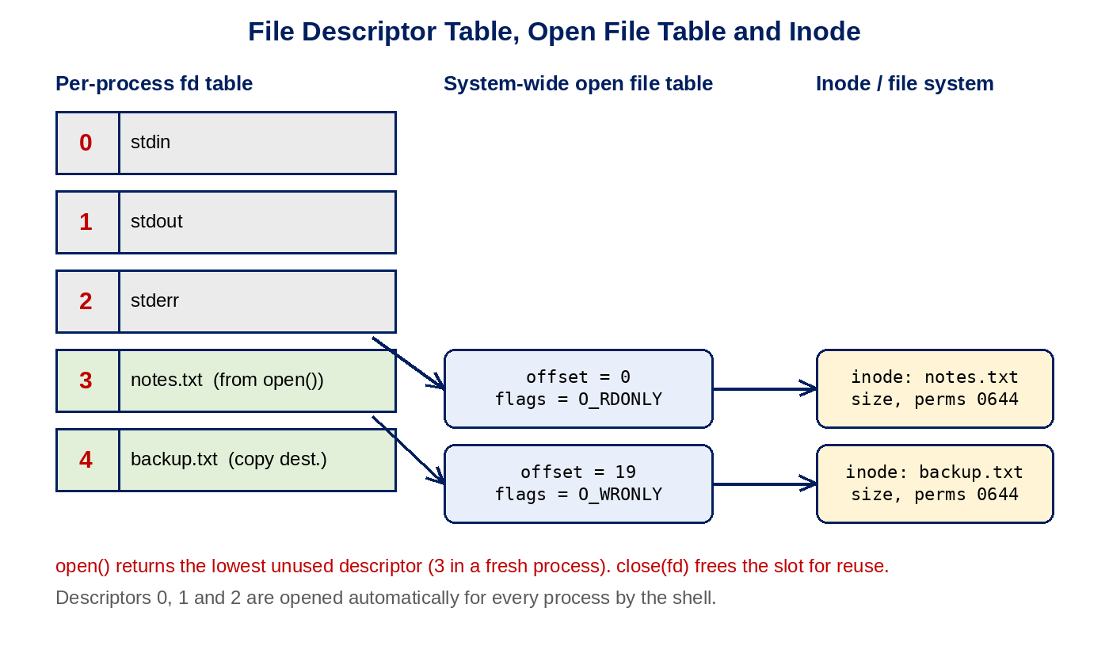
Figure 2.1: Relationship between descriptor table, open file table and inode
Open flags and file mode. The behaviour of open() is controlled by flags that the program combines with the bitwise OR operator. The flags used in this project are:
Flag | Meaning | Used in
O_RDONLY | Open for reading only | readFile, copyFile (source)
O_WRONLY | Open for writing only | createFile, writeFile, appendFile, copyFile (destination)
O_CREAT | Create the file if it does not exist | createFile, writeFile, appendFile, copyFile
O_TRUNC | Discard existing content when opening | writeFile, copyFile (destination)
O_APPEND | Every write goes to the end of the file | appendFile
Table 2.2: open() flags used in the project
When O_CREAT is used, the third argument of open() gives the permission bits of the new file. The project uses 0644 (owner read/write; group and others read only), which the kernel then adjusts by the process umask.
Error handling. System calls report failure through their return value: open() returns -1 when it cannot open the file (for example because the file does not exist or permission is denied), and the global variable errno records the reason. The project checks the descriptor after every open() and prints a message when it is negative.
Deleting a file. The unlink() call removes a directory entry (a name) from the file system. The data blocks are released only when the link count of the inode reaches zero and no process still holds the file open.
Reading a directory. A directory is itself a special file whose content is a list of names. opendir() and readdir() provide a portable way to walk through these entries, and are used to list the files in the working directory.
Resource limits. Every process has a limit on the number of simultaneously open descriptors (shown by ulimit -n). Programs must therefore close descriptors when finished. Each function in this project closes the descriptor it opened before returning.

2.2 Existing Methods / Algorithms
File operations can be performed in several ways on Linux. The most common existing approaches are compared below.
Approach | Level | Buffering | Visibility of OS interaction
C standard library (fopen, fread, fprintf) | High level, uses FILE* | Buffered in user space | Descriptor and system calls are hidden
Shell utilities (touch, cat, cp, rm, ls) | Ready-made programs | Depends on the utility | User sees only the result
Graphical file managers | Application level | Handled by the toolkit | Not visible
Direct system calls (this project) | Low level, uses int fd | Only the kernel page cache | Fully visible in the source code
Table 2.3: Comparison of file handling approaches
For copying, the usual algorithm is a read–write loop: read a block of data from the source descriptor into a buffer, write exactly the number of bytes that were read to the destination descriptor, and repeat until read() returns 0 (end of file). Optimised alternatives such as sendfile(), copy_file_range() or memory mapping exist, but the simple loop is portable and easy to understand, so it is the one used here.
For appending, the existing approach is either to move the file offset to the end with lseek(fd, 0, SEEK_END) before writing, or to open the file with the O_APPEND flag so that the kernel positions every write at the end automatically.

2.3 Proposed Approach
The proposed system is a single C program that presents a text menu and dispatches each choice to a dedicated function. Every function works only with descriptors and system calls:
- Display the menu and read the user’s choice.
- Dispatch to the function for the selected operation using a switch statement.
- Read the required file name(s) and text from the user.
- Call open() with the flags that suit the operation and check that the returned descriptor is not negative.
- Transfer data with read() or write() (or remove the file with unlink()).
- Close the descriptor with close() and print a success or error message.
- Return to the menu until the user selects Exit.
The design keeps the program small (one source file) and keeps each operation independent, so that each can be studied, tested and explained separately.

2.4 Advantages of the Proposed Approach
- Uses low-level Linux system calls, so the interaction with the kernel is explicit.
- Efficient file handling through file descriptors without an extra library buffer.
- Simple menu-driven interface that needs no command-line arguments.
- Constant memory use: the copy operation moves data through a 200-byte buffer regardless of the file size.
- Descriptors are closed after each operation, so none are leaked across menu iterations.
- Demonstrates practical operating system concepts and runs directly on Ubuntu Linux.
- Small code base with no external dependencies, so it is easy to compile, read and extend.

CHAPTER -3 SYSTEM REQUIREMENTS

3.1 Hardware Requirements
The application is very light. It performs only small file operations and keeps all of its buffers in a few hundred bytes of memory, so any computer that can run Ubuntu Linux is sufficient.
Component | Minimum | Recommended
Processor | Dual-core, 1.5 GHz (x86-64) | Quad-core, 2.0 GHz or above
Main memory (RAM) | 2 GB | 4 GB or more
Disk space | 500 MB free (Ubuntu / WSL tools and source) | 5 GB free
Input device | Keyboard | Keyboard
Output device | Monitor with terminal support | Monitor with terminal support
Table 3.1: Hardware requirements

3.2 Software Requirements
Software | Details
Operating system | Ubuntu Linux (native installation, virtual machine or WSL)
Programming language | C
Compiler | GCC (GNU Compiler Collection)
Editor | Nano or Visual Studio Code
Version control | Git and GitHub
C library headers | stdio.h, unistd.h, fcntl.h, string.h, dirent.h (part of the standard glibc development files)
Terminal | Ubuntu terminal / bash shell
Table 3.2: Software requirements

3.3 Operating System Environment – Ubuntu / WSL
The project was developed for Ubuntu Linux because it exposes the standard Linux system call interface directly. Students who use Windows can run the same program inside the Windows Subsystem for Linux (WSL), which provides an Ubuntu command-line environment with a real Linux kernel interface, so the system calls behave exactly as on a native Ubuntu installation.
The compiler and the required headers are installed with the following commands:
sudo apt update
sudo apt install build-essential
gcc --version
The package build-essential installs GCC, make and the C library development files, which are all that this project needs.

3.4 Development Tools and Compilers
- GCC compiles the single source file file_manager.c into an executable.
- Nano / VS Code are used to write and edit the source code.
- Git and GitHub keep the source code under version control and allow both team members to share it. The repository is https://github.com/Ramisettysamshritha/Linux-File-Descriptor-and-File-I-O-Management-System.
- Ubuntu terminal is used to compile, run and test the program.

CHAPTER -4 TECHNOLOGY AND TOOLS USED

4.1 C / C++ Programming
The program is written in the C programming language, the language in which UNIX and Linux themselves are written and the one in which the system call interface is documented. C gives direct access to the system calls without any runtime layer in between. C++ is not used in this project.
The language features used are functions, arrays of characters for strings, the while loop for the menu, the switch statement for dispatching and pointers for directory handling. The standard headers included are:
Header | Provides | Used for
stdio.h | printf, scanf, fgets, getchar | Terminal input and output only (menu, prompts, messages)
unistd.h | read, write, close, unlink | Core file I/O system calls
fcntl.h | open and the O_* flags | Opening and creating files
string.h | strlen | Finding the number of bytes to write
dirent.h | opendir, readdir, closedir, struct dirent | Listing files of the working directory
Table 4.1: Header files used

4.2 GCC Compiler
GCC translates the C source code into an executable in four stages: pre-processing (expanding #include directives), compilation to assembly, assembly to object code and finally linking with the C library. The whole process is invoked with one command:
gcc file_manager.c -o file_manager
If the output name is omitted, GCC produces a file called a.out, which is why the project README runs the program as ./a.out. During development the program was also compiled with the -Wall option, which enables the common compiler warnings; it compiles without any warning.

4.3 Linux System Calls
System calls are the services that the kernel offers to user programs. The calls used by the project are listed below.
System call | Header | Prototype (simplified) | Purpose in the project
open() | fcntl.h | int open(const char *path, int flags, mode_t mode) | Creates or opens a file and returns its descriptor
read() | unistd.h | ssize_t read(int fd, void *buf, size_t n) | Reads bytes from a file into memory
write() | unistd.h | ssize_t write(int fd, const void *buf, size_t n) | Writes bytes from memory into a file
close() | unistd.h | int close(int fd) | Releases the descriptor
unlink() | unistd.h | int unlink(const char *path) | Removes a file name (deletes the file)
opendir() / readdir() / closedir() | dirent.h | DIR *opendir(const char *path) etc. | Reads the entries of the current directory
Table 4.2: System calls and library routines for directory access
The lseek() call, which moves the file offset, is part of the call set studied for this project. The current implementation does not need to call it directly because appending is handled by the O_APPEND flag of open(), which makes the kernel move the offset to the end of the file before every write.

4.4 POSIX Threads / Synchronization
POSIX threads and synchronization primitives (mutexes, semaphores) are not used in this project. The application is a single-threaded, sequential program: it handles one menu choice at a time and finishes each operation completely before showing the menu again. Because there is only one flow of control, there is no shared data inside the process that would need protection.
Synchronization would become relevant if several processes or threads wrote to the same file at the same time. In that case file locking with flock() or fcntl(), or a mutex around the shared data, would be required. This is listed as a possible future enhancement in Chapter 8.

4.5 Linux Commands and Utilities
The following commands are used to build, run and verify the project.
Command | Purpose
gcc file_manager.c -o file_manager | Compile the program
./file_manager (or ./a.out) | Run the program
ls -l | Check the files created by the program and their permissions
cat <file> | Cross-check the file content independently of the program
nano <file> / code . | Edit the source code
ls -l /proc/<pid>/fd | Display the descriptors that a running process has open
ulimit -n | Show the per-process limit on open descriptors
git clone / add / commit / push | Obtain and publish the source code through GitHub
Table 4.3: Commands and utilities

4.6 Other Tools / Libraries Used
- Git and GitHub for version control and sharing the project among the team members.
- Nano and Visual Studio Code as source code editors.
- GNU C Library (glibc) which provides the wrappers for the system calls and the standard headers.
- Ubuntu terminal / WSL as the execution environment.
- A project presentation (Linux_File_IO_Project.pptx) prepared for the course is stored in the same repository.

CHAPTER -5 SYSTEM ARCHITECTURE AND DESIGN

5.1 Overall System Architecture
The system is organised in layers. The user interacts with a menu; the application layer reads the choice and calls the matching operation module; each module calls the Linux system call interface; and the kernel carries out the request through its descriptor table, open file table, inode table and file system on the storage device.
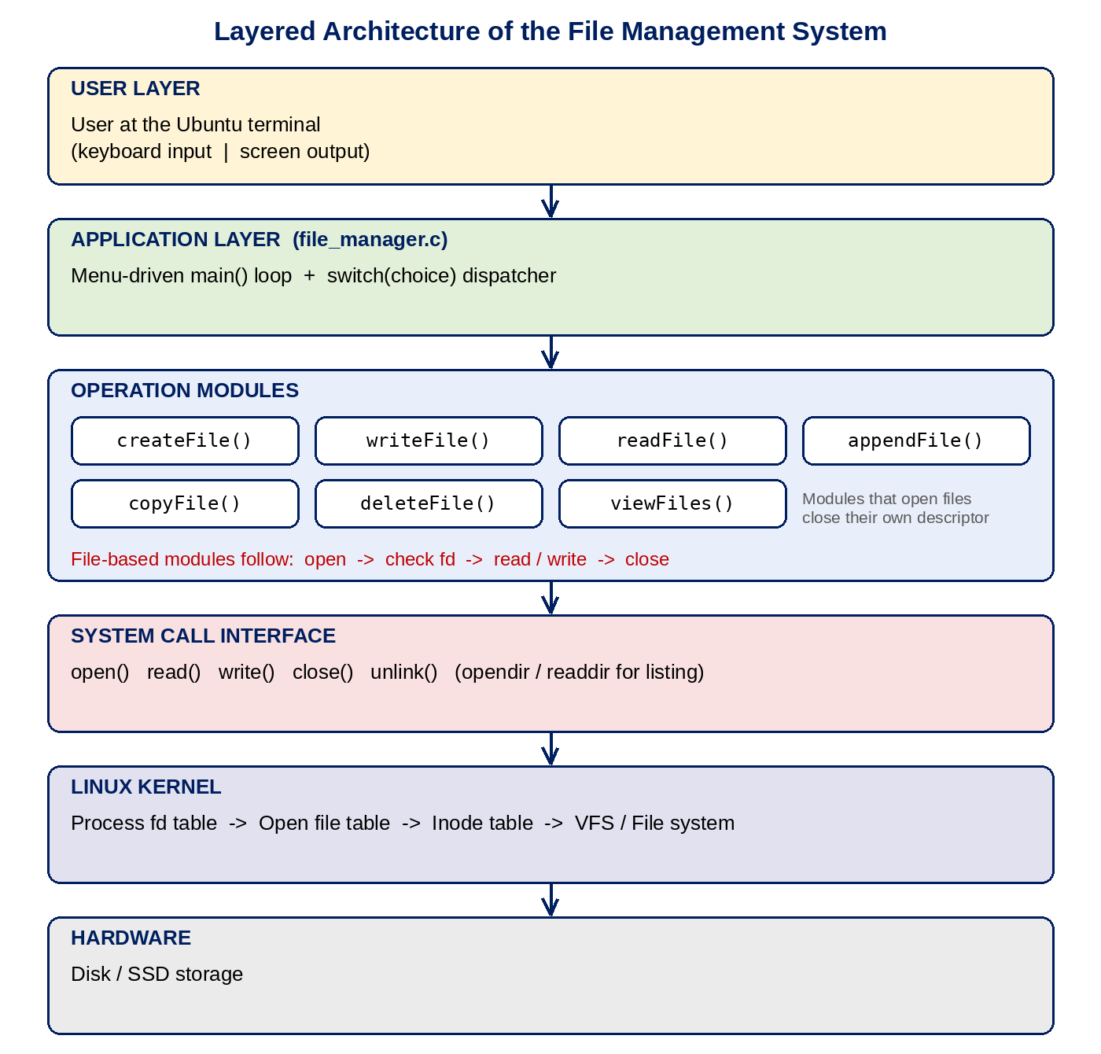
Figure 5.1: Layered architecture of the system
The application layer contains no knowledge of disk layout. All persistent data handling is delegated to the kernel, which is exactly the separation of concerns that an operating system is designed to provide.

5.2 System Workflow
Every menu option follows the same overall workflow, which is described below for a write operation as an example:
- The program prints the menu and waits for the user to type a number.
- main() passes the number to a switch statement, which calls writeFile().
- writeFile() asks for the file name and the text and stores them in character arrays.
- open() is called with O_WRONLY | O_TRUNC | O_CREAT and returns a descriptor.
- If the descriptor is negative, an error message is shown and the function returns.
- Otherwise write() sends the text to the kernel using that descriptor.
- close() releases the descriptor, a success message is printed and control returns to the menu.
The operations differ only in the flags passed to open() and in the system calls used afterwards:
Operation | Flags passed to open() | System calls used | Result
1 Create | O_CREAT | O_WRONLY | open, close | Empty file created (existing content is not touched)
2 Write | O_WRONLY | O_TRUNC | O_CREAT | open, write, close | File holds only the new text
3 Read | O_RDONLY | open, read, close | Content displayed on screen
4 Append | O_WRONLY | O_APPEND | O_CREAT | open, write, close | New text added at the end
5 Copy | Source: O_RDONLY; destination: O_CREAT | O_WRONLY | O_TRUNC | open (twice), read and write in a loop, close (twice) | Destination is a copy of the source
6 Delete | – | unlink | File name removed
7 View | – | opendir, readdir, closedir | File names of the working directory listed
8 Exit | – | – | Program terminates
Table 5.1: Operations, flags and system calls

5.3 Flowchart / Data Flow
The flowchart below shows the control flow of the program. The menu loop runs until the user chooses 8; every other valid choice runs one operation and returns to the menu, and an unknown number results in an “Invalid Choice” message.
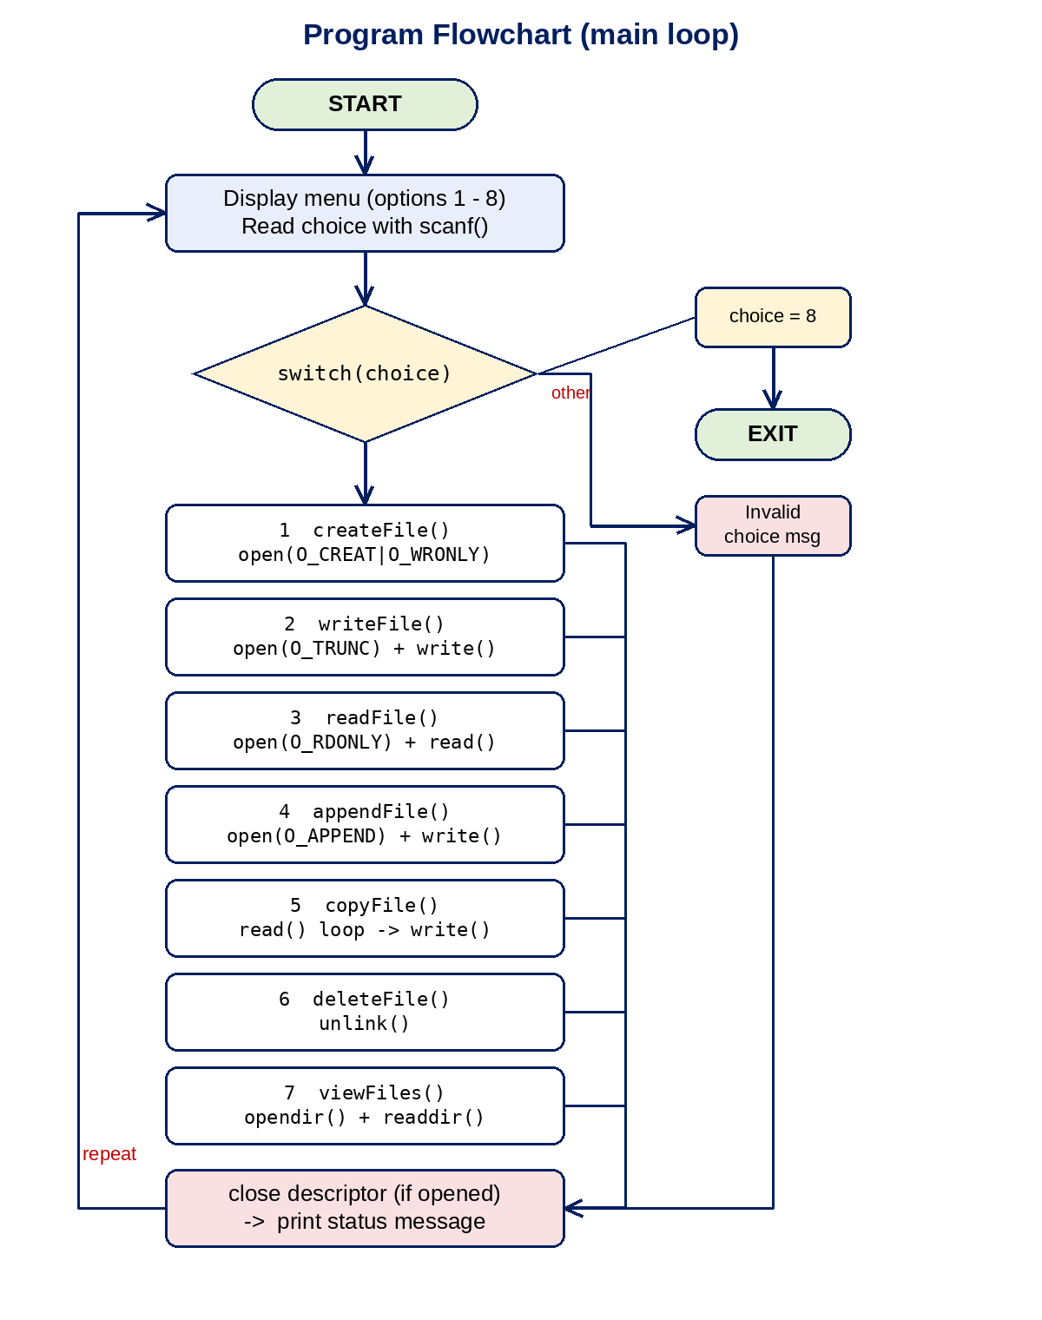
Figure 5.2: Flowchart of the main menu loop
Data flow. For a write operation the text typed by the user is first held in a character array in the process’s memory. The write() call copies it into the kernel, which places it in the page cache and later flushes it to the disk. For a read operation the flow is reversed: the kernel copies data from the file (or its cache) into the program’s buffer, and the program then prints the buffer on the screen. For a copy, the data passes through the program’s 200-byte buffer in a loop, from the source file to the destination file, one block at a time.

5.4 Module Description
Module | Inputs | Processing | Output / errors
main() | Menu choice (int) | Loops, displays the menu, dispatches with switch | Calls the module; “Invalid Choice” for unknown numbers; returns 0 on option 8
createFile() | File name | open() with O_CREAT | O_WRONLY, mode 0644 | “File created successfully” or “File not created”
writeFile() | File name, one line of text | open() with O_TRUNC, write(), close() | “Data written successfully” or “File not found”
readFile() | File name | open(O_RDONLY), read() up to 499 bytes, print | Content under the heading FILE CONTENT, or “Cannot open file”
appendFile() | File name, one line of text | open() with O_APPEND, write(), close() | “Data appended successfully” or “File not found”
copyFile() | Source name, destination name | Read–write loop with a 200-byte buffer | “File copied successfully” or “Source file not found”
deleteFile() | File name | unlink() | “File deleted successfully” or “File not found or cannot delete”
viewFiles() | None | opendir("."), readdir() loop, skips names beginning with a dot | List of files under FILES IN PROJECT, or “Cannot open directory”
Table 5.2: Module description

5.5 Input and Output Design
Input design. All input is typed on the keyboard in response to prompts. The menu choice is read with scanf("%d"), file names with scanf("%s") and lines of text with fgets() (after a getchar() call that discards the newline left in the input by scanf).
Item | Variable | Size | Read with
Menu choice | choice | int | scanf("%d")
File name / source / destination | filename, source, destination | char[50] | scanf("%s")
Text to write or append | data | char[200] | fgets()
Display buffer for reading | buffer | char[500] | filled by read()
Copy buffer | buffer | char[200] | filled by read()
Table 5.3: Input variables and buffers
Output design. All output goes to the terminal as plain text, so the program works in any terminal, including WSL, and every operation ends with a one-line status message. The menu displayed by the program is:
===== FILE MANAGEMENT SYSTEM =====
1. Create File
2. Write File
3. Read File
4. Append File
5. Copy File
6. Delete File
7. View Files
8. Exit
Enter choice:

CHAPTER -6 IMPLEMENTATION

6.1 Module-wise Implementation
main(). An infinite while(1) loop prints the menu, reads the choice and uses a switch statement to call one of the seven operation functions. Choice 8 executes return 0, which ends the program (the kernel then closes any descriptor still open); any other number prints “Invalid Choice”.
createFile(). Reads a file name and calls open(filename, O_CREAT | O_WRONLY, 0644). A negative return value means the file could not be created. Because O_TRUNC is not used, creating a name that already exists leaves its content unchanged. The descriptor is closed immediately because no data is written.
writeFile(). Reads the file name, discards the pending newline with getchar(), reads a line with fgets() and opens the file with O_WRONLY | O_TRUNC | O_CREAT. The previous content is therefore replaced. write(fd, data, strlen(data)) writes exactly the characters typed.
readFile(). Opens the file with O_RDONLY and reads at most sizeof(buffer)-1 (499) bytes into the buffer. A terminating null character is placed after the bytes read so that the buffer can be printed as a string.
appendFile(). Opens the file with O_WRONLY | O_APPEND | O_CREAT. Because of O_APPEND, the kernel moves the offset to the end of the file before each write, so existing content is preserved and the new line is added after it.
copyFile(). Opens the source with O_RDONLY and the destination with O_CREAT | O_WRONLY | O_TRUNC. A while loop calls read() to fill the 200-byte buffer and write() to write exactly the number of bytes obtained, until read() returns 0 at the end of the file. Both descriptors are then closed.
deleteFile(). Calls unlink(filename) and tests whether it returned 0. This is the only operation that does not use a file descriptor, because deleting works on the name, not on an open file.
viewFiles(). Opens the current directory with opendir("."), reads entries with readdir() in a loop, prints every name that does not begin with a dot (hidden files, . and .. are skipped) and calls closedir().

6.2 Algorithm / Pseudocode
ALGORITHM main
LOOP forever
display menu
read choice
SWITCH choice
1: createFile 2: writeFile 3: readFile
4: appendFile 5: copyFile 6: deleteFile
7: viewFiles 8: EXIT program
default: print "Invalid Choice"
END LOOP
ALGORITHM writeFile (append differs only in the flags)
read filename, read text
fd <- open(filename, O_WRONLY | O_TRUNC | O_CREAT, 0644)
IF fd < 0 THEN print error; RETURN
write(fd, text, length(text))
close(fd)
print success
ALGORITHM readFile
read filename
fd <- open(filename, O_RDONLY)
IF fd < 0 THEN print "Cannot open file"; RETURN
n <- read(fd, buffer, 499)
IF n >= 0 THEN buffer[n] <- '\0'
print buffer
close(fd)
ALGORITHM copyFile
read source, destination
fd1 <- open(source, O_RDONLY)
IF fd1 < 0 THEN print "Source file not found"; RETURN
fd2 <- open(destination, O_CREAT | O_WRONLY | O_TRUNC, 0644)
REPEAT
n <- read(fd1, buffer, 200)
IF n > 0 THEN write(fd2, buffer, n)
UNTIL n <= 0
close(fd1); close(fd2)
print success
ALGORITHM deleteFile
read filename
IF unlink(filename) = 0 THEN print "File deleted successfully"
ELSE print "File not found or cannot delete"

ALGORITHM viewFiles
dir <- opendir(".")
IF dir = NULL THEN print error; RETURN
WHILE entry <- readdir(dir) is not NULL
IF first character of entry name is not '.' THEN print name
closedir(dir)

6.3 Core C / C++ Implementation
The complete program is a single file, file_manager.c, of 224 lines. It is reproduced below function by function. The program is written in C (not C++). First the header files, function prototypes and the main menu loop:
#include <stdio.h>
#include <unistd.h>
#include <fcntl.h>
#include <string.h>
#include <dirent.h>

void createFile();
void writeFile();
void readFile();
void appendFile();
void copyFile();
void deleteFile();
void viewFiles();

int main()
{
int choice;

while(1)
{
printf("\n===== FILE MANAGEMENT SYSTEM =====\n");
printf("1. Create File\n");
printf("2. Write File\n");
printf("3. Read File\n");
printf("4. Append File\n");
printf("5. Copy File\n");
printf("6. Delete File\n");
printf("7. View Files\n");
printf("8. Exit\n");

printf("Enter choice: ");
scanf("%d",&choice);

switch(choice)
{
case 1: createFile(); break;
case 2: writeFile(); break;
case 3: readFile(); break;
case 4: appendFile(); break;
case 5: copyFile(); break;
case 6: deleteFile(); break;
case 7: viewFiles(); break;
case 8: return 0;
default: printf("Invalid Choice\n");
}
}
}
createFile() – creates an empty file:
void createFile()
{
char filename[50];

printf("Enter filename: ");
scanf("%s", filename);

int fd = open(filename, O_CREAT | O_WRONLY, 0644);

if(fd < 0)
{
printf("File not created\n");
return;
}

printf("File created successfully\n");
close(fd);
}
writeFile() – writes text, replacing earlier content:
void writeFile()
{
char filename[50];
char data[200];

printf("Enter filename: ");
scanf("%s", filename);

getchar();

printf("Enter text: ");
fgets(data, sizeof(data), stdin);

int fd = open(filename, O_WRONLY | O_TRUNC | O_CREAT, 0644);

if(fd < 0)
{
printf("File not found\n");
return;
}

write(fd, data, strlen(data));

printf("Data written successfully\n");
close(fd);
}
readFile() – reads and displays the content:
void readFile()
{
char filename[50];
char buffer[500];

printf("Enter filename: ");
scanf("%s", filename);

int fd = open(filename, O_RDONLY);

if(fd < 0)
{
printf("Cannot open file\n");
return;
}

int bytes = read(fd, buffer, sizeof(buffer)-1);

if(bytes >= 0)
buffer[bytes] = '\0';

printf("\n----- FILE CONTENT -----\n");
printf("%s\n", buffer);

close(fd);
}
appendFile() – adds text at the end of the file:
void appendFile()
{
char filename[50];
char data[200];

printf("Enter filename: ");
scanf("%s", filename);

getchar();

printf("Enter text to append: ");
fgets(data, sizeof(data), stdin);

int fd = open(filename, O_WRONLY | O_APPEND | O_CREAT, 0644);

if(fd < 0)
{
printf("File not found\n");
return;
}

write(fd, data, strlen(data));

printf("Data appended successfully\n");
close(fd);
}
copyFile() – copies one file to another using a read–write loop:
void copyFile()
{
char source[50];
char destination[50];
char buffer[200];
int bytes;

printf("Enter source file: ");
scanf("%s", source);

printf("Enter destination file: ");
scanf("%s", destination);

int fd1 = open(source, O_RDONLY);

if(fd1 < 0)
{
printf("Source file not found\n");
return;
}

int fd2 = open(destination, O_CREAT | O_WRONLY | O_TRUNC, 0644);

while((bytes = read(fd1, buffer, sizeof(buffer))) > 0)
{
write(fd2, buffer, bytes);
}

printf("File copied successfully\n");

close(fd1);
close(fd2);
}
deleteFile() – deletes a file with unlink():
void deleteFile()
{
char filename[50];

printf("Enter filename to delete: ");
scanf("%s", filename);

if(unlink(filename) == 0)
{
printf("File deleted successfully\n");
}
else
{
printf("File not found or cannot delete\n");
}
}
viewFiles() – lists the files of the working directory:
void viewFiles()
{
DIR *dir;
struct dirent *entry;

dir = opendir(".");

if(dir == NULL)
{
printf("Cannot open directory\n");
return;
}

printf("\n----- FILES IN PROJECT -----\n");

while((entry = readdir(dir)) != NULL)
{
if(entry->d_name[0] != '.')
{
printf("%s\n", entry->d_name);
}
}

closedir(dir);
}

6.4 Linux System Calls / APIs Used
Call | Used in | Arguments in this project | Return value handling
open() | create, write, read, append, copy | Path from the user; flags as in Table 5.1; mode 0644 when creating | Negative value is reported to the user (the copy destination is not checked)
read() | readFile, copyFile | fd, buffer, buffer size | Number of bytes is used to terminate the string / to drive the copy loop; 0 ends the loop
write() | write, append, copy | fd, buffer, number of bytes | Return value is not checked
close() | create, write, read, append, copy | fd | Return value is not checked
unlink() | deleteFile | Path from the user | 0 means success; any other value prints an error
opendir() / readdir() / closedir() | viewFiles | "." (current directory) | NULL from opendir() is reported; readdir() returns NULL after the last entry
Table 6.1: System calls and APIs used
Library functions printf(), scanf(), fgets() and getchar() are used only for the terminal interface. They are not used to access the user’s files.

6.5 Process / Thread Implementation
When the program is started, the shell creates a process for it and the kernel gives that process a descriptor table in which descriptors 0, 1 and 2 are already connected to the terminal. The program then runs as a single process with a single thread; it does not call fork() or create threads. All system calls are blocking: for example, the program waits inside scanf() until the user presses Enter and inside read() until the kernel has delivered the data.
Descriptors obtained by open() exist only for the duration of one menu operation. When the user chooses Exit, the process terminates and the kernel releases every resource that belongs to it.

6.6 IPC / Synchronization Implementation
The project does not implement inter-process communication or synchronization mechanisms, because it consists of one process. Nevertheless the file system itself is a shared resource, and two aspects are worth noting:
- Opening a file with O_APPEND makes the kernel move the offset to the end and write as one step, so concurrent appends from different processes do not overwrite each other’s data.
- Operations such as write and copy are not protected by locks. If two copies of the program modified the same file at the same time, the final content would depend on the order in which the kernel scheduled them. Advisory locking with flock() or fcntl() could be added to prevent this.

6.7 Memory Management Implementation
The program uses only statically sized arrays that live on the stack of the function that declares them. No dynamic memory (malloc()/free()) is used, so memory leaks are not possible. The buffers are:
Function | Buffer | Size (bytes) | Purpose
createFile, writeFile, readFile, appendFile, deleteFile | filename | 50 | File name (up to 49 characters plus terminator)
writeFile, appendFile | data | 200 | Line of text (at most 199 characters including the newline)
readFile | buffer | 500 | Content displayed (at most 499 bytes)
copyFile | source, destination | 50 each | File names
copyFile | buffer | 200 | Block of data passed from source to destination
Table 6.2: Buffers used by the program
Because the copy loop moves 200 bytes at a time, copying a file of any size needs the same small amount of memory. Behind the scenes the kernel keeps recently used file data in its page cache, which makes repeated reads fast without any action from the program.
The file-name buffers are filled with scanf("%s"), which does not limit the length of the input. Names longer than 49 characters would overflow the array; the improvement scanf("%49s", filename) is noted as future work.

6.8 Optional User Interface Implementation
The user interface is a text menu displayed in the terminal. It was chosen because it needs no graphical libraries, works over SSH and in WSL, and keeps the focus of the project on system calls. The interface follows a simple pattern: numbered options, a prompt for the choice, one prompt per required input and a one-line result message. After every operation the menu is displayed again, so several operations can be performed in a single run. A graphical or ncurses-based interface could be added later without changing the file operation functions.

CHAPTER -7 EXECUTION AND DEMONSTRATION

7.1 Compilation in Ubuntu
Open a terminal in the folder that contains the source file and compile it with GCC:
gcc file_manager.c -o file_manager
GCC prints nothing when compilation succeeds. The command gcc -Wall file_manager.c -o file_manager was also used to confirm that the program compiles without warnings. To obtain the source code from GitHub first, run:
git clone https://github.com/Ramisettysamshritha/Linux-File-Descriptor-and-File-I-O-Management-System
cd Linux-File-Descriptor-and-File-I-O-Management-System

7.2 Execution Commands
./file_manager
If the program was compiled without the -o option, the executable is named a.out and is started with ./a.out. The menu appears and the program keeps running until option 8 is chosen. Files are created in the folder from which the program was started.
Note: the program expects keyboard input. If the input stream is closed (for example by pressing Ctrl+D at the menu), the menu repeats; stop it with Ctrl+C.

7.3 Sample Inputs and Outputs
The following test run was executed on Ubuntu Linux. Each row shows the menu choice and inputs, and the message printed by the program.
No. | Menu choice and input | Output of the program
1 | 1 → notes.txt | File created successfully
2 | 2 → notes.txt → “Hello from Team 14” | Data written successfully
3 | 3 → notes.txt | ----- FILE CONTENT ----- Hello from Team 14
4 | 4 → notes.txt → “Appended line two” | Data appended successfully
5 | 3 → notes.txt | FILE CONTENT shows both lines: Hello from Team 14 / Appended line two
6 | 5 → notes.txt → backup.txt | File copied successfully
7 | 7 | FILES IN PROJECT lists file_manager.c, file_manager, backup.txt, notes.txt
8 | 6 → notes.txt | File deleted successfully
9 | 3 → notes.txt (after deletion) | Cannot open file
10 | 3 → ghost.txt (never created) | Cannot open file
11 | 5 → ghost.txt → z.txt | Source file not found
12 | 6 → ghost.txt | File not found or cannot delete
13 | 9 | Invalid Choice
14 | 8 | Program exits
Table 7.1: Test cases with observed results
Test 5 shows that appending preserves the earlier content. Tests 9 to 12 show that the error checks work: the program reports the problem instead of failing silently. The file listing in test 7 shows the files in the directory in the order returned by the file system, which is not alphabetical.

7.4 Screenshots of Execution
The following figures show the terminal output of the program during the test run in Section 7.3.
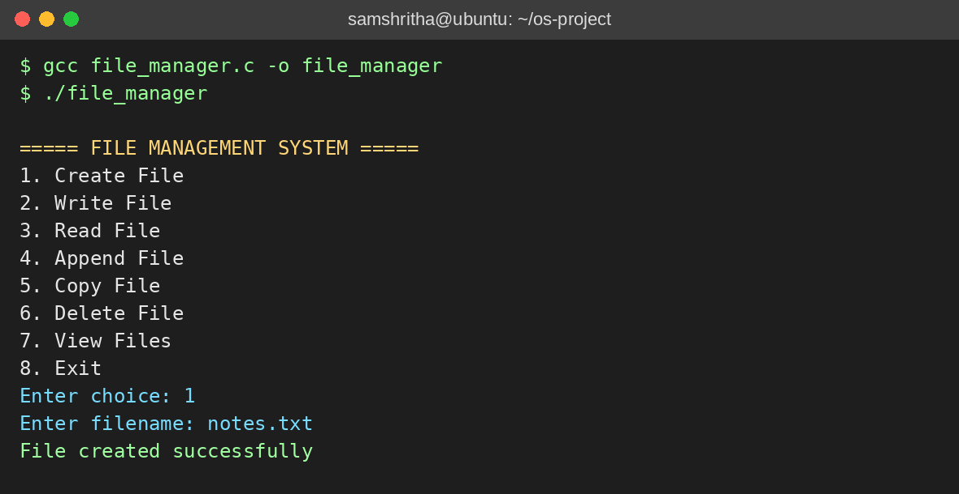
Figure 7.1: Compilation, start-up and creation of a file
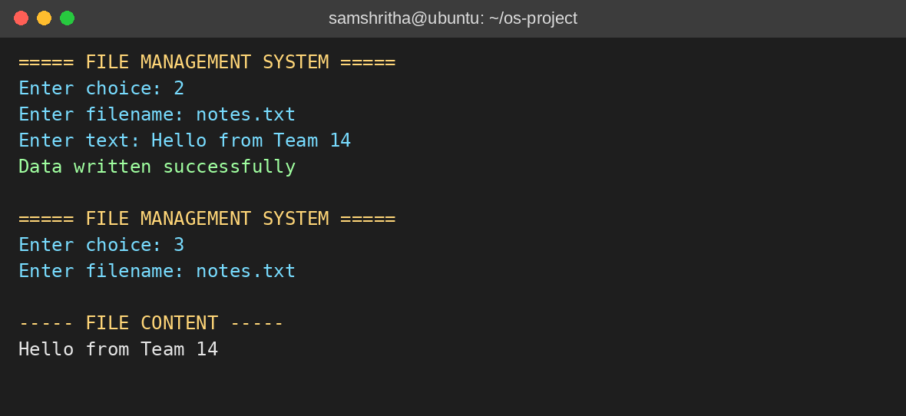
Figure 7.2: Writing text to a file and reading it back
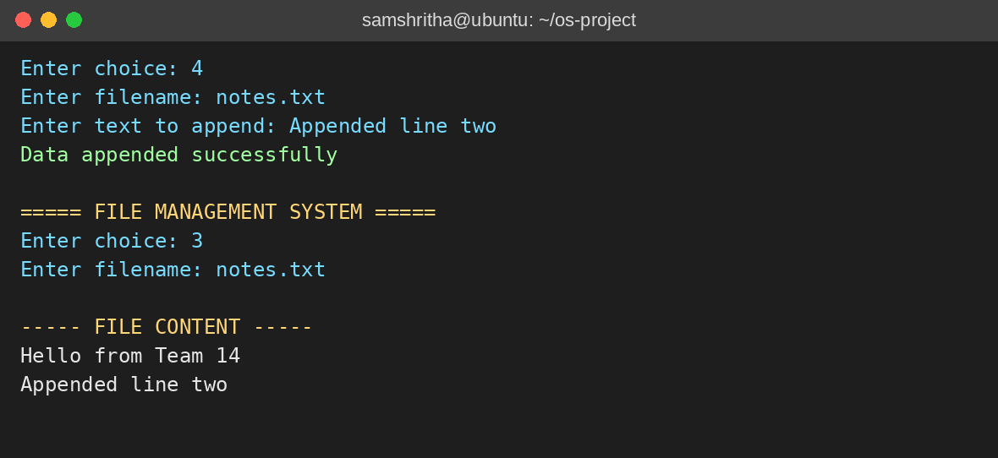
Figure 7.3: Appending text and reading the file again
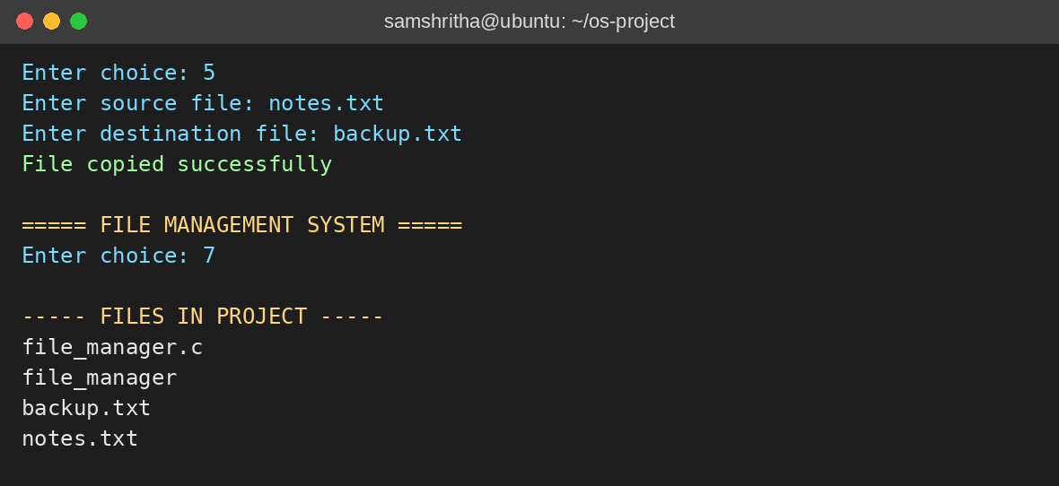
Figure 7.4: Copying a file and viewing the files of the directory
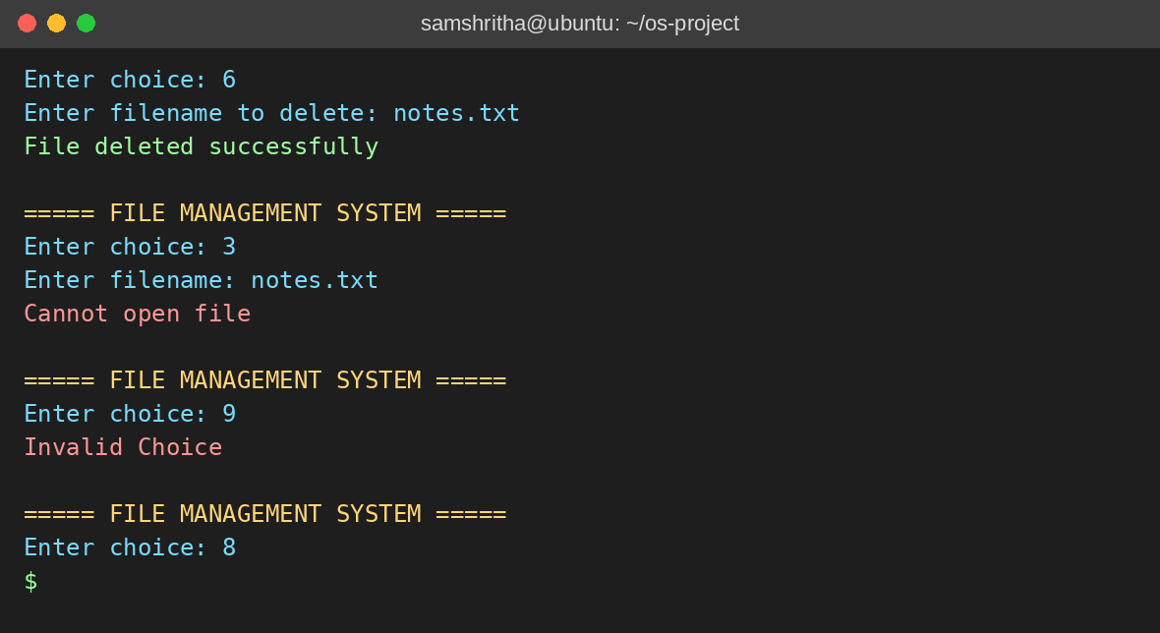
Figure 7.5: Deleting a file, error handling and exit

7.5 Demonstration of OS Concepts
Step in the demonstration | Operating system concept shown
Choose 1 and give a name | open() with O_CREAT asks the kernel to create an inode and a directory entry and returns a file descriptor
Choose 2, then 3 | write() copies data from user memory into the kernel; read() copies it back; the descriptor identifies the open file in each call
Choose 4 | O_APPEND: the kernel moves the offset to the end of the file before the write
Choose 5 | Two descriptors are open at the same time; data moves through a small user buffer in a loop until read() returns 0 (end of file)
Choose 6 | unlink() removes the directory entry; reading the name afterwards fails because open() returns -1
Choose 7 | A directory is read like a file made of names, using opendir() and readdir()
Choose 3 with a missing name | System calls fail by returning -1; the program must check the result and tell the user
Choose 8 | Process termination: the kernel reclaims the process and its descriptor table
Table 7.2: Mapping of demonstration steps to OS concepts
The descriptor table of the running program can be inspected from a second terminal with ls -l /proc/<pid>/fd, where <pid> is the process number shown by pgrep file_manager. While the program waits at the menu, only the standard descriptors are open, because every operation closes the descriptors it opened. Output captured while the program was waiting at the menu in a test where its input came from a pipe and its output was redirected to /dev/null:
lr-x------ 1 64 Oct 5 08:17 0 -> pipe:[1473]
l-wx------ 1 64 Oct 5 08:17 1 -> /dev/null
l-wx------ 1 64 Oct 5 08:17 2 -> /dev/null
In a normal terminal session, descriptors 0, 1 and 2 point to the terminal device (for example /dev/pts/0). Only descriptors 0, 1 and 2 are present, which confirms that no descriptor is leaked between operations. Files created by the program receive the permissions -rw-r--r-- under the common umask 022, matching the mode 0644 passed to open().

CHAPTER -8 CONCLUSION

8.1 Summary of the Project
The Linux File Descriptor and File I/O Management System is a menu-driven terminal application written in C for Ubuntu Linux. It creates, writes, reads, appends, copies and deletes files and lists the files of the working directory, using file descriptors and system calls instead of the buffered functions of the C library. Each operation opens the file with the flags that fit the task, checks the returned descriptor, transfers data and closes the descriptor, which demonstrates in a practical way how a user program communicates with the Linux kernel.
Limitations. The following limitations were identified while testing the program and are recorded here honestly so that they can be addressed in future work:
- scanf("%s") has no length limit, so file names longer than 49 characters can overflow the buffer; names with spaces are not supported.
- Entering a non-numeric value at the menu makes scanf("%d") fail repeatedly, so the menu repeats with “Invalid Choice” until the program is interrupted.
- The return values of write() and close() are not checked, and the destination descriptor in copyFile() is not checked after open().
- readFile() shows at most 499 bytes of a file, and writeFile() and appendFile() accept one line of at most 199 characters per operation.
- If read() fails, readFile() prints a buffer that was not initialised; initialising the buffer would avoid this.
- The program is single-process and uses no locking, so simultaneous use of the same file by several programs is not coordinated.
Future scope. Possible extensions are bounded input with fgets() or scanf("%49s"), complete error checking with errno and perror(), reading files of any size in a loop, explicit use of lseek() for random access, file locking with flock(), directory operations, file renaming and permission changes, and a graphical or ncurses interface.

8.2 Objectives Achieved
Objective | Status | How it was achieved
Create and open files using system calls | Achieved | createFile() and the other functions call open() with suitable flags
Read and write data using file descriptors | Achieved | readFile(), writeFile() use read() and write() on the descriptor
Append data to existing files | Achieved | appendFile() uses O_APPEND
Copy one file to another | Achieved | copyFile() uses a read–write loop
Delete files with the proper system call | Achieved | deleteFile() uses unlink()
Manage descriptors and close files after use | Achieved | Every function that calls open() calls close() before returning (except on a failed open, when there is nothing to close)
Handle file errors and give feedback | Largely achieved | Failures of open() and unlink() produce clear messages; further checks are listed as future work
Demonstrate Linux file I/O and OS concepts | Achieved | Menu-driven program with the demonstration in Chapter 7
Table 8.1: Objectives and their status

8.3 Results Achieved
- A complete working program of 224 lines in one source file, which compiles with GCC on Ubuntu without warnings under -Wall.
- Eight menu options, all of which were executed in the test run of Chapter 7 and produced the expected result.
- Correct handling of missing files in the read, copy and delete operations, with an appropriate message each time.
- Verification that appending preserves existing content and that copying produces an identical file.
- Confirmation that only the standard descriptors remain open between operations, so descriptors are not leaked.
- The source code, README, the problem statement document and the project presentation are published in the GitHub repository.

8.4 Skills and Learning Outcomes
- Understanding of file descriptors, the descriptor table, the open file table and inodes.
- Practical use of the system calls open, read, write, close and unlink and of the directory routines opendir and readdir.
- Ability to choose suitable open() flags such as O_CREAT, O_TRUNC and O_APPEND for a task.
- Writing C programs on Linux, compiling them with GCC and testing them from the terminal.
- Awareness of resource management, buffer sizes and error handling in systems programming.
- Use of Git and GitHub for teamwork and for technical documentation.

CHAPTER -9 REFERENCES

9.1 Books
[1] A. Silberschatz, P. B. Galvin and G. Gagne, Operating System Concepts, 10th ed., Wiley, 2018.
[2] M. Kerrisk, The Linux Programming Interface: A Linux and UNIX System Programming Handbook, No Starch Press, 2010.
[3] W. R. Stevens and S. A. Rago, Advanced Programming in the UNIX Environment, 3rd ed., Addison-Wesley, 2013.
[4] A. S. Tanenbaum and H. Bos, Modern Operating Systems, 4th ed., Pearson, 2014.
[5] B. W. Kernighan and D. M. Ritchie, The C Programming Language, 2nd ed., Prentice Hall, 1988.
[6] R. Love, Linux Kernel Development, 3rd ed., Addison-Wesley, 2010.

9.2 Research Papers
[7] D. M. Ritchie and K. Thompson, “The UNIX Time-Sharing System,” Communications of the ACM, vol. 17, no. 7, pp. 365–375, 1974.
[8] M. K. McKusick, W. N. Joy, S. J. Leffler and R. S. Fabry, “A Fast File System for UNIX,” ACM Transactions on Computer Systems, vol. 2, no. 3, pp. 181–197, 1984.
[9] S. R. Kleiman, “Vnodes: An Architecture for Multiple File System Types in Sun UNIX,” Proceedings of the USENIX Summer Conference, 1986.

9.3 Linux / GNU Documentation
[10] Linux manual pages: open(2), read(2), write(2), close(2), unlink(2), lseek(2), opendir(3), readdir(3). https://man7.org/linux/man-pages/
[11] The GNU C Library Reference Manual. https://www.gnu.org/software/libc/manual/
[12] GCC, the GNU Compiler Collection – Online Documentation. https://gcc.gnu.org/onlinedocs/
[13] The Open Group, POSIX.1-2017 (IEEE Std 1003.1-2017) Base Specifications, Issue 7. https://pubs.opengroup.org/onlinepubs/9699919799/

9.4 Online Resources
[14] Project source code and README, GitHub. https://github.com/Ramisettysamshritha/Linux-File-Descriptor-and-File-I-O-Management-System
[15] Linux kernel documentation, Overview of the Linux Virtual File System. https://docs.kernel.org/filesystems/vfs.html
[16] Ubuntu Documentation. https://help.ubuntu.com/
[17] Microsoft Learn, Windows Subsystem for Linux documentation. https://learn.microsoft.com/windows/wsl/

