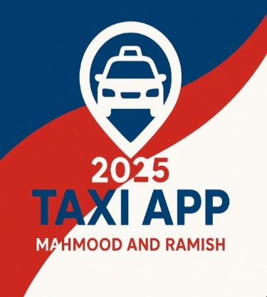

**Kabul University** 

**Information Science & Engineering Department**

Taxi Application Afghanistan Project

Full Proposal Application

Deadline for submission of applications:

**SECTION 1: About The Applicant’s Organization:**

* Organization’s legal name: Taxi Application Afghanistan.
* Private Company (Transport in collaboration with Government.
* Official address: Kabul main office: District 13, Kabul Afghanistan **,**
* Official website: www.kabul.tx.
* Name of the executive director/head of CSO: ENG, Mahmood and Ramish
* Name of the contact person/s: ENG, Ahmad
* Contact telephone: +93778876743 ,+93792421974 ,+94749432797
* Contact email address: [mahmoodhassaniict@gmail.com](mailto:mahmoodhassaniict@gmail.com).
* Estimated project budget (USD): $5,000,000
* Project duration (months): 12 Month.
* Proposed start date of the project (07/06/2025):
* Proposed end date of the project (06/10/2026):

1. **Project Overview:**

* • Multi-platform taxi booking application
* • Rider and Driver apps (Mobile & Desktop)
* • Admin dashboard for control and analytics
* • Real-time ride tracking and s
* ecure payments

1. **Project Description:**

* Team & Salaries: $90,800
* Equipment & Devices: $5,000
* Office & Utilities: $10,800
* Car Testing: $2,000
* Marketing: $20,000
* Legal & Admin: $3,000
* Emergency Buffer: $100,000
* Total Budget: $150,600

### **Methodology:**

The Taxi Application Afghanistan project will follow a structured, step-by-step approach to ensure effective implementation:

**Assessment and Planning:**  
Conduct initial assessments in Kabul and other province to identify system gaps and user needs.

**System Design and Development:**  
Develop digital Taxi App tools (web platforms, mobile apps) based on local needs, ensuring they are user-friendly and secure.

**Training and Capacity Building:**  
Provide targeted training for Taxi App, IT staff, and administrators on how to use and manage the new systems.

**Pilot and Feedback:**  
Launch a pilot phase in selected areas, gather user feedback, and make improvements before full rollout.

**Full Implementation:**  
Deploy the systems across both provinces and ensure they are integrated into existing workflows.

**Monitoring and Evaluation:**  
Continuously monitor progress, collect data, and conduct evaluations to measure impact and make adjustments.

**Sustainability:**  
Prepare for long-term use by handing over the system to local authorities and establishing ongoing support structures.

1. **Monitoring and Evaluation (M&E):**

**Monitoring and Evaluation (M&E)** for Taxi Application **Afghanistan** will track project progress, measure its impact, ensure accountability, and identify areas for improvement. It involves collecting data through regular reporting, surveys, and performance indicators to assess the effectiveness of the project. The results will help guide decision-making and improve the system throughout its implementation.

1. **Sustainability** for **Transport Afghanistan** ensures that the project remains effective and continues after its implementation, focusing on long-term financial, technical, and institutional support.

# Budget Summary

* Team & Salaries: $90,800
* Equipment & Devices: $5,000
* Office & Utilities: $10,800
* Car Testing: $2,000
* Marketing: $20,000
* Legal & Admin: $3,000
* Emergency Buffer: $100,000
* Total Budget: $150,600

1. **ANNEXES**

**Annex A: Detailed Budget Breakdown**

* 1. A detailed, itemized budget showing the costs for each category: Staffing, Infrastructure, IT Equipment, Monitoring & Evaluation, etc.

**Annex B: Project Timeline (Gantt chart)**

* 1. A Gantt chart outlining the key project milestones, timelines, and tasks for **Health Link Afghanistan** from initiation to completion.

**Annex C: Risk Assessment Matrix**

* 1. A table detailing the risks, their likelihood, impact, and corresponding mitigation strategies for the project.

**Annex D: Staffing Plan**

* 1. A detailed list of the project team, including roles, responsibilities, and key personnel involved in **Transport Afghanistan**.

**Annex E: Monitoring and Evaluation Framework**

* 1. Detailed M&E tools, including KPIs, data collection methods, and reporting mechanisms for tracking the project's progress and impact.

**Annex F: Technical Specifications**

* 1. Full technical details on the IT systems, software, and equipment being used in **Transport Afghanistan**.

**Annex G: Letters of Support**

* 1. Letters from government officials, donors, or partners who endorse the **Taxi Application Afghanistan** project.

**Annex H: References**

* 1. A list of all references, research papers, reports, and documents used to support the development of the proposal.

Conclusion

1. • Scalable and robust urban mobility solution
2. • Efficient resource allocation
3. • Ready for launch and expansion
4. • Strong emergency reserve ensures stability

**Prepare by: Ramish and Mahmood**

