IDP PROJECT REPORT
On
“VOICE ACTIVATED HOME AUTOMATION”
Submitted in partial Fulfillment of the requirements for the Degree of
ELECTRONICS AND COMMUNICATION ENGINEERING
Submitted
By
V.Venkata Rami Reddy
211LA05039


INDEX

CONTENTS | PAGE NO

- Abstract | 2
- Introduction | 3-4
- Proposed Work | 5
- Circuit Diagram | 5
3.2 Components Required | 6-12
- Working | 13
- Results | 14
- Advantages | 15
- Disadvantages | 16
- Applications | 17
- Conclusion | 18
- Bibliography | 19

1.ABSTRACT

Wireless technologies are rapidly growing, also becoming very illustrious and extensively being used everywhere and the clients appreciate the convenient and easy lifestyle of being wireless. Nowadays with the engrained Bluetooth technology, various digital devices build a system in which the appliances and the devices are interconnected with each other. The Bluetooth technology could be used as one of the significant communication attributes in automation system. The range of communication is 10 to 100mts depending on the version of Bluetooth technology and operates on freely available 2.4GHz bandwidth spectrum. With this capability of Bluetooth; in this paper, a Bluetooth technology-based home automation system is proposed enabling elderly and physically disabled people to control the home appliances through their voice commands. Implementation of this proposed automation system has proved its efficiency.

2.INTRODUCTION
Introduction

Automation plays a key role in human life. Home automation allows us to control household electrical appliances like light, door, fan, AC etc. It also provides home security and emergency system to be activated. Home automation not only refers to reduce human efforts but also energy efficiency and time saving. The main objective of home automation and security is to help handicapped and old aged people who will enable them to control home appliances and alert them in critical situations.

This project put forwards the implementation of home automation and security system using Arduino microprocessor and Android smartphone. Home appliances are connected to the microprocessor and communication is established between the Arduino and Android mobile device or tablet via Bluetooth module. We would develop an authentication to the system for authorized person to access home appliances. The device with low cost and scalable to less modification to the core is much important. It presents the design and implementation of automation system that can monitor and control home appliances via android phone or tablet

Voice controlled wireless smart home system has been presented for elderly and disabled people. The concept of controlling home appliances using human voice is interesting. The proposed system has two main components, they are

voice recognition system, and wireless system. This system to control home appliances uses a voice controlled android application. By the increasing use of PC (personal computers), internet, mobile phone and wireless technology, it makes it easy for a user to remotely access and control the appliances.

A lot of research has been done and many solutions have been proposed to remotely access the home appliances. Some of them used internet, wireless technology to communicate and control home appliances, others used Bluetooth and GSM technology for controlling the home appliances.

The main aim of our system is to build a perfect companion for someone to be at home. Generally, home automation research targeted many needs like applications that provide the luxury and smart requirements while some threw light on the special needs for elderly and disabled etc. our system is a computer-based system that can accept voice to direct commands and process them. The system provides us switching any device ON/OFF."
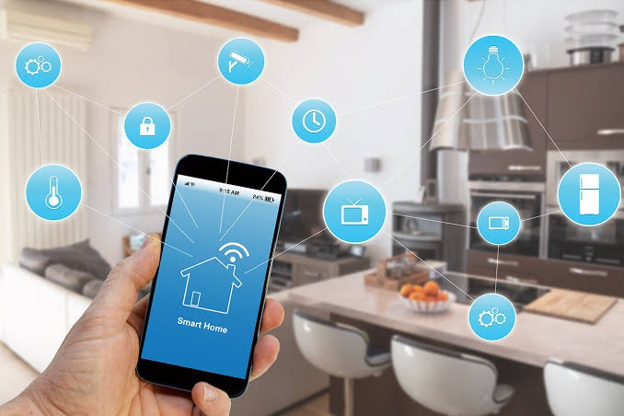

3. PROPOSED WORK

3.1 CIRCUIT DIAGRAM:
This below figure shows the circuit diagram and connections
of the Voice Activated Home Automation.

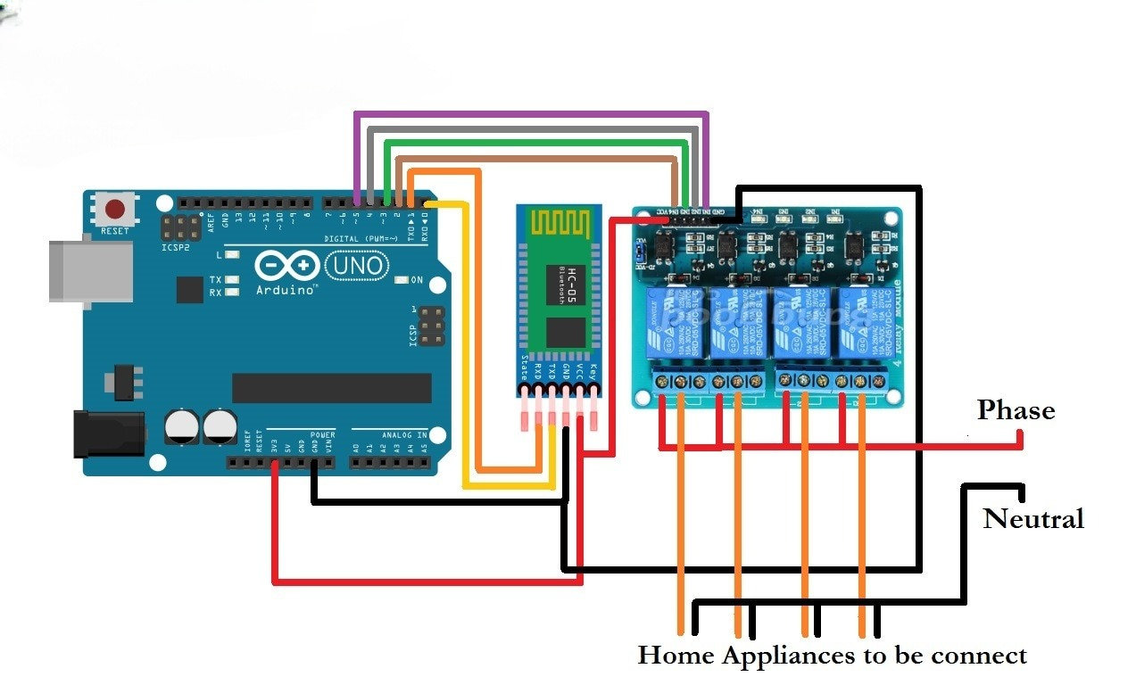
Fig 3.1.1: Circuit Diagram

3.2 COMPONENTS REQUIRED:

- HC – 05 Bluetooth Module – 1
- Arduino UNO
- Smart Phone or Tablet  1
- 1 KΩ Resistor – 4
- Relay Module (4 channel)
- Power Supply
- Breadboard
- Connecting wires
- App for transmitting voice to Bluetooth
- LED

3.2.1 HC-05 BLUETOOTH MODULE: -
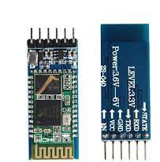
Another important thing to consider is the Bluetooth module (HC-06), which will be the medium for connecting the android phone with the Arduino Uno, we refer it to the slave module. The voltage that is required of Bluetooth module is 3.3, and the major reason for choosing this module is its less voltage consumption, and it is also compatible for the microcontroller to work in a very low voltage.

Fig:3.2.1 Bluetooth Module (HC-05)
Bluetooth Protocol | Bluetooth Specificationv2.0+EDR
Frequency | 2.4GHz ISM band
Modulation | GFSK (Gaussian Frequency Shift Keying)
Emission power | <4dBm, Class 2
Sensitivity | <-84dBm at 0.1% BER
Speed | 2.1 Mbps (Max)/160kbps, Synchronous:1Mbps/1Mbps
Security | Authentication and encryption
Profiles | Bluetooth serial port
Power Supply | +3.3 Vdc 50 mA
Working temperature | -20, +75 centigrade
Dimension | 26.9mm*13mm*2.2mm
Mode | Slave
Baud rate(default) | 9600
Pin code | 1234

Fig: Bluetooth Module Features

3.2.2 ARDUINO UNO: -
Arduino Uno is a circuit board with ATmega328 built in it, the Arduino Uno which we are using consists of 14 digital input/output pins (where the 6 pins can be used as PWM output pins), 6 of them are analogue, there is also USB connecting port, a power jack, and reset button. This microcontroller is very basic and simple for the demonstration purpose. We can power the Board by AC-to-DC adapter or battery and by USB cable through the computer. One of the other best things about this microcontroller is that it has CPU which comprise a significant amount of RAM, ROM and some other components as well. Other than that, we would be required to use the protoboard, which is basically a combination of 41 pins that are used to connect the jumper with each other. And we are considering the android phone for this project where an application will work via Internet and Bluetooth.
Why we are using Arduino Uno?
In the market there are a lot of micro-controllers. To name some of them are: Parallax basic stamp, Net media’s BX-24 etc. There are some others as well but based on their usage and functionality, specifically their features comparatively Arduino Uno is the best microcontroller
which can fulfil our purpose. Following are some of the major functionalities of choosing this microcontroller:
- Inexpensive
- Cross-platform
- Straightforward
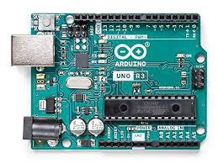
- Open source

Fig:3.2.2 Arduino UNO
Microcontroller | ATmega328
Operating Voltage | 5volts
Recommended input voltage | 7 to 12 volts
Limits of inputs voltage | 6 to 20 volts
Digital I/O Pins | 14(of which 6 provides PWM signal)
Analog Input Pins | 6
DC current per I/O pin | 40mA
DC current for 3.3v pin | 50mA
Flash Memory | 32KB(ATmega328) of which 0.5KB used by bootloader
SRAM | 2KB
EEPROM | 1KB
Clock Speed | 16MHz
Length | 68.6mm
Width | 53.4mm
Weight | 25g

3.2.3 MOBILE PHONE: -
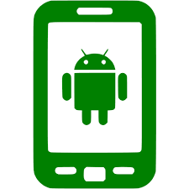

Fig3.2.3 smart phone

3.2.4 RESISTOR: -
The main function of resistors in a circuit is to control the flow of current to other components. Take an LED (light) for example. If too much current flows through an LED it is destroyed. So, a resistor is used to limit the current.
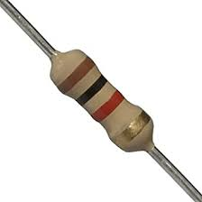

Fig.3.2.4Resistor

3.2.5 RELAY MODULE: -
In order to control the voltage and power of the Arduino Uno, we have fitted it with the Relays module which ultimately controls and prevents the high voltage through its electromagnetic behaviour to detect the current. As this project is all about controlling the home utilities via a mobile application, so the utilities that we are considering are light bulbs and portable fans. So, for our project, this is also one of the important requirements to justify these utilities for the practical demonstration. Along with that, we have also included block-connectors which are resistant to acid and flame.
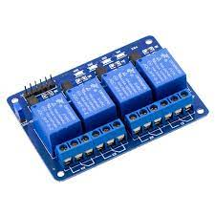

Fig: 3.2.5 4-channel Relay Module

3.2.6 POWER SUPPLY: -
It is used to give supply for mall electrical components.
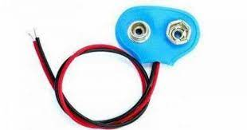
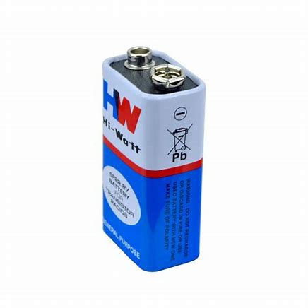
Fig. 3.2.6 9 H-W Battery & Connector

3.2.7 BREAD BOARD: -
A breadboard is a construction base for prototyping of electronics. This makes it easy to use for creating temporary prototypes and experimenting with circuit design
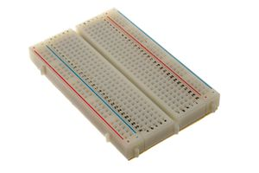

Fig.3.2.7 Bread Board

3.2.8 CONNECTING WIRES: -
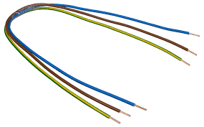
Connecting wires allows an electrical current to travel from one point on a circuit to another, because electricity needs a medium through which to move. In the case of computers, wires are embedded into circuit boards, carrying pulses of electricity that are interpreted as binary signals of zeros and ones.

Fig.3.2.8 Connecting Wires
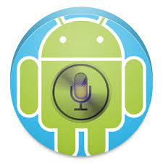
3.2.9 AMR VOICE: -
Fig :3.2.9 AMR Voice app icon
This Application is an important constituent for this project. This app uses your internal Voice recognition in your smartphone to send the data serially to the Bluetooth connected to your Arduino. This application data takes special data forma

3.2.10 LED: -
A light-emitting diode (LED) is a two-lead semiconductor light source. It is a p–n junction diode that emits light when activated.
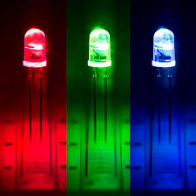
When a suitable current is applied to the leads, electrons are able to recombine with electron holes within the device, releasing energy in the form of photons. This effect is called electroluminescence.

Fig.5 LED

Fig.3.2.10 LED

4.WORKING
In this project, a simple Voice Activated Home Automation system is designed. Voice commands are used to control different appliances. We will now see the working of the project. All the connections are made as per the circuit diagram above. After making the necessary connections, we have to switch on the power supply to the circuit. Now, we need to pair the Phone’s Bluetooth to the HC – 05 Bluetooth Module. Before that, we have to install the App mentioned above in the phone. The home screen of the app looks something like this,
Next step is to connect the phone with the Bluetooth module. For this, choose the option “Connect Robot” and select the appropriate Bluetooth Device. If the devices aren’t paired earlier, we need to pair them now using the Pin of the HC – 05 Bluetooth Module.
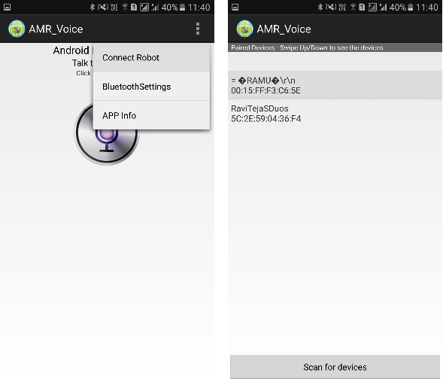
After successful connection, the devices are ready to transmit data. For that, press the press microphone icon on the app and start giving voice commands. When the string “turn on light” is detected by the app, it will send the string as “*turn on light#”. So, the actual message received by the Bluetooth Module is in the format of “*Message#”. The reason for padding the ‘*’ and ‘#’ at the begging and end of the string is to identify the starting and ending of the message.
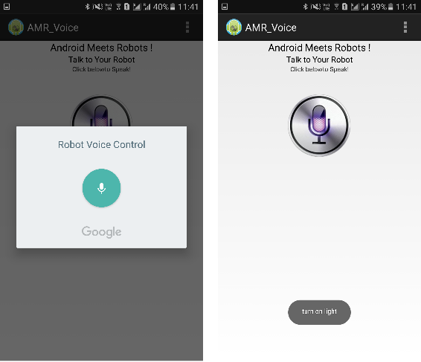
We are able to delete the ‘#’ from the string but left out the ‘*’ in order to identify the starting of the string. The received message is compared with some predefined strings and if the message matches with any of them, then corresponding action like turning on or turning off the load happens. We have used the following commands: “turn on AC”, “turn off AC”, “turn on light”, “turn off light”, “turn on TV off TV”, “turn on fan”, “turn off fan”, “turn on all” and “turn off all”.

5.RESULTS

Below figure shows all the circuit connections of the project “Voice Activated Home Activation”

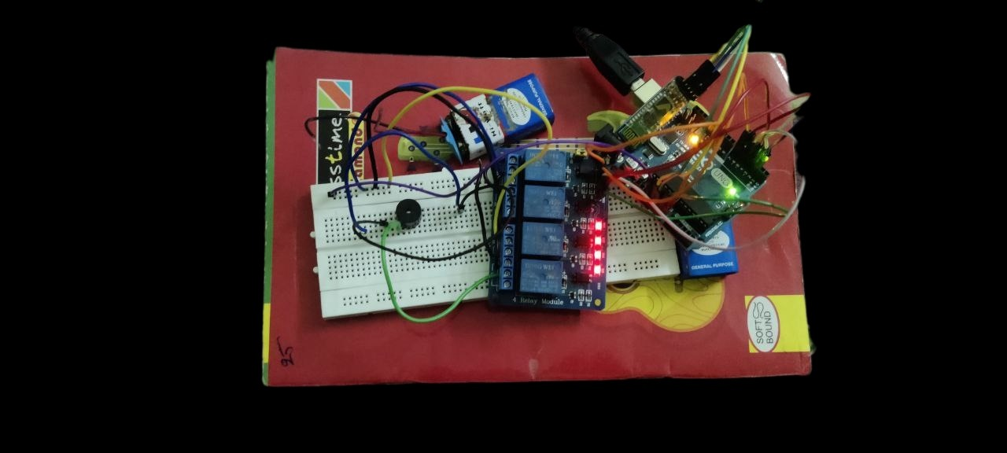
Fig:4.1.1 circuit connections of the project

We will now see the design of the Voice Activated Home Automation circuit. First, we will connect the Bluetooth Module to the Arduino. Since Bluetooth uses UART protocol, we need to use the RX and TX pins of the Arduino. We will be using “Software Serial” library to define our own RX and TX pins (Pin 2 is RX and Pin 3 is TX). Next, we will connect the relays to the Arduino. Since we used a readymade relay board with 4 – channels, all we need to do is to connect the inputs of the individual relays to the Arduino.
NOTE: We did not connect any load to the relay but you can always connect some small loads and check out the functioning. Be extra careful while using AC Mains with relay board.
After successful connection, the devices are ready to transmit data. For that, press the press microphone icon on the app and start giving voice comman

6.ADVANTAGES
- Home Automation is Necessary for patients.
- Better Home security.
- Hands free commands.
- Energy saving.
- Economical design

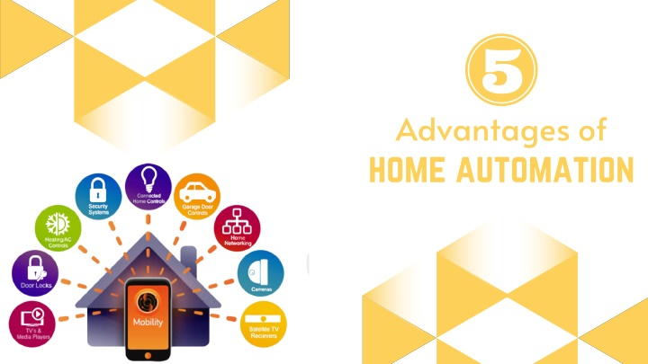

7.DISADVANTAGES

- Upfront costs.
- Power consumption more.
- Security Issues
a) APP security
b) Wireless security
c) Integrated systems.
- It is network based.

8.Applications

- The Voice Activated Home Automation system will help us control different loads (electrical appliances) with simple voice commands.
- This kind of system is very useful for people with disabilities.
- Further, the project can be expanded by adding different sensors (light, smoke, etc.).

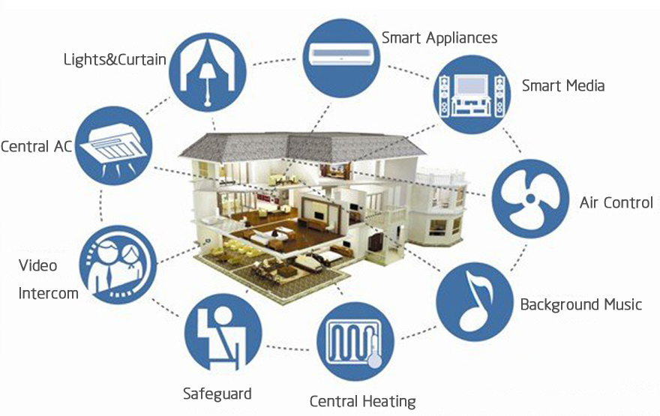
Fig: Applications of Home Automation

.

9.Conclusion

This project helps us to design low-cost home automation using ATmega328p IC the system is easy to use and has good reliability and real time features. These systems provide controlled voice command for home automation The purpose is to control some of the major household devices by voice. It is not only aimed at providing a healthy and comfortable lifestyle to the users, but also at aiding the sick or handicapped and people living alone, so that they can easily handle all their tasks at a convenience. Making the design sleeker and easier to handle, with a method to control
more appliances at a time are the future requirement. We have so far achieved in controlling the same appliance, example, a light bulb, at the same time in two different rooms, and we have been able to control larger loads, for example, an air conditioner. The design of the voice controlled
home automation system, is both portable and ready to be installed in your main household circuit.
Finally, the voice-controlled home automation will be a better communication between the humans and the non-living beings which can work efficiently.

10.Bibliography

- https://www.electronicshub.org/voice-activated-home-automation/
- https://youtu.be/0kWb6hh5VPg
- https://www.researchgate.net/publication/340226739_VOICE_CONTROLLED_HOME_AUTOMATION#:~:text=Voice%20Controlled%20Wireless%20Home%20Automation,their%20phone%20through%20voice%20command

