Terraform and IaC Lab
Azure VNet with Azure Verified Modules and GitHub Actions
Lab Submission and Evidence Report
Item | Detail
Deliverable | End-to-end VNet deployment via AVM, OIDC-authenticated GitHub Actions CI/CD with an approval gate, plus completion evidence
Repository | https://github.com/Ramitha-V/terraform-avm-vnet-lab (public)
Azure subscription | Visual Studio Enterprise Subscription (personal)  893b392b-ea1f-46d7-b1ea-5786b50744c1
Azure tenant | d11c26a0-db1e-4723-9773-6daa7ec34bed
Region | Central India (centralindia)
AVM module | Azure/avm-res-network-virtualnetwork/azurerm pinned to 0.22.2
Terraform | 1.15.9 (pinned in CI and used locally)
Status | Complete — plan, approval, apply, Azure validation and idempotency all verified
Date | 11 September 2026

1. Objective and business scenario
A cloud team must deploy a standard development virtual network into an Azure subscription without storing long-lived Azure credentials in GitHub. The deployment must be reproducible, reviewed before it reaches Azure, and provably stable when re-run.
This submission implements that scenario end to end and captures the evidence required by the lab completion checklist.

1.1 Requirements addressed
# | Requirement | How it was met
1 | VNet with two non-overlapping subnets | AVM VNet module creates vnet-avm-dev (10.20.0.0/16) with snet-app-dev (10.20.1.0/24) and snet-data-dev (10.20.2.0/24)
2 | Use an Azure Verified Module, version pinned | Azure/avm-res-network-virtualnetwork/azurerm version = "0.22.2"
3 | Remote Terraform state | Azure Storage backend rg-tfstate-dev / sttfstatelabfb1lz8 / container tfstate, key network/dev.tfstate
4 | No long-lived Azure credentials | OIDC workload identity federation; the repository holds zero secrets — only non-sensitive environment variables
5 | Pre-deployment guardrails | terraform fmt -check, init, validate, TFLint (+ azurerm ruleset), Trivy IaC scan — all before plan
6 | Saved plan artifact | terraform plan -out=tfplan uploaded as artifact tfplan-dev; apply consumes that exact file
7 | Human approval before apply | GitHub environment dev-apply with a required reviewer; the apply job waits until approved
8 | Idempotency | Re-run after apply reports *No changes. Your infrastructure matches the configuration.*
9 | Documentation | Repository README.md plus this report, including a troubleshooting matrix

2. Solution architecture
The solution is split into three planes: a bootstrap plane created once with the Azure CLI, a delivery plane in GitHub Actions, and the target plane in Azure that Terraform manages.
Developer ──push──▶ feature branch ──PR──▶ GitHub
│
┌───────────────────┴───────────────────┐
▼ ▼
job: plan (env: dev-plan) job: apply (env: dev-apply)
OIDC ▸ Entra app *-plan OIDC ▸ Entra app *-apply
RBAC: Reader (subscription) RBAC: Contributor (subscription)
+ Storage Blob Data Contributor + Storage Blob Data Contributor
│ ▲
fmt ▸ init ▸ validate ▸ TFLint ▸ Trivy ▸ plan │
│ REQUIRED APPROVAL
└──── artifact: tfplan-dev ─────────────┘
│
▼
Azure: rg-avm-vnet-dev
AVM module 0.22.2 ▸ vnet-avm-dev
├─ snet-app-dev 10.20.1.0/24
└─ snet-data-dev 10.20.2.0/24

Terraform state ▸ rg-tfstate-dev / sttfstatelabfb1lz8 / tfstate / network/dev.tfstate
Figure 1 — Pipeline and resource topology.

2.1 Resources deployed
Resource | Name | Detail
Resource group | rg-avm-vnet-dev | centralindia; tags environment=dev, managed_by=terraform, workload=avm-lab
Virtual network | vnet-avm-dev | Address space 10.20.0.0/16, created by the AVM module
Subnet (app tier) | snet-app-dev | 10.20.1.0/24
Subnet (data tier) | snet-data-dev | 10.20.2.0/24
State resource group | rg-tfstate-dev | Bootstrap only — never managed by this Terraform configuration
State storage account | sttfstatelabfb1lz8 | Standard_LRS, StorageV2, HTTPS-only, min TLS 1.2, public blob access disabled

Terraform reported 8 resources to add on the first plan — the resource group, the virtual network, the two subnets, and the module's supporting telemetry/identity resources.

3. Azure bootstrap (one-time, outside Terraform)
The state backend must exist before Terraform runs, so it is created imperatively and kept out of the Terraform configuration to avoid a chicken-and-egg dependency.
az group create -n rg-tfstate-dev -l centralindia

az storage account create -g rg-tfstate-dev -n sttfstatelabfb1lz8 \
-l centralindia --sku Standard_LRS --kind StorageV2 \
--min-tls-version TLS1_2 --allow-blob-public-access false

# data-plane RBAC for the signed-in user, then the state container
az role assignment create --assignee <user-object-id> \
--role "Storage Blob Data Contributor" --scope <storage-account-id>

az storage container create -n tfstate \
--account-name sttfstatelabfb1lz8 --auth-mode login
Listing 1 — Backend bootstrap.
Azure AD (Entra) data-plane authorisation is used throughout; storage account keys are never issued, stored, or referenced.

4. Identity and security model
Authentication uses OpenID Connect workload identity federation. GitHub mints a short-lived OIDC token for the job, Entra ID exchanges it for an Azure access token, and no client secret ever exists. Two separate identities enforce least privilege so that a plan can never mutate infrastructure.
Purpose | Entra application | Application (client) ID | Azure RBAC
Plan / read-only | gh-tf-avm-vnet-lab-plan | fc870e14-1477-4c6a-b1cf-d22c7ece7622 | Reader on the subscription + Storage Blob Data Contributor on the state storage account
Apply / write | gh-tf-avm-vnet-lab-apply | a783eac7-ea6c-4b68-8140-3972677e7349 | Contributor on the subscription + Storage Blob Data Contributor on the state storage account

The plan identity needs blob write access because Terraform takes and releases a state lock even during a read-only plan.

4.1 Federated credential subjects
Each application carries federated credentials scoped to this repository and to a single GitHub environment, so a workflow running in dev-plan cannot borrow the apply identity.
issuer : https://token.actions.githubusercontent.com
audience : api://AzureADTokenExchange
subject : repo:Ramitha-V/terraform-avm-vnet-lab:environment:dev-plan
subject : repo:Ramitha-V/terraform-avm-vnet-lab:environment:dev-apply

# GitHub now also issues ID-decorated subjects; both forms are registered:
subject : repo:Ramitha-V@162662008/terraform-avm-vnet-lab@1365348212:environment:dev-plan
subject : repo:Ramitha-V@162662008/terraform-avm-vnet-lab@1365348212:environment:dev-apply
Listing 2 — Federated identity credential subjects (see issue 2 in section 10).

4.2 GitHub environment configuration
Environment | Identity used | Protection | Variables
dev-plan | plan app (Reader) | None — runs automatically on every pull request | AZURE_CLIENT_ID, AZURE_TENANT_ID, AZURE_SUBSCRIPTION_ID, TF_STATE_RESOURCE_GROUP, TF_STATE_STORAGE_ACCOUNT, TF_STATE_CONTAINER, TF_STATE_KEY
dev-apply | apply app (Contributor) | Required reviewer — the job blocks until a human approves | Same seven variables, with the apply application's AZURE_CLIENT_ID

There are no GitHub Actions secrets in this repository. Every value is a non-sensitive environment variable; the only credential is the ephemeral OIDC token minted per job.
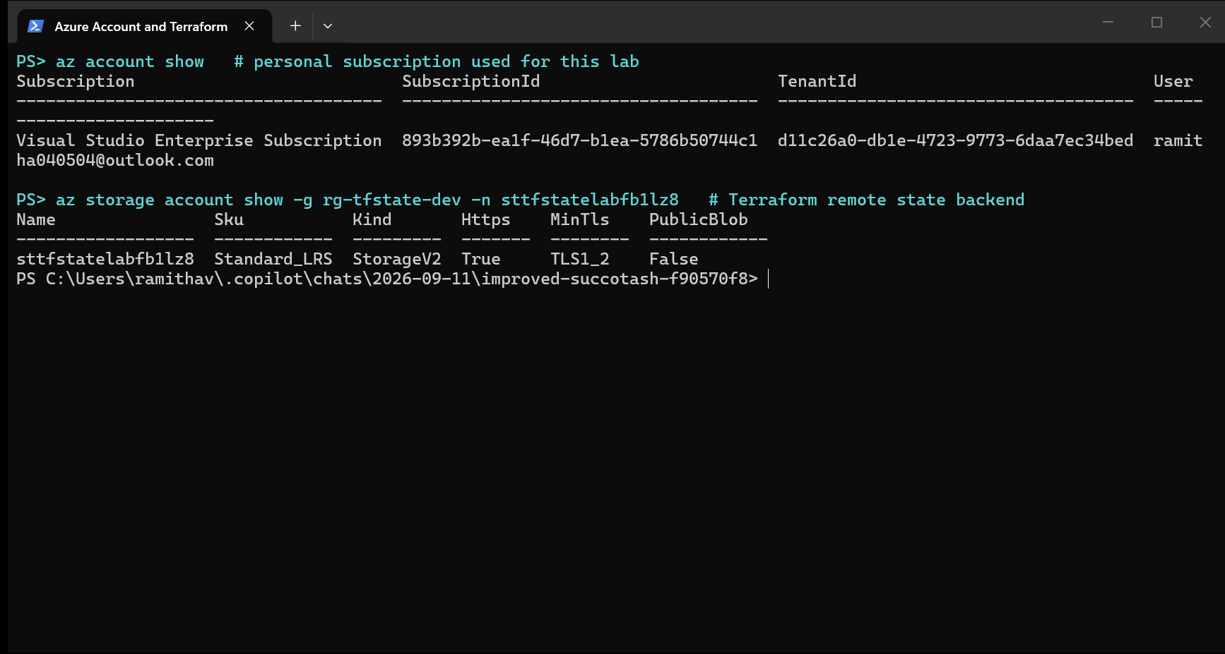
Figure 2 — Personal Azure subscription in use and the hardened Terraform state storage account.
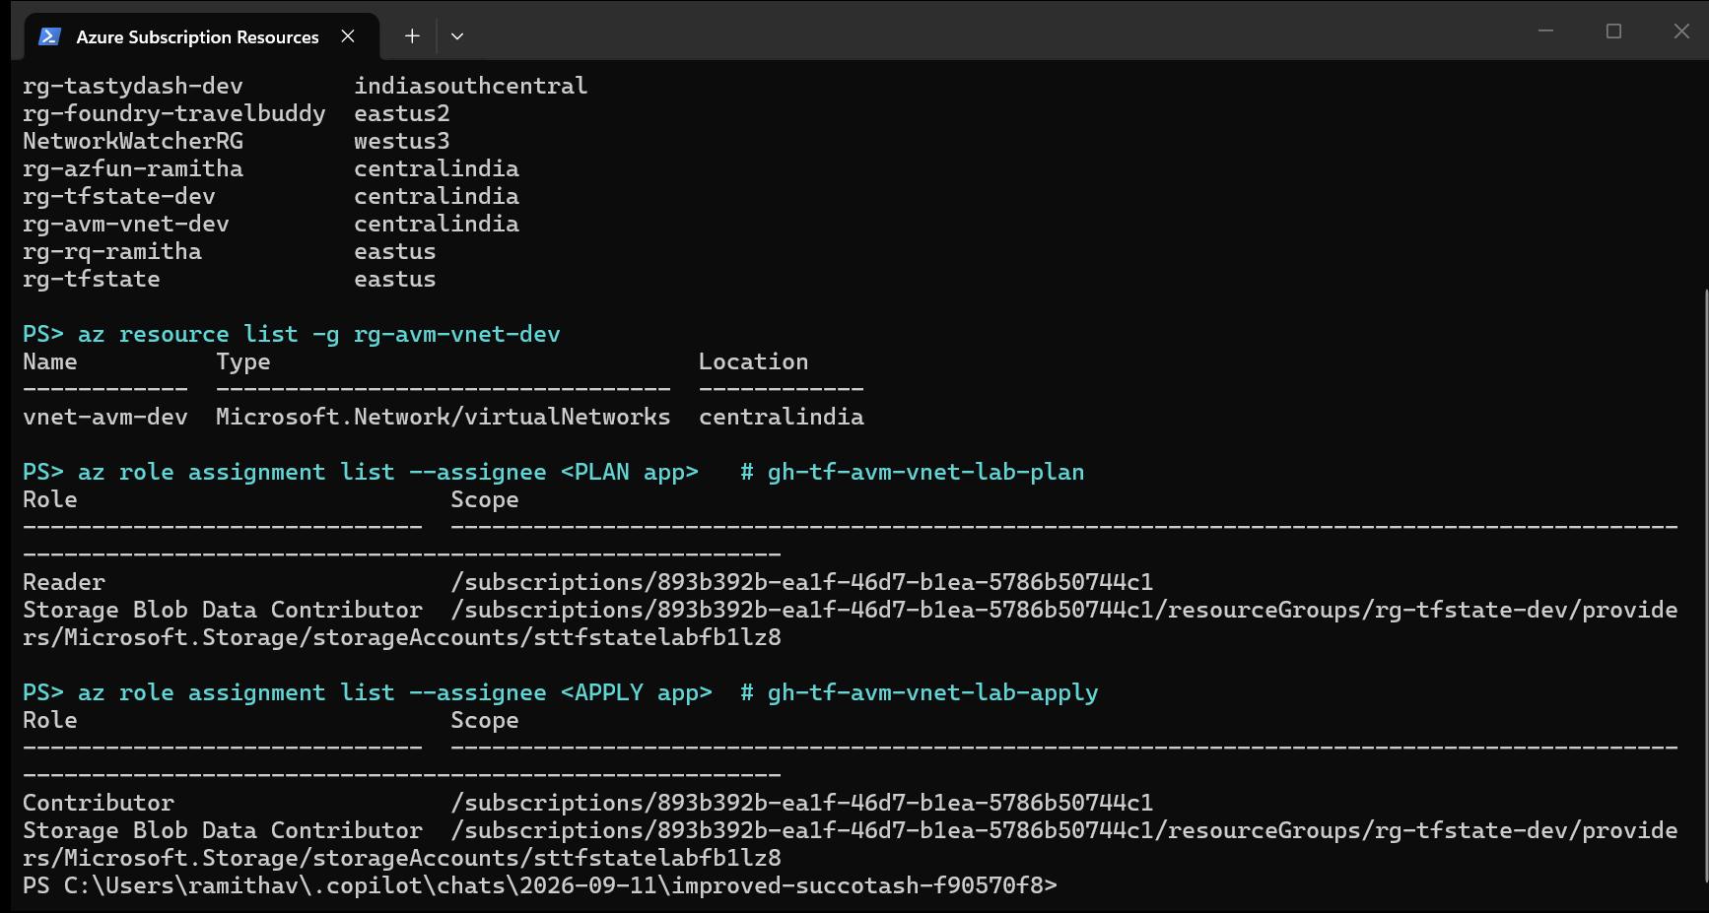
Figure 3 — Deployed resource inventory and least-privilege RBAC: Reader for the plan identity, Contributor for the apply identity.

5. Repository structure
terraform-avm-vnet-lab/
├── .github/
│ └── workflows/
│ └── terraform-dev.yml plan + apply pipeline
├── infra/
│ └── dev/
│ ├── backend.tf partial azurerm backend
│ ├── providers.tf Terraform + provider constraints
│ ├── main.tf resource group + AVM VNet module
│ ├── variables.tf typed, validated inputs
│ ├── outputs.tf deployment outputs
│ ├── terraform.tfvars.example
│ └── .tflint.hcl TFLint + azurerm ruleset config
├── .gitignore excludes state, plans, .terraform/, *.tfvars
└── README.md lab documentation and troubleshooting
Listing 3 — Repository layout.
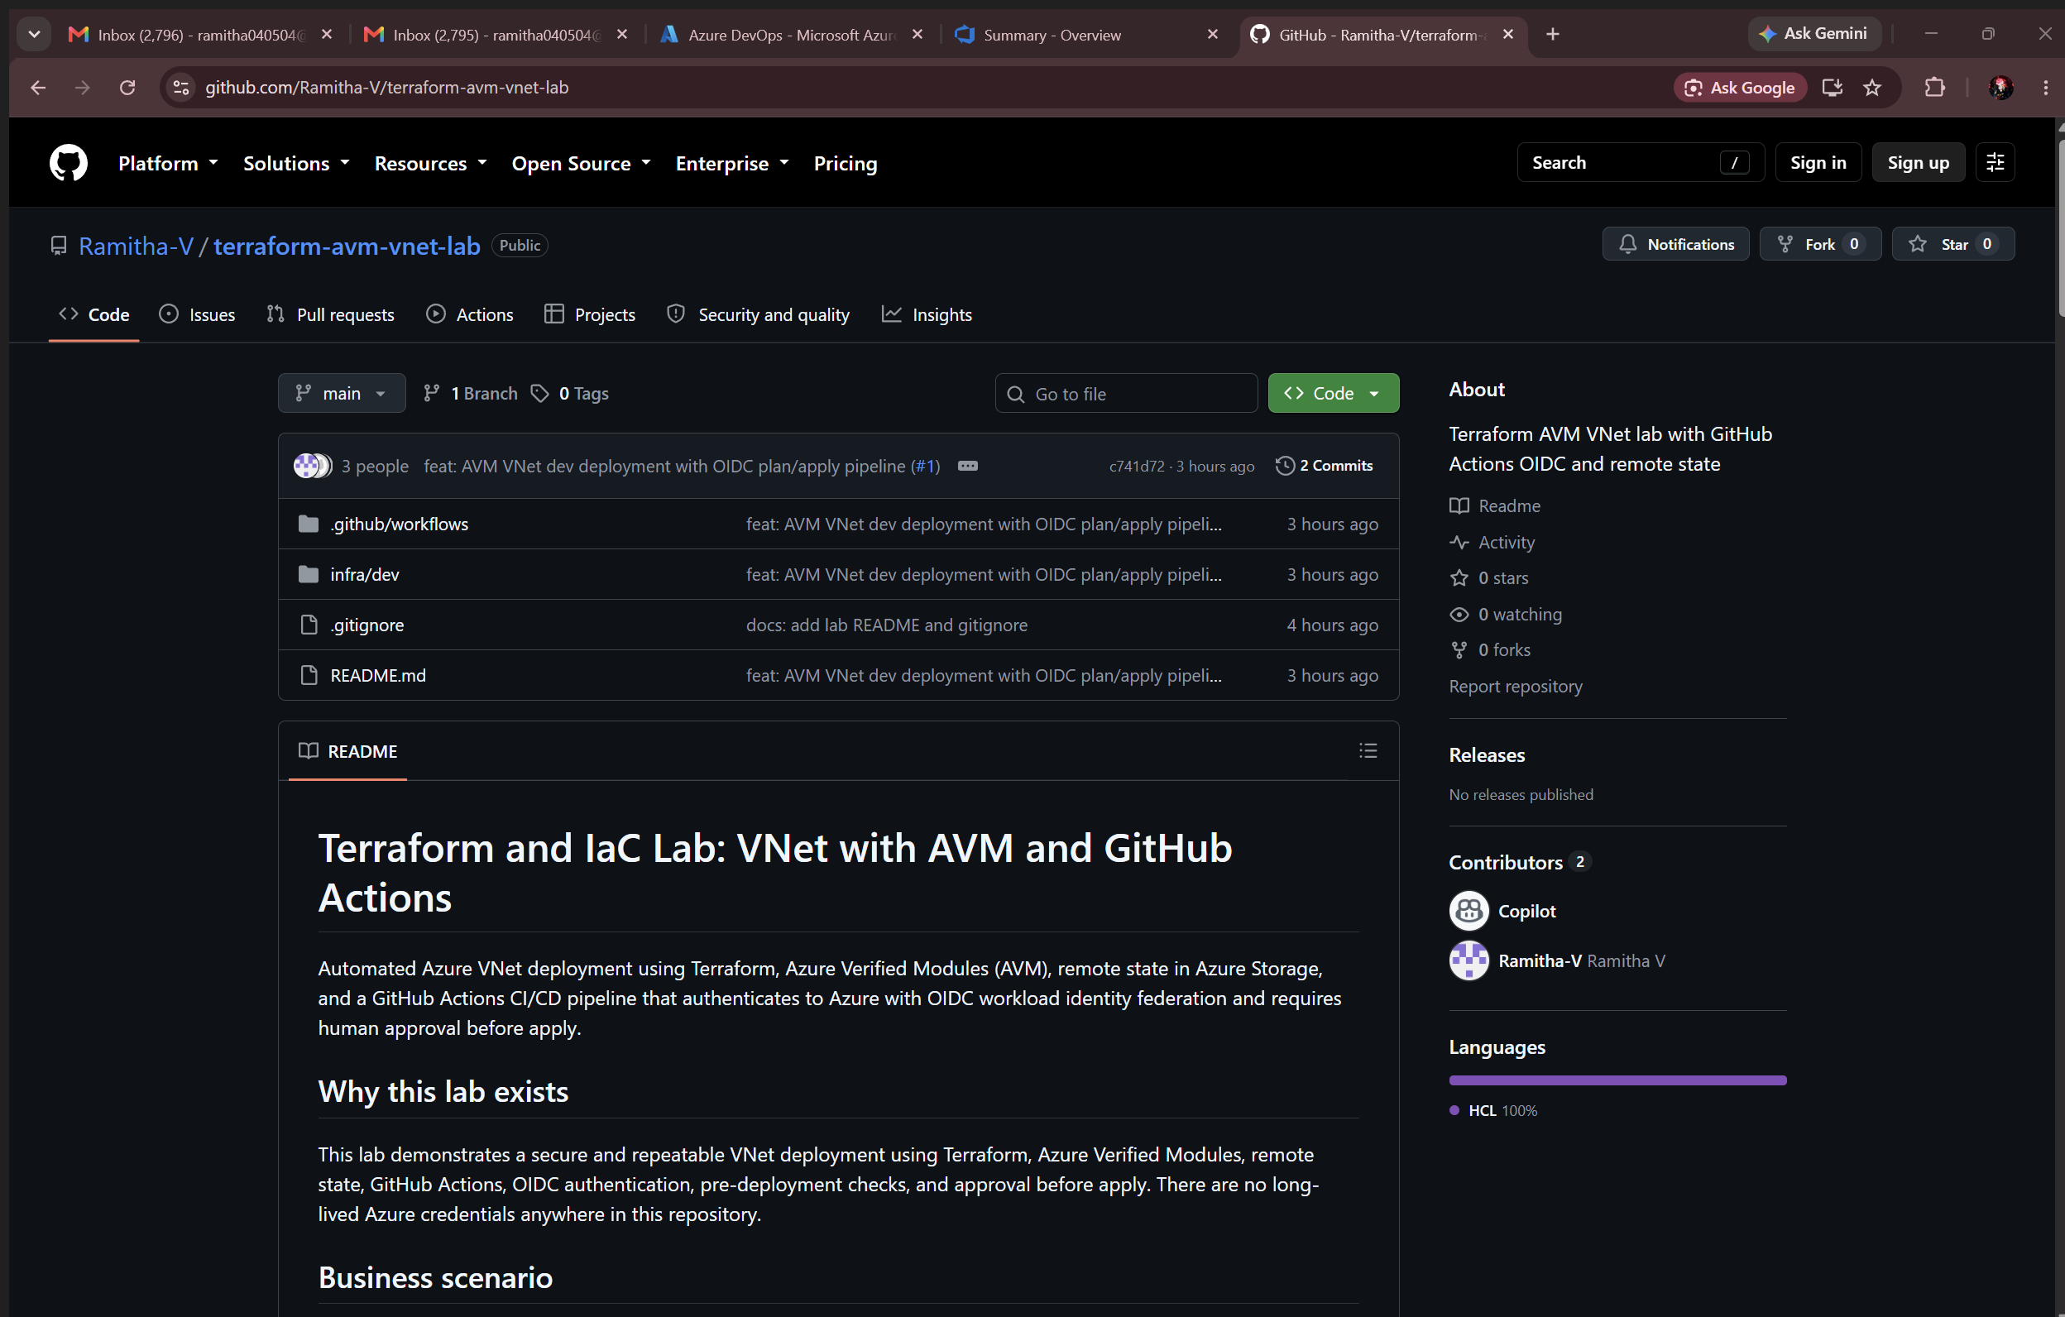
Figure 4 — Public repository with the committed structure and README.

5.1 Root module — main.tf
resource "azurerm_resource_group" "network" {
name = var.resource_group_name
location = var.location

tags = {
environment = "dev"
managed_by = "terraform"
workload = "avm-lab"
}
}

module "vnet" {
source = "Azure/avm-res-network-virtualnetwork/azurerm"
version = "0.22.2"

name = var.vnet_name
location = azurerm_resource_group.network.location
parent_id = azurerm_resource_group.network.id
address_space = var.address_space

subnets = {
app = { name = "snet-app-dev", address_prefixes = ["10.20.1.0/24"] }
data = { name = "snet-data-dev", address_prefixes = ["10.20.2.0/24"] }
}

tags = azurerm_resource_group.network.tags
}
Listing 4 — infra/dev/main.tf. Note parent_id, not resource_group_name (see issue 1 in section 10).

5.2 Backend and providers
# backend.tf — deliberately partial; values are supplied by the pipeline
terraform {
backend "azurerm" {}
}

# providers.tf
terraform {
required_version = ">= 1.9, < 2.0"
required_providers {
azurerm = { source = "hashicorp/azurerm", version = "~> 4.0" }
}
}

provider "azurerm" {
features {}
storage_use_azuread = true
subscription_id = var.subscription_id
}
Listing 5 — Partial backend keeps environment-specific state coordinates out of Git.

6. Pipeline design
A single workflow, Terraform AVM VNet - Dev, contains two jobs. It triggers on pull requests that touch infra/** or the workflow itself, and on manual dispatch.
Job | Environment | Gate | Responsibility
plan | dev-plan | None | Guardrails and a saved plan; read-only in Azure
apply | dev-apply | needs: plan + if: github.ref == 'refs/heads/main' + required reviewer | Applies the exact approved plan artifact

6.1 Guardrail sequence in the plan job
- terraform fmt -check -recursive — fails on any unformatted file.
- terraform init -reconfigure with six -backend-config values, including use_azuread_auth=true and use_oidc=true.
- terraform validate — configuration and module input correctness.
- TFLint v0.64.0 with the Terraform recommended preset and the azurerm ruleset 0.32.0.
- Trivy IaC configuration scan at HIGH,CRITICAL with --exit-code 1, vendored modules excluded.
- terraform plan -out=tfplan, the human-readable plan written to the job summary, and tfplan uploaded as artifact tfplan-dev with if-no-files-found: error.
Only after every one of those steps succeeds does an artifact exist for the apply job to consume, so a failed guardrail makes deployment structurally impossible.

6.2 Workflow authentication block
permissions:
contents: read
id-token: write # required for GitHub to mint the OIDC token

concurrency:
group: terraform-vnet-dev
cancel-in-progress: false # never cancel a run that may hold the state lock

jobs:
plan:
environment: dev-plan
env:
ARM_USE_OIDC: "true"
ARM_CLIENT_ID: ${{ vars.AZURE_CLIENT_ID }}
ARM_TENANT_ID: ${{ vars.AZURE_TENANT_ID }}
ARM_SUBSCRIPTION_ID: ${{ vars.AZURE_SUBSCRIPTION_ID }}
Listing 6 — The ARM_* variables must be job-level so that vars.* resolves against the job's environment (see issue 3 in section 10).

6.3 Approval-gated apply
apply:
if: github.ref == 'refs/heads/main'
needs: plan
environment: dev-apply # required reviewer blocks the job here
steps:
- uses: actions/download-artifact@v4
with: { name: tfplan-dev, path: infra/dev }

- run: terraform -chdir=infra/dev apply -auto-approve tfplan
Listing 7 — Apply replays the reviewed plan file; it never re-plans, so what was approved is what is deployed.

7. Execution evidence
The work was delivered through a pull request, merged to main under branch protection, and then applied through the approval gate.

7.1 Pull request and branch protection
Pull request #1 carried the root module and the workflow. main is protected: direct pushes are rejected and the Terraform Plan status check is required before merge. The pull request was squash-merged as commit c741d72.
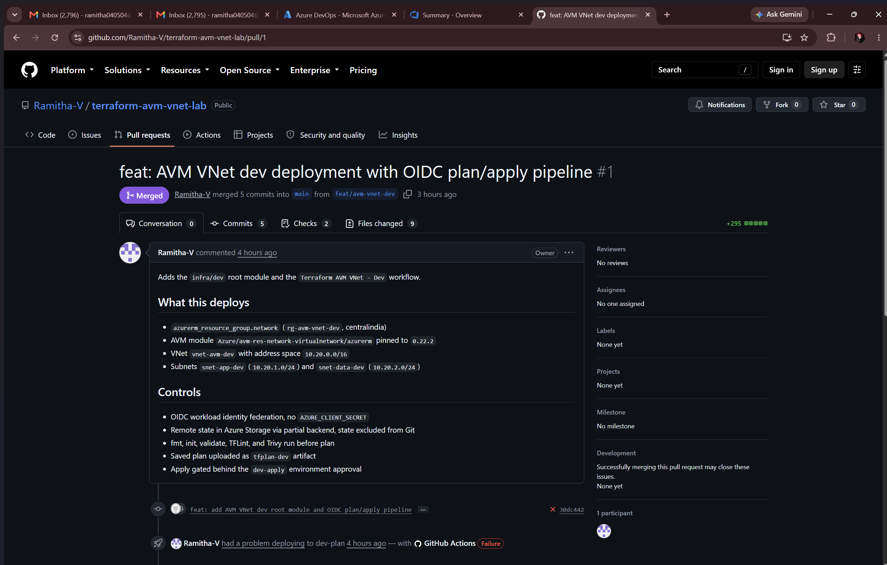
Figure 5 — Pull request #1, merged after the required Terraform Plan check passed.

7.2 Workflow run history
Seven runs were produced. Runs #1 to #4 are genuine CI failures that were diagnosed and fixed — they are retained deliberately as evidence that the guardrails do block bad runs. Section 10 documents each root cause. Run #5 is the fully green plan that unblocked the merge, run #6 is the approved apply, and run #7 is the idempotency re-run.
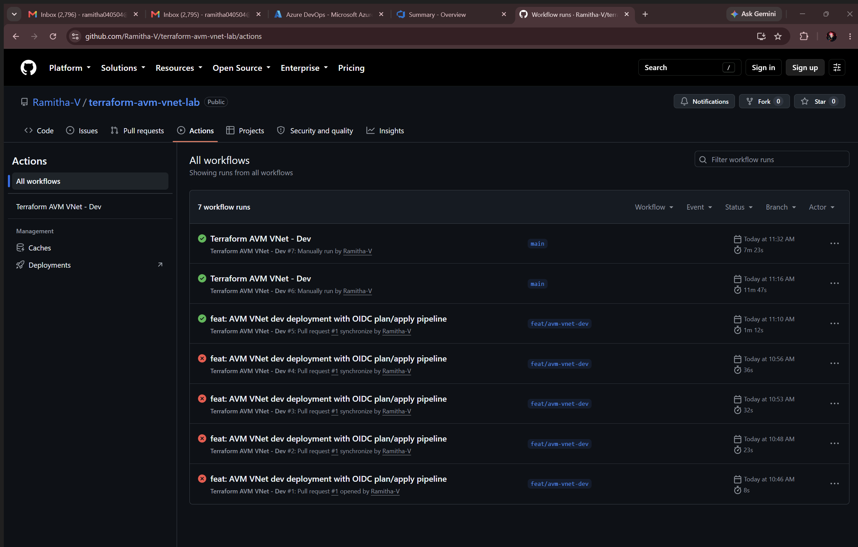
Figure 6 — All workflow runs, including the four blocked runs and the three successful ones.

7.3 Approval gate
After the merge, the workflow was dispatched on main. The plan job completed and uploaded the artifact; the apply job then entered a waiting state and would not start until an authorised reviewer approved the dev-apply deployment.
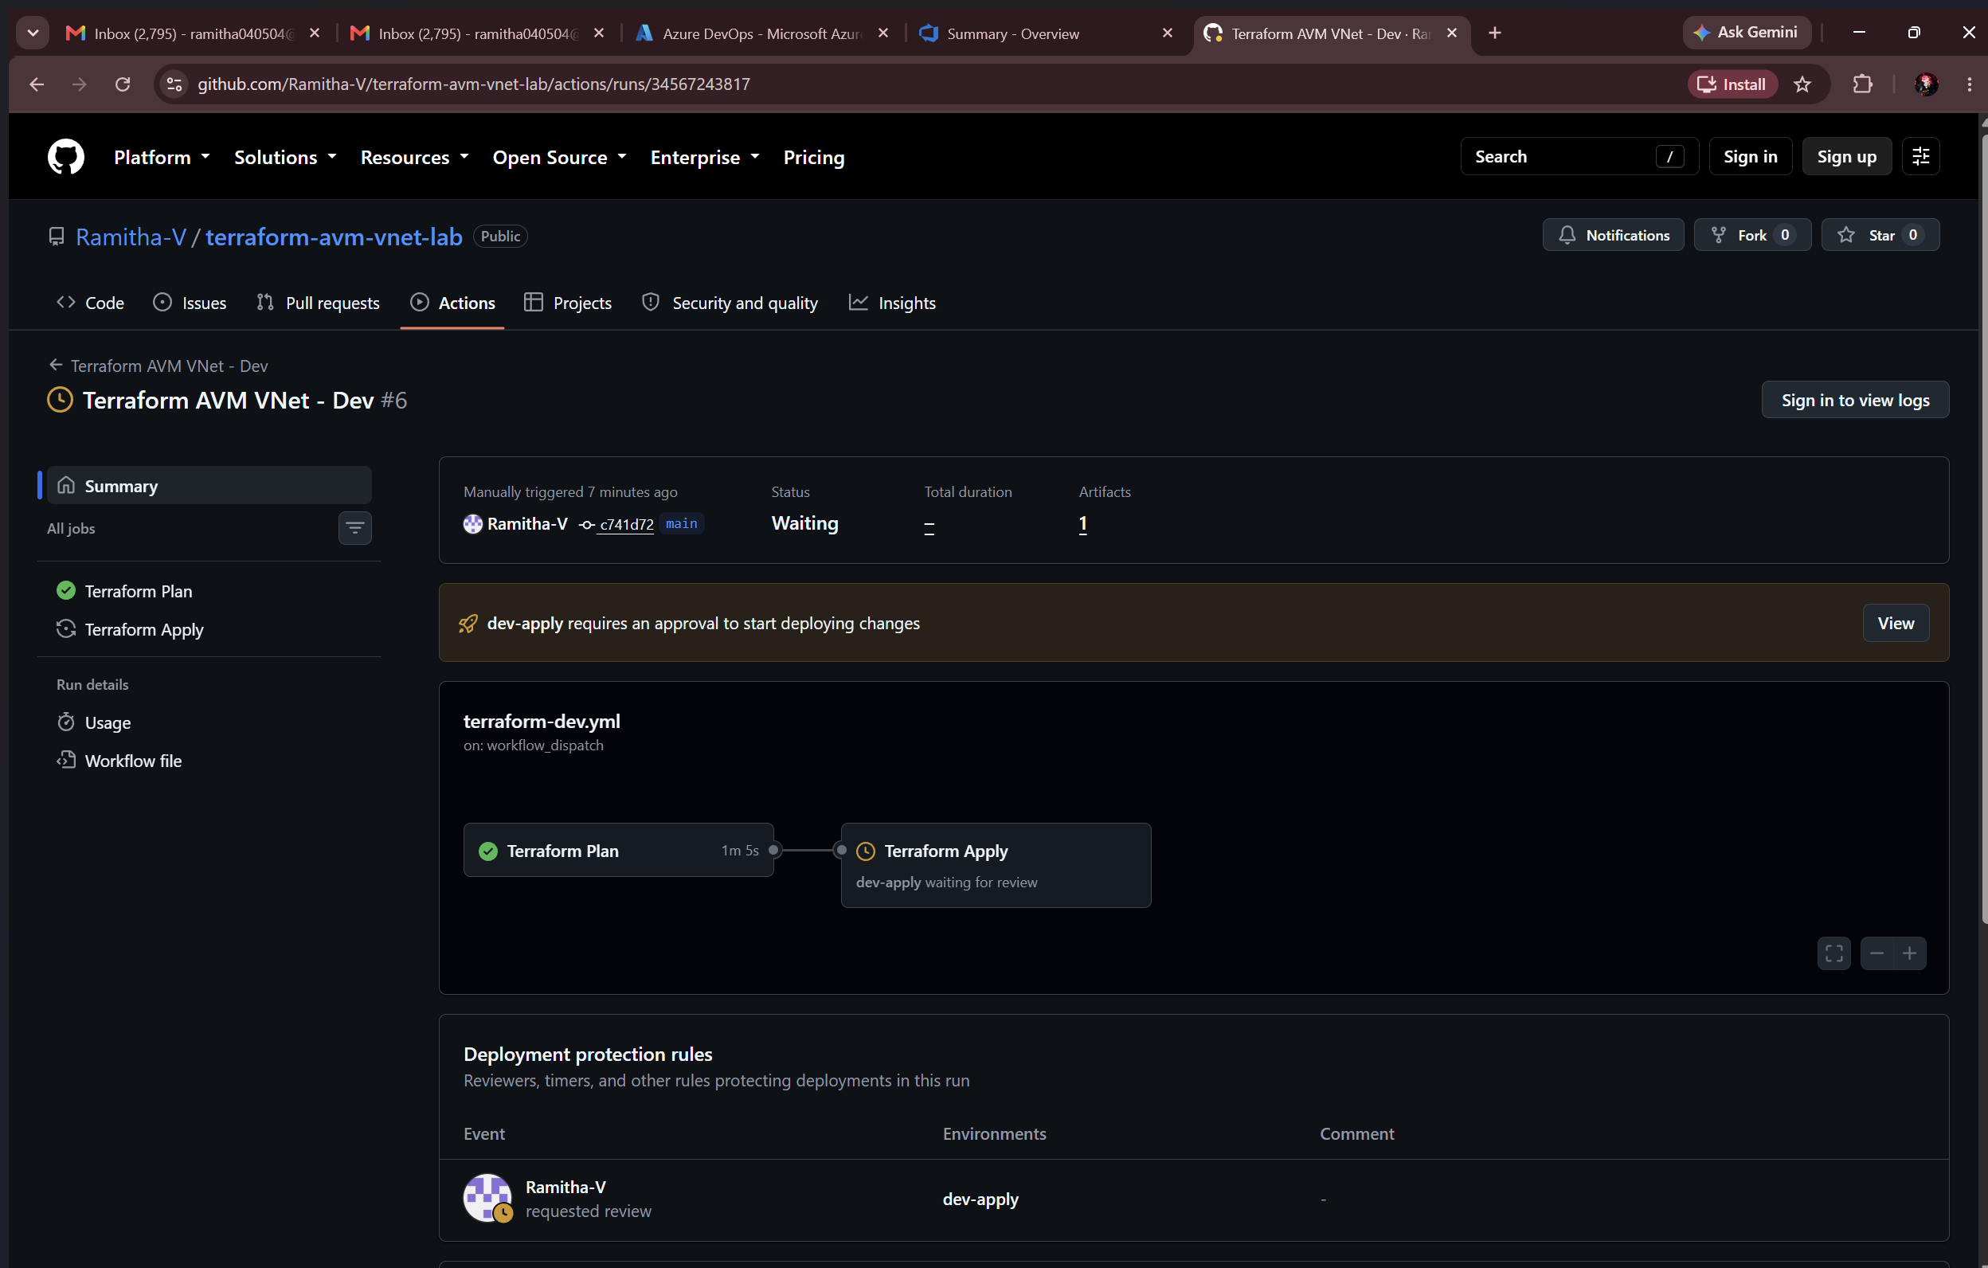
Figure 7 — Run #6 waiting: "dev-apply requires an approval to start deploying changes". Plan succeeded, one artifact produced, apply held.

7.4 Approved apply
The deployment was approved with a recorded review comment. GitHub stores the reviewer decision against the environment, which satisfies the approval evidence requirement. Both jobs then completed successfully in 11 minutes 47 seconds.
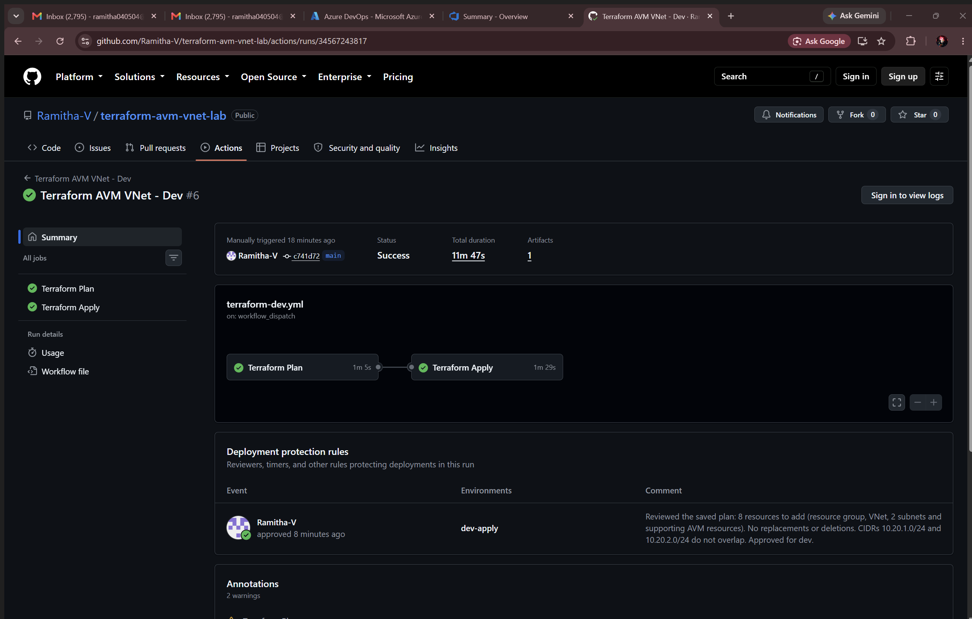
Figure 8 — Run #6 succeeded, with the deployment protection rule showing the recorded approval.

8. Azure validation
The deployed topology was verified directly against the subscription with the Azure CLI, independently of Terraform.
az network vnet show -g rg-avm-vnet-dev -n vnet-avm-dev
az network vnet subnet list -g rg-avm-vnet-dev --vnet-name vnet-avm-dev -o table
az storage blob list --container-name tfstate --account-name sttfstatelabfb1lz8 \
--auth-mode login -o table
Listing 8 — Validation commands.
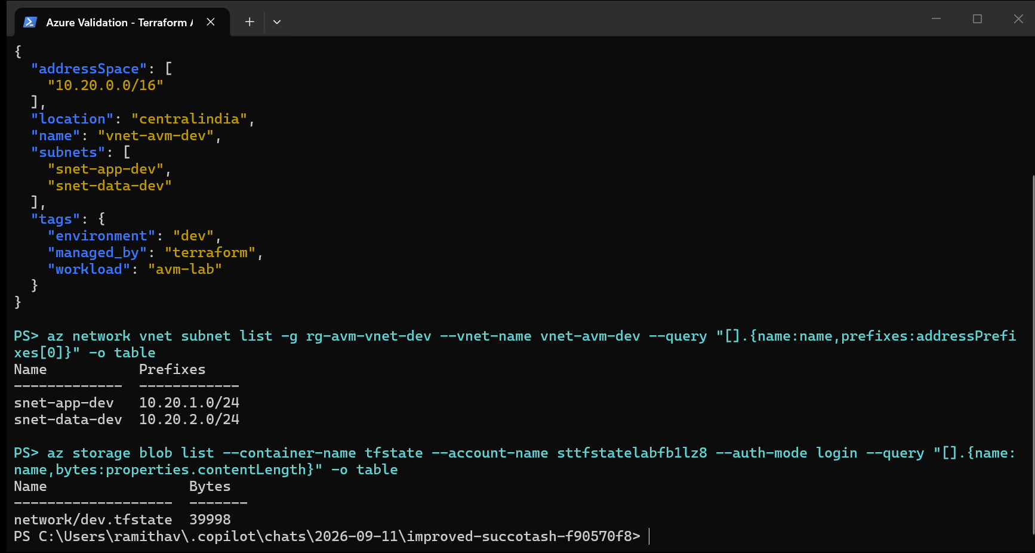
Figure 9 — VNet 10.20.0.0/16 with both subnets and the expected tags, and the remote state blob network/dev.tfstate in Azure Storage.
Check | Expected | Observed | Result
Virtual network exists | vnet-avm-dev in rg-avm-vnet-dev | Present, centralindia | Pass
Address space | 10.20.0.0/16 | 10.20.0.0/16 | Pass
Subnet 1 | snet-app-dev 10.20.1.0/24 | Matches | Pass
Subnet 2 | snet-data-dev 10.20.2.0/24 | Matches, non-overlapping | Pass
Tags | environment, managed_by, workload | All three present | Pass
Remote state | network/dev.tfstate in container tfstate | Present, 39,998 bytes | Pass
State in Git | No state file committed | .gitignore excludes *.tfstate*; repository clean | Pass

9. Idempotency proof
Run #7 re-executed the same pipeline against the unchanged configuration. Terraform read the remote state, refreshed against Azure, and reported:
No changes. Your infrastructure matches the configuration.

Terraform has compared your real infrastructure against your configuration and
found no differences, so no changes are needed.
Listing 9 — Plan output from run #7.
This confirms that the configuration is convergent: repeated execution produces no drift and no unintended mutation.
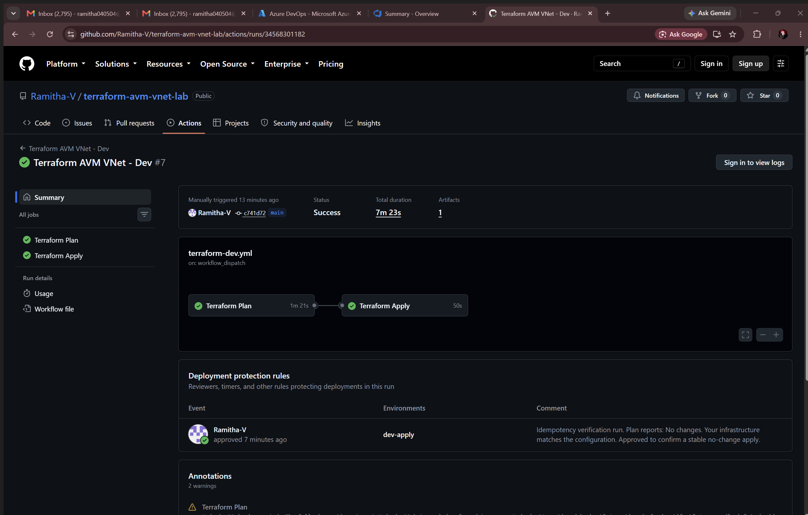
Figure 10 — Run #7 succeeded with a no-change plan, approved and applied for completeness.

10. Issues encountered and resolutions
Five substantive failures occurred during delivery. Each is recorded with its symptom, root cause, and the fix that is now in the repository.
# | Symptom | Root cause | Resolution
1 | terraform init rejected the module: unsupported argument resource_group_name | AVM VNet 0.22.2 is an azapi-based module. It takes parent_id — the full resource-group resource ID, regex-validated — not a resource group name. | Changed the module block to parent_id = azurerm_resource_group.network.id.
2 | AADSTS700213: No matching federated identity record found | GitHub now issues ID-decorated OIDC subjects, e.g. repo:Ramitha-V@162662008/terraform-avm-vnet-lab@1365348212:environment:dev-plan, instead of the classic repo:owner/repo:environment:name. | Registered the observed decorated subjects as additional federated credentials alongside the classic ones. Both forms now validate.
3 | Authenticating using the Azure CLI is only supported as a User (not a Service Principal) | azure/login@v2 authenticates the CLI, but the AzureRM provider and the state backend do their own auth and will not inherit a service-principal CLI session. | Added job-level ARM_USE_OIDC, ARM_CLIENT_ID, ARM_TENANT_ID, ARM_SUBSCRIPTION_ID and -backend-config="use_oidc=true". The env block must be job-level so vars.* resolves against the job environment.
4 | terraform validate failed inside the module: "argument must not be null" | Terraform 1.10.5 eagerly evaluates the module's ipam_pools validation expression instead of short-circuiting on the null check — a toolchain bug, not a configuration error. | Pinned CI and local development to Terraform 1.15.9, which evaluates the expression correctly. The pin is documented in the README.
5 | The Trivy installer action exited 1 roughly 125 ms after reporting "found version: 0.65.0" | Installer-action flakiness, not a security finding — no scan had run at the point of failure. | Replaced the action with a pinned container: docker run --rm -v "$GITHUB_WORKSPACE:/src:ro" aquasec/trivy:0.65.0 config /src/infra/dev --severity HIGH,CRITICAL --exit-code 1, skipping .terraform so vendored modules are not scanned.

10.1 Version-pinning note
Three of the five failures were version or tag problems. Every external dependency is now pinned explicitly: the AVM module at 0.22.2, Terraform at 1.15.9, TFLint at v0.64.0, the TFLint azurerm ruleset at 0.32.0, and Trivy at container tag 0.65.0. Marketplace action tags for Trivy require a leading v (v0.28.0), which is a common transcription error.

11. Completion checklist
Mapped directly to the lab's completion-evidence table.
Completion evidence | Expected result | Outcome | Evidence
GitHub plan job | All checks pass and the tfplan artifact is created | fmt, init, validate, TFLint and Trivy all passed; artifact tfplan-dev produced | Figures 5, 6, 7
Approval | dev-apply records an authorised reviewer decision | Run #6 held at the gate, then approved with a recorded review comment | Figures 7, 8
GitHub apply job | The saved plan applies successfully | Run #6 succeeded in 11 m 47 s applying the downloaded tfplan | Figure 8
Azure validation | VNet and both subnets exist in the intended subscription and resource group | vnet-avm-dev with snet-app-dev and snet-data-dev in rg-avm-vnet-dev | Figures 3, 9
Idempotency | A subsequent plan shows no unexpected changes | Run #7: *No changes. Your infrastructure matches the configuration.* | Figure 10
Documentation | README and troubleshooting guidance are complete and usable | Repository README.md plus this report and the section 10 issue matrix | Figure 4

12. Cleanup and teardown
The environment is intentionally left running so the deployment can be inspected during assessment. When teardown is required, remove resources in this order:
# 1. destroy the managed infrastructure through Terraform
terraform -chdir=infra/dev destroy \
-var="subscription_id=893b392b-ea1f-46d7-b1ea-5786b50744c1"

# 2. remove the bootstrap state backend
az group delete -n rg-tfstate-dev --yes --no-wait

# 3. remove the federated identities and their role assignments
az ad app delete --id fc870e14-1477-4c6a-b1cf-d22c7ece7622
az ad app delete --id a783eac7-ea6c-4b68-8140-3972677e7349
Listing 10 — Teardown order. Destroy the workload before deleting the state account, otherwise state is lost and resources are orphaned.

13. References
- Azure Verified Modules portal — https://azure.github.io/Azure-Verified-Modules/
- AVM Terraform lab sample — https://learn.microsoft.com/en-us/samples/azure-samples/avm-terraform-labs/avm-terraform-labs/
- GitHub Actions OIDC Terraform sample — https://learn.microsoft.com/en-us/samples/azure-samples/github-terraform-oidc-ci-cd/github-terraform-oidc-ci-cd/
- AVM VNet module, Terraform Registry — https://registry.terraform.io/modules/Azure/avm-res-network-virtualnetwork/azurerm/latest
- AVM VNet module source — https://github.com/Azure/terraform-azurerm-avm-res-network-virtualnetwork
- Submission repository — https://github.com/Ramitha-V/terraform-avm-vnet-lab

Scope note: this is a single development environment built for learning. A production implementation should align identity, RBAC, networking, policy, naming, state isolation, action pinning and approval requirements with the applicable landing-zone governance model.

