PHASE 6 – REASSIGNMENT & LEVEL 2 ESCALATION
Incident Lifecycle Automation in ServiceNow
Implementation Documentation with ServiceNow Screenshot Evidence

1. Phase Objective
Escalate the incident from the initial support stage to the specialist Network group for Level 2 investigation.

2. Implementation Details
The VPN incident was reassigned to the Network group because the issue required specialist investigation.
Work note recorded: “Incident escalated to Network group (Level 2) for further investigation of the VPN connectivity issue.”

3. Configured / Verified Records
Field | Value
Incident | INC0010014
Assignment Group | Network
Escalation Level | Level 2

4. Screenshot Evidence
Only evidence relevant to this phase is included below.
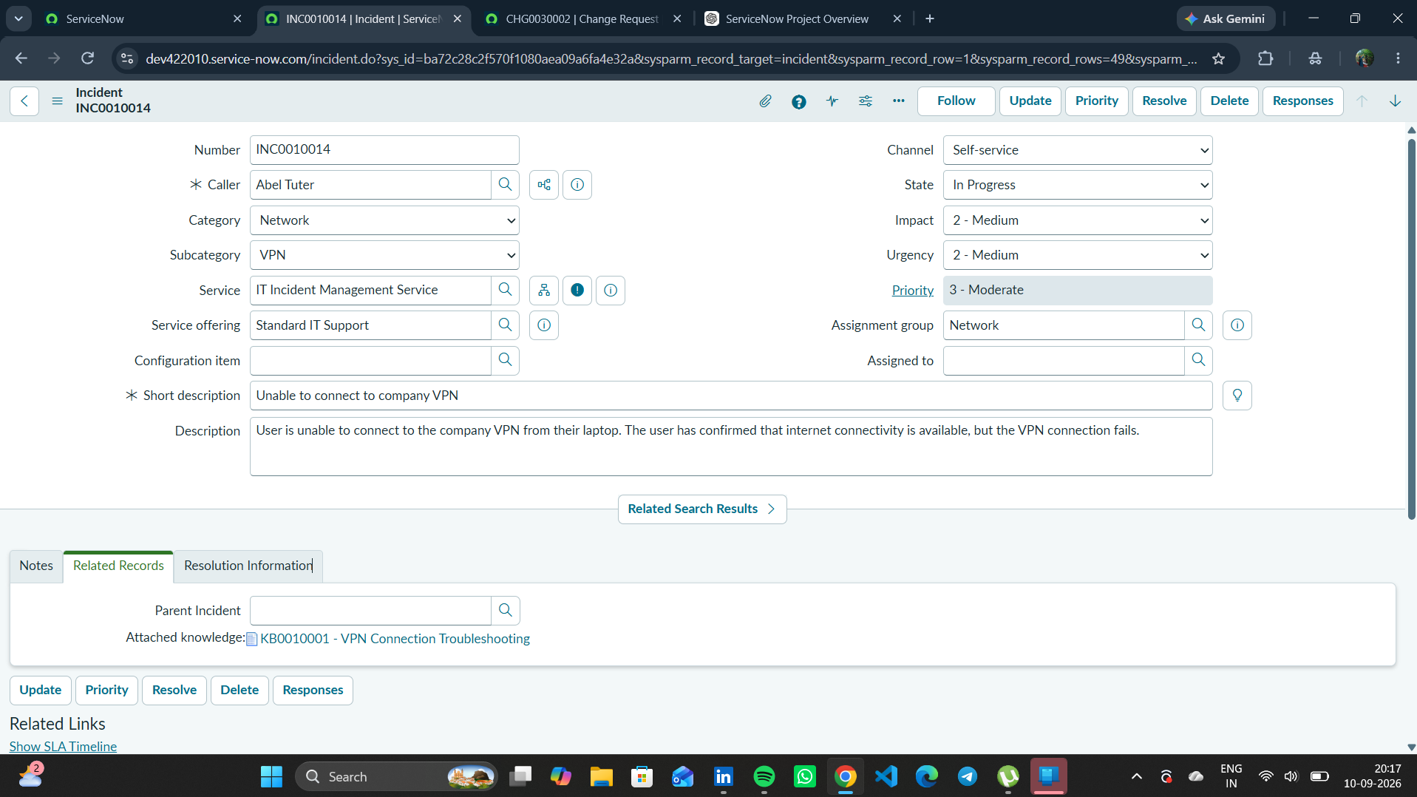
Figure 1. INC0010014 showing Network group assignment and Level 2 escalation evidence.

5. Phase Outcome
- INC0010014 was escalated to the Network group.
- The escalation was documented in the incident work notes.
- The incident was ready for specialist investigation.
Status: COMPLETED

6. Evidence Files
- 0b2e6494-9a92-435d-ae61-660529f8fbc2.png

