PHASE 1 – REQUIREMENT ANALYSIS & PLANNING
Incident Lifecycle Automation in ServiceNow
ServiceNow Developer Instance | Project Planning Documentation

1. Phase Objective
The objective of Phase 1 was to analyze the project requirement and define the complete incident lifecycle before configuring the ServiceNow instance. The project was planned around a realistic IT support scenario in which a user cannot connect to the company VPN even though normal internet connectivity is available.

2. Business Scenario
A company user reports that the corporate VPN connection fails from a laptop. The incident must be classified, prioritized, assigned to the appropriate support group, investigated using Knowledge Management, escalated to Level 2 when necessary, supported by Change Management when required, tracked through a child incident, and finally resolved and validated.

3. Functional Requirements Identified
- Create an IT Incident Management service and a Standard IT Support service offering.
- Create and classify an incident using Category and Subcategory.
- Determine priority from Impact and Urgency.
- Assign the incident to the appropriate specialist support group.
- Use an approved Knowledge article during troubleshooting.
- Document Level 2 escalation and investigation through work notes and incident state.
- Create an Emergency Change when a change is required to restore service.
- Create a child incident for detailed Level 2 investigation tracking.
- Record resolution information and move the incident lifecycle to Resolved.
- Validate the final records and maintain traceability between the incident, knowledge, change, and child incident.

4. Planned End-to-End Workflow
The following workflow was defined during planning and later implemented in ServiceNow:
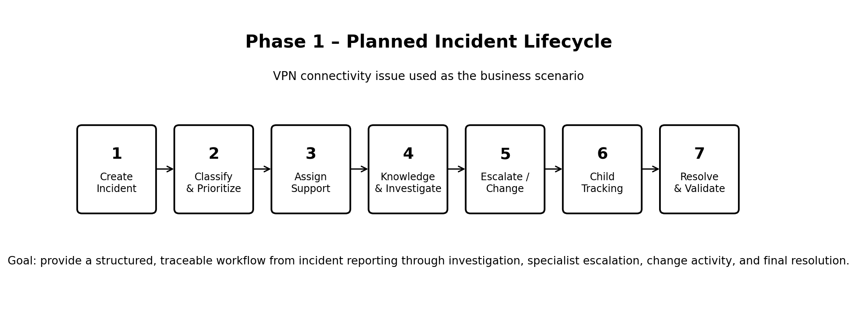
Figure 1. Phase 1 planning evidence – proposed incident lifecycle.

5. Planned ServiceNow Records
Record | Planned Purpose | Final Project Record
Incident | Main VPN incident lifecycle | INC0010014
Knowledge Article | Reusable VPN troubleshooting guidance | KB0010001
Emergency Change | Support restoration of VPN service | CHG0030002
Child Incident | Separate Level 2 investigation tracking | INC0010016
Service | IT incident management service | IT Incident Management Service
Service Offering | Standard support offering | Standard IT Support

6. Expected Outcomes
- A structured incident lifecycle that can be demonstrated end-to-end.
- Consistent classification and priority assessment.
- Clear ownership and specialist escalation.
- Reusable troubleshooting knowledge.
- Traceable change and child-incident activity.
- A fully documented and validated resolution.

7. Phase 1 Evidence
Phase 1 is a planning and requirements phase, so it does not have a unique ServiceNow record screenshot. Figure 1 is included as the planning evidence for this phase. The actual ServiceNow configuration screenshots begin with the implementation phases.

8. Phase 1 Completion
Status: COMPLETED
The project requirements, business scenario, expected records, and end-to-end incident lifecycle were defined before implementation.

