PHASE 8 – EMERGENCY CHANGE REQUEST CREATION
Incident Lifecycle Automation in ServiceNow
Implementation Documentation with ServiceNow Screenshot Evidence

1. Phase Objective
Create an Emergency Change to support restoration of the VPN service when change activity is required.

2. Implementation Details
An Emergency Change request, CHG0030002, was created to support resolution of the VPN connectivity issue.
The change description references Incident INC0010014 and explains that the Network team was investigating the VPN issue and that an emergency change may be required to restore connectivity.
The incident work notes also recorded CHG0030002 for traceability. In this instance, the standard Incident rfc field was not available, so traceability was maintained through the change description and incident work note.

3. Configured / Verified Records
Field | Value
Change Number | CHG0030002
Model | Emergency
Type | Emergency
State | New
Service | IT Incident Management Service
Service Offering | Standard IT Support
Priority | 3 - Moderate
Impact | 2 - Medium
Assignment Group | Network

4. Screenshot Evidence
Only evidence relevant to this phase is included below.
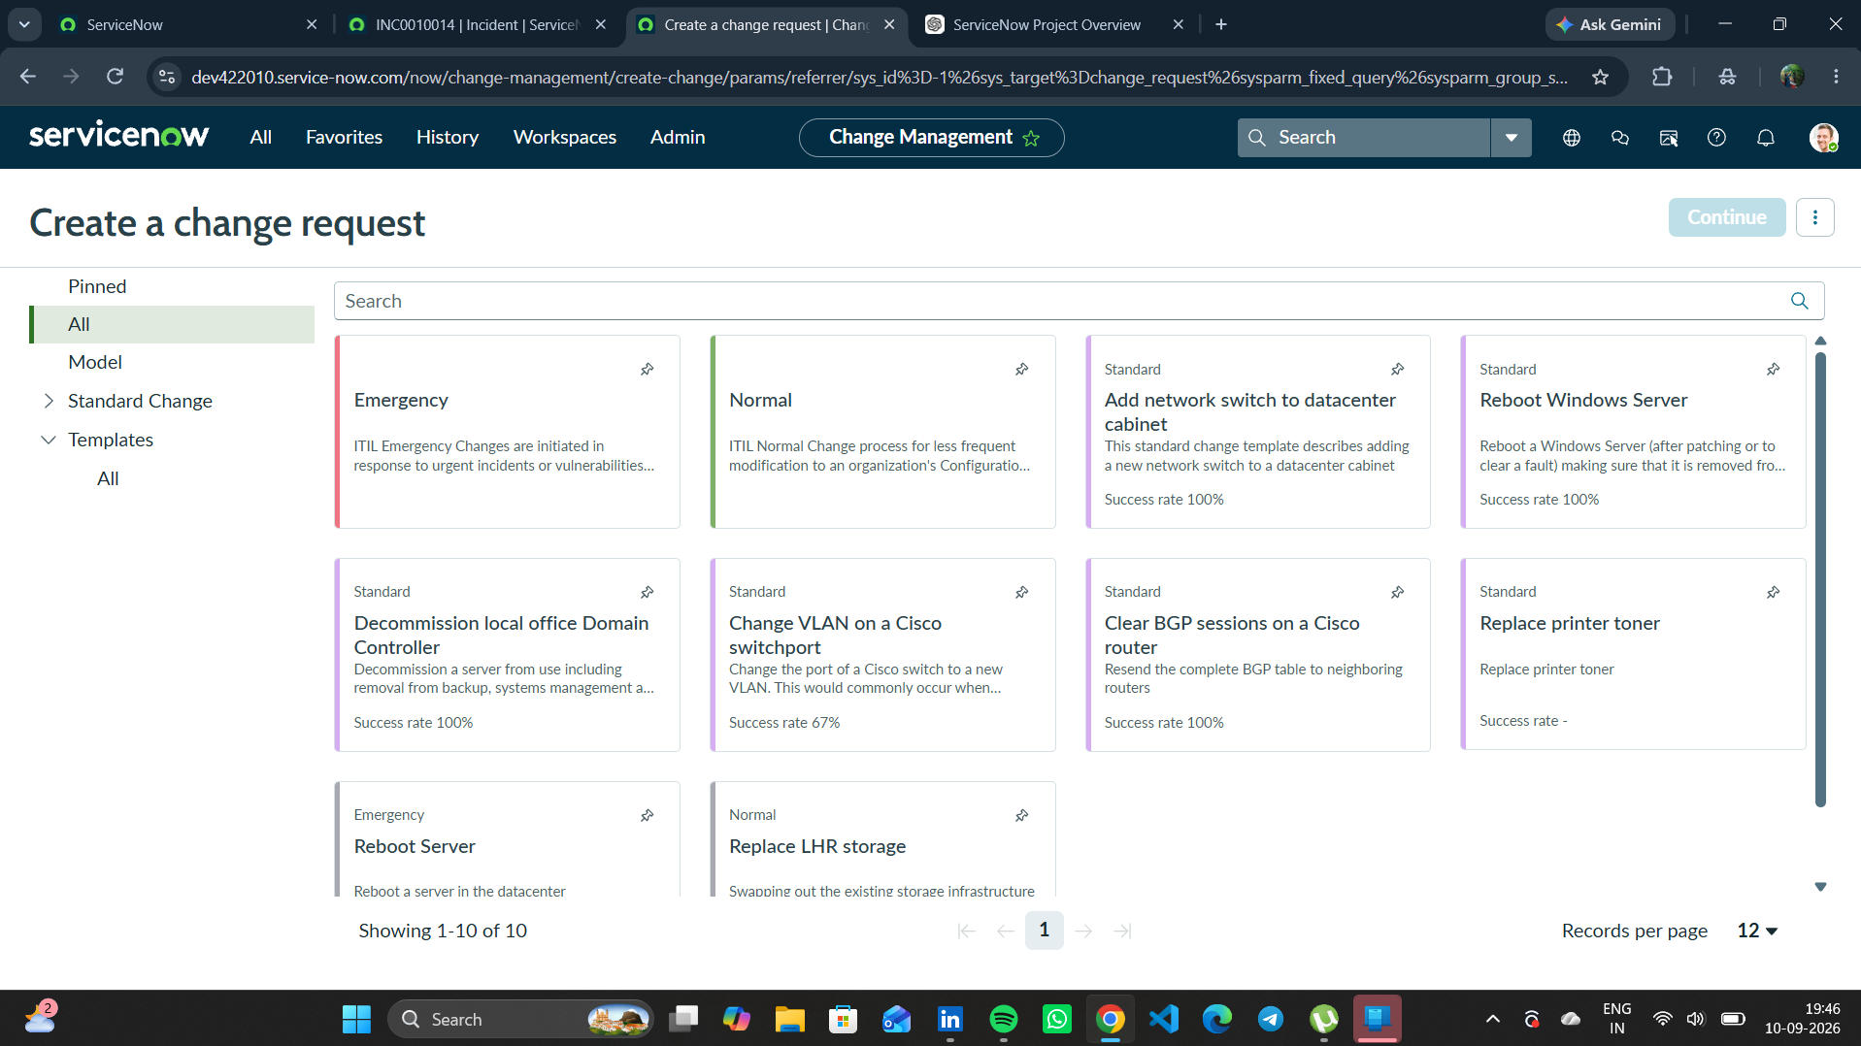
Figure 1. Emergency Change creation evidence for the VPN restoration activity.
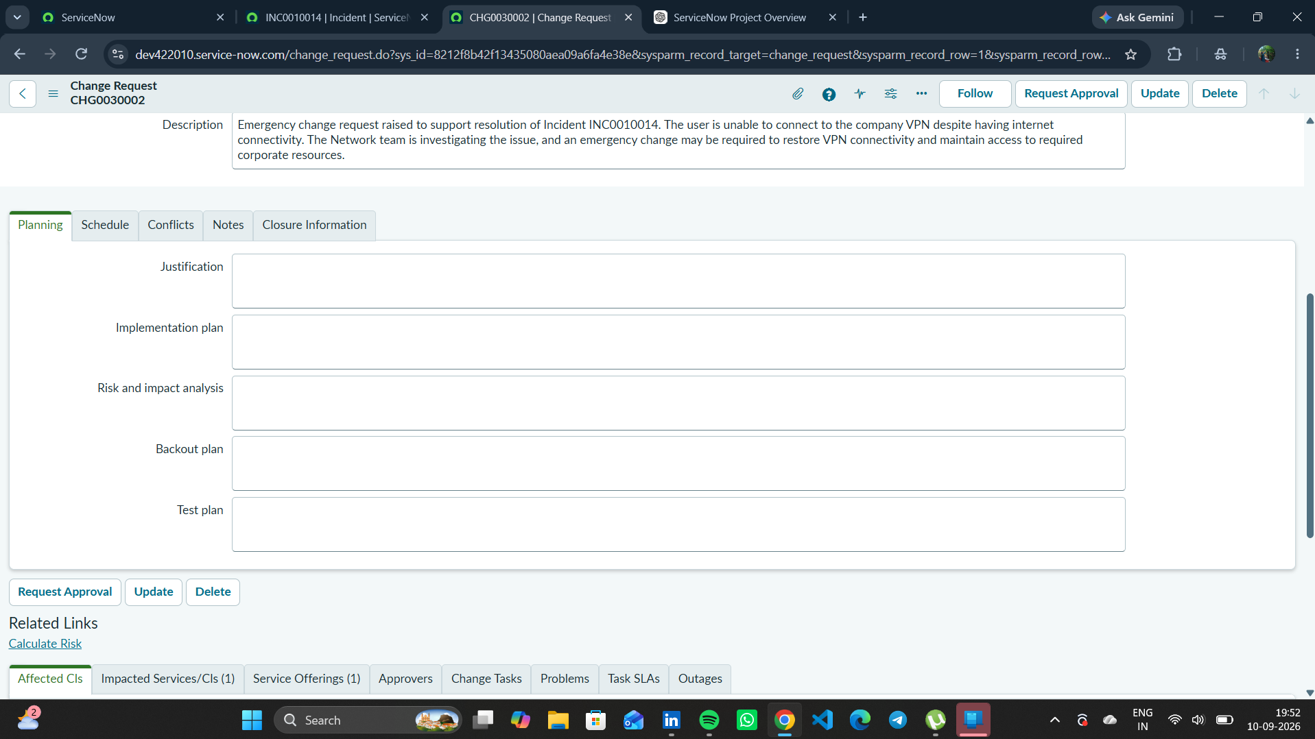
Figure 2. Saved CHG0030002 Emergency Change record.

5. Phase Outcome
- CHG0030002 was successfully created as an Emergency Change.
- The change was assigned to the Network group.
- The change was documented against INC0010014 for project traceability.
Status: COMPLETED

6. Evidence Files
- b9643277-14cc-4192-9c3f-ece56376489a.png
- 8f137fa9-365c-4757-b0c9-8a6fecf61563.png

