PHASE 9 – CHILD INCIDENT CREATION
Incident Lifecycle Automation in ServiceNow
Implementation Documentation with ServiceNow Screenshot Evidence

1. Phase Objective
Create a child incident to separately track the Level 2 investigation while maintaining a parent-child relationship with the main incident.

2. Implementation Details
Child incident INC0010016 was created from the parent incident INC0010014.
The child record was used to track the detailed Level 2 investigation and troubleshooting of the VPN connectivity issue.
The Related Records information confirmed Parent Incident = INC0010014.

3. Configured / Verified Records
Field | Value
Parent Incident | INC0010014
Child Incident | INC0010016
Category | Network
Subcategory | VPN
Service | IT Incident Management Service
Service Offering | Standard IT Support
Assignment Group | Network
Short Description | VPN connectivity investigation - Level 2 support

4. Screenshot Evidence
Only evidence relevant to this phase is included below.
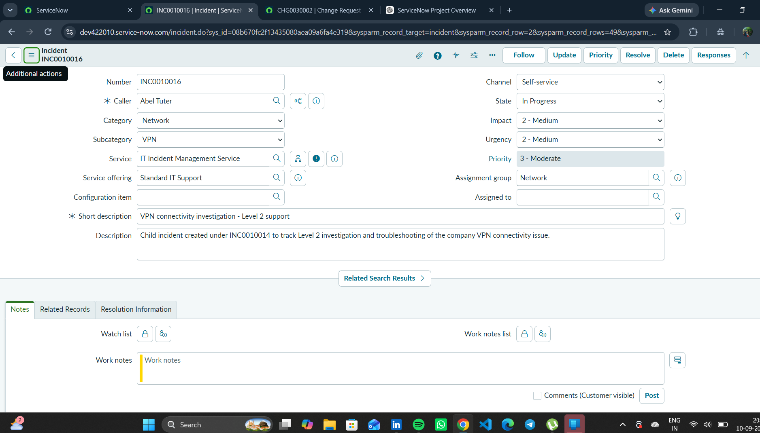
Figure 1. INC0010016 child incident showing its relationship to parent incident INC0010014.

5. Phase Outcome
- INC0010016 was created successfully.
- The parent-child relationship was established.
- The child incident provided a dedicated record for Level 2 investigation.
Status: COMPLETED

6. Evidence Files
- 41023da8-a079-47e9-9d02-5cc8a016d70e.png

