PHASE 12 – FINAL VALIDATION
Incident Lifecycle Automation in ServiceNow
Implementation Documentation with ServiceNow Screenshot Evidence

1. Phase Objective
Validate that all major lifecycle components were completed and that the final records meet the project requirements.

2. Implementation Details
The final implementation was checked against the required lifecycle checkpoints.
The parent incident, child incident, approved Knowledge article, Emergency Change, classification, assignment, and resolution details were verified.

3. Configured / Verified Records
Field | Value
Parent Incident | INC0010014 – Resolved
Child Incident | INC0010016 – Resolved
Knowledge | KB0010001 – Approved
Emergency Change | CHG0030002 – New
Priority | 3 - Moderate
Assignment | Network
Resolution Code | Resolved by change

4. Screenshot Evidence
Only evidence relevant to this phase is included below.
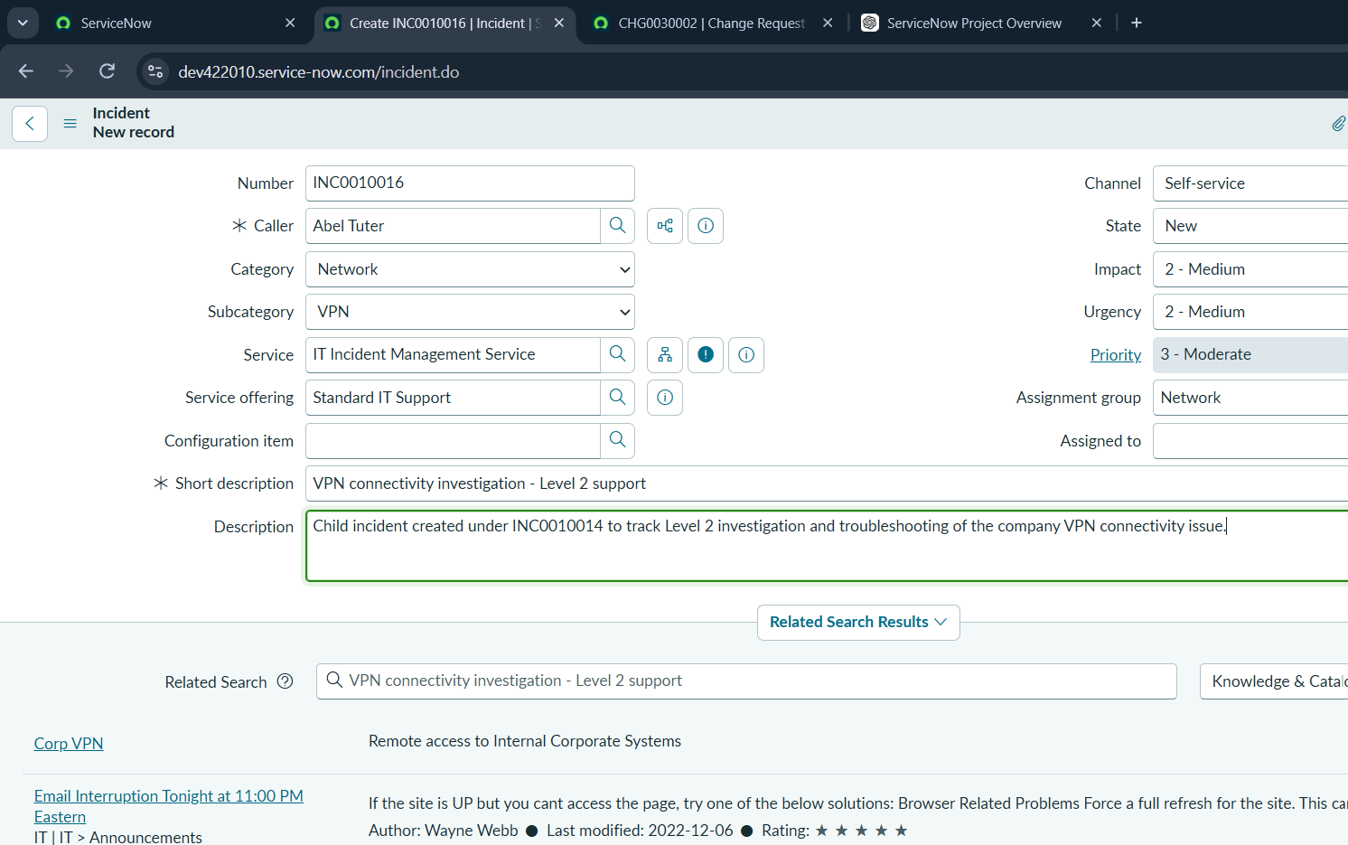
Figure 1. Final validation evidence from the completed ServiceNow lifecycle.

5. Phase Outcome
- Classification and priority — Pass
- Network Level 2 assignment — Pass
- Knowledge article integration — Pass
- Emergency Change creation — Pass
- Parent-child incident relationship — Pass
- Parent and child resolution — Pass
- Resolution code and notes — Pass
Status: COMPLETED

6. Evidence Files
- 0eadfe07-3cec-40dc-b683-2c5d4cf5144f.png

