PHASE 13 – TESTING & DEPLOYMENT VALIDATION
Incident Lifecycle Automation in ServiceNow
Implementation Documentation with ServiceNow Screenshot Evidence

1. Phase Objective
Perform final functional validation of the implemented incident lifecycle and confirm that the demonstrated workflow behaves as intended.

2. Implementation Details
Testing covered the main lifecycle checkpoints: incident creation, classification, priority, assignment, Knowledge reuse, Level 2 investigation, Emergency Change creation, child-incident tracking, and final resolution.
The final records were reviewed to confirm that the intended outcome was achieved and that supporting evidence was documented.

3. Configured / Verified Records
Field | Value
Test Scenario | VPN connectivity incident lifecycle
Parent Incident | INC0010014
Child Incident | INC0010016
Knowledge | KB0010001
Emergency Change | CHG0030002
Overall Result | PASS

4. Screenshot Evidence
Only evidence relevant to this phase is included below.
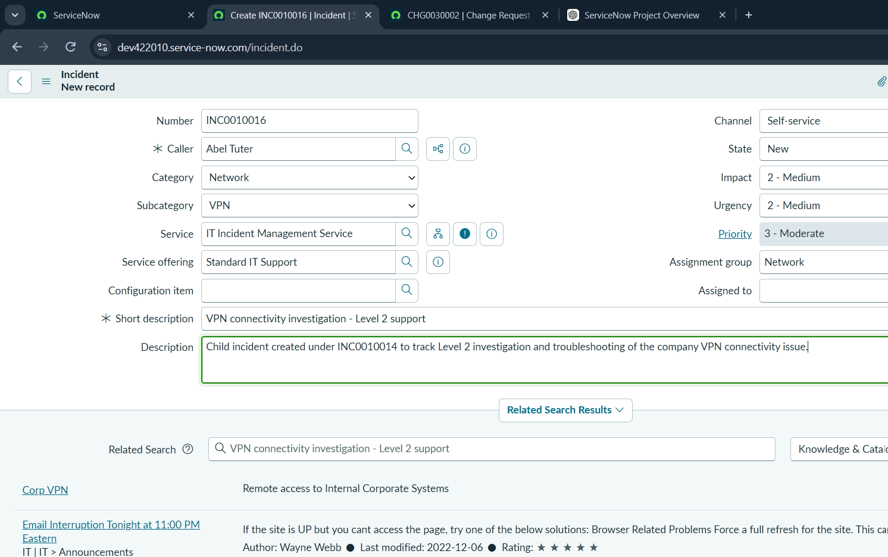
Figure 1. Final ServiceNow state used as validation evidence for the tested lifecycle.

5. Phase Outcome
- Incident lifecycle test — PASS
- Knowledge integration test — PASS
- Level 2 escalation/investigation test — PASS
- Emergency Change test — PASS
- Child incident tracking test — PASS
- Resolution and closure validation — PASS
Status: COMPLETED

6. Evidence Files
- 0eadfe07-3cec-40dc-b683-2c5d4cf5144f.png

