PHASE 14 – CONCLUSION
Incident Lifecycle Automation in ServiceNow
Implementation Documentation with ServiceNow Screenshot Evidence

1. Phase Objective
Summarize the completed ServiceNow Incident Lifecycle Automation project and its final outcome.

2. Implementation Details
The project successfully demonstrates a complete and traceable ServiceNow incident lifecycle for a company VPN connectivity problem.
Incident Management was connected with Knowledge Management and Change Management, while a child incident was used to track specialist Level 2 investigation.
The final implementation provides a clear operational flow from incident reporting through investigation, escalation, change activity, resolution, and validation.

3. Configured / Verified Records
Field | Value
Parent Incident | INC0010014 – Resolved
Child Incident | INC0010016 – Resolved
Knowledge Article | KB0010001 – Approved
Emergency Change | CHG0030002 – New
Final Lifecycle | Create → Classify → Prioritize → Assign → Investigate → Knowledge → Escalate → Change → Child Tracking → Resolve → Validate

4. Screenshot Evidence
Only evidence relevant to this phase is included below.
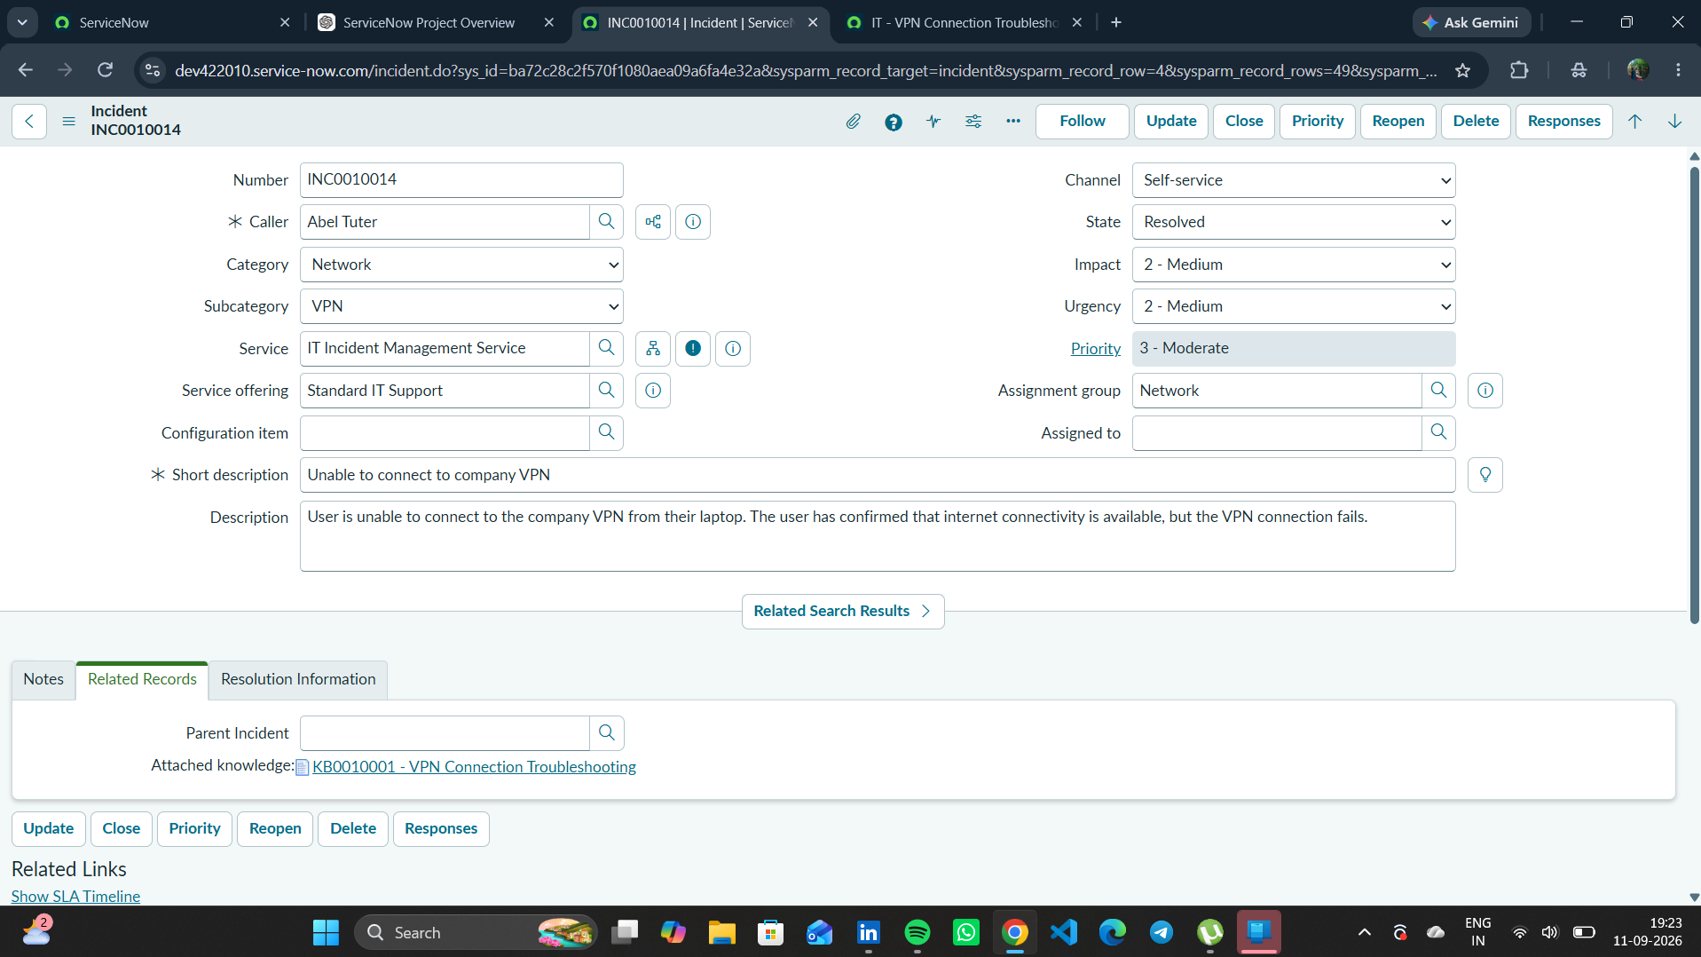
Figure 1. Final resolved incident evidence supporting the project conclusion.

5. Phase Outcome
- The planned incident lifecycle was implemented successfully.
- All major project records were created and validated.
- The parent and child incidents reached Resolved state.
- The project is ready for demonstration and submission.
Status: COMPLETED

6. Evidence Files
- 95f51ea9-8d4b-4ef8-a607-6948281f1ec6.png

