PHASE 7 – LEVEL 2 INVESTIGATION TRACKING
Incident Lifecycle Automation in ServiceNow
Implementation Documentation with ServiceNow Screenshot Evidence

1. Phase Objective
Track the specialist team's investigation by moving the incident into an active investigation state and documenting progress.

2. Implementation Details
The incident was moved to In Progress while the Network team investigated the VPN connectivity issue.
Work note recorded: “Level 2 Network team is actively investigating the VPN connectivity issue. Troubleshooting is in progress and the incident is being monitored for resolution.”

3. Configured / Verified Records
Field | Value
Incident | INC0010014
State | In Progress
Assignment Group | Network
Assigned To | Left blank because group membership could not be verified

4. Screenshot Evidence
Only evidence relevant to this phase is included below.
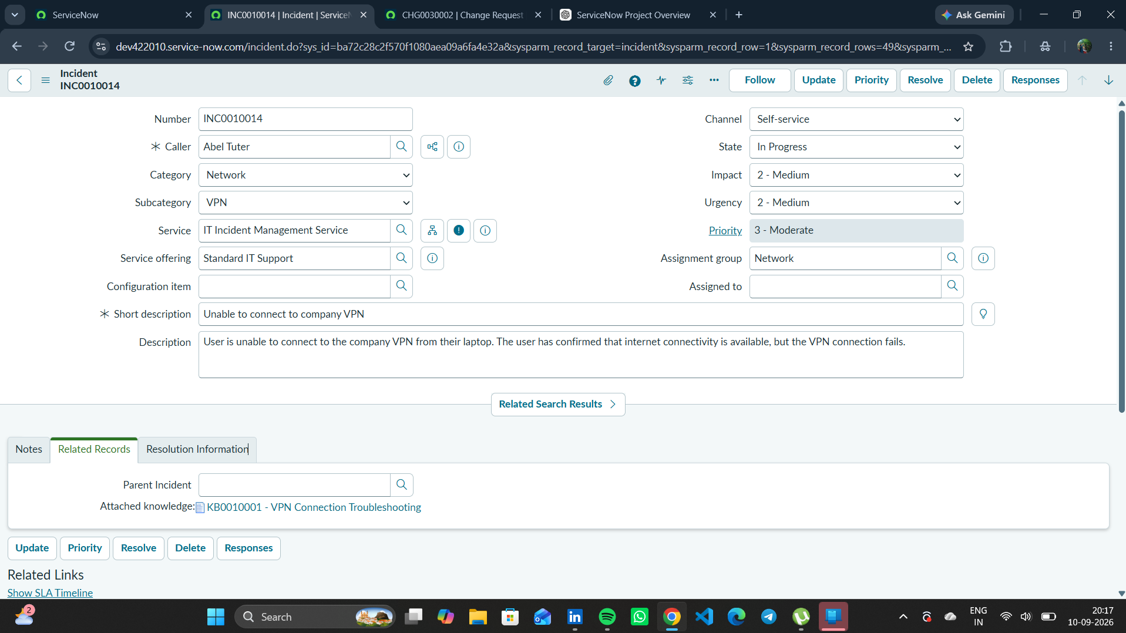
Figure 1. INC0010014 showing the Level 2 investigation and active incident state.

5. Phase Outcome
- The incident entered In Progress state.
- Network Level 2 investigation was documented.
- The activity history provides evidence of ongoing troubleshooting.
Status: COMPLETED

6. Evidence Files
- 0b2e6494-9a92-435d-ae61-660529f8fbc2.png

