PHASE 10 – INCIDENT RESOLUTION
Incident Lifecycle Automation in ServiceNow
Implementation Documentation with ServiceNow Screenshot Evidence

1. Phase Objective
Complete the incident lifecycle by recording the resolution details and moving the parent incident to Resolved.

2. Implementation Details
After the Network team's investigation and the Emergency Change activity, the parent incident was resolved.
Resolution notes recorded: “VPN connectivity issue was investigated by the Level 2 Network team. Emergency change CHG0030002 was created to support restoration of VPN services. Connectivity was restored and the incident is resolved.”
ServiceNow confirmed that INC0010014 and its child incident(s) were resolved.

3. Configured / Verified Records
Field | Value
Incident | INC0010014
Resolution Code | Resolved by change
Emergency Change | CHG0030002
Final State | Resolved
Child Incident | INC0010016 – also resolved

4. Screenshot Evidence
Only evidence relevant to this phase is included below.
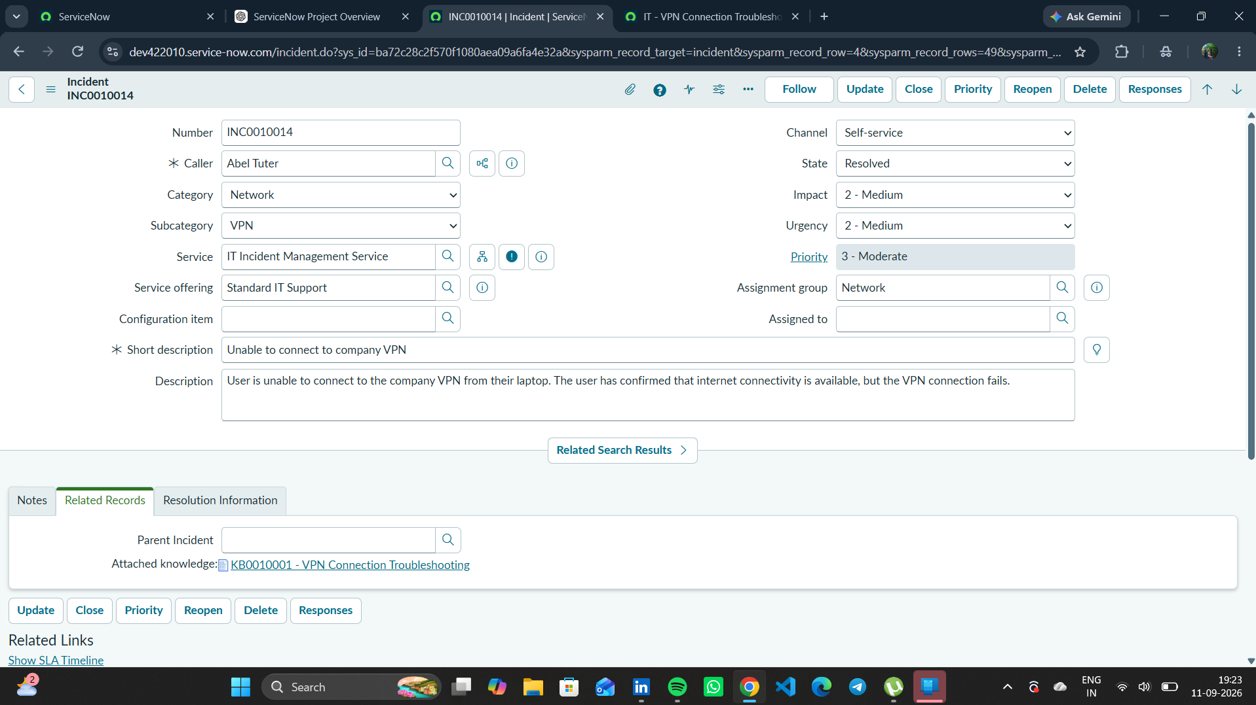
Figure 1. Final resolved state of INC0010014 and resolution evidence.

5. Phase Outcome
- Resolution code was set to Resolved by change.
- CHG0030002 was referenced in the resolution notes.
- INC0010014 reached Resolved state.
- The child incident was also resolved.
Status: COMPLETED

6. Evidence Files
- 95f51ea9-8d4b-4ef8-a607-6948281f1ec6.png

