**PROGRAMMING FUNDAMENTALS ASSIGNMENT # 03**

by

**HAMMAD MUHAMMAD (NUML-F23-48942)**

**RAMIZ RAJA (NUML-F23-50489)**

**ABDUL MANNAN BHATTI (NUML-F23-43496)**

**JAWAD AHMED (NUML-F23-55006)**



**Submitted To**: QURAT UL AIN RAJA

**Subject:** PROGRAMMING FUNDAMENTALS

**Date:** 26/11/2023

**Department of Computer Science**

**National University of Modern Languages**

**Q. Write a program that takes an array of integer as input and output the reversed array?**

**Answer:**

#include<iostream>

#include<conio.h>

using namespace std;

int main()

{

int arr[10], i ;

cout<<"enter 10 array elements:";

for(i=0;i<10;i++)

{

cin>>arr[i];

}

cout<<"\n The output is:";

for(i=0;i<10;i++)

{

cout<<arr[i]<<" ";

}

cout<<"\n Output after Reversing an array:";

for(i=(10-1);i>=0;i--)

cout<<arr[i]<<" ";

cout<<endl;

return 0;

}

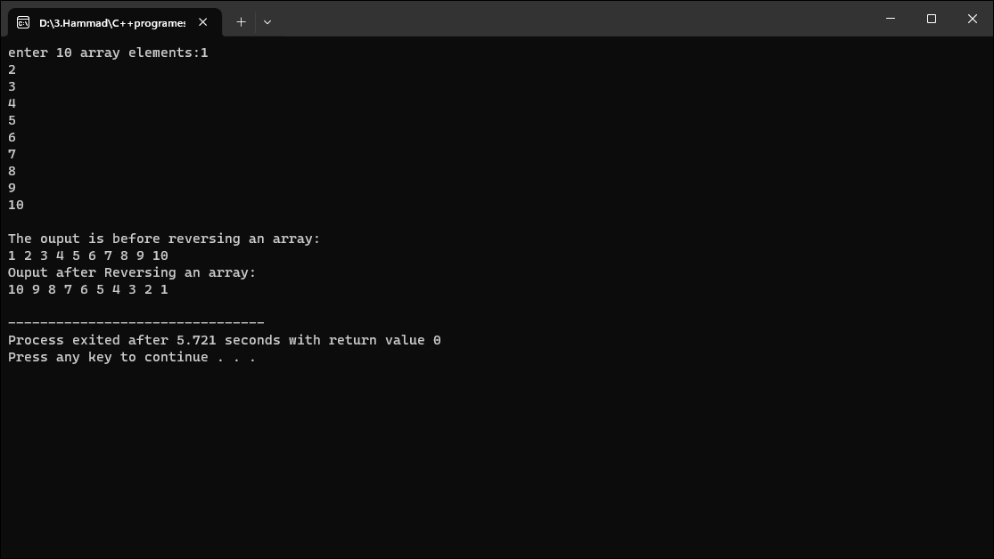

**Q. Create a Program that initialize a 3x3 matrix and perform the following operations:**

* **Calculate the sum of all elements**
* **Find the maximum and minimum values in the matrix**
* **Transpose the matrix?**

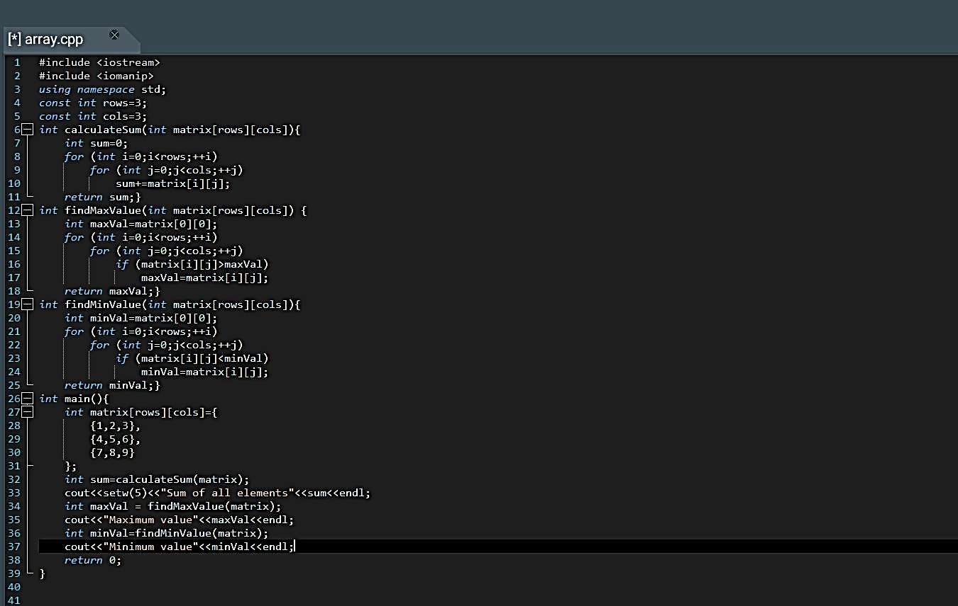

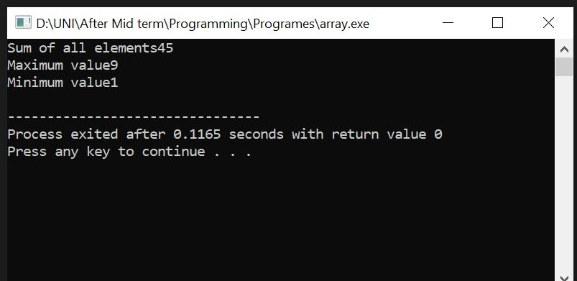

**Q. Write a Program that allows the user that input elements into an array. Implement a function to search for a specific element in an array and update it with a new value if found.**

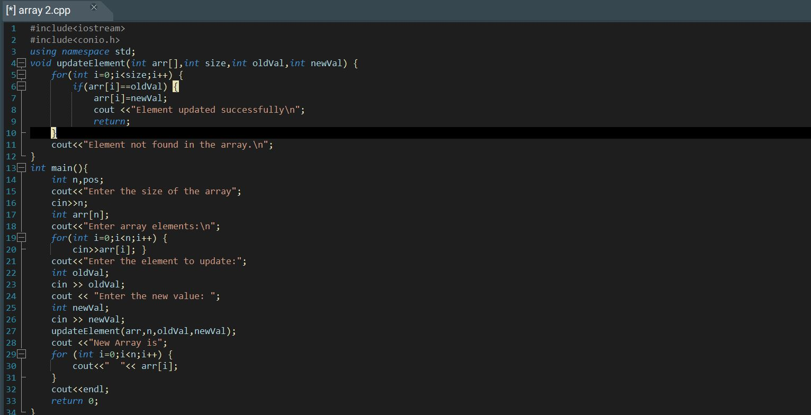

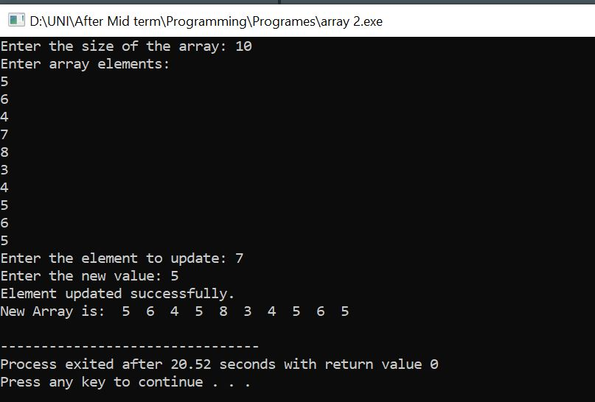

**Q. Implement a Program that takes an array of numbers as input and sorts it as ascending order using a sorting element of you choice?**

**Answer**

#include<iostream>

#include<conio.h>

using namespace std;

int main()

{

int n;

cout<<"enter number of element in an array:";

cin>>n;

int arr[n];

cout<<"\n enter values in the elements:";

for(int i=0;i<n;i++)

{

cin>>arr[i];

}

for(int i=0;i<n-1;i++)

{

for(int j=i+1;j<n;j++)

{

if(arr[j]<arr[i])

{

int temp=arr[j];

arr[j]=arr[i];

arr[i]=temp;

}

}

}

for(int i=0;i<5;i++)

cout<<arr[i]<<" ";

cout<<endl;

return 0; }

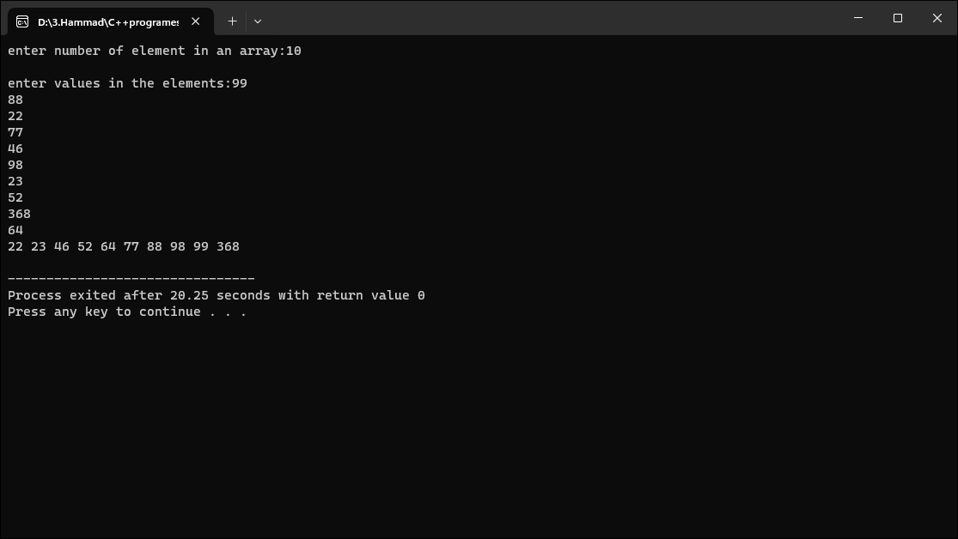

**Q. Develop a program that multiplies two matrices of dimensions m*n and n*p. Ensure the program checks for valid matrix dimensions before attempting multiplications.**

**Answer**

#include<iostream>

#include<conio.h>

using namespace std;

int main()

{

int a[3][3],b[3][3], i , j, k, result[3][3]={0};

cout<<"enter first matrix elements:"<<endl;

for(i=0;i<3;i++)

{for(j=0;j<3;j++)

{cout<<"enter number in pocket["<<i<<"]["<<j<<"]";

cin>>a[i][j];}

}

cout<<" first matrix is"<<endl;

for(i=0;i<3;i++)

{for(j=0;j<3;j++)

{cout<<a[i][j]<<" ";}

cout<<endl;}

cout<<"enter second matrix elements:"<<endl;

for(i=0;i<3;i++)

{for(j=0;j<3;j++)

{cout<<"enter number in pocket["<<i<<"]["<<j<<"]";

cin>>b[i][j];}

}

cout<<"second matrix is"<<endl;

for(i=0;i<3;i++)

{for(j=0;j<3;j++)

{cout<<b[i][j]<<" ";}

cout<<endl;}

for(i=0;i<3;i++)

{for(j=0;j<3;j++)

{result[i][j]=result[i][j]+a[i][j]*b[k][j];}

}

cout<<"multiplication of two matrix is:"<<endl;

for(i=0;i<3;i++)

{for(j=0;j<3;j++)

{cout<<result[i][j]<<" ";}

cout<<endl;}

return 0;}

