Predicting Student Dropout Using Big Data Analytics: A Machine Learning Approach to Early Academic Risk Detection
A Data-Driven Study Based on a 10,000-Student Institutional Dataset
Department of Computer Science / Data Science
University of Kigali (UoK)
July 2026

Abstract
Student attrition is a persistent challenge for higher-education institutions worldwide, with direct consequences for institutional funding, accreditation, and student welfare. This study applies Big Data analytics and machine learning techniques to a dataset of 10,000 student records to identify the demographic, academic, and behavioural factors most strongly associated with dropout. Following a structured pipeline of data cleaning, missing-value imputation, outlier treatment, and feature engineering, four classification algorithms — Logistic Regression, Decision Tree, Random Forest, and Support Vector Machine — were trained and evaluated using accuracy, precision, recall, F1-score, and ROC-AUC. The dataset exhibited an overall dropout rate of 23.5%. Logistic Regression achieved the highest F1-score (0.585) and a strong ROC-AUC of 0.821, while Random Forest achieved the highest overall accuracy (0.780). Feature-importance analysis identified cumulative and semester GPA, stress index, and attendance rate as the dominant predictors of dropout, while demographic factors such as gender and internet access showed negligible influence. The findings support the deployment of an early-warning analytics system that flags at-risk students using academic and well-being indicators, enabling timely, evidence-based intervention by academic advisors.
Keywords: student dropout prediction, big data analytics, machine learning, educational data mining, early-warning system, Random Forest, logistic regression

1. Introduction

1.1 Background
Student dropout — the premature discontinuation of a student's enrolled programme before graduation — remains one of the most costly and disruptive problems facing higher-education institutions. Beyond the personal and financial toll on the student, high attrition rates reduce institutional revenue, damage graduation-rate metrics used in accreditation, and strain academic support resources that could otherwise be directed proactively. Traditional dropout-management practices rely on reactive, manually triggered interviews after a student has already missed multiple classes or failed several assessments — by which point intervention is frequently too late.
The proliferation of institutional data — enrolment records, learning-management-system logs, attendance systems, and financial-aid databases — has created an opportunity to apply Big Data analytics to detect at-risk students long before formal withdrawal. This project explores how a structured analytics pipeline, combining data preprocessing, exploratory analysis, and supervised machine learning, can be used to build a predictive model of student dropout from a 19-attribute, 10,000-record institutional dataset.

1.2 Problem Statement
Academic institutions frequently possess the raw data required to predict dropout risk, but they lack systematic analytical processes to convert that data into actionable, timely insight. Interventions are typically applied uniformly rather than being targeted at the students who need them most, wasting limited advising capacity and allowing high-risk students to disengage unnoticed.

1.3 Objectives
- To design and apply a complete Big Data preprocessing pipeline (cleaning, imputation, outlier treatment, feature engineering) to a real-world student dataset.
- To conduct exploratory data analysis (EDA) to uncover patterns and relationships between student characteristics and dropout outcomes.
- To build, train, and compare multiple machine learning classifiers for predicting student dropout.
- To identify the most influential predictors of dropout using feature-importance analysis.
- To propose evidence-based recommendations for an institutional early-warning intervention system.

1.4 Significance of the Study
This study demonstrates a reproducible, technology-agnostic analytics workflow that any institution with comparable student-record data could adopt. It also provides a concrete, quantified answer to the question of which factors institutions should monitor most closely — namely academic performance trend and stress/well-being indicators — rather than relying on assumptions about demographic risk factors.

2. Related Work
Educational Data Mining (EDM) and Learning Analytics have become established sub-fields applying data-mining and machine-learning techniques to student records, learning-management-system logs, and assessment data to model performance and retention. Prior studies have consistently found academic performance indicators (GPA, credit accumulation, assignment completion) to be the strongest predictors of dropout, followed by engagement measures such as attendance and Learning Management System (LMS) activity. Socio-economic variables such as family income and parental education have been reported as secondary, context-dependent predictors, with effect sizes that vary considerably across institutions and countries.
Commonly applied algorithms in this domain include Logistic Regression and Decision Trees for their interpretability, and ensemble methods such as Random Forest and Gradient Boosting for improved predictive accuracy at the cost of transparency. Class imbalance — dropout is typically a minority class — is a recurring methodological challenge addressed through class weighting, resampling (SMOTE), or threshold tuning, an issue this study addresses via class-weighted classifiers. Big Data platforms such as Apache Spark and Hadoop are commonly cited as the scale-up path once an institution's data volume exceeds single-machine processing capacity; the methodology in this report is designed to be portable to such platforms (see Section 3.5).

3. Methodology

3.1 Dataset Description
The dataset used in this study, student_dropout_dataset_v3.csv, contains 10,000 student records and 19 attributes spanning demographic (Age, Gender, Family Income, Parental Education), behavioural (Study Hours per Day, Attendance Rate, Assignment Delay Days, Travel Time, Part-Time Job, Stress Index), and academic (GPA, Semester GPA, CGPA, Semester, Department) variables, together with the binary target label Dropout (1 = dropped out, 0 = retained).
Attribute | Type | Description
Student_ID | Integer | Unique student identifier
Age | Float | Student age in years
Gender | Categorical | Male / Female
Family_Income | Float | Annual household income
Internet_Access | Categorical | Home internet access (Yes/No)
Study_Hours_per_Day | Float | Average daily self-study hours
Attendance_Rate | Float | Percentage class attendance
Assignment_Delay_Days | Integer | Average late-submission days
Travel_Time_Minutes | Float | Commute time to campus
Part_Time_Job | Categorical | Holds part-time employment (Yes/No)
Scholarship | Categorical | Receives scholarship (Yes/No)
Stress_Index | Float | Self-reported stress score
GPA / Semester_GPA / CGPA | Float | Academic performance measures
Semester | Categorical | Academic year (Year 1–4)
Department | Categorical | Academic department
Parental_Education | Categorical | Highest parental education level
Dropout | Binary | Target label (1 = dropout, 0 = retained)

3.2 Data Preprocessing
Data preprocessing followed standard Big Data quality-assurance steps. Duplicate-record screening (excluding the identifier column) found 0 duplicate rows. Missing values were present in three columns — Family_Income, Study_Hours_per_Day, and Stress_Index (500 missing values each), and Parental_Education (511 missing values) — consistent with typical institutional data-collection gaps. Numeric missing values were imputed using column medians (robust to skew), while the categorical Parental_Education field was imputed using its modal category.
Outlier treatment was performed using the Interquartile Range (IQR) method: values beyond 1.5×IQR from the first/third quartiles were capped (winsorised) rather than removed, to preserve sample size while limiting the influence of extreme values on distance-based and linear models.
Feature | Outliers Capped
Age | 33
Family_Income | 683
Study_Hours_per_Day | 138
Attendance_Rate | 57
Travel_Time_Minutes | 25
Stress_Index | 137
GPA | 0
Semester_GPA | 0
CGPA | 0

Two engineered features were added to capture trend and engagement effects not present in the raw attributes: GPA_Trend (Semester_GPA − CGPA, capturing short-term academic trajectory relative to historical performance) and Engagement_Score (a weighted composite of normalised attendance and study hours).

3.3 Exploratory Data Analysis
Exploratory analysis examined the target class balance, the distribution of dropout across departments and academic years, and the relationship between dropout and each continuous predictor via correlation analysis, kernel density plots, and box/violin plots. Results are presented in Section 4.

3.4 Model Development
Categorical variables were label-encoded, and the dataset was split into training (80%) and test (20%) sets using stratified sampling to preserve class proportions. Four supervised classification algorithms were trained: Logistic Regression and Support Vector Machine (RBF kernel) on standardised features, and Decision Tree and Random Forest on raw feature values. All models used class-weighting to counteract the class imbalance (23.5% dropout rate) rather than resampling, to avoid introducing synthetic data. Model performance was evaluated using accuracy, precision, recall, F1-score, and ROC-AUC, computed on the held-out test set.

3.5 Big Data Tooling and Scalability
The analysis was implemented in Python using pandas for data wrangling, scikit-learn for machine learning, and matplotlib/seaborn for visualisation — an approach well-suited to the 10,000-record scale of this dataset. For institutional deployment at scale (multi-year, multi-campus records reaching millions of rows), the identical preprocessing and feature-engineering logic can be re-implemented using Apache Spark (PySpark DataFrames and MLlib) for distributed processing, with cleaned data staged in a Hadoop Distributed File System (HDFS) or a columnar warehouse, and student events (attendance swipes, LMS logins) streamed through Apache Kafka for near-real-time risk scoring. SQL-based data marts or MongoDB collections can serve the resulting risk scores to an advising dashboard.

4. Results

4.1 Class Distribution
The dataset shows a class imbalance typical of dropout studies: 23.5% of students (2354) dropped out, versus 76.5% retained.
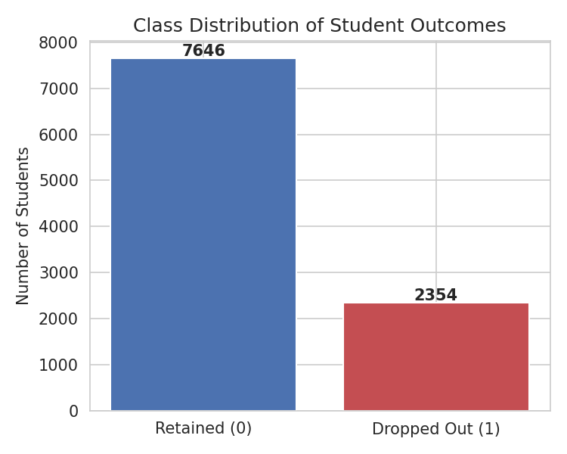
Figure 1. Class distribution of the target variable (Dropout).

4.2 Dropout by Department and Academic Year
Dropout rates were broadly similar across departments, ranging narrowly rather than showing one department as a clear outlier.
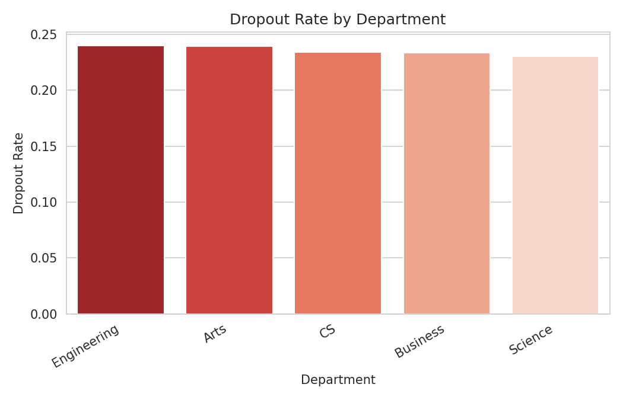
Figure 2. Dropout rate by academic department.
Department | Dropout Rate
Engineering | 24.01%
Arts | 23.94%
CS | 23.40%
Business | 23.33%
Science | 23.05%

Dropout rate by academic year followed a similar near-flat pattern, with Year 2 marginally the highest and Year 1 the lowest.
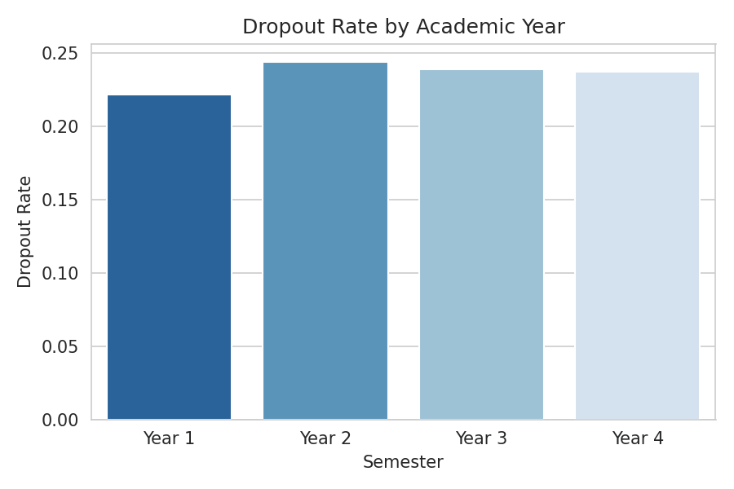
Figure 3. Dropout rate by academic year (Semester).

4.3 Academic Performance and Dropout
Cumulative GPA (CGPA) shows the clearest separation between the two classes: students who eventually dropped out cluster at markedly lower CGPA values than those who remained enrolled.
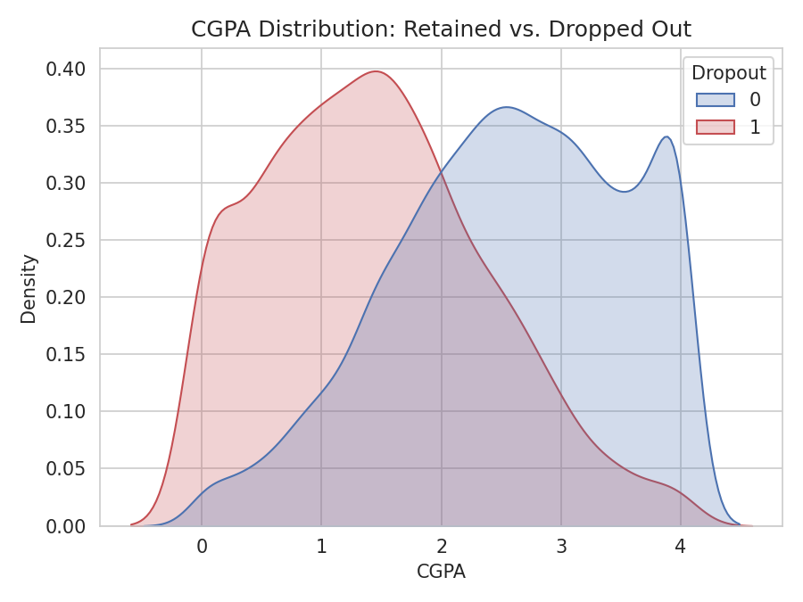
Figure 4. CGPA distribution for retained vs. dropped-out students.
Attendance rate shows a similar, though less pronounced, pattern, with dropped-out students exhibiting a lower median attendance and wider spread.
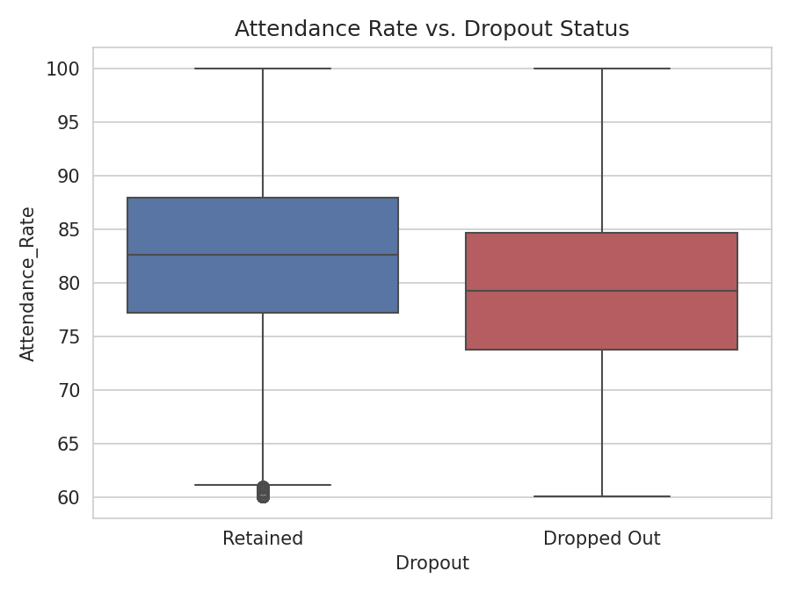
Figure 5. Attendance rate by dropout status.

4.4 Correlation Analysis
A correlation matrix of numeric features against the Dropout label confirms that academic-performance variables (GPA, Semester GPA, CGPA) carry the strongest negative correlation with dropout, while Stress Index carries the strongest positive correlation.
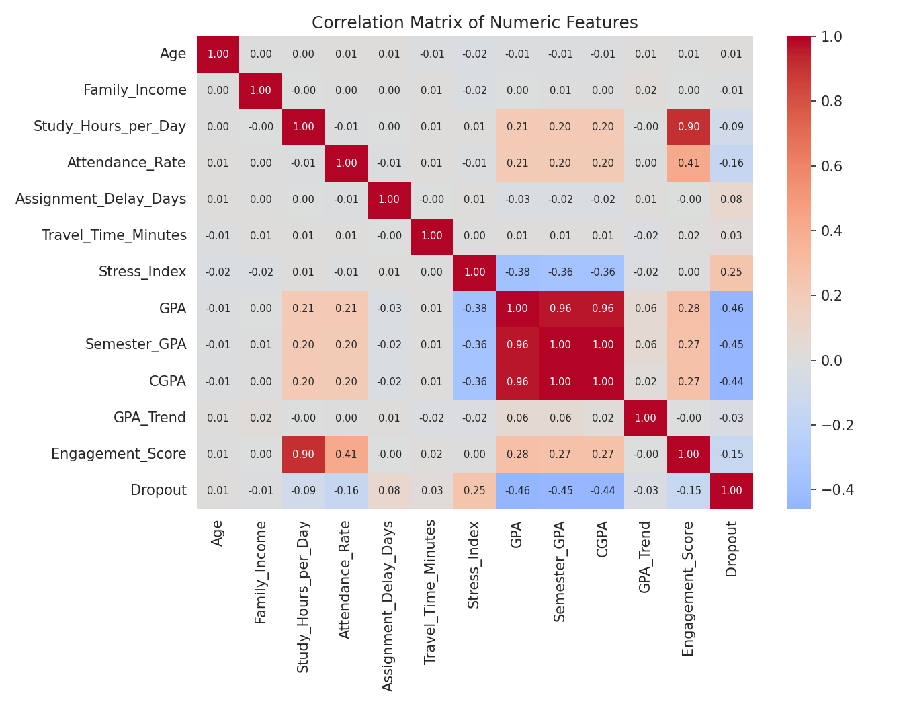
Figure 6. Correlation matrix of numeric features.
Feature | Correlation with Dropout
GPA | -0.460
Semester_GPA | -0.445
CGPA | -0.445
Stress_Index | 0.249
Attendance_Rate | -0.164
Engagement_Score | -0.149
Study_Hours_per_Day | -0.087
Assignment_Delay_Days | 0.082

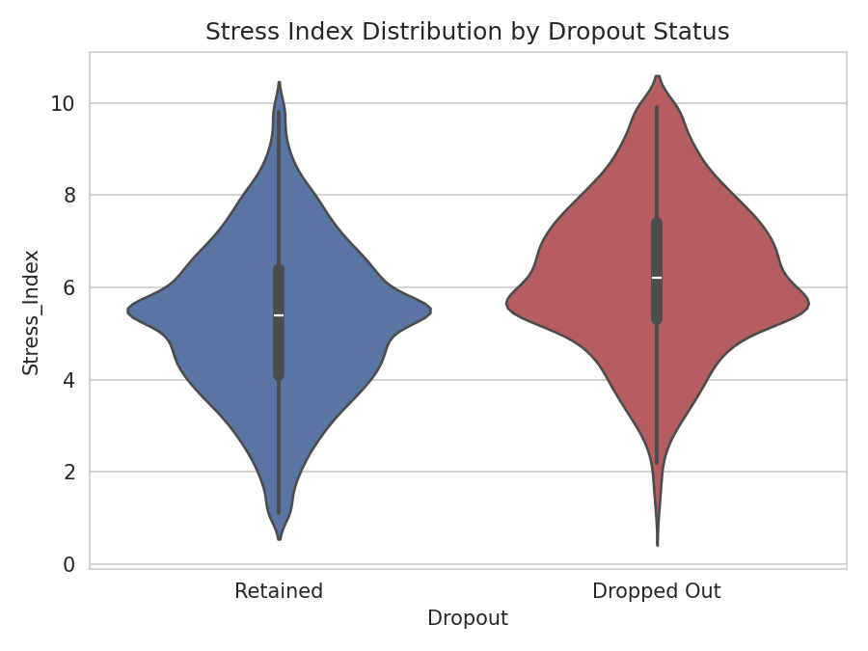
Figure 7. Stress Index distribution by dropout status.

4.5 Behavioural Factors
Part-time employment and scholarship status were also examined; students without a scholarship and students juggling part-time work showed marginally elevated dropout rates, though the effect size was modest relative to academic performance and stress.
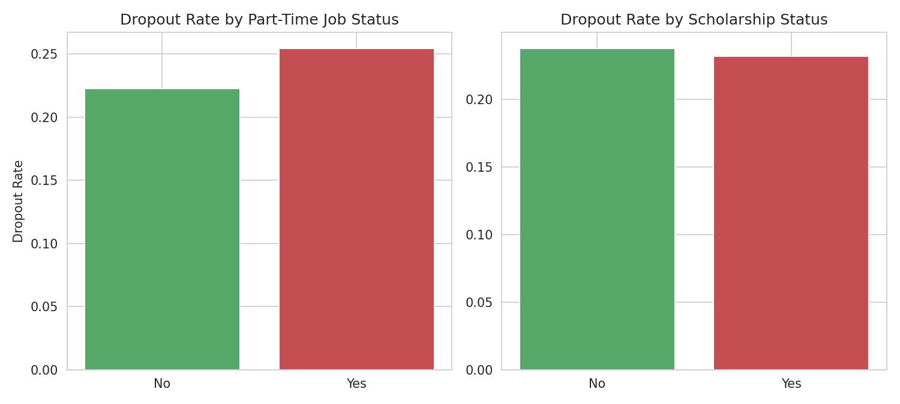
Figure 8. Dropout rate by part-time job status and scholarship status.

4.6 Model Performance
Table 4 summarises the performance of all four classifiers on the held-out test set (2,000 students).
Model | Accuracy | Precision | Recall | F1-score | ROC-AUC
Logistic Regression | 0.743 | 0.472 | 0.769 | 0.585 | 0.821
Decision Tree | 0.719 | 0.432 | 0.624 | 0.511 | 0.738
Random Forest | 0.780 | 0.527 | 0.639 | 0.578 | 0.807
SVM (RBF) | 0.735 | 0.460 | 0.726 | 0.563 | 0.803

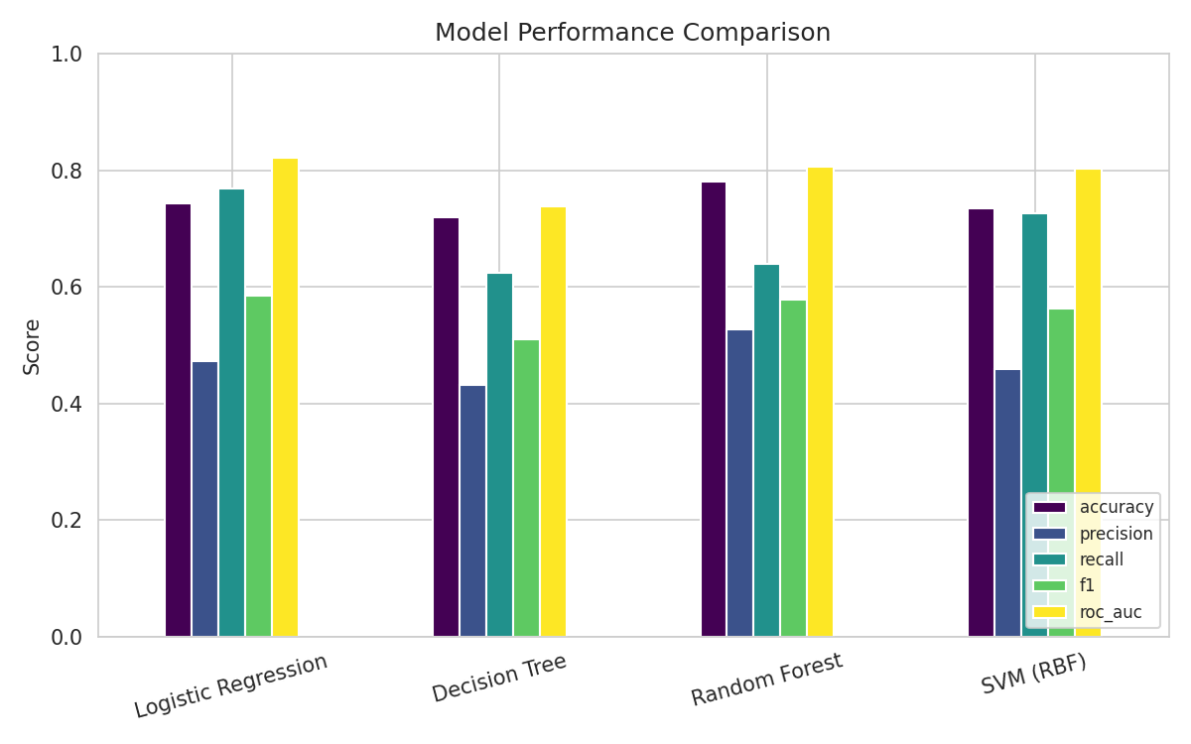
Figure 9. Performance comparison across all four models.
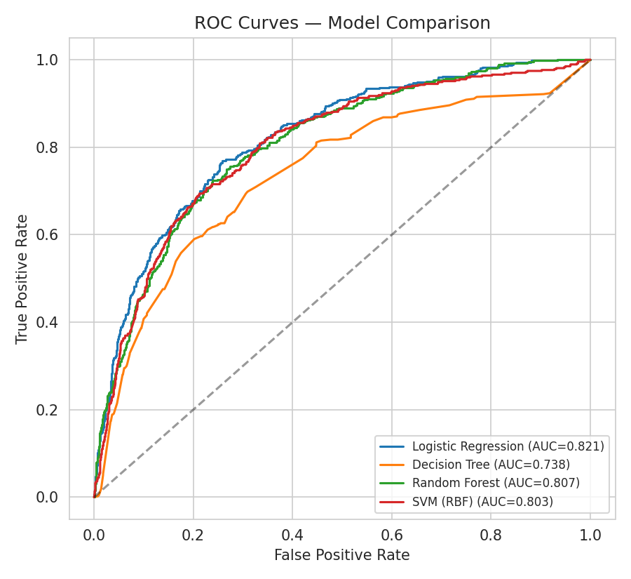
Figure 10. ROC curves for all four classifiers.
Logistic Regression achieved the highest F1-score (0.585), balancing precision and recall most effectively for the minority dropout class, while Random Forest produced the highest raw accuracy (0.780) and the highest precision among all models. Given the class imbalance, F1-score and ROC-AUC are considered more representative measures of practical usefulness than accuracy alone.
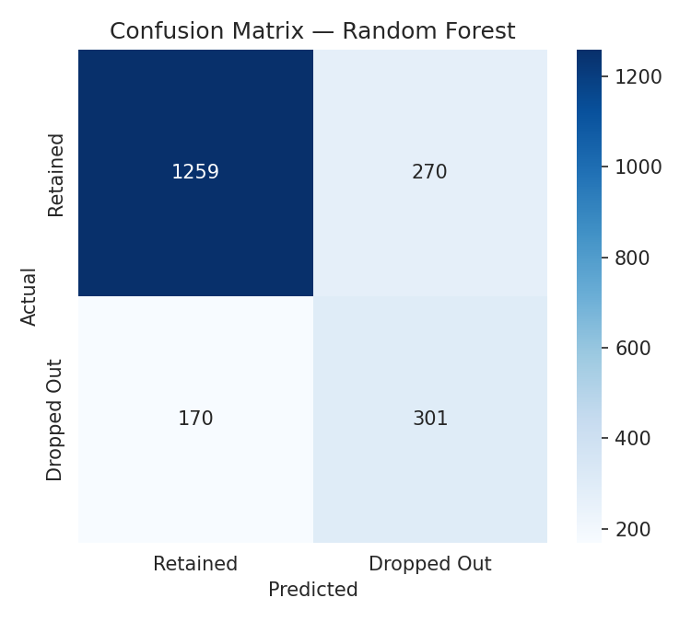
Figure 11. Confusion matrix for the Random Forest classifier on the test set.

4.7 Feature Importance
Random Forest feature importances corroborate the correlation analysis: academic performance measures dominate, followed by stress and engagement indicators, with demographic and administrative attributes contributing comparatively little.
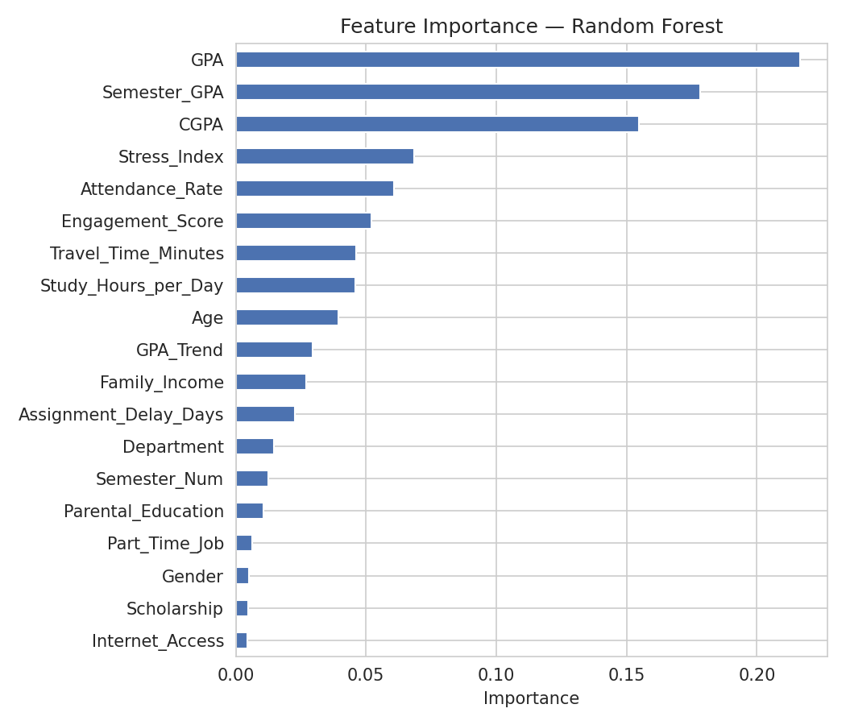
Figure 12. Random Forest feature importance ranking.
Rank | Feature | Importance
1 | GPA | 0.2164
2 | Semester_GPA | 0.1781
3 | CGPA | 0.1549
4 | Stress_Index | 0.0685
5 | Attendance_Rate | 0.0609
6 | Engagement_Score | 0.0519
7 | Travel_Time_Minutes | 0.0462
8 | Study_Hours_per_Day | 0.0457

5. Discussion
The results provide strong, consistent evidence that academic performance trajectory — rather than demographic background — is the dominant signal for dropout risk in this dataset. GPA, Semester GPA, and CGPA together account for the majority of feature importance in the Random Forest model and show the strongest correlations with the target label, echoing well-established findings in the educational data-mining literature. This suggests that dropout is, in this population, primarily an academic-performance and well-being phenomenon rather than a socio-economic or demographic one: Family_Income, Gender, Internet_Access, and Parental_Education all rank near the bottom of the importance ranking.
The prominence of Stress_Index as the second-strongest correlate of dropout (after the GPA family of variables) is a notable and actionable finding: it indicates that student well-being monitoring — not solely academic monitoring — should be part of any early-warning system. Attendance rate and the engineered Engagement_Score also contribute meaningfully, reinforcing that day-to-day engagement behaviours are measurable, leading indicators of eventual withdrawal, observable well before a formal dropout event.
From a modelling perspective, no single algorithm dominates across all metrics. Logistic Regression's higher recall makes it preferable when the institutional priority is to catch as many at-risk students as possible (minimising false negatives), accepting a higher rate of unnecessary outreach (false positives). Random Forest's higher precision makes it preferable when advising capacity is constrained and false alarms are costly. In practice, an institution could deploy Logistic Regression as a broad first-pass screen and reserve Random Forest or a Random-Forest-derived risk score for prioritising limited advisor capacity among the flagged students.
Limitations of this study include the cross-sectional nature of the dataset (a single snapshot per student rather than a full longitudinal history of grades and attendance over time), the moderate class imbalance which constrains achievable precision for the minority class, and the absence of LMS-level behavioural data (e.g., login frequency, forum participation) that has been shown elsewhere to add incremental predictive value beyond attendance and grades.

6. Conclusion and Recommendations
This study applied a complete Big Data analytics pipeline — cleaning, imputation, outlier treatment, feature engineering, exploratory analysis, and multi-model machine learning — to a 10,000-student dataset to identify predictors of dropout and to build predictive classifiers. The analysis found that academic performance (GPA/CGPA), self-reported stress, and attendance/engagement are the dominant predictors of dropout, while demographic factors play a comparatively minor role. Logistic Regression and Random Forest both provide practically useful predictive performance (ROC-AUC above 0.80), supporting their use as the basis of an institutional early-warning system.

6.1 Recommendations
- Deploy a lightweight, continuously updated dropout-risk score (e.g., Logistic Regression) integrated into the student information system, refreshed each semester with current GPA, attendance, and stress-survey data.
- Prioritise advisor outreach using the higher-precision Random Forest score for students already flagged by the broad screening model, to make efficient use of limited advising capacity.
- Incorporate a lightweight, validated student stress/well-being survey into routine data collection, given its strong and independent association with dropout.
- Extend data collection to include longitudinal, per-term academic history and LMS engagement logs to support trend-based and time-series risk modelling in future iterations.
- For institution-wide, multi-year scale-up, migrate the pipeline to a distributed Big Data stack (Apache Spark on data staged in HDFS, streaming ingestion via Kafka) to support near-real-time scoring across the full student population.

References
Baker, R. S., & Inventado, P. S. (2014). Educational data mining and learning analytics. In Learning Analytics (pp. 61–75). Springer.
Delen, D. (2010). A comparative analysis of machine learning techniques for student retention management. Decision Support Systems, 49(4), 498–506.
Kotsiantis, S. B., Pierrakeas, C., & Pintelas, P. E. (2003). Preventing student dropout in distance learning using machine learning techniques. In International Conference on Knowledge-Based and Intelligent Information and Engineering Systems (pp. 267–274). Springer.
Márquez-Vera, C., Cano, A., Romero, C., & Ventura, S. (2013). Predicting student failure at school using genetic programming and different data mining approaches with high dimensional and imbalanced data. Applied Intelligence, 38(3), 315–330.
Pedregosa, F., et al. (2011). Scikit-learn: Machine learning in Python. Journal of Machine Learning Research, 12, 2825–2830.
Romero, C., & Ventura, S. (2020). Educational data mining and learning analytics: An updated survey. Wiley Interdisciplinary Reviews: Data Mining and Knowledge Discovery, 10(3), e1355.
Zaharia, M., et al. (2016). Apache Spark: A unified engine for big data processing. Communications of the ACM, 59(11), 56–65.

