**Curriculum Vitae (CV)**

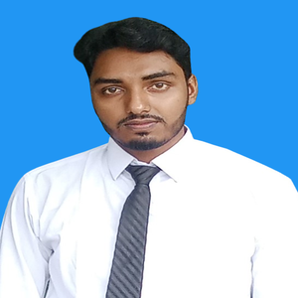

**Ramjan Ali**

**House no-21,Road no-05**

**Jaldhaka, Nilphamari**

**Mobile no-01309407685**

**Email:eng.12002014brur@gmail.com**                               

**Fathers name:**Ashadul Haque

**Mothers name:**Ajifa Begum

**Date of birth:**15 September 2001

**Present address:**Dakshin cherenga,Jaldhaka,Nilphamari

**Nationality:**Bangladeshi

**Marital status:**unmarried

**Current position:**Honors 1st year 2nd semester

**Religion:**Islam

**Blood group:**O+(positive**)**

|  |  |  |  |  |
| --- | --- | --- | --- | --- |
| Qualification | | | | |
| **Institution** | **Degree** | **Year** | **GPA/CGPA** | **Board** |
| Binnaguri high school | JSC | 2015 | 5.00 | Dinajpur |
| Binnaguri high school | SSC | 2018 | 4.83 | Dinajpur |
| Jaldhaka govt.college | HSC | 2020 | 5.00 | Dinajpur |
| Begum Rokeya University | honours | 2022 | 3.45 | ----------------- |

**Language skill:**fluent in Bangla ,English and Hindi, excellent at written and spoken English

**Interest:**Reading books and newspapers,watching movies and travelling.

**Reference:**Asif Al Mathin

Head of the department

Department of English

Begum Rokeya University

**Phone :**01320546425



                                                                                                                 signature