Minikube start –memory=4096 –drvier=docker/virtualbox...
kubectl get nodes

pod.yaml

kubectl create -f pod.yaml

kubectl get pod -o wide

kubectl decribe pod podname

kubectl delete pod podname

minkube stop

kubectl logs podname

kubectl get deploy,
kubectl apply -f .yaml

lubectl get pods -w

kubectl get deploy

kubectl get pods

kubectl get rs

Kubernetes working flowing with ip isseu soved using service labels

Pod: Smallest unit that runs your application.
- Pod IP: Each pod gets its own IP address.
- ReplicaSet: Keeps the required number of pods running.
- Deployment: Manages ReplicaSet and pod lifecycle.
- Replicas = 10: Always maintains 10 identical pods.
- Labels: Used to identify and group pods.
- Service: Provides a stable IP and DNS for pods.
- Service Selector: Routes traffic using pod labels.
- LoadBalancer Service: Exposes app to external users.
- Traffic Routing: Requests are load-balanced across pods.
- Pod Failure: If a pod dies, a new pod is created automatically.
- Self-Healing: System recovers without manual intervention.
- High Availability: Application remains accessible at all times.
- User Access: Users never connect directly to pods.
- Main Flow: User → LoadBalancer → Service → Pods

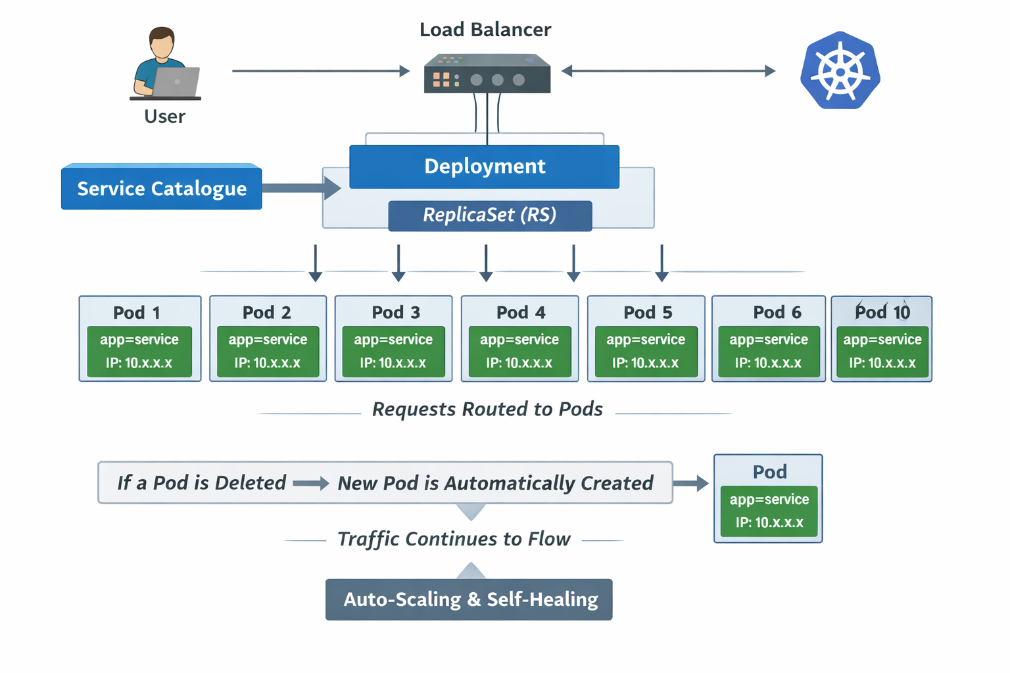

yaml kind of creation of deplyment:
cluster -> inside the ckuster only
loadbalancees- expose to external world
Nodepart ->Inside the orgnazsation
IngressL-> nginx ingres controller needed
config files ands secrets,
config for nonsecure values, secrest fro secure values
container and kuberntes in productio which are running, cant able to , detect the change in env , variables,
so we need to restart the container, so this may casued traffc is loss,
so instead of container restart or recreate we can just use the , _{volumes mount}

_{Rbac:}
_{users and services}
_{user management :}
_{sergice management:}
_{1.serrvice account}
_{2.roles/cliuster roles}
_{3.role binding /crb}

