Case Study : Performance Driven Solution for Green Industry

http://www.ideas2it.com/images/tiny-home-images/logo.png









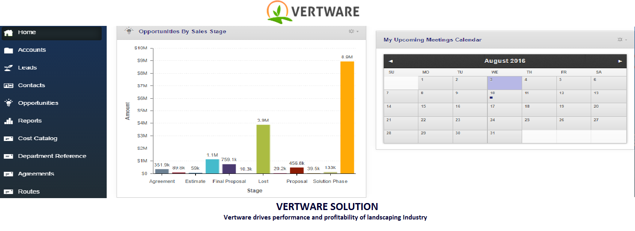

Contractors in the Landscaping Business need to visualize their sales pipeline, control their operations, build estimates, track their delivery services, and generate reports within a single system. They also need to perform financial planning for the upcoming year and measure actual performance against planned. Contractors also need to measure their performance against average industry performance using specific KPIs.

Employees (users) also need to generate estimated cost of an opportunity and suggested price for an agreement to ensure that their gross profit margins are in line with company and department expectations. System was also required to track product usage for specific routes and agreements and perform a combined tracking on an agreement level.

Application had to be developed in multiple phase with the first phase going live in a span of six months. This product was deployed in production in multiple instances while in parallel features were being added to the product that had to be deployed in all instances.

REQUIREMENTS

CRM for Landscaping Industry that allows contractors to clearly visualize sales pipeline, sales and revenue data, and real-time account performance data while allowing them to perform financial planning.

We recognized that the solution needed to be a multi-tenant CRM that leverages data from multiple customers to generate average KPIs and measures clients against average performance of the wide range of customer base.

The first phase of application was developed using Zurmo, a Yii based CRM platform written in PHP, which reduced the time to develop and market the product. This allowed the customer to test the product with their customers and obtain feedback. Additional modules that were required by the client were developed on Zurmo.

We also developed an automation script using Fabrik that allows simultaneous deployment of code to multiple servers.

Currently, the product is being currently developed using Laravel which allows additional accounting based functionalities to be added to the final product and introduces multi tenancy.

***ERP Integration :*** QuickBooks, Salesforce

***Success Story :*** Using this solution, customer has successfully sold the product to around eight clients.

***Customer :*** Vertware, a Landscaping Solution Platform

THE WAY

WE WENT ABOUT IT

TECHNOLOGY

LANGUAGES, METHODOLOGIES, DB

**DATABASE**

MySQL

**OTHERS**

**Source Control**

Github

**Project Management**

Getdonedone, Excel

**HOSTING**

Amazon AWS

**TOOLS**

Zurmo (Yii)

**METHODOLOGIES**

Agile

**PLATFORMS / LANGUAGES**

PHP, Laravel, Amazon AWS

**JavaScript**

jQuery

**HTML/CSS**

Bootstrap













CUSTOMER SEGMENT



Landscaping

4 FTE







800, West El Camino Real, #180, Mountain View, CA 94040. contact@ideas2it.com +14087559621 www.ideas2it.com

INDUSTRY

CUSTOMER LOCATION

USA

DELIVERY MODEL

TIME & MATERIAL

TEAM SIZE

1 year

PROJECT DURATION

Start-up