LEETCODE – Problems
BLIND-75

21. Merge two sorted linked lists -
Example1 : Input: list1 = [1,2,4], list2 = [1,3,4] Output: [1,1,2,3,4,4]
Example 2: Input: list1 = [], list2 = [] Output: []
Example 3: Input: list1 = [], list2 = [0] Output: [0]

Solution :
Merge as per given order.
BF -> iterate over a list until one point to null , if list1 node < list2 node . .. then add .
Approach1 : start with a dummy node, and a tail node. Iterate and compare nodes of list1,list2 . Move tail.next .
Approach2 : To merge in sorted order Iterate over lists. Check pointers as L1<l2 -> dummy.nest=l1 .

1.Two Sum –
Example 1: Input: nums = [2,7,11,15], target = 9 Output: [0,1]
Explanation: Because nums[0] + nums[1] == 9, we return [0, 1].
Example 2: Input: nums = [3,2,4], target = 6 Output: [1,2]
Example 3: Input: nums = [3,3], target = 6 Output: [0,1]

20. Valid parenthesis-
Example 1: Input: s = "()" Output: true
Example 2: Input: s = "()[]{}" Output: true
Example 3: Input: s = "(]" Output: false
Example 4: Input: s = "([])" Output: true
Example 5: Input: s = "([)]" Output: false

125.Valid Palindrome-
Example 1: Input: s = "A man, a plan, a canal: Panama" Output: true
Explanation: "amanaplanacanalpanama" is a palindrome.
Example 2: Input: s = "race a car" Output: false
Explanation: "raceacar" is not a palindrome.
Example 3: Input: s = " " Output: true
Explanation: s is an empty string "" after removing non-alphanumeric characters.
Since an empty string reads the same forward and backward, it is a palindrome.

100.Same tree-
Input: p = [1,2,3], q = [1,2,3] 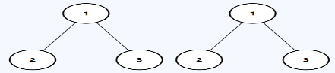 Output: true
Input: p = [1,2], q = [1,null,2] 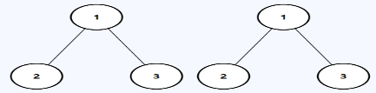 Output: false
Input: p = [1,2,1], q = [1,1,2] 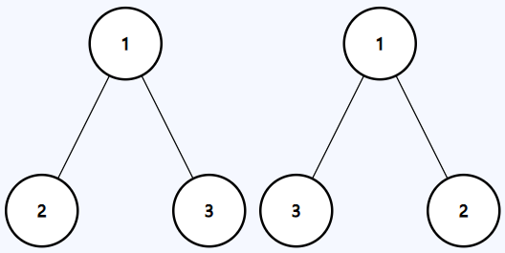 Output: false

Solution :
Use Depth-First Search (DFS ) , even if one node is null but other isn’t then it will mismatch.
If both is null -> true : false. If not null , return the same function with next nodes as (p.left , q.left || p.right && q.right )
Because at end both node’s left,right would be null. O(log (n) ) / O(n)
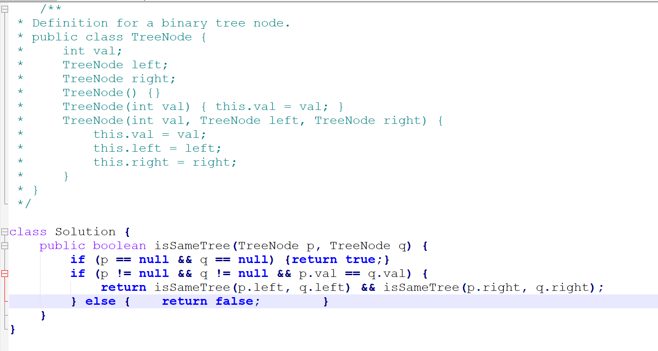
Best : Iterative DFS : both null -> continue ;

104. Maximum Depth of Binary Tree –
Input: root = [3,9,20,null,null,15,7] Output: 3

