# ALPR Project: Technical Proposal for Database and Visualizations Selection

# Created by Ramkumar Sembaiyan [12-Oct-2024]

# 1. Database Selection for ALPR System

For an **Automatic License Plate Recognition (ALPR)** system, the choice between **SQL** and **NoSQL** databases depends on the specific requirements of our system, including data structure, scalability, and query needs. Here’s a breakdown of when we can use each type and the pros and cons of both for an ALPR system:

|  |  |  |
| --- | --- | --- |
| **Criteria** | **SQL (Relational)** | **NoSQL (Non-relational)** |
| **Data structure** | Structured (fixed schema) | Unstructured/semi-structured (flexible schema) |
| **Scalability** | Vertical (scale-up with more powerful servers) | Horizontal (scale-out across many servers) |
| **Data relationships** | Ideal for complex relationships (e.g., vehicles, plates, events) | Not as good for relational data, better for unstructured |
| **Data integrity** | Strong (ACID compliance) | May sacrifice consistency for performance |
| **Performance** | Good for moderate data sizes, but can slow down with large-scale operations | Optimized for high-velocity, large-scale data |
| **Complex querying** | Excellent (supports JOINs, aggregations) | Limited (complex queries can be inefficient) |

#### Recommendations:

If ALPR system requires **structured data with strong relationships** (e.g., vehicles, cameras, license plates, violations), SQL (e.g., MySQL, PostgreSQL) would be a better fit.

If ALPR system needs to handle **massive amounts of unstructured or semi-structured data** (e.g., images, high-velocity logs) and scalability is a concern, NoSQL (e.g., MongoDB, Cassandra) may be more appropriate.

### Comparisons between Popular relational DB :

|  |  |  |
| --- | --- | --- |
| **Criteria** | **MySQL** | **SQL Server** |
| **Cost** | Free and open-source | Paid, except for limited Express version |
| **Community Support** | Extensive, large open-source community | Strong, but focused on enterprise users |
| **Performance** | Great for moderate traffic and read-heavy applications | Optimized for large-scale data with enterprise-grade performance |
| **Scalability** | Scales well with tuning, but more suited for smaller datasets | Easily scalable for high transaction volumes and large datasets |
| **Features** | Basic features, lacks advanced analytics | Advanced features (in-memory processing, data warehousing) |
| **Security** | Basic security features | Strong security (row-level security, encryption) |
| **Backup & Recovery** | Requires manual setup for point-in-time recovery | Advanced backup features (point-in-time, transaction logs) |
| **Cloud Compatibility** | Widely supported (AWS, Azure, GCP) | Best with Microsoft Azure and integration with other Microsoft tools |
| **Ease of Use** | Easy to set up and maintain | More complex setup and maintenance |
| **Integration** | Works with most systems and cloud platforms | Seamless integration with Microsoft ecosystem (Power BI, Azure, etc.) |

### Popular Cloud Databases

|  |  |  |
| --- | --- | --- |
| **Cloud DB** | **Description** | **Advantages** |
| **Amazon RDS (MySQL or SQL Server)** | Managed relational database service from AWS, supports both MySQL and SQL Server. | - Fully managed |
| - Auto-scaling |
| - Multi-AZ for high availability |
| **Azure SQL Database** | Managed SQL Server in the cloud, part of Microsoft Azure. | - Best for SQL Server |
| - Seamless integration with Power BI |
| - High security and scalability |
| **Google Cloud SQL (MySQL)** | Managed MySQL service from Google Cloud Platform (GCP). | - Fully managed |
| - Auto-scaling |
| - Multi-regional deployments |
| **Amazon Aurora (MySQL-compatible)** | High-performance managed MySQL-compatible database from AWS. | - Better performance than MySQL |
| - Auto-scaling and high availability |
| **Firebase Realtime Database (NoSQL)** | Managed NoSQL cloud database by Google, designed for real-time apps. | - Great for real-time updates |
| - Simplified schema for ALPR events |
| **MongoDB Atlas (NoSQL)** | Managed cloud version of MongoDB, a popular NoSQL database. | - Document-based, ideal for flexible data structures |
| - Auto-scaling |

#### Recommendation

For **budget-conscious ALPR projects** that don’t require advanced features, **MySQL** would be a better choice. However, if your ALPR system grows in scale and you need enterprise-level features, **SQL Server** would be the preferred option despite the cost.

We shall start with mysql DB and upgrade to enterprise /Cloud DB as data grows.

## Proposed Database Tables for ALPR

To collect various data for analysis and perform datascience, we may start with following tables.

#### 1. Camera Location Table (infer_alprcameraloc)

This table stores details about the ALPR cameras, including their location and technical specifications. Each camera is uniquely identified by a camera_id. This table is essential for tracking the hardware configuration and placement of cameras across different locations, enabling efficient diagnostics and maintenance.

|  |  |  |
| --- | --- | --- |
| **Field** | **Description** | **Type** |
| camera_id | Unique identifier for the camera | INT |
| Type | Type of camera (e.g., fixed, mobile) | VARCHAR |
| Resolution | Camera resolution (e.g., 1080p, 720p) | VARCHAR |
| FPS | Frames per second captured by the camera | INT |
| locationaddress | Physical address or location description | VARCHAR |
| latitude | latitude altitude in meters | DECIMAL |
| longitude | Longitude of the camera location | DECIMAL |
| cameraposition | Camera mounting position (e.g., overhead, side) | VARCHAR |

#### **2. ALPR Details Table (infer_alpr_details)**

The infer_alpr_details table captures the key results from the ALPR system, including the license plate number, associated camera, and additional vehicle-related details. This table enables analysis of ALPR results, confidence levels, and vehicle classification. The image_path links to the actual image stored on disk.

|  |  |  |
| --- | --- | --- |
| **Field** | **Description** | **Type** |
| ALPRId | Unique identifier for each ALPR record | INT |
| camera_id | Reference to the camera that captured the data | INT |
| V_Platenumber | Detected vehicle license plate number | VARCHAR |
| timestamp | Time when the vehicle was recognized | TIMESTAMP |
| image_path | Path to the stored image (in the server directory or cloud S3 bucket) captured by the camera | VARCHAR |
| Confidencescore | Confidence score of the ALPR detection | DECIMAL |
| VehicleType | Type of vehicle (e.g., car, truck, bike) | VARCHAR |
| FuelType | Fuel type of the vehicle | VARCHAR |
| RegistrationState | Vehicle's registration state or region | VARCHAR |
| Error | Error encountered during recognition, if any | VARCHAR |
| EventsCalled | Events triggered by the ALPR system | VARCHAR |

#### **3. ALPR Events Table (infer_alpr_events)**

The infer_alpr_events table tracks each event triggered by the ALPR system, including the steps taken during event handling and any custom data fields for additional insights. This table provides a detailed audit trail of ALPR-triggered events after detecting the license plates, supporting monitoring and troubleshooting of the system.

|  |  |  |
| --- | --- | --- |
| **Field** | **Description** | **Type** |
| EventId | Unique identifier for each event | INT |
| ALPRId | Reference to the related ALPR record | INT |
| camera_id | Camera involved in the event | INT |
| V_Platenumber | License plate involved in the event | VARCHAR |
| timestamp | Timestamp of the event | TIMESTAMP |
| EventStepid | Step identifier in the event workflow | INT |
| EventStatus | Status of the event (e.g., success, failure) | VARCHAR |
| Error | Error encountered, if any | VARCHAR |
| Customfield1 | Custom field for additional event-specific data | VARCHAR |
| Customfield2 | Additional custom data field | VARCHAR |
| Error | Field for storing specific error details | VARCHAR |
| Customfield3 | Third custom field for other details | VARCHAR |

#### **4. ALPR Exceptions Table (infer_alprexception)**

This table stores exceptions or errors encountered by the ALPR system, as well as recommended next steps for resolution.

|  |  |  |
| --- | --- | --- |
| **Field** | **Description** | **Type** |
| Exceptionid | Unique identifier for the exception | INT |
| ALPRId | Reference to the related ALPR record | INT |
| Camera_Id | Camera involved in the exception | INT |
| Exception | Description of the exception | VARCHAR |
| NextSteps | Recommended steps to resolve the exception | VARCHAR |

‘* Attached CSV files to show how the DB tables look.

## Important Data collection and Ingestion Consideration in the Design:

If the ALPR system is expected to scale significantly—handling large volumes of transactions, data, and traffic—switching to a **messaging architecture** becomes crucial to avoid these potential bottlenecks.

Here’s when messaging architecture should be considered as the system scales:

1. Reducing Database Load
2. Mitigating Database Locking Issues
3. Enhancing Scalability
4. Asynchronous Processing
5. ALPR in Edge computing

#### **Example of a Messaging Architecture Flow**

1. **Cameras** capture vehicle data and send it to **Kafka** (or any message broker using).
2. **Kafka** queues the messages and buffers them for the processing service.
3. The **ALPR Processor** subscribes to the Kafka queue, processes the vehicle data using the ALPR model, and extracts relevant information.
4. The processed data (e.g., plate number, image path) is sent to a **SQL/NoSQL Database** for storage.
5. The **real-time dashboard** (Power BI/Grafana) queries the database or subscribes to an update service to visualize the data in real-time.

# Visualization -Report and Dashboard Considerations

When it comes to developing dashboards for Automatic License Plate Recognition (ALPR) systems, several tools cater to different needs, capabilities, and expertise levels. Here’s a brief overview of some popular options:

• **Power BI**: A powerful, user-friendly analytics tool offering extensive data visualization capabilities and a free desktop version.

• **Grafana**: An open-source platform ideal for real-time monitoring and visualization of time-series data, easily extensible with plugins.

• **Metabase**: A straightforward open-source business intelligence tool that allows for easy dashboard creation and data exploration without advanced skills.

• **Tableau**: A robust data visualization tool known for its advanced analytics and rich features for creating interactive dashboards (subscription-based).

• **Custom Developed Apps**: Tailored applications that provide complete control over dashboard functionality and integration, requiring development resources.

To begin our experience with data visualization, we will start with Power BI Desktop, which offers a user-friendly interface and robust features at no cost

Note: Below is only for examples: we need to deep dive on what visualizations are required for real time in ALPR

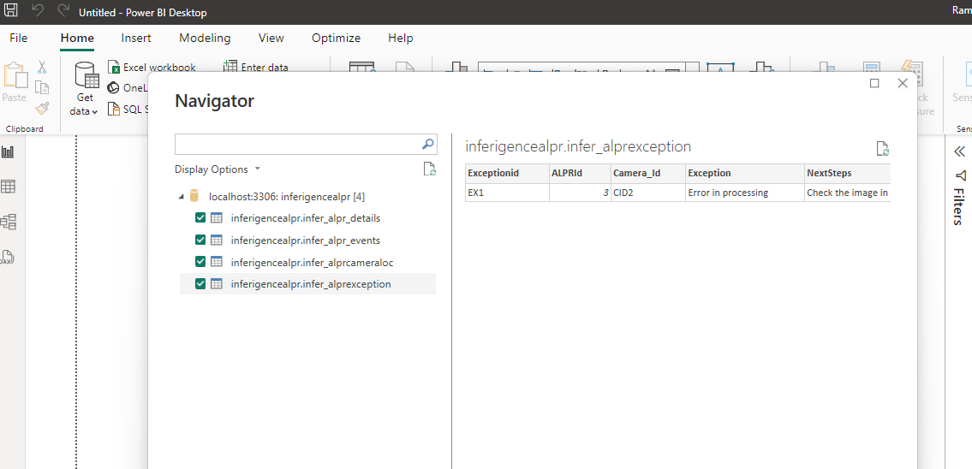

## Visualizations [PowerBI Desktop Reports]

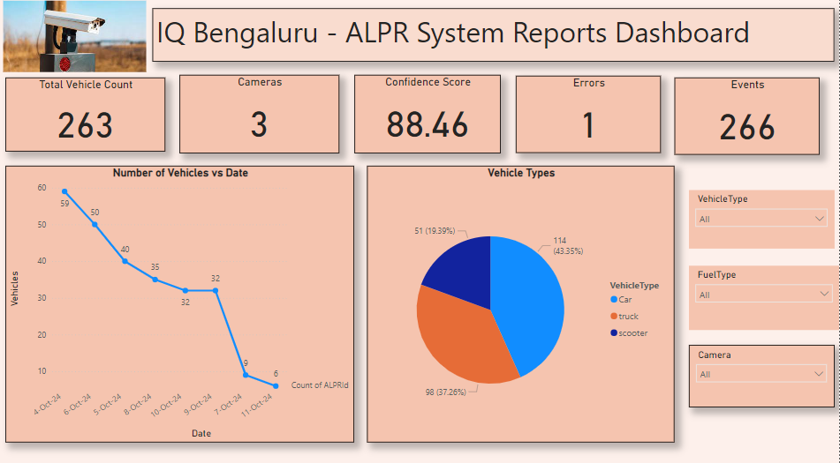

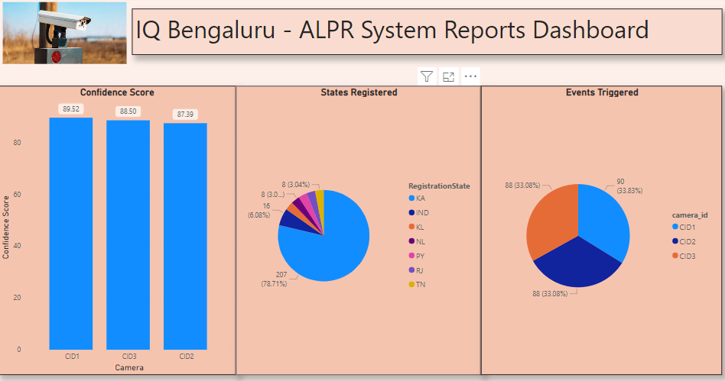

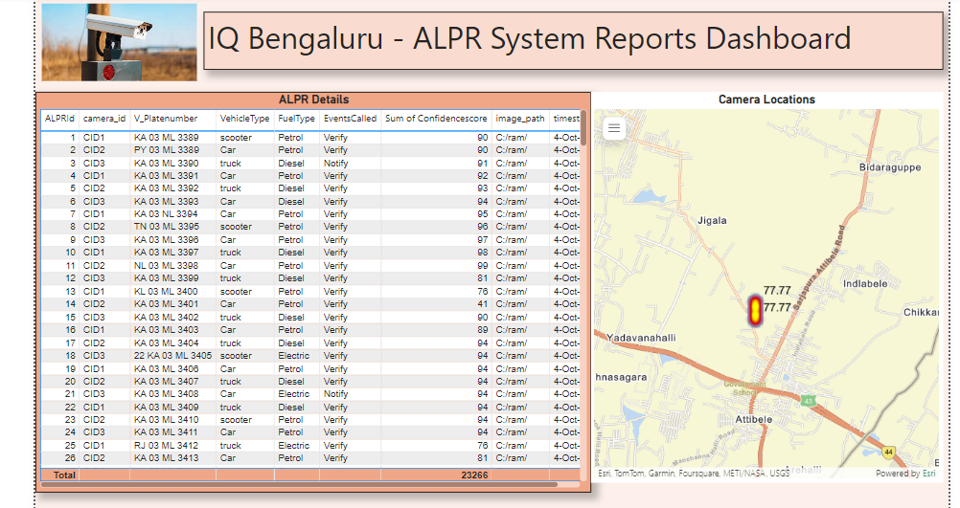

If we finalize Power BI service for Dashboards, we can use the premium with nominal charge (20$ per month) for all the products in the organization, which has many features including autorefresh, sharing the dashboards ,subscribe alert etc. Until then we can use the free desktop version. We can also explore Graffana, and other custom dashboards tools if PowerBI is not suitable.

## Reports in Power BI Service (cloud based)

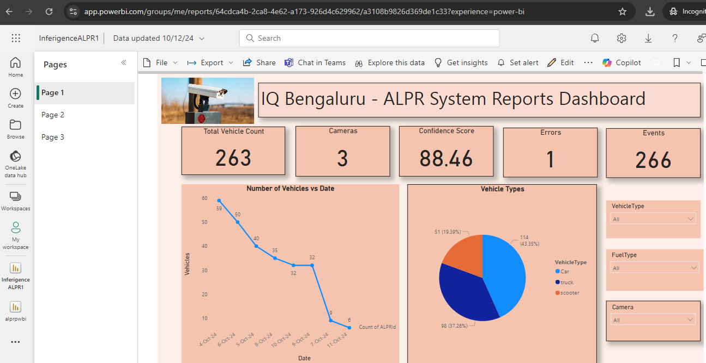

### The final dashboard may look like below in power BI service portal

