Verified Features of AXI4 Slave RTL:

1. Multiple Address Write Verification:
The AXI4 Full Slave was verified using multiple independent write transactions directed to different user-defined memory locations. Three unique addresses were issued with corresponding write data values. Unlike burst transfers, each transaction represented an independent write operation. Waveform analysis confirmed that each write request was accepted and processed immediately, and the data was successfully stored at the intended memory locations. Subsequent read operations verified the correctness of the stored data.

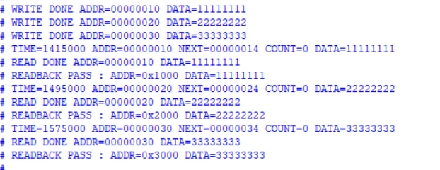
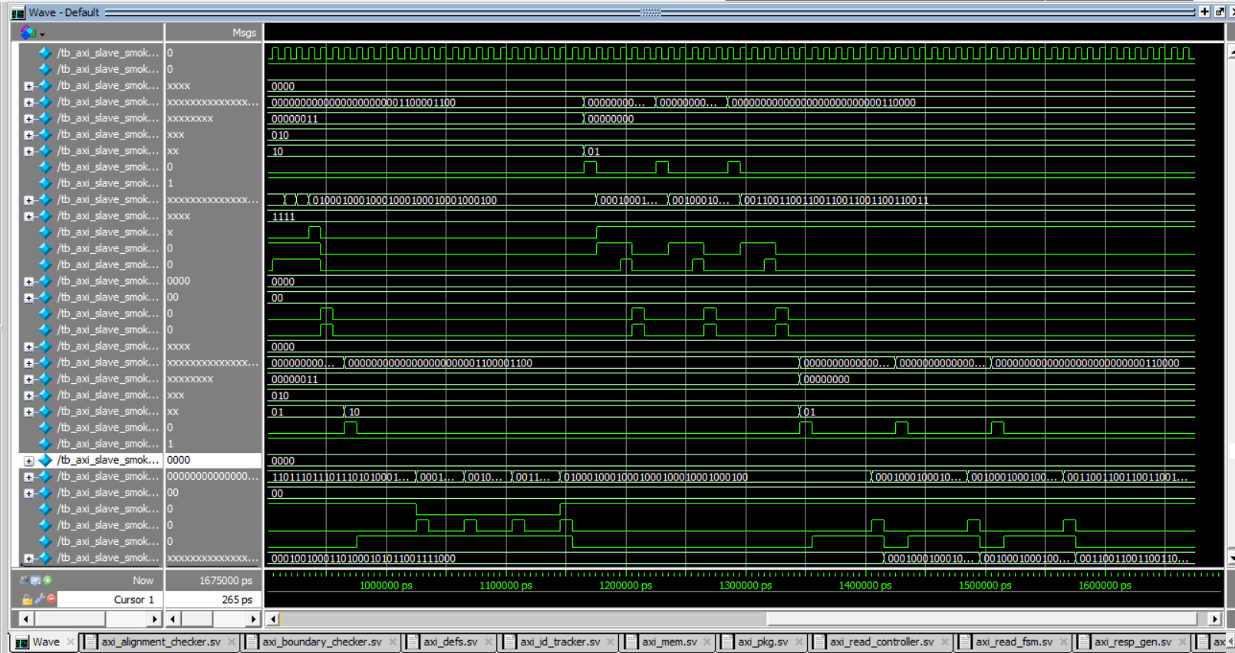

2. Concurrent Read/Write Verification:
The slave was tested under simultaneous read and write activity to verify independent operation of the AXI read and write channels. A write transaction and a read transaction were initiated concurrently. The waveform results confirmed that both transactions progressed independently without blocking or interfering with one another. This demonstrates proper separation of the read and write paths within the AXI4 Full Slave architecture.

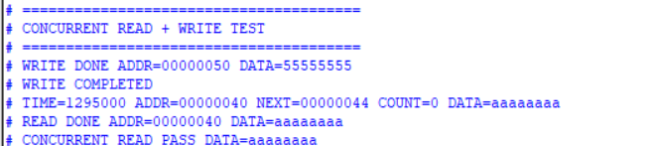
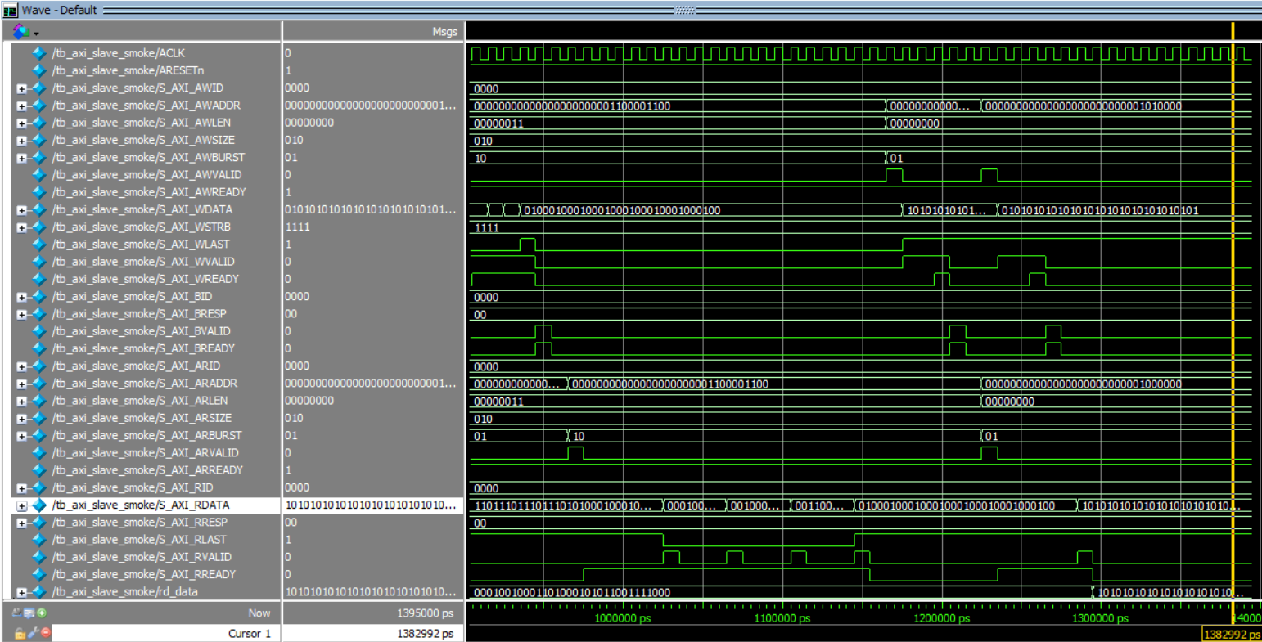
3. Transaction ID Verification:
Multiple transactions were generated using different AXI transaction IDs. The write response channel returned the correct BID corresponding to the issued AWID, while the read response channel returned the correct RID corresponding to the issued ARID. The observed results confirm that transaction identifiers are preserved throughout the protocol flow, ensuring correct transaction tracking and response association.
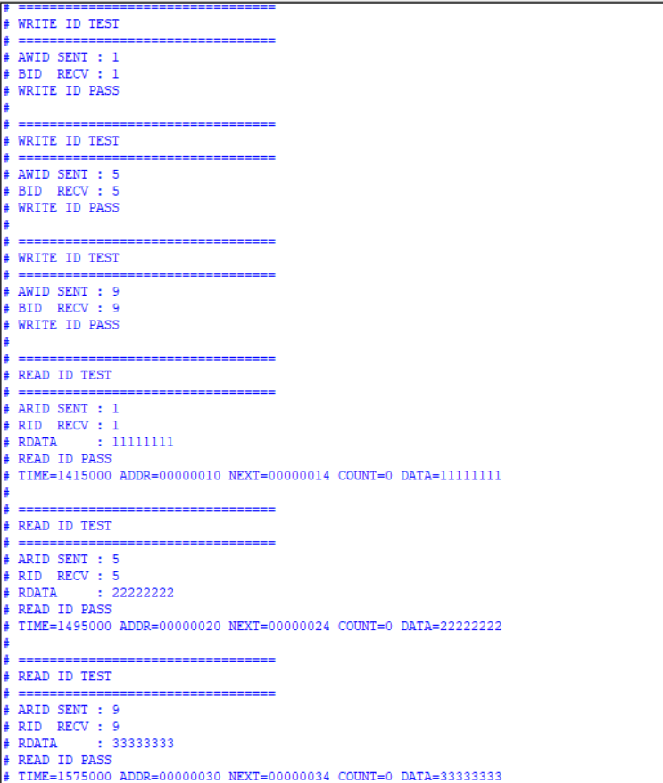

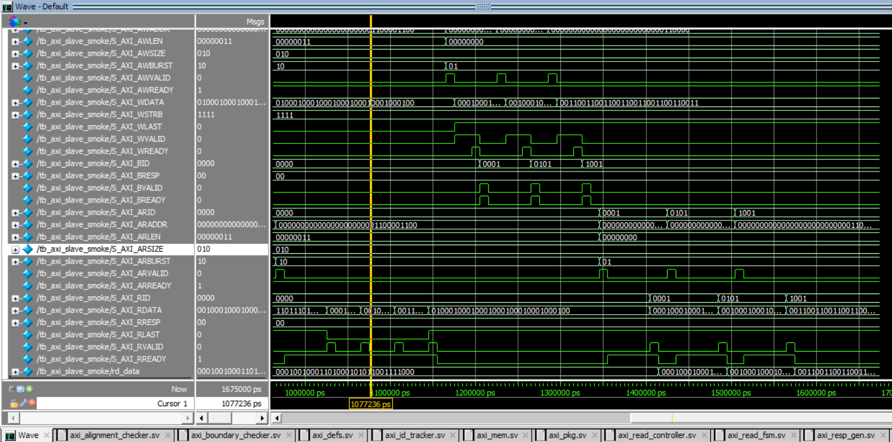
4. Multiple Outstanding Transactions Verification:
Multiple write address transactions were issued before the completion of previous transactions. The incoming requests were buffered within the internal transaction FIFO and serviced sequentially by the write channel. Waveform analysis confirmed that pending transactions remained stored until they were processed, demonstrating the ability of the AXI4 Full Slave to accept and manage multiple outstanding transactions while maintaining correct transaction ordering.
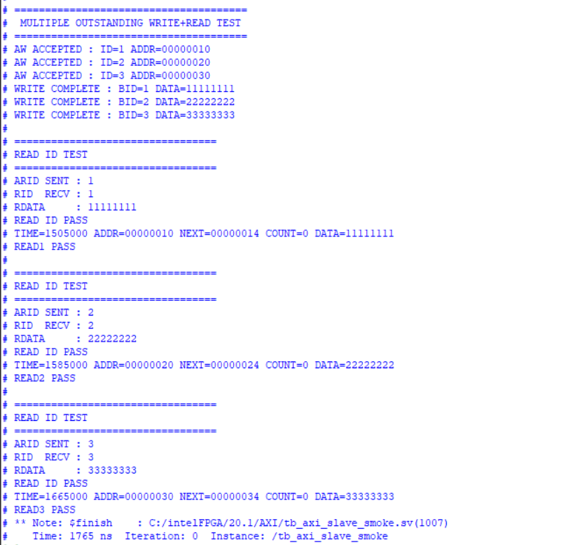

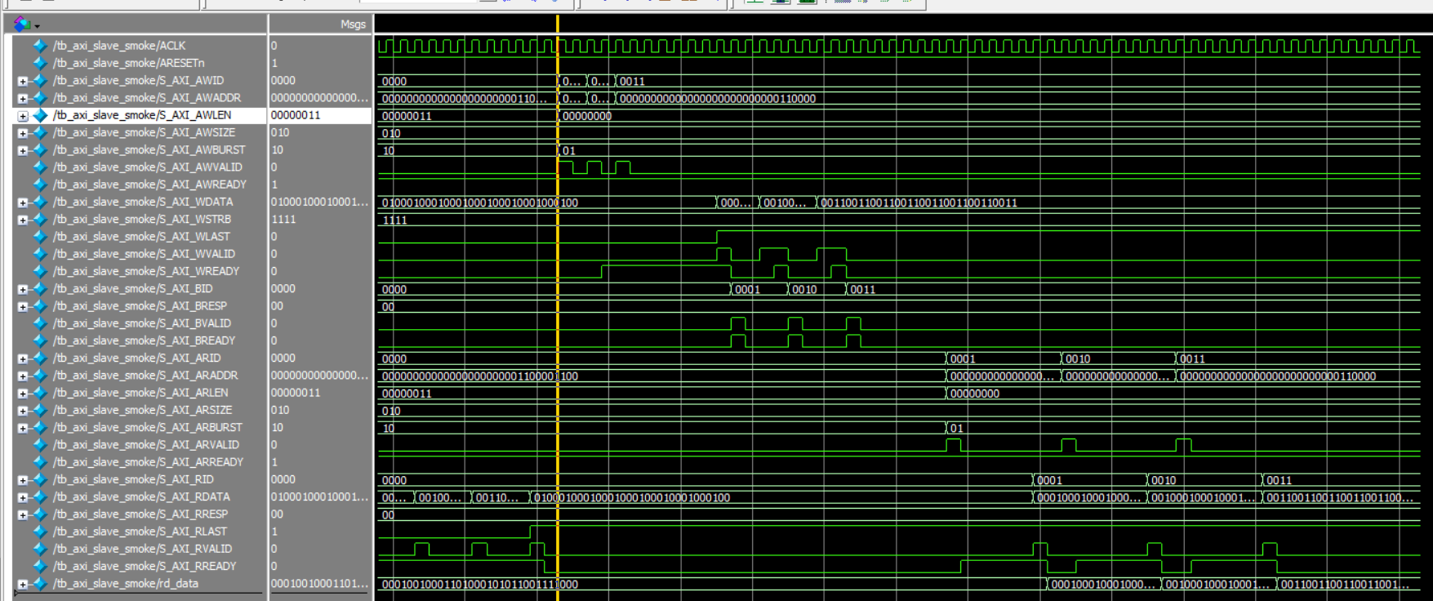
5. Backpressure Verification:
Backpressure behaviour was verified by intentionally delaying the assertion of BREADY and RREADY signals. During this period, the slave maintained valid response information by keeping BVALID and RVALID asserted until the corresponding ready signal was received. Once the handshake was completed, the transactions proceeded normally. This confirms compliance with the AXI handshake protocol and validates the slave's ability to operate correctly under stalled receiver conditions.
