TryHackMe — Solar, exploiting log4j WRITEUP

Task-2 Reconnaissance
Q. What service is running on port 8983? (Just the name of the software)
A. Apache Solr

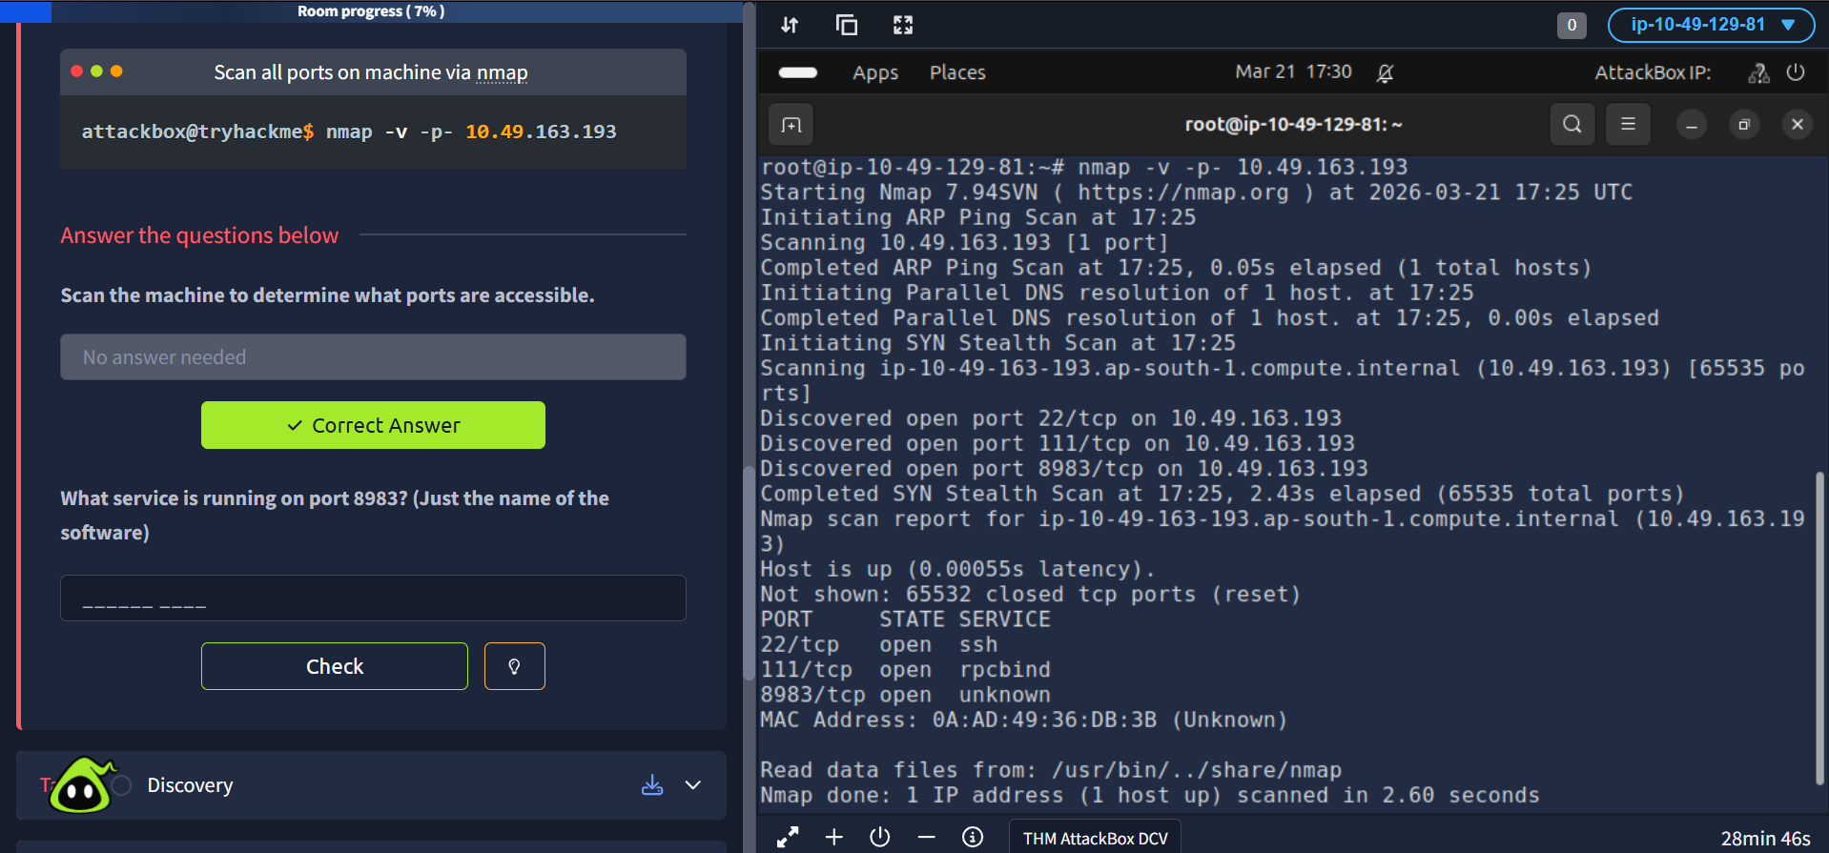
We can search up port 8983 software on the internet to find the answer
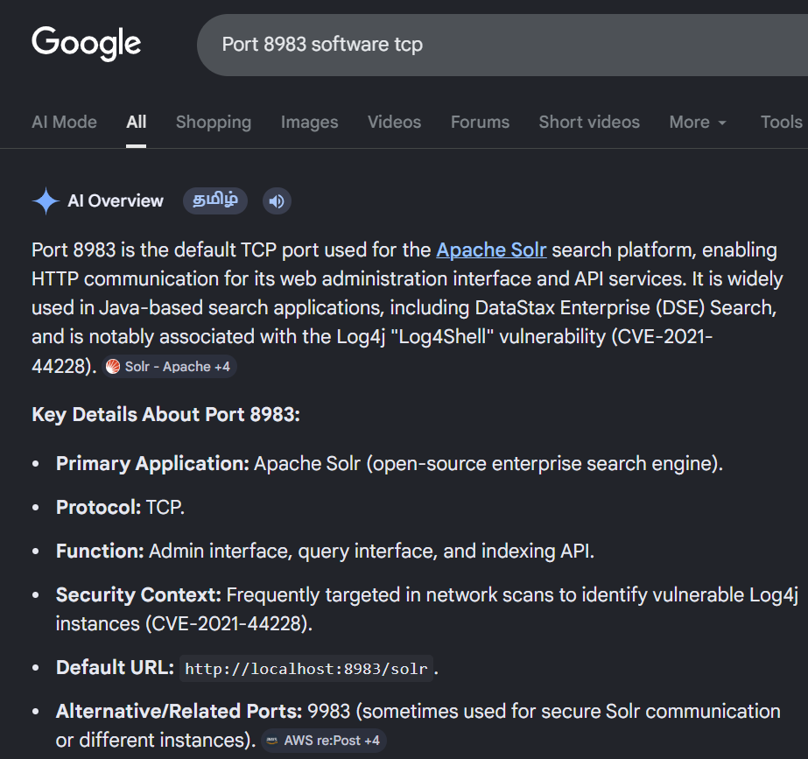
Open http://10.49.163.193:8983(opens in new tab) in new tab in the attackbox’s firefox browser

Task-3 Discovery
Q. Take a close look at the first page visible when navigating to http://10.10.242.148:8983. You should be able to see clear indicators that log4j is in use within the application for logging activity. What is the -Dsolr.log.dir argument set to, displayed on the front page?
A. /var/solr/logs

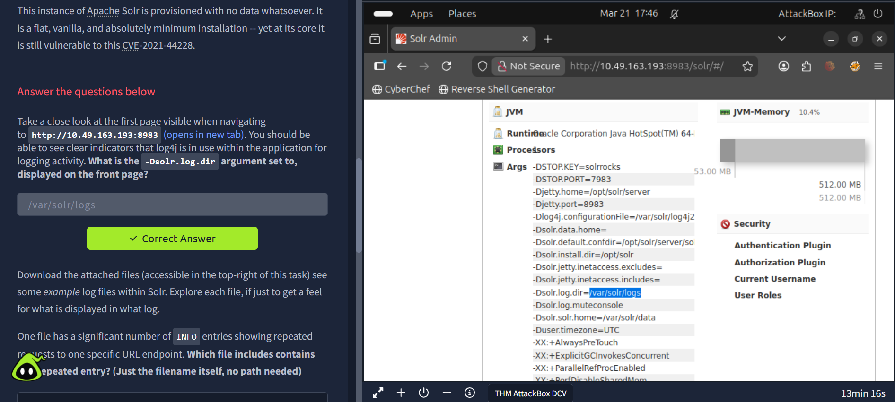

Download the given files in the task, you will see this after extracting the compressed zip file
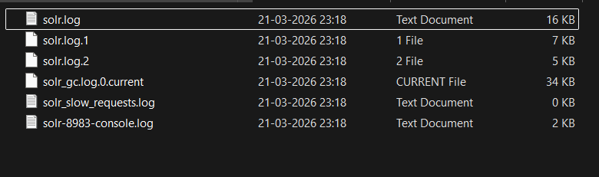
Q. One file has a significant number of INFO entries showing repeated requests to one specific URL endpoint. Which file includes contains this repeated entry? (Just the filename itself, no path needed)
solr.log
Q. What "path" or URL endpoint is indicated in these repeated entries?
/admin/cores

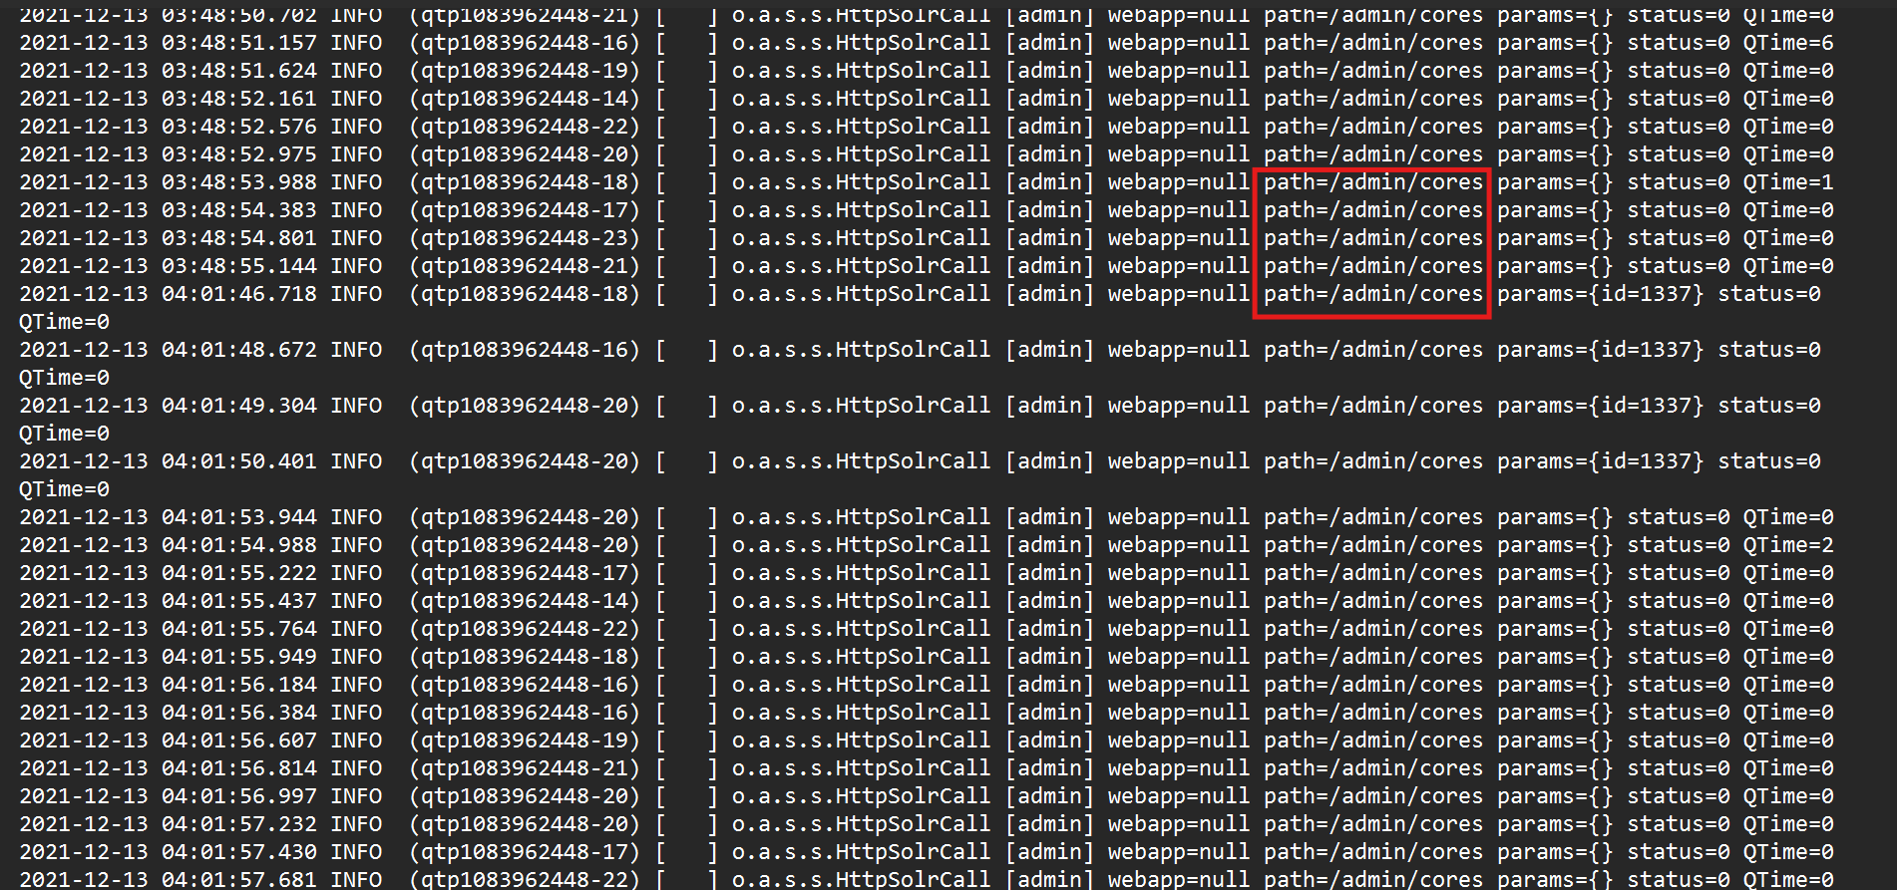
Viewing these log entries, what field name indicates some data entrypoint that you as a user could control? (Just the field name)

params
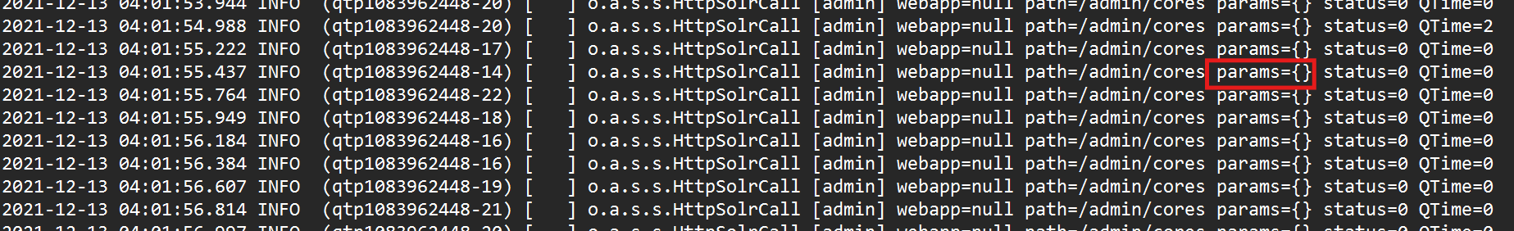

Task-4 Proof of Concept
Q. Read Only

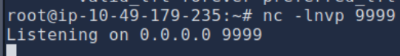

curl is simply acting as a manual HTTP client.
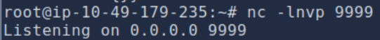
It will take some time

Task-5 Exploitation
Q. What is the output of running this command? (You should leave this terminal window open as it will be actively awaiting connections)
A. listening on 0.0.0.0:1389

Task- 6 Persistence
Q. What user are you?
A. solr

Task-7 Detection
Q. Read Only

Task- 8 Bypasses
Q. Read Only

Task-9 Mitigation
Q. What is the full path of the specific solr.in.sh file?
A. /etc/default/solr.in.sh

Task-10 Patching
Q. Read Only

