**ASSESSMENT OF MARGINAL WORKERS IN TAMILNADU**

**BATCH MEMBER 732521104040 : RAMKUMAR.R**

**Phase 4 submission document**

**Project Title: Assessment of Marginal Workers in TamilNadu**

**Phase 3: *Development Part 1***

**Topic :** In this part you will continue building your project.

Perform the demographic analysis

* Calculate the distribution of marginal workers based on age, industrial category, and sex

using data aggregation and manipulation.

* Create visualizations.

Create visualizations using data visualization libraries (e.g., Matplotlib, Seaborn).

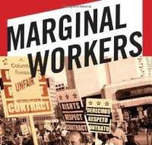

**DATA SOURCE :**

[**https://tn.data.gov.in/catalog/marginal-workers-classified-age-industrial-category-and-sex-census-2011-india-and-states**](https://tn.data.gov.in/catalog/marginal-workers-classified-age-industrial-category-and-sex-census-2011-india-and-states)

**Given data set:**

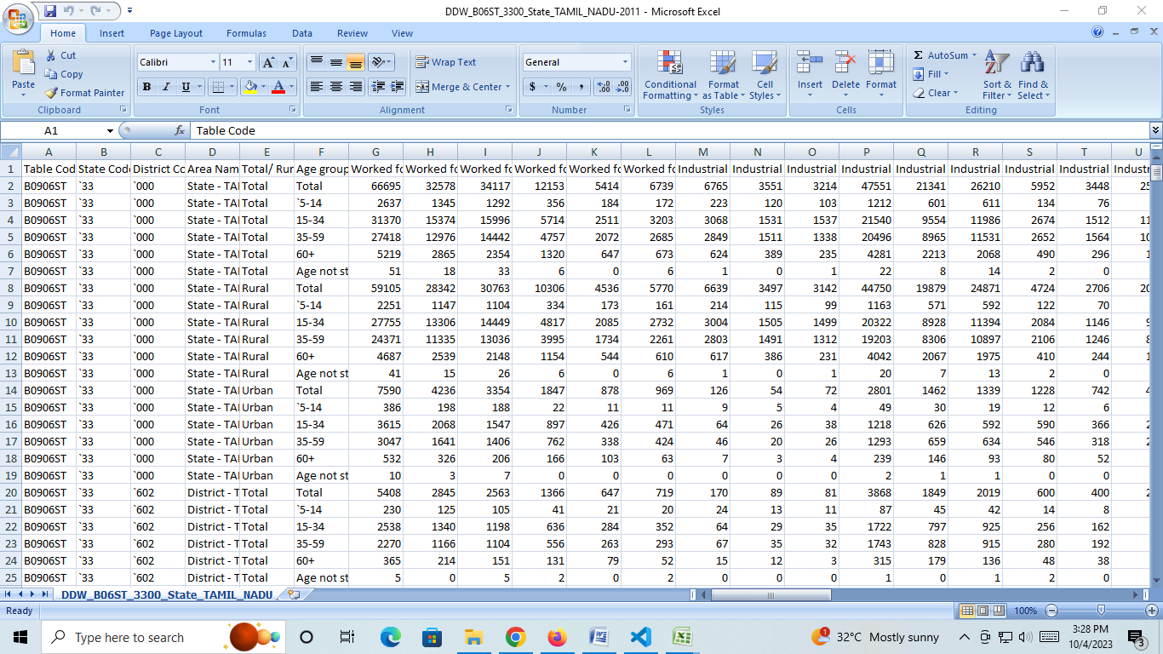

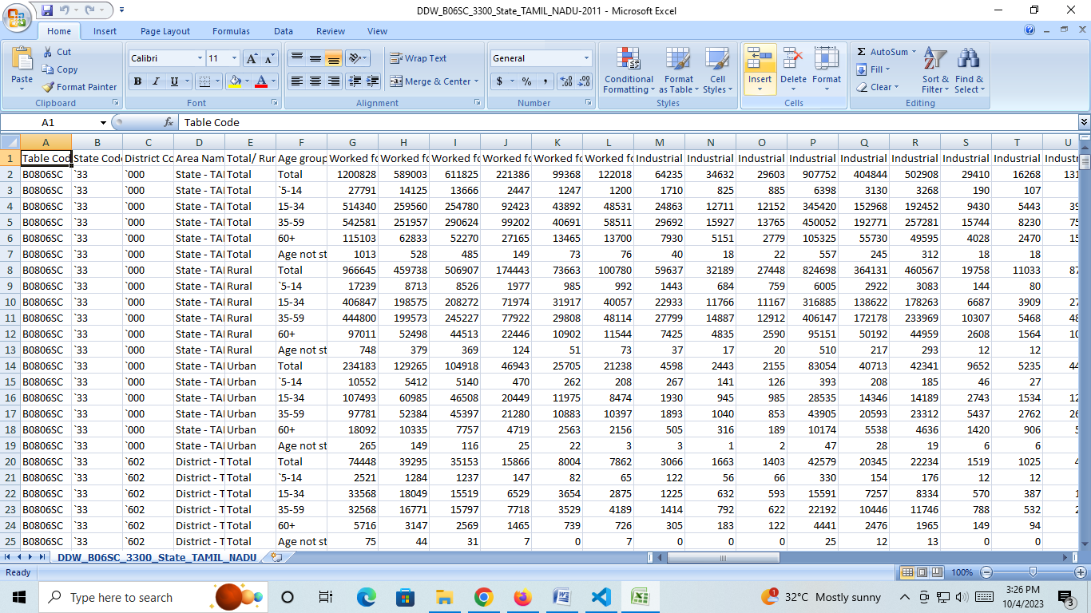

**Demographic Analysis in Assessment of Marginal Workers in TamilNadu :**

Demographic analysis can be crucial when assessing the population of marginal workers in Tamil Nadu, India. To perform such an analysis, you would typically consider factors like:

1. Age: Analyzing the age distribution of marginal workers can reveal trends related to young or aging labor forces.

2. Gender: Understanding the gender distribution among marginal workers can help in identifying gender-based employment disparities.

3. Educational Level: Assessing the education levels of marginal workers can provide insights into skill levels and potential for job mobility.

4. Rural vs. Urban Distribution: Examining whether marginal workers are predominantly from rural or urban areas can inform policy and employment initiatives.

5. Income: Analyzing income levels of marginal workers can highlight income inequality and living standards.

6. Occupational Distribution: Studying the types of jobs marginal workers are engaged in can help tailor vocational training and support programs.

7. Migration Patterns: Investigating if there is significant migration of workers within or outside Tamil Nadu can inform labor market dynamics.

These demographic insights can guide policymakers, organizations, and government agencies in developing targeted programs to uplift and support marginal workers in Tamil Nadu. Data sources for this analysis typically include census data, labor surveys, and employment records.

**How to perform demographic analysis in Assessment of Marginal Workers in TamilNadu :**

Performing a demographic analysis to assess marginal workers in Tamil Nadu involves several steps. Here's a general guide on how to go about it:

1. Define Your Research Objectives:

   Clearly outline what you aim to achieve with your demographic analysis. Are you interested in understanding employment trends, improving job opportunities, or addressing specific issues faced by marginal workers?

2. Data Collection:

   Gather relevant data from various sources, including government census data, labor surveys, and research reports. Ensure the data is up-to-date and specific to Tamil Nadu.

3. Select Key Demographic Factors:

   Identify the demographic factors you want to analyze. As mentioned earlier, these can include age, gender, education, income, occupation, location (rural or urban), and more.

4. Data Cleaning and Preparation:

   Clean and organize the data. This may involve dealing with missing values, outliers, and ensuring data consistency.

5. Data Analysis:

   Utilize statistical and data analysis tools to examine the data. Create visualizations such as graphs and charts to present your findings effectively.

6. Interpret the Results:

   Analyze the data to draw meaningful insights. For example, you might find that a significant proportion of marginal workers in Tamil Nadu are young, female, and engaged in low-paying agricultural jobs.

7. Comparative Analysis:

   Compare your findings with historical data or with data from other regions to identify trends and anomalies.

8. Policy Implications:

   Use your analysis to suggest policy changes or interventions that could benefit marginal workers in Tamil Nadu. This might include educational programs, skills training, and employment initiatives.

9. Disseminate Findings:

   Share your results with relevant stakeholders, including government bodies, non-profit organizations, and academic institutions. Effective communication can help drive change and improvement.

10. Review and Update:

   Demographic analysis is an ongoing process. Continuously monitor and update your analysis to keep it relevant and effective in addressing the evolving needs of marginal workers.

It's important to note that this process may require expertise in data analysis and statistical tools. Collaborating with researchers or experts in the field can be beneficial. Additionally, adhering to ethical guidelines and ensuring data privacy is crucial when working with sensitive demographic data.

**Calculate the distribution of marginal workers based on age, industrial category, and sex using data aggregation and manipulation.**

To calculate the distribution of marginal workers based on age, industrial category, and sex, you can use a programming language like Python and a data manipulation library such as Pandas. Here's a simplified example program that demonstrates how to perform this task:

```python

import pandas as pd

# Sample data (replace with your actual data source)

data = {

    'Age': [25, 35, 45, 28, 40, 50, 30],

    'Industrial_Category': ['Agriculture', 'Manufacturing', 'Services', 'Agriculture', 'Manufacturing', 'Services', 'Agriculture'],

    'Sex': ['Male', 'Female', 'Male', 'Female', 'Male', 'Female', 'Male'],

}

# Create a DataFrame from the data

df = pd.DataFrame(data)

# Perform data aggregation

result = df.groupby(['Age', 'Industrial_Category', 'Sex']).size().reset_index(name='Count')

# Print the distribution

print(result)

```

In this program:

1. You define a sample dataset with columns for Age, Industrial Category, and Sex. Replace this with your actual dataset.

2. Create a Pandas DataFrame from the data.

3. Use the `groupby` method to group the data based on Age, Industrial Category, and Sex.

4. The `size()` method counts the number of occurrences in each group, and `reset_index` resets the index to make it more readable.

5. Finally, you print the distribution, which will display the count of marginal workers by age, industrial category, and sex.

Make sure to replace the sample data with your actual dataset for a meaningful analysis. Additionally, you might want to load data from a CSV file, a database, or another source depending on your data availability.

**Create visualizations using data visualization libraries (e.g., Matplotlib, Seaborn).**

To perform a demographic analysis of marginal workers in Tamil Nadu and create visualizations, you can use Python with libraries like Pandas for data manipulation and Matplotlib or Seaborn for creating visualizations. Here's a simplified program:

```python

import pandas as pd

import matplotlib.pyplot as plt

import seaborn as sns

# Sample data (replace with your actual data source)

data = {

    'Age': [25, 35, 45, 28, 40, 50, 30],

    'Gender': ['Male', 'Female', 'Male', 'Female', 'Male', 'Female', 'Male'],

    'Education': ['High School', 'College', 'High School', 'High School', 'College', 'College', 'High School'],

    'Income': [3000, 4500, 2500, 3200, 4800, 4000, 2700],

}

# Create a DataFrame from the data

df = pd.DataFrame(data)

# Visualization 1: Age Distribution

plt.figure(figsize=(8, 6))

sns.histplot(data=df, x='Age', kde=True)

plt.title('Age Distribution of Marginal Workers')

plt.xlabel('Age')

plt.ylabel('Frequency')

plt.show()

# Visualization 2: Gender Distribution

plt.figure(figsize=(8, 6))

sns.countplot(data=df, x='Gender')

plt.title('Gender Distribution of Marginal Workers')

plt.xlabel('Gender')

plt.ylabel('Count')

plt.show()

# Visualization 3: Education Level

plt.figure(figsize=(8, 6))

sns.countplot(data=df, x='Education')

plt.title('Education Level of Marginal Workers')

plt.xlabel('Education')

plt.ylabel('Count')

plt.xticks(rotation=45)

plt.show()

# Visualization 4: Income Distribution

plt.figure(figsize=(8, 6))

sns.histplot(data=df, x='Income', kde=True)

plt.title('Income Distribution of Marginal Workers')

plt.xlabel('Income')

plt.ylabel('Frequency')

plt.show()

```

This program provides four visualizations based on age, gender, education level, and income of marginal workers. Make sure to replace the sample data with your actual dataset. You may want to load your data from a CSV file or another source.

Ensure you have the required Python libraries installed by running `pip install pandas matplotlib seaborn` if you haven't already.