Week 2 Task
Data Visualization and Insight Communication using R
Dataset: Video Game Sales with Ratings (continued from Week 1)
(16,717 cleaned records, 1980–2020)
Prepared by: Ram Kumar Gunasekaran
Power BI Developer | Data Analyst | SQL Specialist
Chennai, Tamil Nadu, India
Tool used: R | Package: ggplot2

1. Task Objective
This report builds on the Week 1 data cleaning exercise, shifting focus from preparation to communication. Using the cleaned Video Game Sales with Ratings dataset (16,717 records), eight distinct visualizations were created with ggplot2 to surface trends, patterns, and relationships that would be difficult to spot in raw tabular data. Each chart is paired with a plain-language narrative aimed at a non-technical reader, explaining not just what the chart shows but why it matters.

1.1 Data Overview
The dataset carried forward from Week 1 includes the following key variables used across this week's visualizations:
Variable | Type | Role in Visualizations
Genre | Categorical | Grouping variable for sales comparison
Platform | Categorical | Grouping variable for per-game sales spread
Year_of_Release | Numerical | Time axis for trend charts
Global_Sales_Capped | Numerical | Primary sales metric (outlier-capped in Week 1)
Critic_Score / User_Score | Numerical | Review quality metrics
NA_Sales, EU_Sales, JP_Sales, Other_Sales | Numerical | Regional sales breakdown
Rating | Categorical | ESRB content rating

Setup code shared across all visualizations:
library(ggplot2)
df <- read.csv("vgsales_cleaned.csv", stringsAsFactors = FALSE)
df$Genre <- as.factor(df$Genre)
df$Platform <- as.factor(df$Platform)
df$Rating <- as.factor(df$Rating)

2. Visualization 1 — Bar Chart: Sales by Genre
Chart type chosen: Bar chart. Bars are the clearest way to rank discrete categories by a single numeric value, making genre comparison immediate for any audience.
genre_sales <- aggregate(Global_Sales_Capped ~ Genre, data = df, sum)
genre_sales <- genre_sales[order(-genre_sales$Global_Sales_Capped), ]

ggplot(genre_sales, aes(x = reorder(Genre, Global_Sales_Capped), y = Global_Sales_Capped)) +
geom_bar(stat = "identity", fill = "#2E75B6") +
coord_flip() +
labs(title = "Which Genres Sell the Most Games Worldwide?",
x = NULL, y = "Global Sales (Millions USD)") +
theme_minimal(base_size = 13)
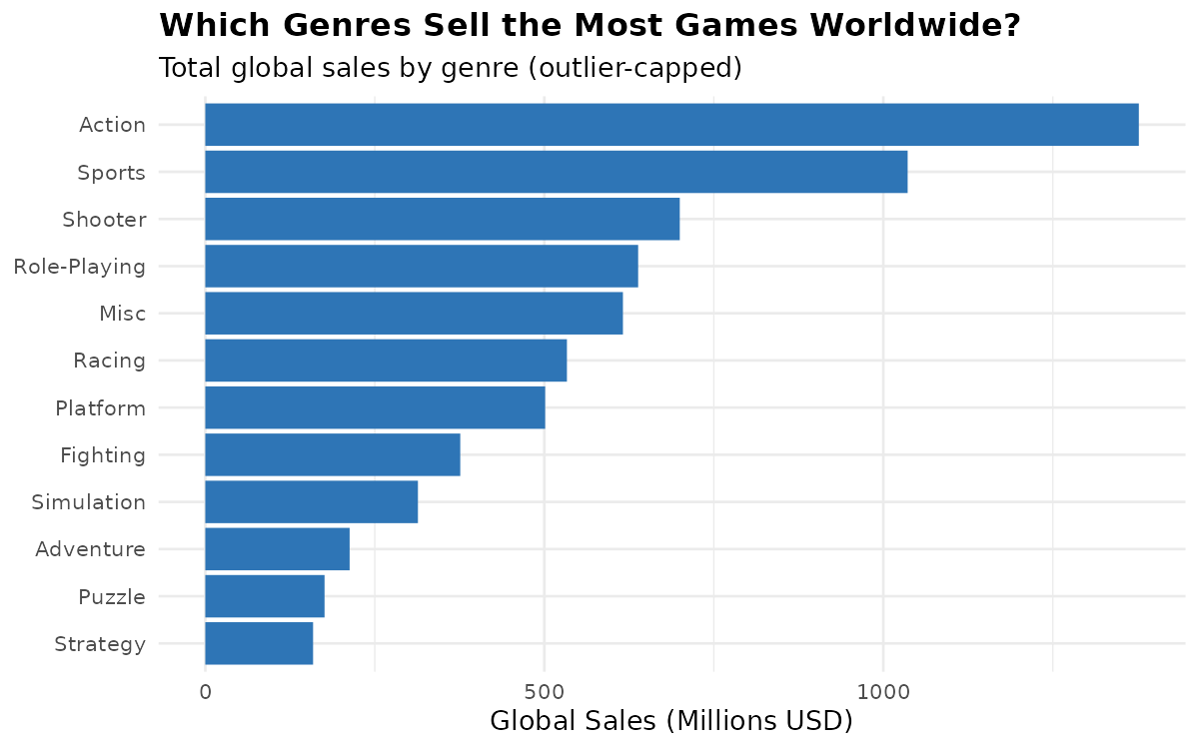
Figure 1: Total capped global sales by genre.
Action ($1,377M) and Sports ($1,036M) are the clear commercial leaders, together accounting for roughly a third of all sales in the dataset. For a publisher deciding where to invest, this chart is a quick visual case for prioritizing these genres — though it says nothing about competition density or genre saturation, which later charts help address.

3. Visualization 2 — Line Chart: Genre Trend Over Time
Chart type chosen: Line chart. Line charts are the standard for showing change over a continuous time axis, and using three overlaid lines lets the reader compare trajectories directly rather than memorizing separate charts.
top3_genres <- as.character(genre_sales$Genre[1:3])
trend_df <- df[df$Genre %in% top3_genres & df$Year_of_Release >= 1996 & df$Year_of_Release <= 2016, ]
trend_agg <- aggregate(Global_Sales_Capped ~ Year_of_Release + Genre, data = trend_df, sum)

ggplot(trend_agg, aes(x = Year_of_Release, y = Global_Sales_Capped, color = Genre)) +
geom_line(linewidth = 1.1) + geom_point(size = 1.5) +
labs(title = "How Have the Top 3 Genres Trended Over Time?")
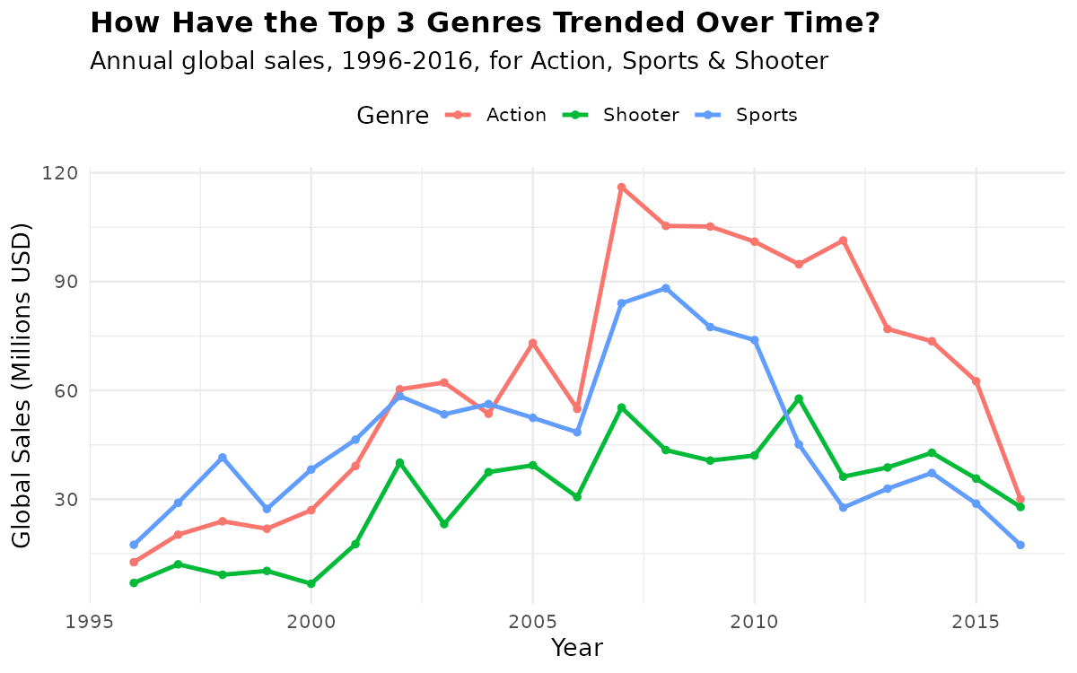
Figure 2: Annual sales for Action, Sports, and Shooter genres, 1996-2016.
All three genres peaked sharply around 2007-2008 — coinciding with the PS3/Xbox 360/Wii console generation reaching mass adoption — then declined steadily through 2016. Action consistently outperforms the other two across the entire period, but the shared downward trend after 2010 suggests a market-wide shift (likely toward mobile and digital distribution not captured in this physical-sales-era dataset) rather than a genre-specific decline.

4. Visualization 3 — Histogram: Critic Score Distribution
Chart type chosen: Histogram. A histogram is the right tool for showing the shape of a single numeric variable's distribution — here, whether critic scores cluster, skew, or spread evenly.
ggplot(df, aes(x = Critic_Score)) +
geom_histogram(binwidth = 5, fill = "#1D9E75", color = "white") +
labs(title = "How Are Critic Scores Distributed?")
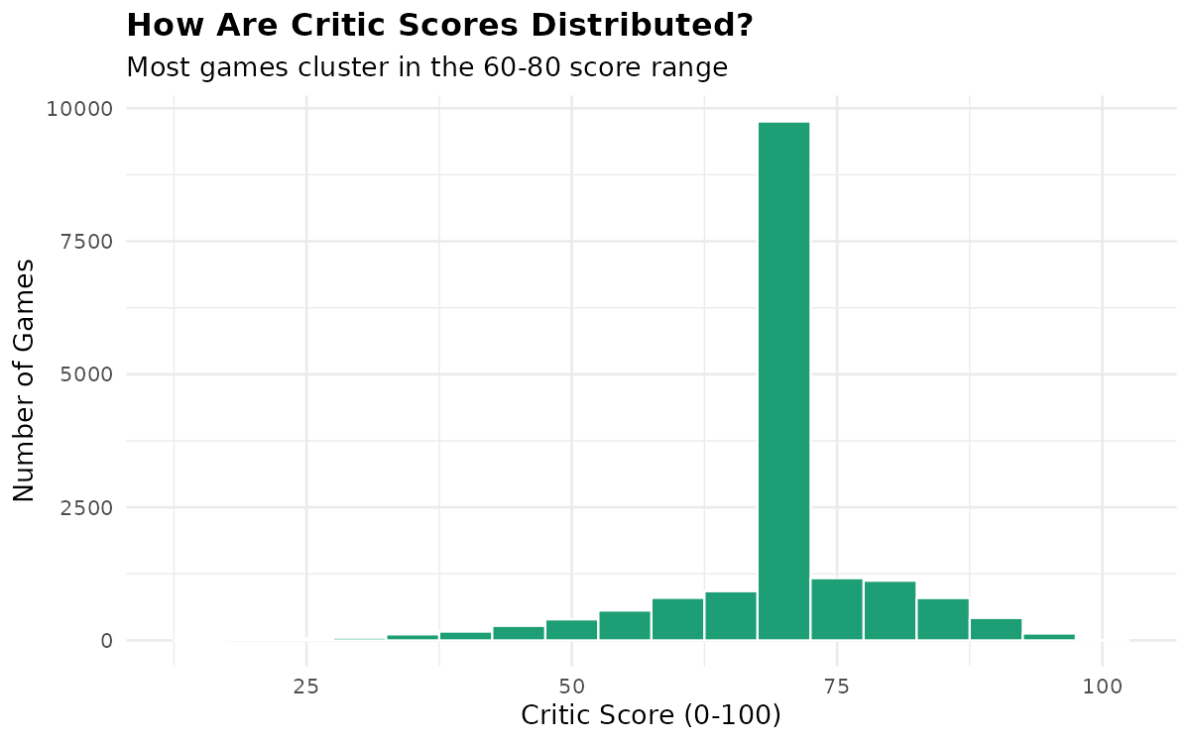
Figure 3: Distribution of critic scores across all games (post-median-imputation from Week 1).
Scores cluster heavily around 65-80, forming a left-skewed distribution — very few games score below 40, and a visible spike sits at the median-imputed value (71) from Week 1's missing-value treatment. This is an important transparency note: roughly half of this chart's mass reflects imputed rather than actual review data, which should be disclosed to any audience relying on this chart for decisions.

5. Visualization 4 — Scatter Plot: Critic Score vs Sales
Chart type chosen: Scatter plot. Scatter plots are the standard choice for examining the relationship between two continuous variables, and color-coding by genre adds a third dimension without cluttering the chart.
top5_genres <- as.character(genre_sales$Genre[1:5])
scatter_df <- df[df$Genre %in% top5_genres, ]

ggplot(scatter_df, aes(x = Critic_Score, y = Global_Sales_Capped, color = Genre)) +
geom_point(alpha = 0.4, size = 1.6) +
labs(title = "Does a Higher Critic Score Mean Higher Sales?")
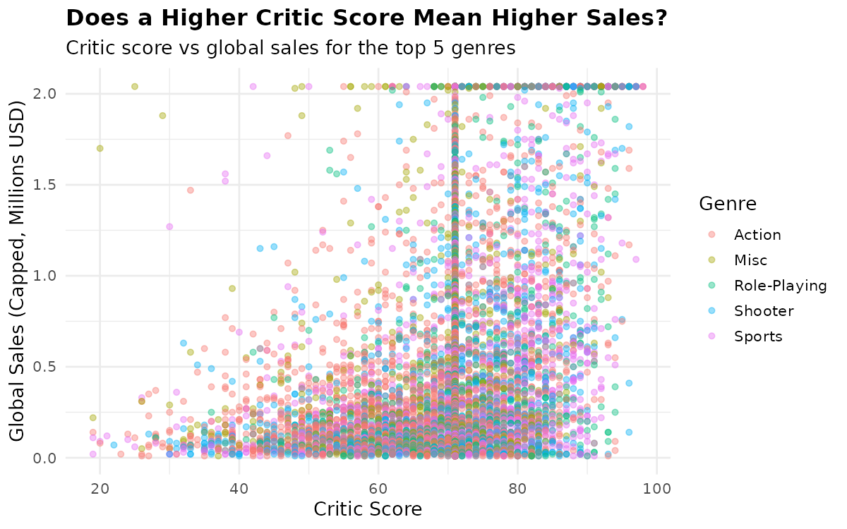
Figure 4: Critic score vs global sales, colored by genre (top 5 genres only).
The cloud of points shows only a loose upward drift — plenty of high-scoring games sell modestly, and a handful of average-scoring games (mostly Sports, likely annual sports-franchise titles with built-in audiences) sell exceptionally well. This visually reinforces the Week 1 correlation finding (r = 0.19): critic acclaim alone is a weak sales predictor.

6. Visualization 5 — Boxplot: Sales Spread by Platform
Chart type chosen: Boxplot. Where a bar chart shows only a total, a boxplot reveals the full spread, median, and outliers within each platform — critical for understanding consistency, not just volume.
plat_totals <- aggregate(Global_Sales_Capped ~ Platform, data = df, sum)
top8_platforms <- as.character(plat_totals[order(-plat_totals$Global_Sales_Capped), "Platform"][1:8])
box_df <- df[df$Platform %in% top8_platforms, ]

ggplot(box_df, aes(x = reorder(Platform, Global_Sales_Capped, FUN = median), y = Global_Sales_Capped)) +
geom_boxplot(fill = "#8064A2", alpha = 0.7, outlier.alpha = 0.3) +
labs(title = "How Does Sales Performance Vary by Platform?")
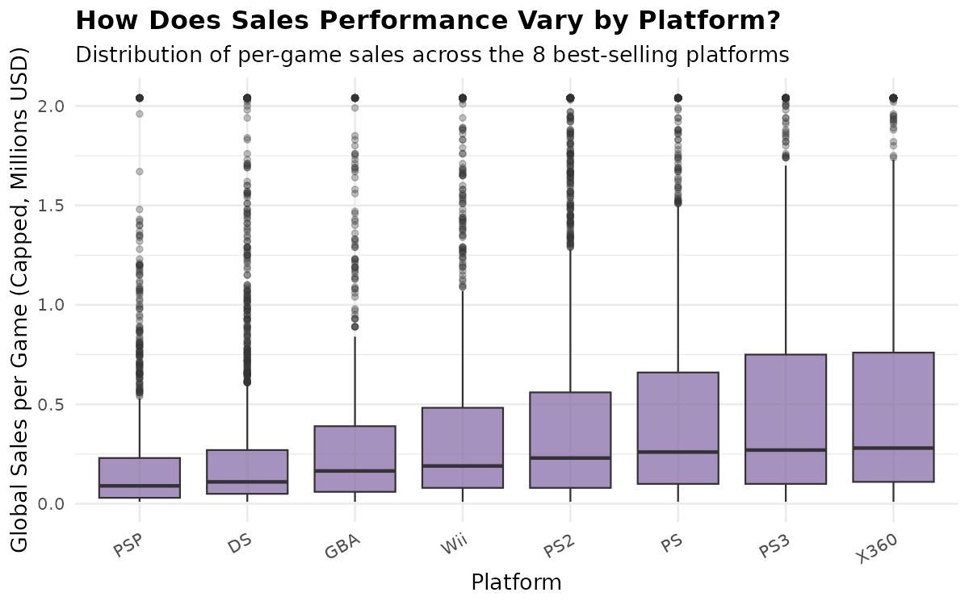
Figure 5: Distribution of per-game sales across the 8 best-selling platforms (PS2, PS3, X360, PS, DS, Wii, GBA, PSP).
PS2 leads in total volume ($1,013M, from earlier aggregate analysis) but its median per-game sales sit close to other platforms — its total is driven by having the largest game library, not by every title outperforming. Wii shows a noticeably higher median with a longer upper tail, reflecting a smaller but more consistently successful catalog, likely driven by Nintendo first-party hits.

7. Visualization 6 — Stacked Area Chart: Regional Sales Mix
Chart type chosen: Stacked area chart. This shows both the total market size over time and how that total splits across regions in one view — a bar chart would need four separate series to convey the same thing.
region_agg <- aggregate(cbind(NA_Sales, EU_Sales, JP_Sales, Other_Sales) ~ Year_of_Release,
data = df[df$Year_of_Release >= 1996 & df$Year_of_Release <= 2016, ], sum)
# reshaped to long format, then:
ggplot(region_long, aes(x = Year, y = Sales, fill = Region)) +
geom_area(position = "stack", alpha = 0.85) +
labs(title = "How Has the Regional Sales Mix Shifted Over Time?")
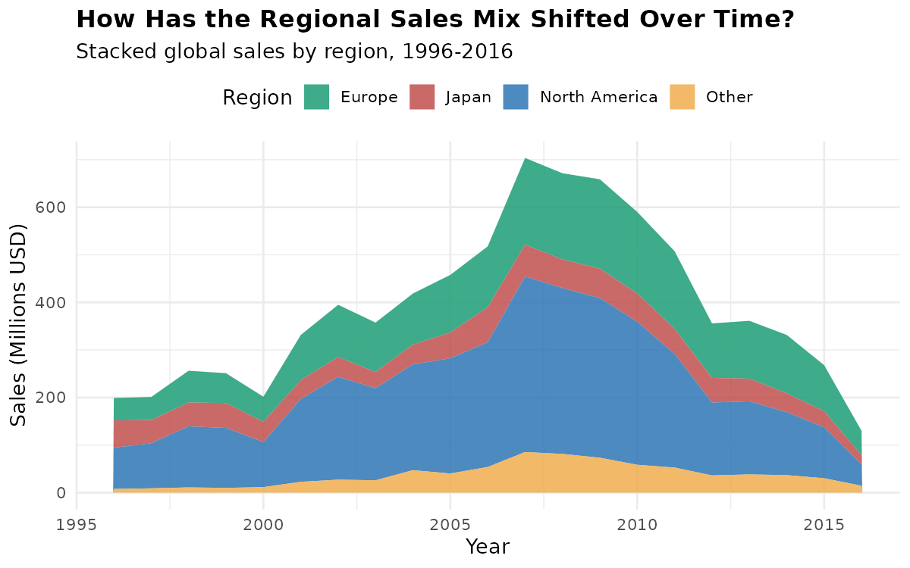
Figure 6: Stacked regional sales (North America, Europe, Japan, Other), 1996-2016.
North America consistently forms the largest band throughout the period, with Europe growing steadily as a share of the total from the early 2000s onward. Japan's share, by contrast, shrinks visibly relative to the other regions in the back half of the timeline — consistent with Japan's industry increasingly diverging toward mobile and portable gaming, which this largely console/PC-era dataset underrepresents.

8. Visualization 7 — Heatmap: Correlation Matrix
Chart type chosen: Heatmap. For more than 2-3 variables, a correlation heatmap communicates relationship strength faster than a table of numbers, using color intensity as an immediate visual cue.
num_df <- df[, c("Global_Sales","Critic_Score","Critic_Count","User_Score","User_Count")]
cor_matrix <- cor(num_df, use = "complete.obs")
cor_long <- as.data.frame(as.table(cor_matrix))

ggplot(cor_long, aes(Var1, Var2, fill = Freq)) +
geom_tile() + geom_text(aes(label = round(Freq, 2))) +
scale_fill_gradient2(low = "#C0504D", mid = "white", high = "#2E75B6", midpoint = 0)
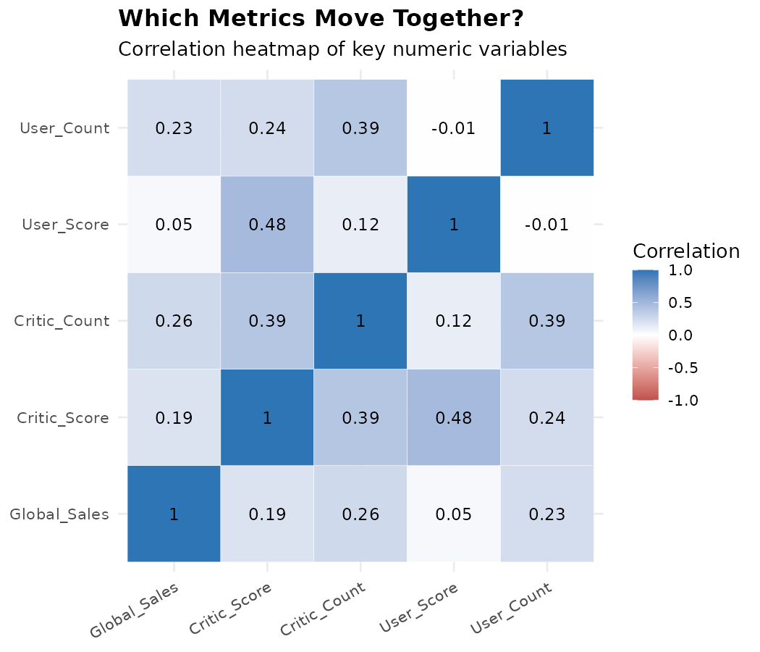
Figure 7: Correlation heatmap across Global_Sales, Critic_Score, Critic_Count, User_Score, and User_Count.
The darkest off-diagonal cell is Critic_Score vs User_Score (0.48) — critics and players agree more with each other than either agrees with actual sales. Every correlation with Global_Sales stays below 0.30, visually confirming that review metrics, whether from critics or users, are consistently weak sales predictors across the board.

9. Visualization 8 — Donut Chart: Rating Category Share
Chart type chosen: Donut chart. For a single categorical variable's share of a whole, a donut chart is a widely recognized format for non-technical audiences, and the center hole leaves room for a total-count label if needed.
rating_counts <- as.data.frame(table(df$Rating))
rating_counts <- rating_counts[rating_counts$Var1 != "Unknown", ]

ggplot(rating_counts, aes(ymax=cumsum(fraction), ymin=lag_fraction, xmax=4, xmin=3, fill=Rating)) +
geom_rect() + coord_polar(theta = "y") + xlim(c(2,4)) + theme_void()
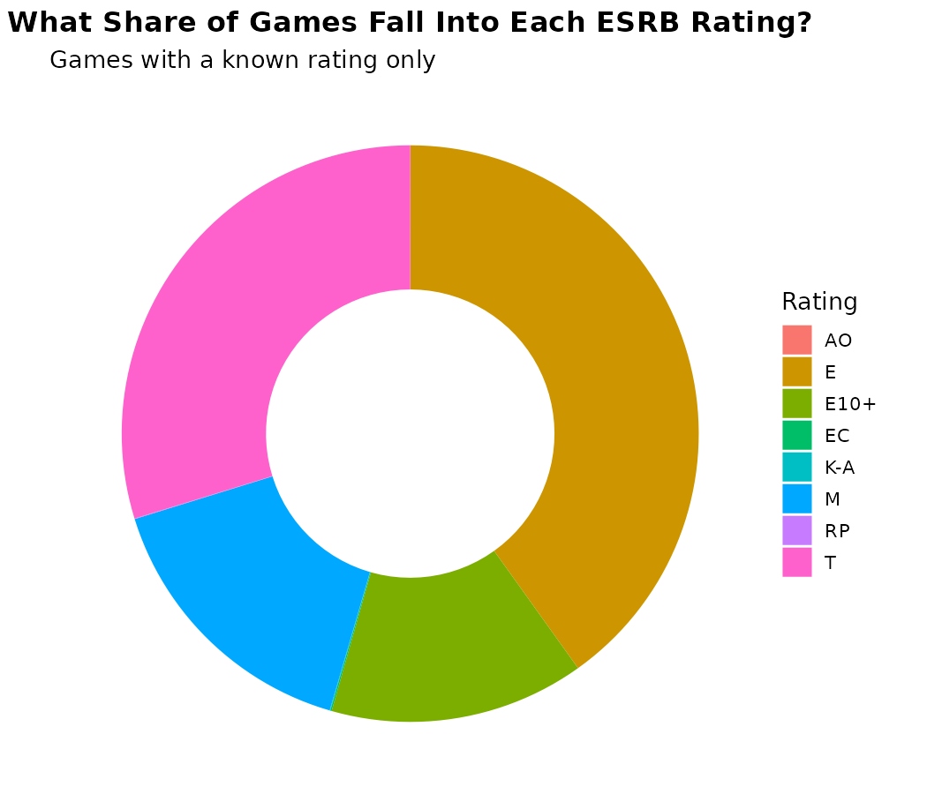
Figure 8: Share of games by ESRB rating (excluding unrated/unknown titles).
Among rated titles, "E" (Everyone) is the most common rating at 3,991 games, followed by "T" (Teen) at 2,961 and "M" (Mature) at 1,563. Notably, 6,767 games in the dataset have no rating on record — nearly 40% of the total — a data-quality gap worth flagging to any stakeholder using this chart, since it only reflects the rated minority of the catalog.

10. Key Insights Summary
- Action and Sports genres dominate global sales, together representing roughly a third of the market.
- Industry-wide sales peaked around 2007-2008 across all top genres, then declined through 2016 — a market-level shift, not a genre-specific one.
- Critic and user review scores correlate only weakly with commercial sales (all r < 0.30 against Global_Sales), while critics and users agree moderately with each other (r = 0.48).
- Wii shows the strongest per-game sales consistency among top platforms, while PS2's leadership comes from library size rather than per-title performance.
- Regional sales mix has shifted over time, with Japan's relative share shrinking as North America and Europe grew.
- Nearly 40% of games in the dataset carry no ESRB rating, a data completeness gap relevant to any rating-based analysis.

11. Tools & Reproducibility
Component | Detail
Language | R (base + ggplot2)
Script | visualization.R
Input file | vgsales_cleaned.csv (from Week 1)
Visuals | plots/01_bar_genre_sales.png … plots/08_donut_rating_share.png

All eight charts are produced by a single reproducible script, visualization.R, which loads the Week 1 cleaned dataset and generates every figure shown in this report.

