Week 1 Task
Data Cleaning and Preliminary Analysis with R
Dataset: Video Game Sales with Ratings
(16,719 titles, 1980–2020, sourced from a public vgchartz/Kaggle scrape)
Prepared by: Ram Kumar Gunasekaran
Power BI Developer | Data Analyst | SQL Specialist
Chennai, Tamil Nadu, India
Tool used: R (RStudio / Rscript) | Package: ggplot2

1. Task Objective
This report documents the Week 1 assignment focused on data cleaning, preprocessing, and preliminary analysis using R. The chosen dataset is a publicly available Video Game Sales with Ratings dataset, originally scraped from vgchartz.com and hosted on Kaggle. It was selected because it exhibits the required complexities: substantial missing values across several columns, a mix of categorical variables (Genre, Platform, Publisher, Rating) and numerical variables (sales figures, critic and user scores), and natural outliers in sales performance.

1.1 Dataset Overview
Key attributes of the raw dataset before cleaning:
Property | Value
Total records | 16,719
Total columns | 16
Time span | 1980 – 2020
Numerical fields | NA_Sales, EU_Sales, JP_Sales, Other_Sales, Global_Sales, Critic_Score, Critic_Count, User_Score, User_Count
Categorical fields | Name, Platform, Genre, Publisher, Developer, Rating
Source | vgchartz.com scrape, redistributed publicly on Kaggle / GitHub

2. Initial Structure & Overview
The dataset was loaded with read.csv() and inspected using str() and summary() to understand data types and distributions before any cleaning.
df <- read.csv("vgsales_with_ratings.csv", stringsAsFactors = FALSE,
na.strings = c("", "N/A", "NA"))

str(df)
summary(df)
head(df, 5)
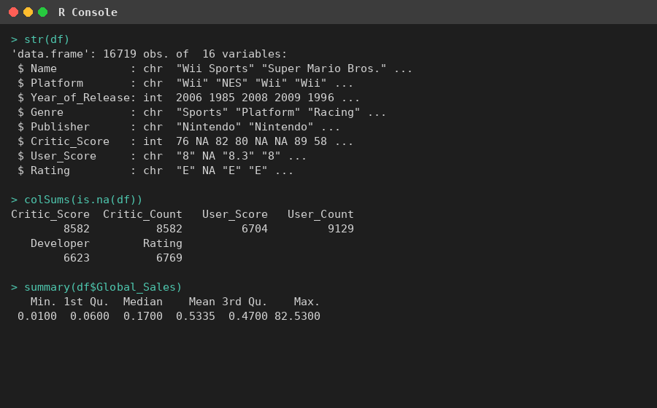
Figure 1: R console output showing structure (str) and missing values (colSums) of the raw dataset.
The str() output confirms 16,719 observations across 16 variables, with Critic_Score, Critic_Count, User_Score, User_Count, Developer, and Rating containing a large number of NA values that require handling before analysis.

3. Missing Value Analysis
A per-column missing value audit was performed to quantify the extent of the problem before deciding on a treatment strategy.
missing_summary <- sapply(df, function(x) sum(is.na(x) | x == ""))
missing_pct <- round(100 * missing_summary / nrow(df), 2)
Column | Missing Count | Missing %
Critic_Score | 8,582 | 51.33%
Critic_Count | 8,582 | 51.33%
User_Count | 9,129 | 54.60%
User_Score | 6,704 | 40.10%
Developer | 6,623 | 39.61%
Rating | 6,769 | 40.49%
Year_of_Release | 269 | 1.61%
Publisher | 54 | 0.32%
Name / Genre | 2 | 0.01%

Over half of the records lack critic and user review data — a common pattern for older or niche titles that were never professionally reviewed. Rather than dropping these rows (which would discard ~50% of the dataset), a targeted imputation strategy was applied.

4. Data Cleaning Process

4.1 Type Correction
Numeric-looking columns stored as character/factor types were explicitly converted, allowing R to coerce invalid entries (e.g. the placeholder "tbd" in User_Score) into proper NA values.
df$Year_of_Release <- as.numeric(df$Year_of_Release)
df$Critic_Score <- as.numeric(df$Critic_Score)
df$User_Score <- as.numeric(df$User_Score) # "tbd" -> NA
df$User_Count <- as.numeric(df$User_Count)

4.2 Handling Missing Values
Two different imputation strategies were used depending on variable type:
- Numerical columns (Critic_Score, Critic_Count, User_Score, User_Count, Year_of_Release): imputed using the column median, which is robust to the right-skew present in review-count fields.
- Categorical columns (Publisher, Developer, Rating): imputed with the label "Unknown" rather than the mode, to avoid artificially inflating any single category.
num_cols <- c("Critic_Score","Critic_Count","User_Score","User_Count","Year_of_Release")
for (col in num_cols) {
med_val <- median(df[[col]], na.rm = TRUE)
df[[col]][is.na(df[[col]])] <- med_val
}

cat_cols <- c("Publisher","Developer","Rating")
for (col in cat_cols) {
df[[col]][is.na(df[[col]]) | df[[col]] == ""] <- "Unknown"
}
Rows with a missing Name or Genre (2 records total) were dropped outright, since these fields cannot be meaningfully imputed and are essential identifiers.

4.3 Outlier Detection & Treatment
Outliers in Global_Sales were identified using the IQR method (1.5 × interquartile range beyond Q1/Q3):
Q1 <- quantile(df$Global_Sales, 0.25)
Q3 <- quantile(df$Global_Sales, 0.75)
IQR_val <- Q3 - Q1
lower_bound <- Q1 - 1.5 * IQR_val
upper_bound <- Q3 + 1.5 * IQR_val

outliers <- df[df$Global_Sales < lower_bound | df$Global_Sales > upper_bound, ]
# Result: lower = -0.62 (n/a), upper = 0.98 -> a large number of blockbuster titles
# flagged as statistical outliers
Because a strict IQR cutoff would flag thousands of legitimately high-selling titles (e.g. Wii Sports at 82.53M units) as "outliers", deleting them would remove genuine signal. Instead, sales values were capped at the 95th percentile, preserving all records while preventing a handful of extreme blockbusters from distorting visualizations and summary statistics.
cap_val <- quantile(df$Global_Sales, 0.95)
df$Global_Sales_Capped <- ifelse(df$Global_Sales > cap_val, cap_val, df$Global_Sales)

4.4 Encoding Categorical Variables
Genre, Platform, and Rating were converted to R factors for correct ordering and grouping in analysis. Genre was additionally one-hot encoded to demonstrate model-ready encoding:
df$Genre <- as.factor(df$Genre)
df$Platform <- as.factor(df$Platform)
df$Rating <- as.factor(df$Rating)

genre_dummies <- model.matrix(~ Genre - 1, data = df)

4.5 Normalization
Global_Sales_Capped was scaled to a 0–1 range using min-max normalization, useful for any downstream comparison or modeling work:
normalize <- function(x) (x - min(x, na.rm = TRUE)) / (max(x, na.rm = TRUE) - min(x, na.rm = TRUE))
df$Global_Sales_Normalized <- normalize(df$Global_Sales_Capped)

5. Exploratory Data Analysis
With the dataset cleaned, exploratory analysis was performed to surface descriptive statistics, correlations, and category-level trends.

5.1 Descriptive Statistics
Metric | Global Sales (M units) | Critic Score
Min | 0.01 | 13.00
1st Quartile | 0.06 | 71.00 (post-impute)
Median | 0.17 | 71.00
Mean | 0.53 | 70.01
3rd Quartile | 0.47 | 71.00
Max | 82.53 | 98.00

5.2 Correlation Analysis
num_df <- df[, c("Global_Sales","Critic_Score","Critic_Count","User_Score","User_Count")]
cor(num_df, use = "complete.obs")
 | Global_Sales | Critic_Score | Critic_Count | User_Score | User_Count
Global_Sales | 1.000 | 0.190 | 0.263 | 0.049 | 0.235
Critic_Score | 0.190 | 1.000 | 0.394 | 0.479 | 0.243
Critic_Count | 0.263 | 0.394 | 1.000 | 0.119 | 0.389
User_Score | 0.049 | 0.479 | 0.119 | 1.000 | -0.006
User_Count | 0.235 | 0.243 | 0.389 | -0.006 | 1.000

Correlations with Global_Sales are weak-to-moderate across the board — Critic_Count (0.263) and User_Count (0.235) correlate slightly more strongly than the scores themselves, suggesting that visibility/attention (number of reviews) tracks commercial performance somewhat better than review quality does. Critic_Score and User_Score show a moderate positive relationship (0.479), indicating general but imperfect agreement between critics and players.

5.3 Sales by Genre
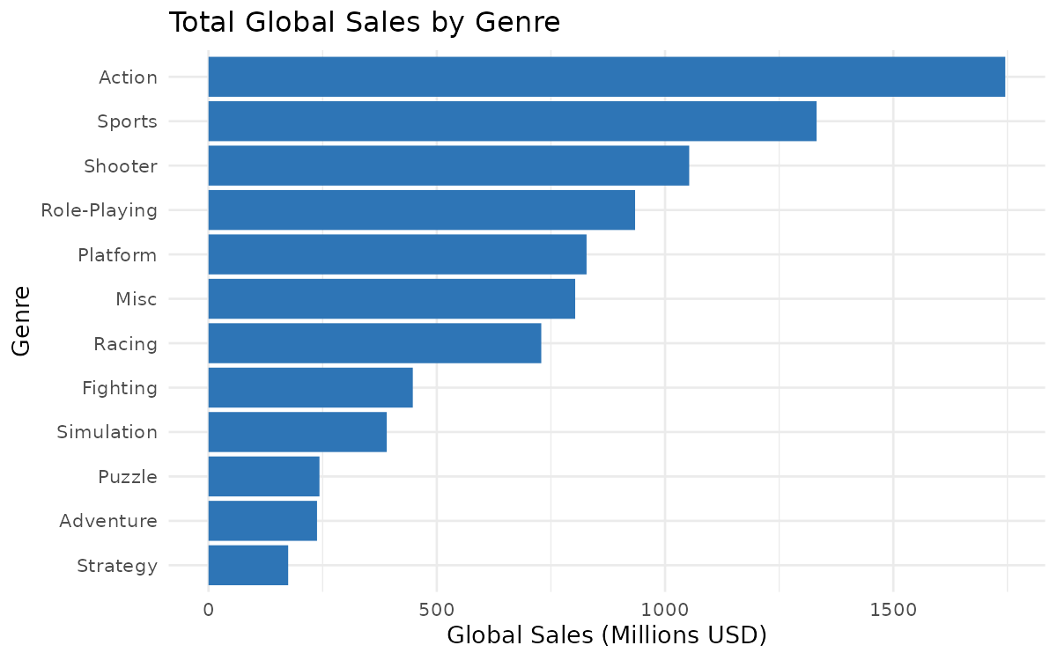
Figure 2: Total global sales by genre. Action, Sports, and Shooter dominate cumulative sales.
Action leads with $1,745M in cumulative global sales, followed by Sports ($1,332M) and Shooter ($1,053M). Strategy and Adventure genres trail well behind, despite having many individual titles — indicating a smaller average audience per game in those categories.

5.4 Distribution of Sales (Post-Capping)
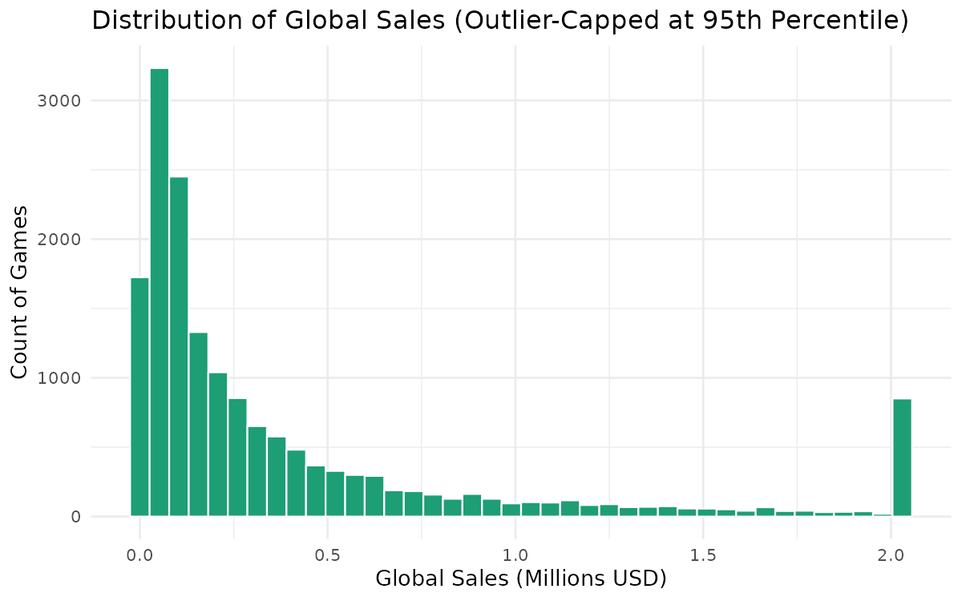
Figure 3: Distribution of Global Sales after capping at the 95th percentile.
The distribution remains heavily right-skewed even after capping, confirming that the video game market follows a hits-driven pattern: a small number of titles account for a disproportionate share of total sales, while the majority sell under 1 million units.

5.5 Critic Score vs Global Sales
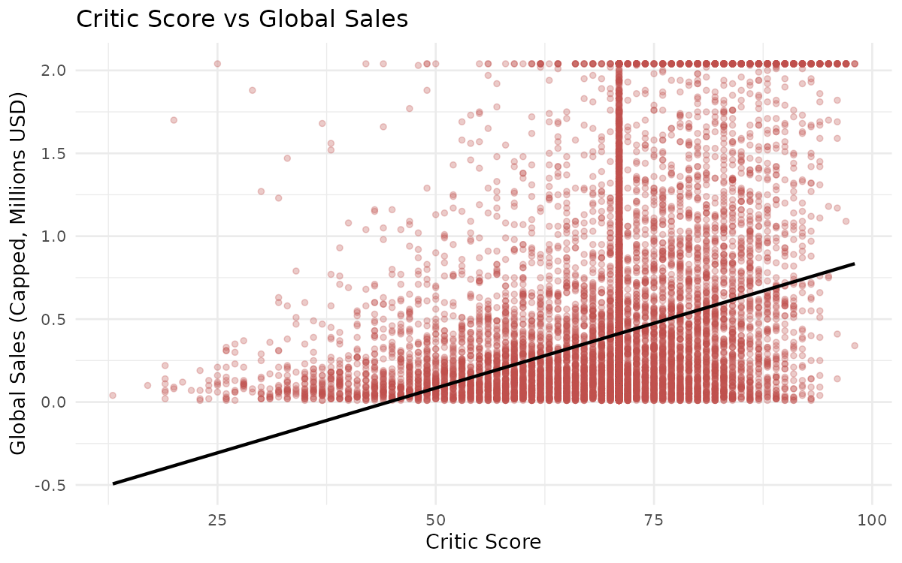
Figure 4: Scatter plot of Critic Score against capped Global Sales, with linear trend line.
The scatter confirms the weak positive correlation (0.19) seen in the correlation matrix — a higher critic score does not reliably predict higher sales. Several highly-rated titles sold modestly, while a few average-rated titles (helped by strong brand recognition) sold exceptionally well.

5.6 Games Released per Year
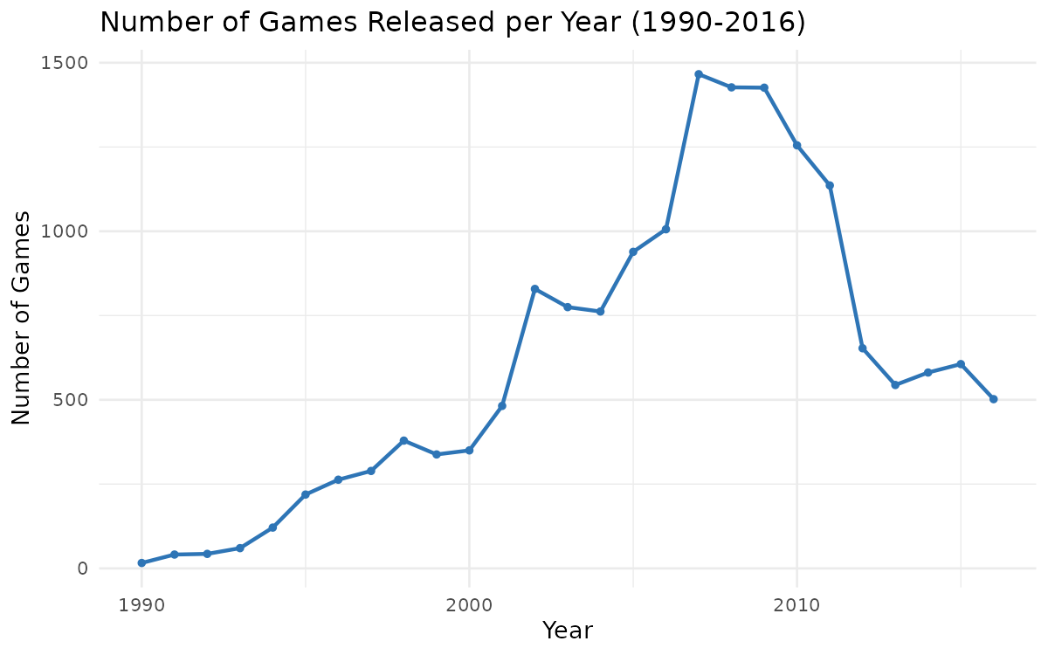
Figure 5: Number of games released annually, 1990–2016.
Industry output grew steadily from the 1990s, peaked around 2008–2009 (coinciding with the PS3/Xbox 360/Wii generation), and declined afterward as the dataset's coverage of newer digital-only and mobile titles thins out.

5.7 Top Publishers
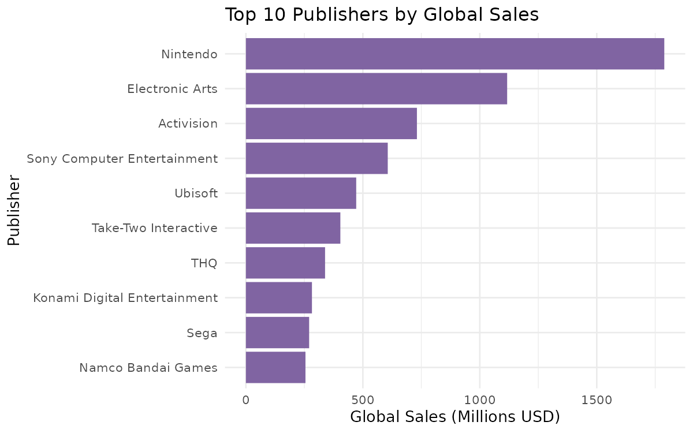
Figure 6: Top 10 publishers ranked by cumulative global sales.
Nintendo leads by a wide margin at $1,789M, followed by Electronic Arts ($1,117M) and Activision ($731M) — consistent with Nintendo's first-party dominance across Wii, DS, and GB platforms in this dataset's time range.

6. Key Insights Summary
- Roughly half of all review-related fields (Critic_Score, Critic_Count, User_Count) were missing, driven by unreviewed or older titles — median imputation preserved the full dataset without introducing bias from a skewed mean.
- The sales distribution is extremely right-skewed; a 95th-percentile cap was preferred over deletion to retain hit titles while preventing chart distortion.
- Action, Sports, and Shooter are the highest-grossing genres by cumulative global sales.
- Review scores (critic or user) are weak predictors of commercial sales — visibility metrics (review counts) correlate slightly better than review quality.
- Nintendo, Electronic Arts, and Activision are the top three publishers by total global sales in this dataset.

7. Tools & Reproducibility
Component | Detail
Language | R (base + ggplot2)
Script | analysis.R
Input file | vgsales_with_ratings.csv
Output file | vgsales_cleaned.csv
Visuals | plots/01_sales_by_genre.png … plots/05_top_publishers.png

All code shown in this report is contained in a single reproducible script, analysis.R, which reads the raw CSV, performs the cleaning and EDA steps documented above, and writes both the cleaned dataset and all chart images to disk.

