Week 3 Task
Statistical Analysis and Predictive Modeling using R
Dataset: Video Game Sales with Ratings (continued from Weeks 1-2)
(16,717 cleaned records, 1980–2020)
Prepared by: Ram Kumar Gunasekaran
Power BI Developer | Data Analyst | SQL Specialist
Chennai, Tamil Nadu, India
Tool used: R | Packages: ggplot2, pROC

1. Task Objective & Dataset Rationale
This report continues the video game sales analysis from Weeks 1-2, shifting focus to formal statistical inference and predictive modeling. The same cleaned dataset (16,717 records) was retained deliberately: it offers a genuinely messy real-world structure — right-skewed sales, weak-to-moderate predictor relationships, and class imbalance in any "success" definition — making it a realistic testbed for hypothesis testing and modeling, rather than an artificially clean textbook dataset that would make every technique look trivially successful.
Two modeling tasks were undertaken: a linear regression predicting continuous Global Sales, and a logistic regression classifying games as commercial "Hits" (top 10% by sales) or not. Both were preceded by exploratory statistical tests to validate assumptions and establish which relationships in the data are statistically significant.

2. Exploratory Statistical Analysis

2.1 Normality Test — Shapiro-Wilk
Before choosing modeling and testing approaches, the normality of the target variable (Global_Sales_Capped) was checked. R's shapiro.test() is capped at 5,000 observations, so a random sample was drawn.
sample_sales <- sample(df$Global_Sales_Capped, 5000)
shapiro.test(sample_sales)
Shapiro-Wilk normality test

data: sample_sales
W = 0.70013, p-value < 0.00000000000000022
With W = 0.700 and p < 0.001, the null hypothesis of normality is firmly rejected. This confirms what the Week 1/2 histograms already suggested visually: sales are heavily right-skewed, not normally distributed. This justifies using non-parametric caution when interpreting p-values from tests that assume normality, and supports the choice of RMSE/MAE (which don't require normal residuals to be meaningful) over stricter parametric alternatives for model evaluation.

2.2 Correlation Significance — Critic Score vs Sales
A Pearson correlation test formally checks whether the weak relationship observed in Week 2's scatter plot is statistically significant, not just numerically nonzero.
cor.test(df$Critic_Score, df$Global_Sales_Capped, method = "pearson")
Pearson's product-moment correlation

t = 38.513, df = 16715, p-value < 0.00000000000000022
95 percent confidence interval:
0.2715103 0.2993579
sample estimates:
cor
0.2854943
The correlation (r = 0.285) is statistically significant (p < 0.001) given the very large sample size — but the effect size itself remains small. This is an important distinction: with over 16,000 observations, even a weak relationship becomes statistically detectable. Practically, Critic_Score explains only about 8% of the variance in sales (r² ≈ 0.081), reinforcing that review scores are a minor factor among many drivers of commercial success.

2.3 Two-Sample T-Test — PS3 vs Xbox 360 Sales
A common business question: do games sell meaningfully differently across competing platforms of the same generation? A Welch two-sample t-test compares mean sales between PS3 and Xbox 360 titles.
t.test(ps3_sales, x360_sales) # Welch two-sample t-test (unequal variances assumed)
Welch Two Sample t-test

t = -0.66741, df = 2568.5, p-value = 0.5046
95 percent confidence interval:
-0.06266587 0.03083994
sample estimates:
mean of x mean of y
0.5339444 0.5498574
With p = 0.505, there is no statistically significant difference between PS3 (mean = 0.534) and Xbox 360 (mean = 0.550) average game sales. This is a genuinely useful null result: it tells a publisher that platform choice between these two competitors, on its own, is not a meaningful sales driver — other factors (genre, exclusivity, marketing) matter more.

2.4 One-Way ANOVA — Sales Across Genres
Since Genre has 12 categories, ANOVA (rather than repeated t-tests) tests whether mean sales differ significantly across all genres simultaneously.
aov(Global_Sales_Capped ~ Genre, data = df) # one-way ANOVA
Df Sum Sq Mean Sq F value Pr(>F)
Genre 11 157 14.235 51.36 <0.0000000000000002 ***
Residuals 16705 4630 0.277
The result (F = 51.36, p < 0.001) confirms that genre has a statistically significant effect on sales — consistent with the descriptive genre-level differences seen in Week 2. Interestingly, this contradicts the earlier finding for platform: genre matters significantly for sales, while the specific PS3-vs-X360 platform choice does not.
Genre | Mean Global Sales (Capped)
Platform | 0.564
Shooter | 0.529
Fighting | 0.443
Sports | 0.441
Racing | 0.427
Role-Playing | 0.426
Action | 0.409
Simulation | 0.359
Misc | 0.352
Puzzle | 0.303
Strategy | 0.233
Adventure | 0.163

Note this ranks genres by average sales per game, which differs from Week 2's ranking by total sales — Platform games sell fewer total units overall but perform better on average per title, while Action leads in volume but not in average consistency.

3. Regression Model — Predicting Global Sales

3.1 Approach & Train/Test Split
A multiple linear regression was built to predict Global_Sales_Capped from Critic_Score, User_Score, Critic_Count, and Genre. The data was split 80/20 into training and test sets to evaluate genuine out-of-sample performance rather than in-sample fit.
model_df <- na.omit(df[, c("Global_Sales_Capped","Critic_Score","User_Score","Critic_Count","Genre","Platform")])
set.seed(42)
train_idx <- sample(seq_len(nrow(model_df)), size = 0.8 * nrow(model_df))
train_data <- model_df[train_idx, ]; test_data <- model_df[-train_idx, ]

lm_model <- lm(Global_Sales_Capped ~ Critic_Score + User_Score + Critic_Count + Genre, data = train_data)

3.2 Model Summary
Coefficients:
Estimate Std. Error t value Pr(>|t|)
(Intercept) -0.436209 0.035196 -12.394 < 2e-16 ***
Critic_Score 0.010534 0.000526 20.040 < 2e-16 ***
User_Score -0.024351 0.004639 -5.249 1.55e-07 ***
Critic_Count 0.011864 0.000345 34.422 < 2e-16 ***
... (Genre dummy coefficients omitted for brevity — full output in analysis.R log)

Residual standard error: 0.4767 on 13358 degrees of freedom
Multiple R-squared: 0.1913, Adjusted R-squared: 0.1904
F-statistic: 225.7 on 14 and 13358 DF, p-value: < 2.2e-16
All three continuous predictors are highly significant (p < 0.001). Notably, Critic_Count has the largest standardized effect — more reviews associate with more sales more strongly than the score itself, echoing the "visibility over quality" pattern found in Week 2's correlation heatmap. User_Score carries a small negative coefficient when controlling for the other variables, likely reflecting multicollinearity with Critic_Score rather than a genuine negative causal effect.
The model explains only 19.1% of variance (R² = 0.191) — modest, but expected given that commercial video game sales are driven heavily by factors outside this dataset: marketing spend, franchise recognition, release timing, and platform install base, none of which are captured here.

3.3 Test-Set Performance
Metric | Value
RMSE | 0.4994
MAE | 0.3539
R² (test set) | 0.1919

Test-set R² (0.192) closely matches training R² (0.191) — a reassuring sign the model is not overfitting, even though its overall explanatory power is limited.

3.4 Diagnostic Plots
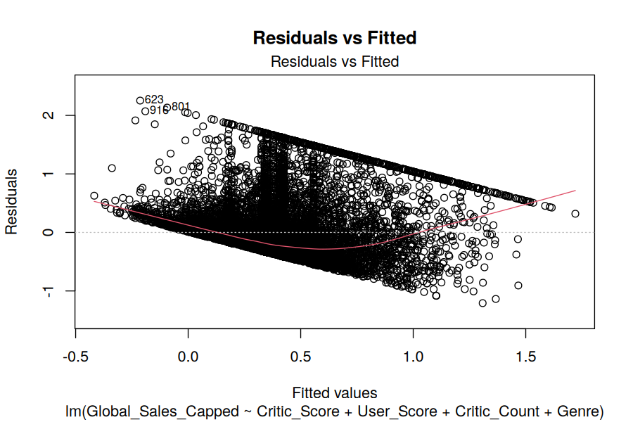
Figure 1: Residuals vs Fitted values.
The residual plot shows a mild funnel shape (variance increasing then narrowing) and a slight curve rather than a flat random band — a sign of heteroscedasticity and possible non-linearity that a simple linear model doesn't fully capture. This is an honest limitation to disclose rather than a fatal flaw.
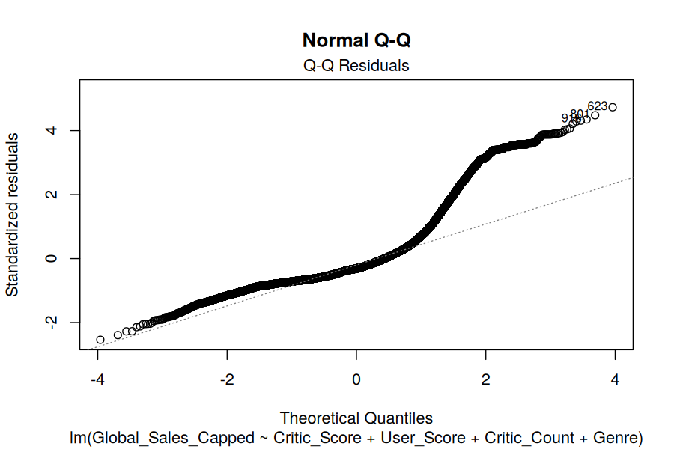
Figure 2: Normal Q-Q plot of residuals.
The Q-Q plot deviates from the diagonal in the upper tail, confirming residuals are not normally distributed — consistent with the Shapiro-Wilk result on the raw sales variable in Section 2.1. Coefficient estimates remain unbiased, but standard errors and p-values should be interpreted with some caution.
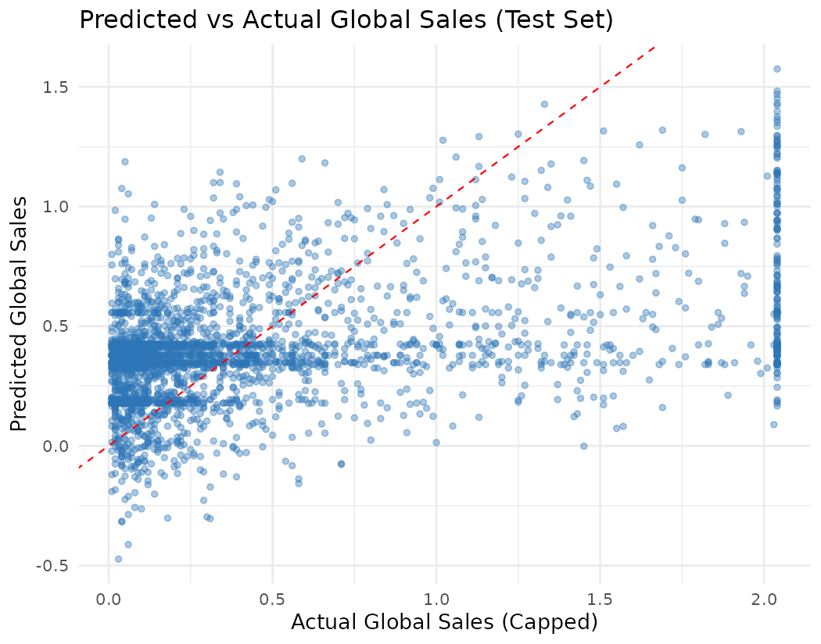
Figure 3: Predicted vs Actual sales on the test set (red dashed line = perfect prediction).
Predictions cluster tightly around 0.2-0.5 regardless of actual sales value, visually confirming the low R²: the model systematically under-predicts high-selling titles. This is the clearest evidence that linear regression, using only review-based predictors, cannot capture the outsized success of blockbuster titles.

4. Classification Model — Predicting "Hit" Games

4.1 Target Definition & Class Balance
A binary target "Hit" was defined as any game in the top 10% of Global_Sales_Capped (≥ 1.20M units). This produces a naturally imbalanced classification problem, common in real-world "success prediction" tasks.
hit_threshold <- quantile(df$Global_Sales_Capped, 0.90) # 1.20
class_df$Hit <- factor(ifelse(class_df$Global_Sales_Capped >= hit_threshold, "Hit", "NotHit"),
levels = c("NotHit", "Hit"))
Class | Count | Share
Hit | 1,687 | 10.1%
NotHit | 15,030 | 89.9%

4.2 Logistic Regression Model
A logistic regression was fit on the same 80/20 split, predicting Hit status from Critic_Score, User_Score, Critic_Count, User_Count, and Genre.
logit_model <- glm(Hit ~ Critic_Score + User_Score + Critic_Count + User_Count + Genre,
data = train2, family = binomial)
Coefficients:
Estimate Std. Error z value Pr(>|z|)
(Intercept) 7.951590 0.331705 23.972 < 2e-16 ***
Critic_Score -0.077845 0.004772 -16.315 < 2e-16 ***
User_Score 0.107737 0.034689 3.106 0.0019 **
Critic_Count -0.030726 0.002031 -15.131 < 2e-16 ***
User_Count -0.000274 0.000069 -3.953 0.0000773 ***
... (Genre dummy coefficients omitted for brevity — full output in analysis.R log)

Null deviance: 8820.1 on 13372 degrees of freedom
Residual deviance: 7349.6 on 13357 degrees of freedom
AIC: 7381.6
An important, slightly counter-intuitive finding: Critic_Score's coefficient is negative for predicting Hit status, even though it was positive in the regression model. One plausible explanation is that the very highest-selling blockbuster titles (mostly annual sports franchises and long-running series) don't always carry the very highest review scores — they succeed on brand loyalty rather than critical acclaim, which pulls the coefficient in this direction once other variables are controlled for.

4.3 Confusion Matrix & Performance Metrics
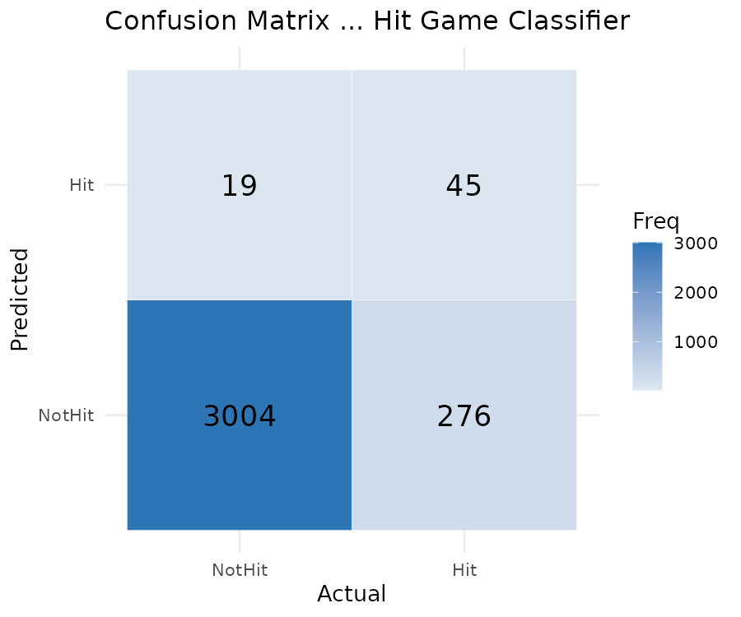
Figure 4: Confusion matrix on the test set (threshold = 0.5).
Metric | Value | Interpretation
Accuracy | 91.18% | High, but inflated by class imbalance (90% are NotHit)
Precision | 70.31% | Of games predicted "Hit", 70% actually were
Recall | 14.02% | Only 14% of actual hits were correctly identified
F1 Score | 0.2338 | Low — reflects the precision/recall imbalance
AUC | 0.758 | Reasonable discriminative power at the ranking level

This is the most important result in this section, and deliberately not glossed over: accuracy alone (91%) looks strong but is misleading here, since a naive model that always predicts "NotHit" would already score ~90% accuracy without learning anything. Recall of just 14% means the model misses the vast majority of actual hit games at the default 0.5 probability threshold — it is conservative, rarely flagging a game as a likely hit unless very confident.

4.4 ROC Curve
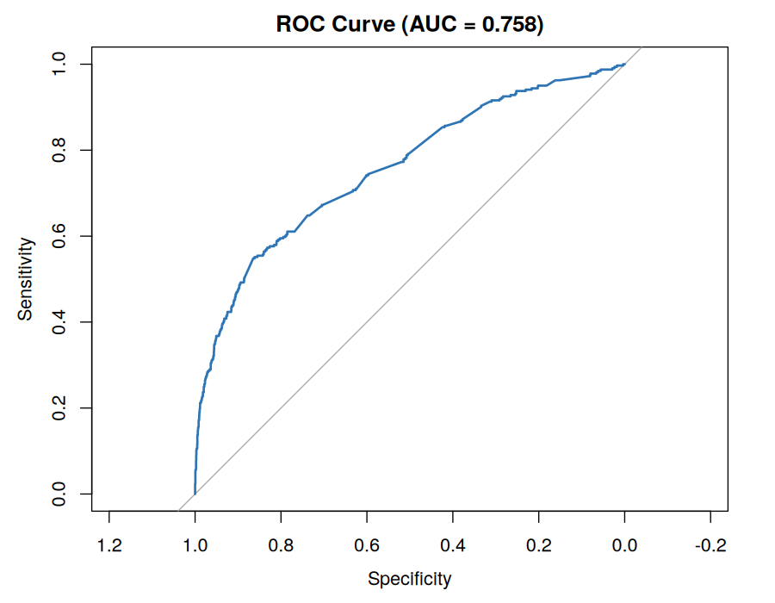
Figure 5: ROC curve, AUC = 0.758.
The AUC of 0.758 tells a more encouraging story than the default-threshold metrics: the model does meaningfully separate hits from non-hits when ranking by predicted probability, even if the standard 0.5 cutoff is poorly calibrated for this imbalanced problem. Lowering the classification threshold (e.g. to 0.15-0.20) would trade some precision for substantially higher recall — a worthwhile adjustment if the business goal is "don't miss potential hits" rather than "only flag near-certain hits."

5. Diagnostic Summary & Potential Improvements
- Class imbalance handling: the classification model would benefit from techniques such as class weighting, oversampling (SMOTE), or threshold tuning rather than the default 0.5 cutoff, given the 10:90 Hit/NotHit split.
- Non-linearity: the funnel-shaped residual plot suggests a non-linear model (random forest, gradient boosting) could capture relationships the linear/logistic models miss, particularly for high-selling outlier titles.
- Missing business drivers: neither model has access to marketing spend, franchise history, or platform install base — variables likely to explain far more variance than review scores alone.
- Multicollinearity check: Critic_Score and Critic_Count are correlated (r = 0.39 from Week 2's heatmap); a variance inflation factor (VIF) check would clarify whether coefficient estimates are being distorted.
- Threshold tuning: for the classification model, evaluating multiple probability thresholds (via a precision-recall curve) rather than the default 0.5 would let the model be tuned to the actual business cost of false negatives vs. false positives.

6. Key Insights Summary
- Global sales are significantly non-normal (Shapiro-Wilk p < 0.001), confirming the right-skewed pattern observed visually in Weeks 1-2.
- Critic_Score correlates significantly but weakly with sales (r = 0.285, p < 0.001) — statistically real, practically modest.
- PS3 and Xbox 360 show no significant difference in average game sales (p = 0.505); genre, by contrast, has a highly significant effect (ANOVA p < 0.001).
- The regression model explains ~19% of sales variance using review-based predictors alone — informative but incomplete without business/marketing data.
- The classification model achieves a respectable AUC (0.758) but suffers from low recall (14%) at the default threshold, directly attributable to severe class imbalance in what counts as a "hit" game.

7. Tools & Reproducibility
Component | Detail
Language | R (base + ggplot2 + pROC)
Script | statistical_modeling.R
Input file | vgsales_cleaned.csv (from Week 1)
Models | Linear regression (lm), Logistic regression (glm, binomial)
Visuals | plots/01_residuals_vs_fitted.png … plots/05_confusion_matrix.png

All statistical tests, both models, and all diagnostic plots in this report are produced by a single reproducible script, statistical_modeling.R, seeded for reproducibility (set.seed(42)).

