**BLOOD BANK MANAGEMENT SYSTEM**



**“Donate Blood, Save Lives”**

**Project Team Members:**

1. **Ramkumar P (Team Leader)**
2. **Saravanan M**
3. **Joice Mary Jose**
4. **Ranjith Kumar M P**

**DOCUMENT PURPOSE**

The basic building aim is to provide blood donation service to the needed person . Blood Bank Management System(BBMS) is a web-based application that is designed to store ,process, retrieve and analyze information concerned with the administrative and inventory management within blood.

This project includes modules like:

1. Login and Sign up
2. Registration for User Donor
3. Stored donor details
4. Hospital Details

**Log in and Signup**

In User Login and signup module, the User Login page is to access the website.

* Email-id
* Password

**Registration for User Donor**

If user hasn’t registered, he/she will go to Signup page to create a new account by providing the required details like ,

* Email-id
* Password
* Aadhar Number
* Name
* Age
* Hospital
* Contact
* Blood Group

**Stored donor details**

Here we can see all the existing donors and also new donors are added to the database. Here we can store ,process, retrieve, update and delete information concerned with the donors given below.

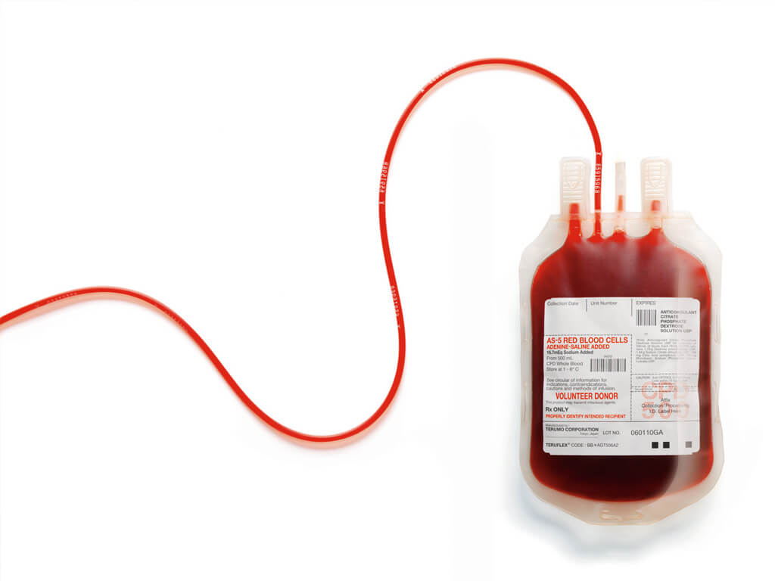

* Email-id
* Password
* Aadhar Number
* Name
* Age
* Hospital
* Contact
* Blood Group

**Hospital Details**

The blood bank management system has connection with these hospitals like

* Government Hospital
* SIMS
* Cauvery Hospital
* Apollo Hospital
* SVS Hospital

**Define module & Functionality:**

The system functions can be described as follows:

* **Registration:** When the user enters the page, they have to register and then new users are added to the database.
* **Login:** When Email Id and password is matched it allows the user to dashboard or else it denies the user to enter into website.
* **Stored Users:** Here all existing and new users are added in the database.

Case Diagram

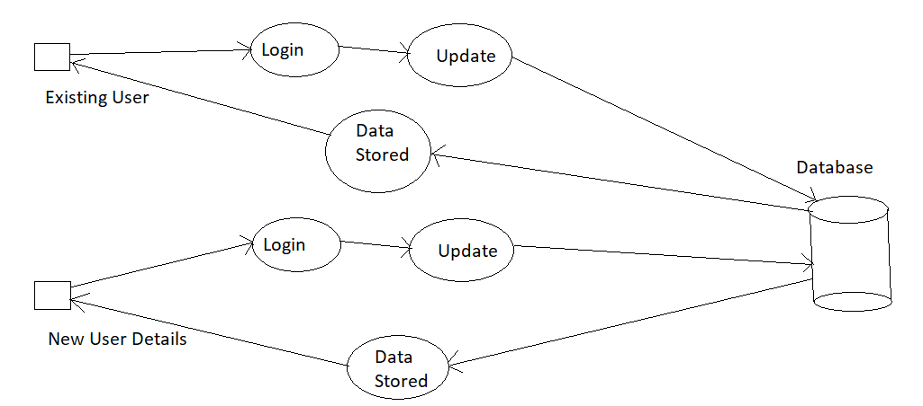

Wireframe for Login:

Log In Page

|  |  |
| --- | --- |
| **Email** | textbox |
| **Password** | textbox |

Login

Registration Page

|  |  |
| --- | --- |
| **Email** | textbox |
| **Password** | textbox |
| **Aadhar Number** | textbox |
| **Name** | textbox |
| **Age** | Dropdown |
| **Hospital** | Dropdown |
| **Contact Number** | textbox |
| **Blood Group** | Dropdown |

Register

Conclusion

Project aim is to provide transparency in this field, make the process of obtaining blood from a blood bank hassle-free and corruption-free and make the system of blood bank management effective.

Blood Bank donation system can collect blood from many donators in short from various sources and distribute them accordingly.