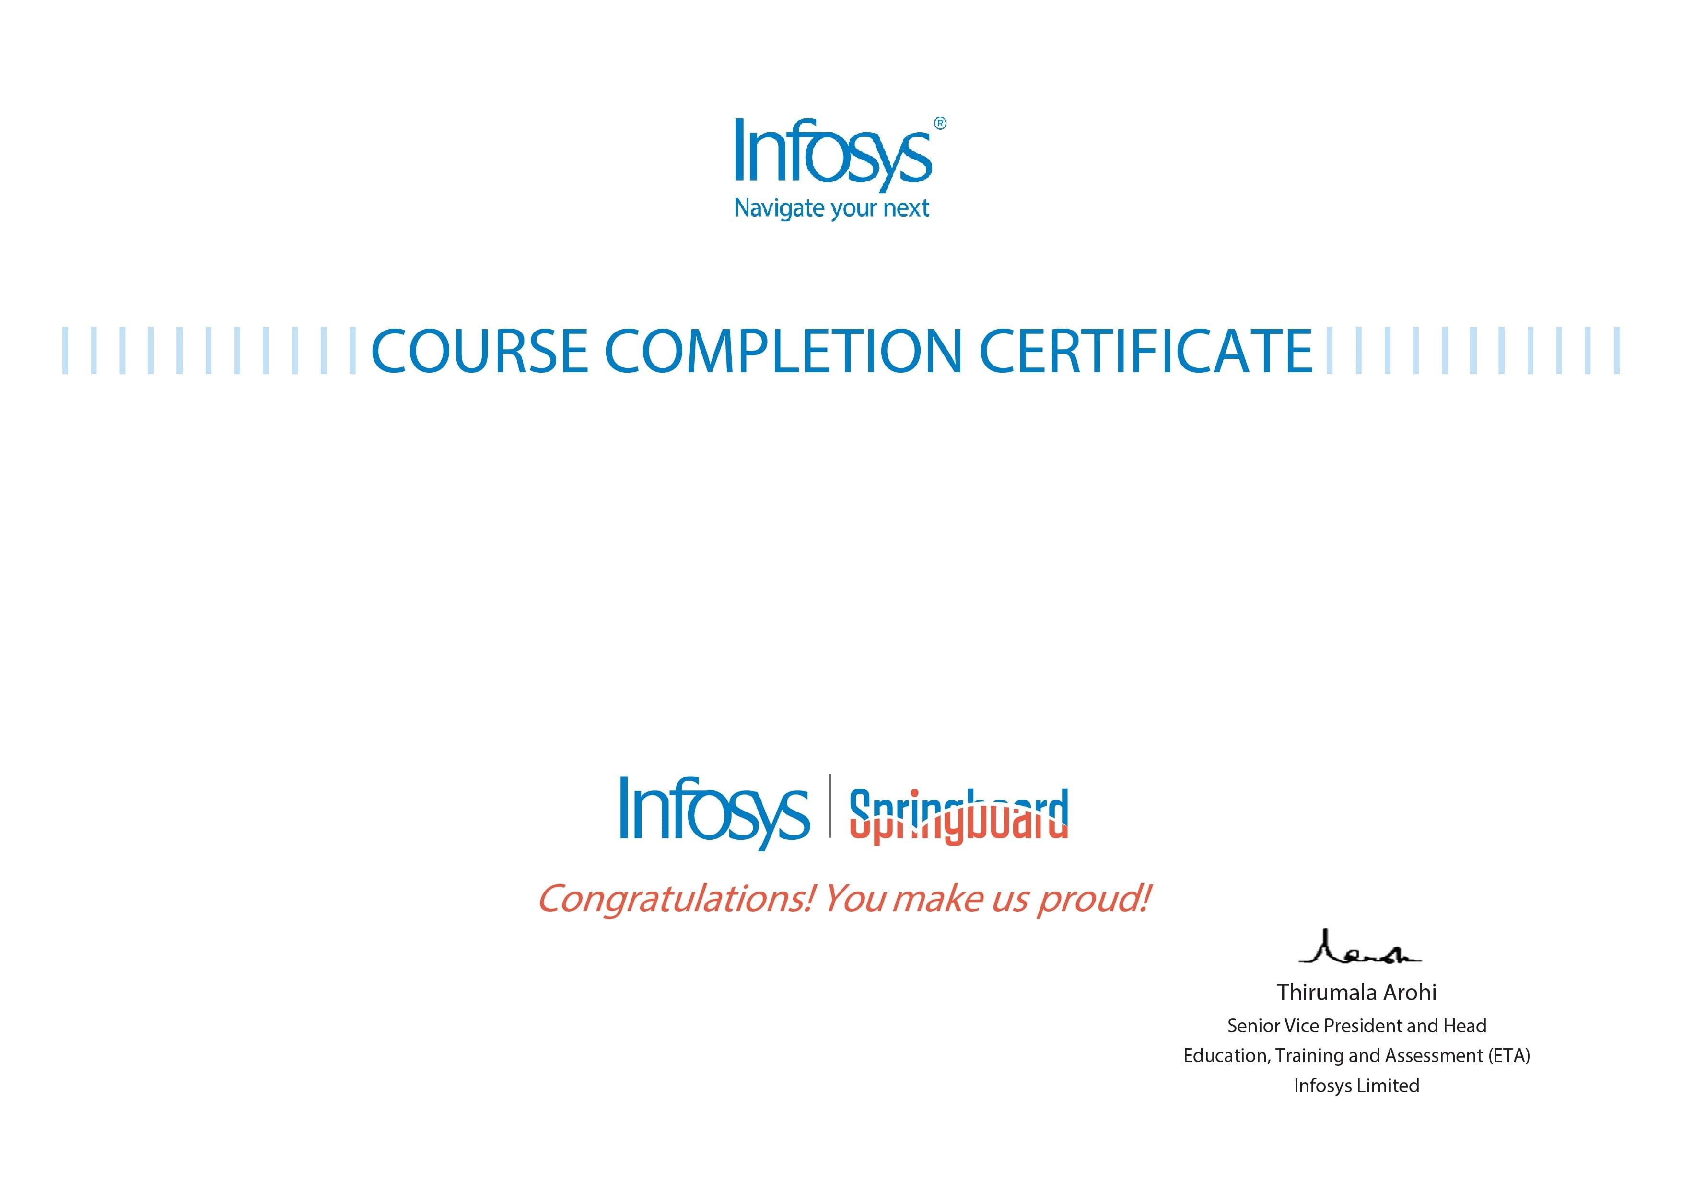

Pruthvi Raj R

Linux Command Line for Beginners

The certificate is awarded to

for successfully completing the course

on Monday, July 4th 2022

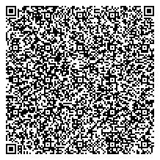

Issued on:

Friday, August 19th 2022

This certi cate can be veri ed by scanning the QR code at https://verify.onwingspan.com