Project (4). (The knowledge flow and the experimenter)
- The first step is to select knowledge Flow icon.
- Load an ARFF file and performs a cross validation using J48.
- See the network of knowledge flow connection figure (1).
- Using configure to on the Arff loader to load the iris data.
- to show the results in separate window use Text viewer, see file (1).
- to show the graph output, using graph viewer, like in network (2).
- figure (3), shows the tree produced for each fold of cross validation.

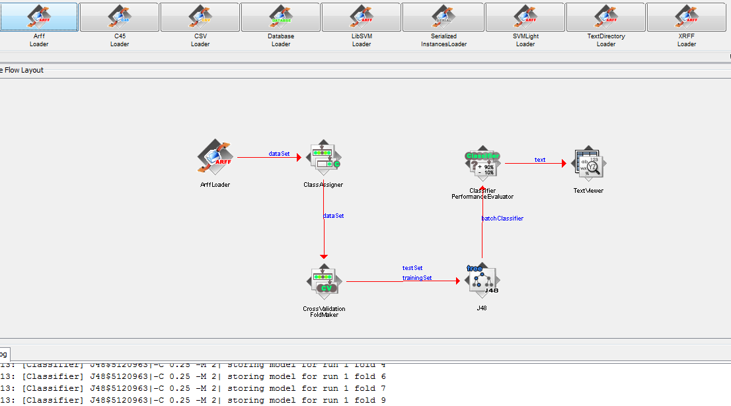
Figure (1).

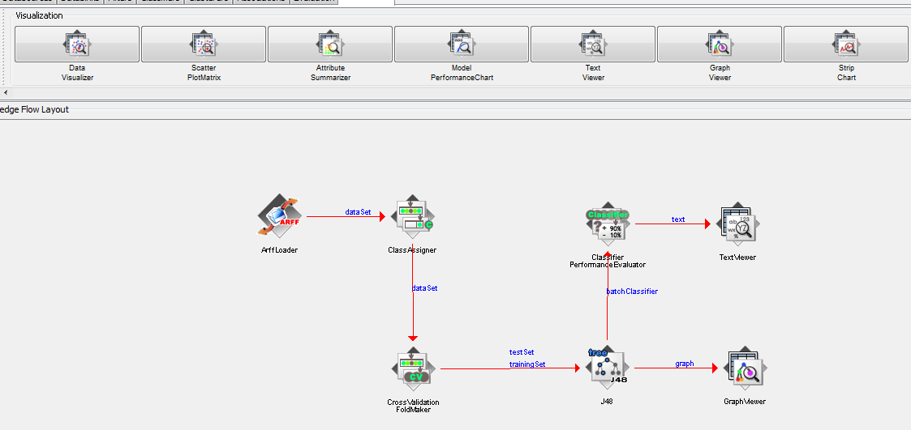
Figure (2).

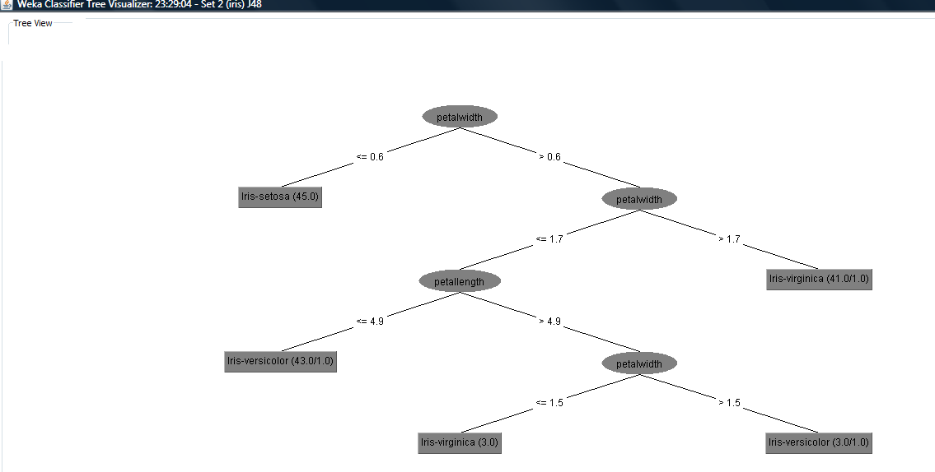
Figure (3).

The experimenter:
Explorer and knowledge Flow help you to determine how well machine learning schemes performs given datasets.
- I will use J4.8 decision tree method and baseline method which are OneR and ZeroR on the Iris dataset.
- Select experimenter.
- Choosing two files the first one for saving the result file and the second one for input data file, which is Iris data file.
- Select the three algorithms {J48, OneR and ZeroR}, see figure (4) for the experimenter environment and see the {output.csv} file for the result.
And see also the input file.
- In the result file, each row represents 1 fold of a 10- fold cross-validation.

- the next step is to analyzing the result:
The test output is:
Available resultsets
(1) rules.ZeroR '' 4.8055541465867952E16
(2) rules.OneR '-B 6' -2.4594270021478615E18
(3) Trees.J48 '-C 0.25 -M 2' -2.17733168393644448E17

- clicking the performs test:
I obtained the following results:

Tester: weka.experiment.PairedCorrectedTTester
Analysing: Percent_correct
Datasets: 1
Resultsets: 3
Confidence: 0.05 (two tailed)
Sorted by: -
Date: 11/10/09 12:07 AM

Dataset (1) rules.Ze | (2) rules (3) trees
------------------------------------------------------------
iris (100) 33.33 | 93.53 v 94.73 v
------------------------------------------------------------
(v/ /*) | (1/0/0) (1/0/0)

Key:
(1) rules.ZeroR '' 4.8055541465867952E16
(2) rules.OneR '-B 6' -2.4594270021478615E18
(3) trees.J48 '-C 0.25 -M 2' -2.17733168393644448E17

Note:
From the above results we can compare the percentage correct:
We can see the J48 has highest percentage which is (94.73%).
8. Figure (5),shows the performed result window.

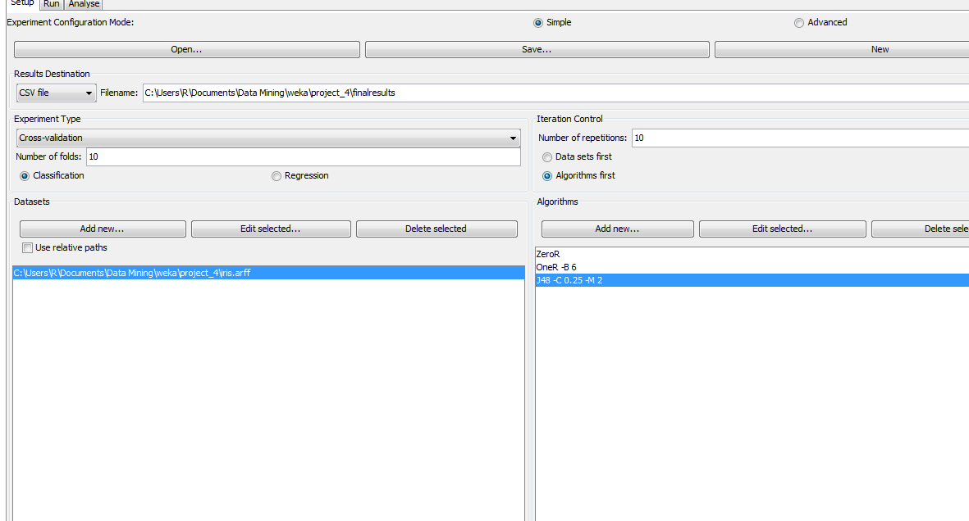
Figure (4).

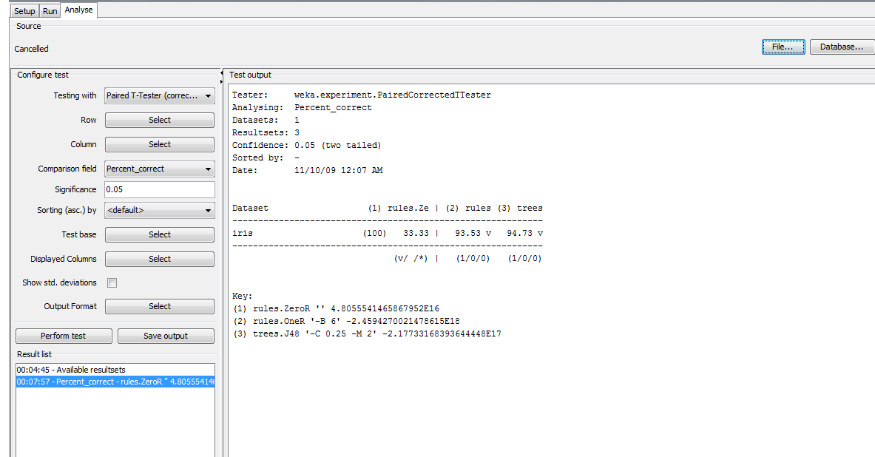
Figure (5).

