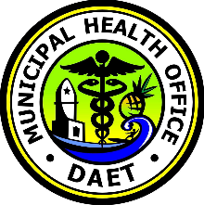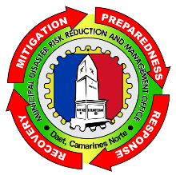

{serialNumber}

*For satisfactorily accumulating the required training hours in the*

***{training}***

*Held at {location}*

*on {date}.*

**SANTIAGO M MELLA JR**

Local Disaster Risk Reduction and Management Officer

**LURENE T TEJADA, M.D, MHCA**

Municipal Health Officer

**REPUBLIC OF THE PHILIPPINES**

**DEPARTMENT OF HEALTH**

**CAMARINES NORTE PROVINCIAL HOSPITAL**

**DAET, CAMARINES NORTE**

**HEALTH EMERGENCY MANAGEMENT STAFF**

*Presents this*

**CERTIFICATE OF COMPLETION**

*To*

{name}

