OMNIDATA HOLDING
Big Data Project Proposal

Integrated Business Data Analytics
&
Executive Decision Support
Using Big Data Technologies
▬▬▬ ◆ ▬▬▬
PREPARED BY
Hamada El-Khatib Gomaa Eid
Mohamed Atef Massad Bayoumi
Mennatallah Taha
Malak Mohamed
Zahraa ِAlaa Nassar

2026

Table of Contents
1. Project Overview 3
2. Team Members 4
3. Tools & Technologies 4
4. Project Workflow & Architecture 5
5. Expected Outcome 7

Company / Organization | OmniData Holding
Project Name | Integrated Business Data Analytics & Executive Decision Support Using Big Data Technologies
Architecture Type | Batch Processing
  Primary Use Case
  Telecommunications Customer Analytics & Churn Analysis
Dataset | Telco Customer Churn Dataset

1. Project Overview

Description
Our project aims to build an end-to-end Big Data Analytics Platform for OmniData Holding that integrates data from different business sectors into a unified analytical environment.
The platform will collect sector-level data, store it using HDFS, process and transform it using Apache Spark, and organize the processed data using Parquet and Hive for analysis and reporting.
As the primary use case, the project will focus on Telecommunications Customer Analytics and Churn Analysis using the Telco Customer Churn Dataset. The analysis will cover customer behavior, subscribed services, charges, tenure, and churn patterns.
The integrated data will be presented through Power BI dashboards, enabling top management to monitor key KPIs, identify potential financial losses, customer churn, and performance issues, and support data-driven decisions.
The project follows a batch-processing architecture, where data is periodically collected, stored, processed, and analyzed. Kafka and real-time streaming are not included in the proposed architecture.

2. Team Members
# | Team Member | Role
1 | Hamada El-Khatib Gomaa Eid | Team Member
2 | Mohamed Atef Massad Bayoumi | Team Member
3 | Mennatallah Taha | Team Member
4 | Malak Mohamed | Team Member
5 | Zahraa Alaa Nassar | Team Member

3. Tools & Technologies
The project relies exclusively on the following batch-oriented Big Data stack:
Technology | Role in the Project
● Linux | Project execution environment
● Hadoop HDFS | Distributed data storage
● Apache Spark | Data processing and transformation
● Parquet | Efficient columnar data storage format
● Apache Hive | Data warehouse and SQL-based analytics
● Power BI | Interactive dashboards and visualization
● GitHub | Code version control and team collaboration

4. Project Workflow & Architecture
The pipeline follows a batch-processing architecture, integrating data from different OmniData Holding sectors through sequential stages, from data ingestion to final business insights:
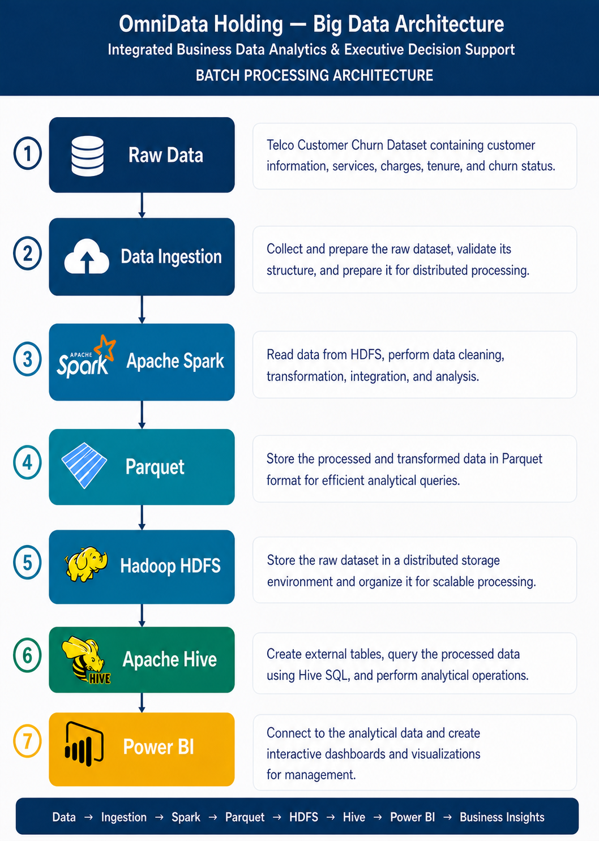
1. Raw Data
Customer, operational, financial, and service data from different OmniData Holding sectors.
2. Data Ingestion
Collect, validate, and prepare data from different business sectors.
3. Apache Spark
Read data from HDFS, clean, transform, integrate, and process data across sectors.
4. Parquet
Store processed and integrated data in an efficient columnar format.
5. Hadoop HDFS
Store and organize raw data from multiple sectors in distributed storage.
6. Apache Hive
Create analytical tables and perform SQL-based cross-sector analysis and business metrics.
7. Power BI
Build executive dashboards with KPIs, financial, customer, and operational insights.
8. Business Insights
Identify important churn patterns, understand relationships between services, tenure, charges, and churn, and support business decision-making and customer retention strategies.

⚠ ARCHITECTURE REQUIREMENT
This project strictly follows a Batch Processing Architecture. Kafka, Flume, Zookeeper, Spark Streaming, or any real-time streaming component are explicitly excluded from the design and implementation.

5. Expected Outcome
The final outcome will be an integrated Big Data Analytics Platform for OmniData Holding that transforms raw sector-level data into structured analytical data and actionable business insights.
The project demonstrates the complete Big Data pipeline end to end:
Data → Ingestion → Spark → Parquet → HDFS → Hive → Power BI → Business Insights

Key Deliverables
- A fully functional batch Big Data pipeline built on Hadoop, Spark, and Hive
- Cleaned and transformed customer dataset stored in optimized Parquet format
- Hive-based analytical tables with churn-related business metrics
- An interactive Power BI dashboard presenting KPIs and churn insights
- Complete project documentation and source code hosted on GitHub

