Homework 1

It is important to define or select similarity measures in data analysis. However, there is no commonly-accepted subjective similarity measure. Results can vary depending on the similarity measures used. Nonetheless, seemingly different similarity measures may be equivalent after some transformation.
Suppose we have the following two-dimensional data set:
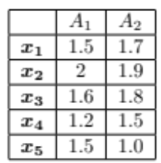
Consider the database as a set of five two-dimensional data points. Given a new data point, x = (1.4,1.6) as a query, rank the database points based on similarity with the query using Euclidean distance, Manhattan distance, supremum distance, and cosine similarity.
Please 1) work on Euclidean distance, Manhattan distance, and supremum distance by hand and a calculator without any help of programming, and submit a word document for the process and answers. and 2) work on cosine similarity using Python (e.g., the Python library sklearn.metrics and its method pairwise_distances, feel free to use other Python libraries), and submit an .ipynb file for the codes and answers.
Both the word document and the .ipynb file will need to be uploaded to Canvas Assignments.

