**Event Owner Registration**

The creative team of "XTY Event Organizers" wants to increase the number of events organized by them for the customers. As, customer expectations raise higher, they decided to develop a web application for event owner registration. Use ASP validation to check all the fields are filled properly or not and provide an error message.

Consider the class **EventOwner.cs**with the following attributes.

|  |  |
| --- | --- |
| **Data Type** | **Attributes** |
| int | _id |
| string | _name |
| string | _email |
| string | _mobileNumber |
| string | _location |
| string | _username |
| string | _password |

The methods for **getters**, **setters** and **constructors** are given in the template code.  
Add Required error message for all fields.

Consider the class **EventOwnerEntity.cs**to bind with the database.  
Consider a controller named **EventOwnerController**and define the following methods

|  |  |
| --- | --- |
| **Method Name** | **Description** |
| ActionResult Create() | This method returns the view to create eventowner. |
| ActionResult Save() | This method save the event owner and return view to Index. |

Create the views for the **EventOwnerController**class with Razor View Engine

EventOwnerEntity class

public class EventOwnerEntity : DbContext

{

public EventOwnerEntity() : base("DefaultConnection")

{

}

public DbSet<EventOwner> EventOwners { get; set; }

}

To view the table data and the table structure, use **script.sql** given in the template code.  
  
**Table properties :**  
CREATE TABLE EventOwners(  
    Id int PRIMARY KEY IDENTITY(1,1),  
    Name varchar(50) NOT NULL,  
    Username varchar(250) NULL,  
    Password varchar(50) NULL,  
    Email varchar(50) NULL,  
    MobileNumber varchar(50) NULL,  
    Location varchar(50) NULL  
);

**Note: Make sure the UI constraints like element names, id's, UI design, element order, alignment and field labels should be followed as specified in the mock-up screen.**

**Screenshot 1 (Create.cshtml) :**  
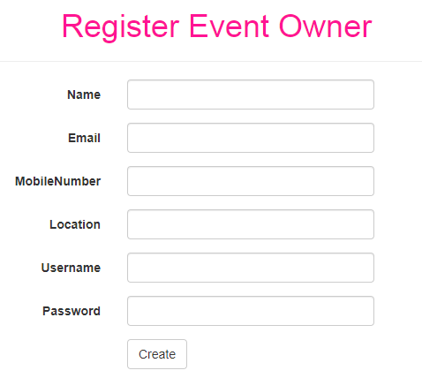

**Screenshot 2 (Create.cshtml) :**

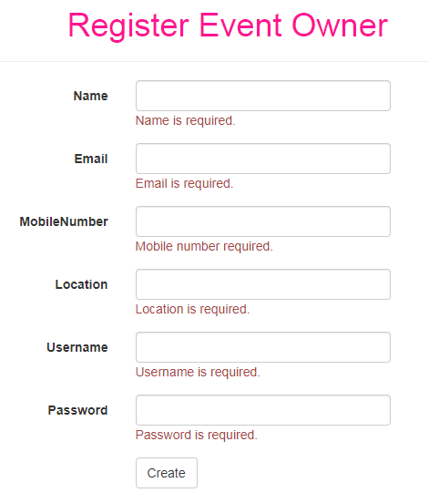

**Screenshot 3 (Create.cshtml) :**

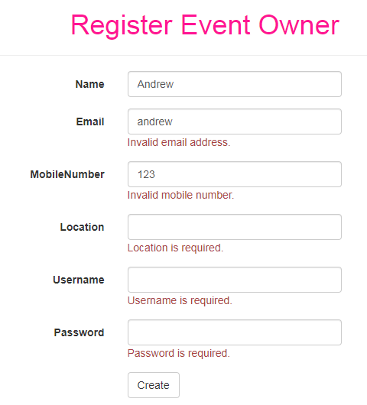

**Screenshot 4 (Create.cshtml) :**

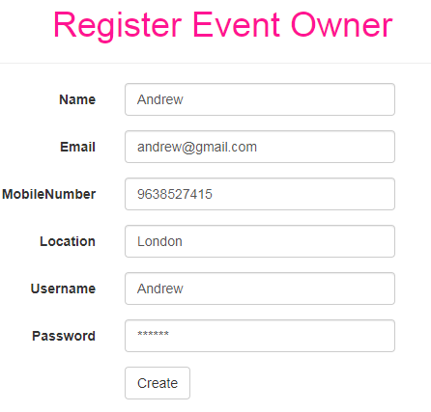

**Screenshot 5 (Create.cshtml) :**

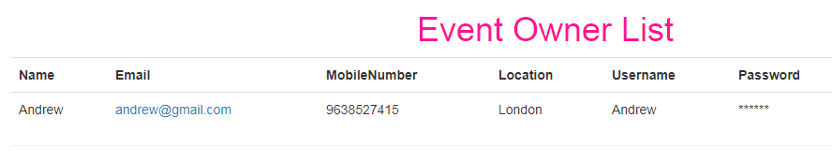

**Screenshot 6 (Create.cshtml) :**

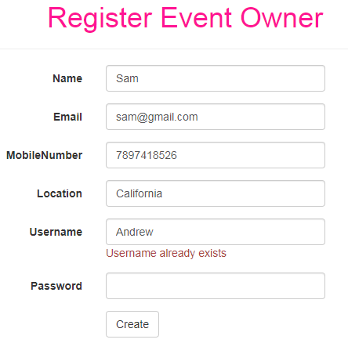

**UI Constraints :**

**Screenshot 1 :**

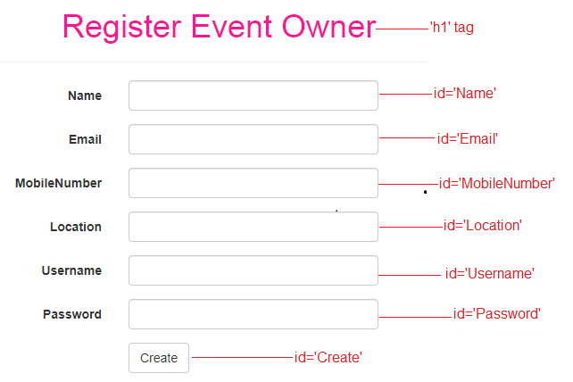  
  
**Screenshot 2 :**  
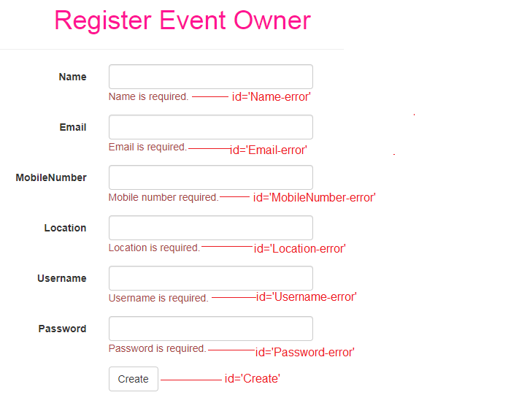

**Screenshot 3 :**

