Interim Project Report

**Full Unit – Interim Report**

A study in (HCI) human computer interaction

Ramnik Dhoot

A report submitted in part fulfilment of the degree of

**BSc (Hons) in Computer Science**

**Supervisor:** Emma Lieu

Department of Computer Science

Royal Holloway, University of London

Table of Contents

Introduction 3

1. Abstract: 3

1.1 My UI’s 4

1.2 HCI Goals for my Ui’s: 5

2. Project Specifications: 7

2.1 Target Audience 9

3. Aims, objectives, and literature survey 10

3.1 Technologies I have used and why. 11

3.2 Motivation 12

3.3 Theory 14

3.3.1 Literature review 18

4. My Progress so far 20

4.1 Work completed. 20

4.1.1 Designs and HCI principles 23

4.1.2 Other HCI methodologies I have included in my designs: 27

4.2 Software engineering 28

Conclusion 29

Bibliography and citations 30

Introduction

This report provides an overview of the progress that has been made on the project so far, including the aims, objectives, planning, completed work, and next steps. I will explain my progress with respect to my timeline and why I have deviated from it. The report also discusses some of the challenges that have been faced during the project and how I have overcome them. I will also talk about a lot of the theoretical knowledge of HCI I have learned and explain how it relates to my project and provide a survey of all the literature and resources I. I will show how I am applying HCI principles to my user interfaces.

This is a complex project that involves designing, creating, and testing three different user interfaces with different HCI principles. The goal of the project is to create user interfaces that are easy to use, efficient, and enjoyable for users. It is also to gain a comprehensive understanding of HCI principles and their application to the design of interactive systems by creating three user interfaces, A shopping website, an Inventory managements systems interface, and a note taking application.

The project is currently in the implementation phase. So far, I have, created the shopping websites layout, created the database and website interfaces layout for my inventory management system, and begun my notes application. Swing has also been learned and used to create a basic GUI for the note’s application as well as bootstrap to make websites. All the major research has been competed as I used this first term to focus on that then next term, I will focus in the Ui’s.

1. Abstract:

Human-computer interaction (HCI) is a very wide field that studies the design and evaluation of interactive computer systems for human use. The goal of HCI is to improve the interaction between users and computer systems by improving the methodologies and processes for designing interfaces, teaching techniques for evaluating interfaces, and developing new techniques for creating these interfaces. Human-Computer Interaction (HCI) focuses on three more major concerns; the people, the computers and that tasks that are performed. The most important aspect of HCI is understanding the user. This involves understanding the user's goals, tasks, and needs, as well as their cognitive, and physical abilities to perform their desired task, the book Human-computer interaction by Alan Dix [1] says that an interaction between a computer and user should be “seamless with respect to their everyday work”. For example, what may be simple to understand for a young person who has been accustomed to computers, may not be as usable to older people. This would be an issue of accessibility. By understanding the end-user, we can design and implement systems and processes that are easy to use and efficient and we can help facilitate effective communication between users and technology.

Some other important aspects of HCI are usability and functionality. Usability is a measure of how easy and efficient a system is to use. A usable system is one that can be learned and used quickly and easily, and one that allows users to complete their desired tasks. Functionality is the services the system provides to the user and the paper [3] explains how the value functionality is only visible when the system is efficiently utilized by the user. However, there are trade-offs with usability and functionality, for example in my interface I have had to Simplify the navigation of my website which reduces the number of clicks needed to access essential features and looks more visually appealing. While this may enhance usability, it limits the visibility or accessibility of certain advanced functions which could decrease efficiency for higher level users.

Because of this, system designers should prioritize understanding the end user's intentions and their approach to tasks. Neglecting the end user's needs can lead to many problems, potentially even endangering people’s lives. Alan Dix [1] talks about how aspects such as psychology, computer science, design, and engineering are all intertwined into HCI and how a good designer would have knowledge of the user’s skills and capabilities and can understand the users' needs, preferences, and behaviours.

In this project I will explore how crucial a systems design is and I will create 3 user interfaces using various principles and methods I have gathered from all the resources I have gone through then I will demonstrate these principles in my Ui’s. I will also talk about the hardware aspect of a computer and evaluate how usable it is regarding my project. In my final report at the end of the year I will explain the projects aims, professional issues, an evaluation of all the work I have done and the theory I have learnt about HCI.

The 3 interfaces I am creating are a shopping website using HTML, CSS, and JavaScript (web-based interface), a notepad desktop application using java and Swing (Graphical user interface), and Database Management System (DBMS) Interface using MySQL for the database and a website for a GUI. They will all have user-centred design where the user's needs, goals, and preferences are at the forefront of the design process. [2] helped me decide which interfaces I should create. I will also be conducting user testing on them while I am designing to improve my design and understand my target users’ needs better.

# 1.1 My UI’s

For the note’s desktop application, I am using Swing which a java library that will help me make a graphical user interface. This is a new technology for me, so I have spent a week learning how to use it, I have used the swing Documentation and manual (2) and also a course on YouTube (10101010). This is targeted towards students so I will design it with principles targeted towards the 14-21 age group. It will be a simple note taking application with limited functionality but with the options you would find in a normal note’s application would all be there, for example, save, load, delete, change size and change font. It will also have images and icons to help navigate throughout the website and everything will be laid out in a way that is intuitive and suitable for users to learn and use.

The website will be a shopping website catering to users with disabilities specifically visual impairment. The website's user experience (UX) design should prioritize simplicity and ease of use as I am designing it to be used in conjunction with a screen reader. This will be designed with a commitment to accessibility encompassing elements such as semantic HTML, clear navigation, high contrast, and keyboard accessibility. I have created a simple interface which is navigated by menus, and this will evolve into a website with descriptive text, alt tags for images, and compatibility with screen readers, facilitating a seamless browsing experience. I am adhering to accessibility guidelines like WCAG, striving for at least AA compliance (1010101010).

The Database interface will be an inventory management system using a MySQL database and html/CSS/js interface, targeted towards business owners who have a warehouse and need to keep inventory of their items. I will start the back end using java and Spring boot to interact with the database and the back end together using java’s servlet library. They will need to use it in different devices such as a phone, tablet, laptop and computer. It will also have a simple navigation design to provide an at-a-glance overview and quick access to key features. This is why I’m using bootstrap as it is responsive so it will provide better control of the layout of the website and also will make it look more visually appealing. I Have been using [7] to help me design the interfaces. It will also implement an account functionality for security, as well as defining user roles and permissions to control access levels based on the user's responsibilities.

2. Project Specifications:

Project Goal: To design and implement three user interfaces (UIs) for software applications, focusing on the UI itself. The UIs should be usable, efficient, and visually appealing.

Project Requirements:

The project has defined clear requirements to guide the development and evaluation of the user interfaces. First the UIs should cater to distinct user groups and tasks, this is so each UI can have different HCI principles in place.

The evaluation process will be robust and comprehensive. Usability, efficiency, and user satisfaction are key metrics for evaluating the overall success, emphasizing a user-centric approach. This means I need to assess how intuitive and user-friendly the interfaces are, how efficiently tasks can be completed, and ensuring that users have a positive and satisfying experience overall.

By aligning the UI design with specific the user requirements for my target users, adhering to modern software engineering principles during implementation, and evaluating the UIs using HCI principles, this project aims to deliver highly usable and effective user interfaces that enhance the overall user experience. This will include basic functionality such as writing in the notes app and being able to buy things in the shopping website.

Project Deliverables:

The project will culminate in the delivery of three implemented user interfaces: a shopping website, a notepad application, and a database management system interface. Alongside the interfaces, a comprehensive final report will be created, outlining the entire design process. This report will delve into the methodologies employed, detailing the conceptualization, prototyping, and implementation stages for each UI. It will then talk about the evaluation phase, where various HCI evaluation methods such as cognitive walkthroughs, heuristic evaluations, and model-based evaluations were applied to assess the usability and other principles of the interfaces. The report will serve as a reflective document, offering insights into the decision-making processes and showcasing how HCI principles were instrumental in shaping the final design of each UI.

Evaluation techniques:

To ensure the good usability and user-friendliness of my user interfaces, I will employ a comprehensive evaluation process using various techniques I have learned from my research. The cognitive walkthrough method will be utilized to assess the interfaces from the user's perspective, this involves an evaluator (me in this case) walking through the interface in the context of the tasks which a typical user will need to achieve. This will aid in identifying potential usability issues and ensuring that the design aligns with users' mental models. Additionally, a heuristic evaluation will be conducted which is a usability inspection method that involves me using established usability heuristics and self-designed heuristics to test the usability of user interfaces. The heuristics I will be using is Nelsen suability heuristics which I explain in my theory section. Furthermore, a model-based evaluation approach will be employed, this method uses a model of how a human would use the system to obtain predicted usability measures by simulation to analyse the interfaces' performance and interaction flow. By combining these evaluation techniques, I can thoroughly assess and enhance the overall usability, efficiency, and satisfaction of the user experience which all determine THE success of this entire project.

# 2.1 Target Audience

* Shopping website: Younger/older Visually Impaired Users:

|  |  |
| --- | --- |
| Younger | Older |
| Younger visually impaired individuals are often more familiar with technology, including screen readers, magnification software, and other assistive technologies. | Older individuals may have varying levels of proficiency with technology, from those who are comfortable using assistive technologies to those who may need simpler interfaces. |
| Often engage in online shopping for a variety of products, including fashion, electronics, and entertainment. | They may visit the website for essential tasks such as online shopping for daily necessities, accessing health information, and staying informed about news and events. |
| Modern Aesthetics: Consider a modern and visually appealing design to resonate with the preferences of younger users. | Provide clear instructions and assistance throughout the website, especially in areas like form filling and checkout processes. |
| Ensure the website is responsive and compatible with various devices, including smartphones and tablets | Consider users with cognitive impairments by providing clear and simple instructions, avoiding jargon, and helping when needed. |
| Provide support for multiple languages and ensure that the website is culturally sensitive and accessible to users from different regions. | |
| Ensure compatibility with a variety of assistive technologies, including screen readers, magnifiers, voice recognition software, and refreshable braille displays. | |

* Inventory management system: Entrepreneurs and Small Business Owners/ managers
  + encompasses a range of business types, including retail stores, e-commerce ventures, manufacturing companies, and service providers.
  + Business owners may have varying levels of technological expertise. The inventory management system should be designed with an intuitive interface to accommodate users with different comfort levels with technology.
  + Business owners are often pressed for time, juggling multiple responsibilities. The inventory management system should be efficient, allowing users to quickly perform tasks and access essential information.
  + Business owners appreciate systems that offer customization options to tailor the inventory management process to their specific business models.
  + Given the sensitivity of inventory and business data, business owners prioritize systems that ensure the security and privacy of their information.
  + The inventory management system should be scalable to accommodate the evolving needs of businesses as they expand.
* Notes application
  + students are primarily focused on their academic studies. They are likely to take a variety of subjects, including core subjects like math, science, literature, and social studies.
  + students may need features that facilitate revision, such as flashcards, summarization tools, and reminders for important dates.
  + College students typically choose a specific field of study. They might need more advanced features tailored to their coursework and research.
  + generally comfortable with technology, Students may have varying attention spans. Design a UI that is visually engaging and easy to navigate, with clear and concise information.
  + Allow users to customize the interface to some extent, such as choosing themes or adjusting font sizes. Personalization can enhance the user experience.
  + Allow for quick actions to streamline notetaking. Shortcuts, quick editing features, and easy sharing options can save time for busy students.

3. Aims, objectives, and literature survey

The aims of this project centre on the design and implementation of three distinct user interfaces (UIs) for software applications, with a primary focus on the UI itself. The project further seeks to evaluate these interfaces through the lens of Human-Computer Interaction (HCI) principles, with a particular emphasis on usability, efficiency, and user satisfaction. Additionally, a key objective is to cultivate a comprehensive understanding of HCI principles and their practical application in the design of interactive systems.

To achieve these aims, I have outlined these specific objectives:

1. Research HCI Principles and UI Technologies: Conduct thorough research into HCI principles and various UI technologies to establish a solid foundation for the design and implementation phases.
2. Design Three UIs for Different User Groups and Tasks: Employ the acquired knowledge to design three distinct UIs, each tailored to meet the specific needs of different user groups and tasks.
3. Implement UIs Using Modern Software Engineering Principles: Apply contemporary software engineering principles during the implementation phase to ensure the UIs are developed efficiently, adhering to industry standards.
4. Conduct Usability Testing: Execute usability testing to evaluate the effectiveness of the UIs. Analyse the results and make necessary adjustments to enhance usability, efficiency, and user satisfaction.
5. Write a Comprehensive Report: Document the entire design process, including research, design decisions, implementation details, and the evaluation outcomes. The report will specifically highlight the application of HCI principles throughout the project.

By systematically addressing these objectives, the project aims to not only deliver functional and user-friendly UIs but also contribute to a deeper understanding of HCI principles and their practical implications in interactive system design.

Top of Form

# 3.1 Technologies I have used and why:

**Java Swing:**

Swing is part of the Java Foundation Classes and is included in the Java Development Kit (JDK) since version 1.2. It is a GUI widget toolkit that provides a collection of standard graphical components for creating user interfaces (UIs). (10101010)

Key features of Swing:

* Platform independence: Swing components are written entirely in Java and do not rely on any platform-specific code. This means that Swing applications can be run on any computer that has a Java Runtime Environment (JRE).
* Extensive set of components: Swing provides a rich set of standard graphical components, including buttons, labels, text fields, menus, and dialog boxes.
* I am making the notes application in swing because it will mainly be used on desktop computer and swing is tailored for making desktop applications.

Reason I used Swing for creating the GUI as opposed to JavaFX:

* It is significantly easier and quicker to learn and use.
* With respect to the future of java, sit is more stable whereas JavaFX may be replaced with new technology in the future.
* Already included in the java JDK so it should be easy to run on my supervisors and markers computers without having to install additional software.
* Swing provides built-in support for accessibility features, making it easier for developers to create applications that are accessible to users with disabilities.

**HTML/CSS/JS with Bootstrap:**

Bootstrap is a free and open-source front-end framework developed and is a powerful and popular toolkit for building responsive and mobile-first web applications. Bootstrap simplifies the process of designing and styling web pages by providing a set of pre-built components, CSS styles, and JavaScript plugins that can be easily integrated into web projects.

Why I used bootstrap and key features:

* Bootstrap provides a pre-built collection of CSS classes and JavaScript components that can significantly expedite the development process which facilitates rapid prototyping.
* **Responsive Design:** Bootstrap is built with responsive design principles, ensuring that your website seamlessly adapts to different screen sizes and devices, including desktops, tablets, and smartphones. This is crucial for providing an optimal user experience across various platforms.
* **Grid System:** Bootstrap's grid system provides a structured layout framework for organizing your website's content. This makes it much easier to create consistent and visually appealing layouts without having to manually adjust margins and padding for each element.
  + Grids help to create a consistent visual experience for users.
  + Grids can also be easily adapted to different screen sizes and devices.
  + Accessibility: Grids can also help to make designs more accessible to users with disabilities. For example, users with low vision may find it easier to scan and understand a grid-based layout. Additionally, grids can be used to create designs that are compatible with screen readers and other assistive technologies.
* **Cross-Browser Compatibility:** Bootstrap is extensively tested across various browsers to ensure consistent rendering and behaviour across different platforms.
* **Consistency:** Bootstrap's consistent design language ensures that your website maintains a cohesive look and feel throughout its pages. This enhances the overall user experience and makes the website more visually pleasing.
* **Accessibility:** Bootstrap incorporates accessibility features that make your website more usable for individuals with disabilities.

There are a few reasons why I did not use a framework to create a website UI where I don't need much functionality:

* Simplicity: I only need a simple website with no complex functionality, so using a framework can add unnecessary complexity. Frameworks often come with a lot of code and features that I wouldn’t need and could make my code more difficult to manage and debug. Additionally, frameworks can add additional processing overhead, which can slow down the website.
* Control: I need complete control over the look and feel of the website and using a framework can be restrictive. Frameworks often have their own built-in styles and layouts, which can limit the ability to create a unique and personalized design. Additionally, frameworks can make it more difficult to customize the behaviour of the website.
* Learning curve: Since I am relatively new to web development, learning a new framework can be very time-consuming. This can delay the development process and make it more difficult to get the website up and running. And since only need to create a simple website functionality wise, the time investment may not be worth it.
* Flexibility: Since I need to frequently make changes to my website as I am using a prototyping approach, using a framework can make this a lot more difficult and time consuming.

# 3.2 Motivation:

Why I’m interested:

My interest in this HCI project stems from a passion for designing and implementing user interfaces (UIs). This project presents a unique opportunity for me to engage in the creation of three distinct UIs tailored for diverse user groups and tasks. The prospect of delving into various UI technologies is very good for me as it will broaden my skill set and empower me to craft UIs that seamlessly blend usability with aesthetic appeal.

Furthermore, the project's emphasis on usability testing is of great significance to me. The ability to conduct such tests and derive meaningful insights from user feedback is a valuable skill that I am eager to cultivate. This hands-on experience will not only enhance the practicality of my UIs but also deepen my understanding of the user experience.

Moreover, the HCI project offers a comprehensive exploration of a wide array of HCI principles, ranging from cognitive psychology to design principles and evaluation methods. The prospect of acquiring knowledge in these diverse areas and subsequently applying them to create interactive systems that are both user-friendly and effective is a compelling aspect of this project. Overall, I am enthusiastic about the multifaceted learning opportunities this HCI project affords, allowing me to blend creativity with a solid understanding of human-computer interaction.

How this will help me in my future career:

Engaging in this HCI project will significantly contribute to my future career development in several keyways. Firstly, it will provide me with a thorough understanding of HCI principles and their practical application in designing interactive systems. This knowledge is invaluable, as it forms the foundation for creating user interfaces that are not only functional but also highly user-friendly and effective across various applications.

Secondly, the project will equip me with practical skills in UI design, implementation, and evaluation—skills that are increasingly sought after in today's job market. As companies prioritize user-centric approaches, the ability to create interfaces that resonate with users becomes a crucial asset. The hands-on experience gained through this project will make me well-positioned to meet this demand.

Moreover, completing this project will nurture a range of transferable skills that are vital in any professional setting. The problem-solving skills developed through HCI, which is inherently a problem-solving discipline, will enhance my ability to identify and address challenges effectively. Critical thinking skills will be honed as I engage with evidence-based practices in HCI, enabling me to evaluate research findings and make informed decisions. The creative aspects of HCI will nurture my ability to generate innovative solutions to design problems, fostering creativity as a key professional attribute. Lastly, the project will further enhance my research skills, providing a solid foundation for evidence-based decision-making in my future career.

In essence, this HCI project serves as a comprehensive learning experience that not only equips me with the technical skills demanded in the field but also cultivates a set of transferable skills crucial for success in a dynamic and evolving professional landscape.

What makes this topic significant for UI designers:

The significance of Human-Computer Interaction (HCI) for UI designers lies in its direct and profound impact on our daily lives. As we engage with computers and various digital devices on a regular basis, the quality of these interactions is crucial. HCI principles serve as a guiding force for UI designers, aiming to make these interactions as efficient, effective, and enjoyable as possible.

HCI principles play a pivotal role in creating user interfaces that align with user expectations, emphasizing ease of learning and use. In a world where digital interactions have become integral to our routines; users seek interfaces that allow them to complete tasks swiftly and effortlessly. Designers, armed with HCI principles, can craft interfaces that not only meet these expectations but also enhance the overall user experience.

Furthermore, HCI principles address the desire for intuitive interfaces. Users prefer interactions that do not necessitate reading manuals or mastering complex procedures. UI designers, by incorporating HCI principles, can create interfaces that are not only user-friendly but also intuitive and easy to comprehend. This is particularly significant as it aligns with the user-centric approach, ensuring that digital tools are accessible and usable for a diverse range of users.

In essence, the significance of HCI for UI designers lies in its ability to bridge the gap between technology and users' expectations. By adhering to HCI principles, designers can create interfaces that not only meet functional requirements but also contribute to a positive and seamless user experience, ultimately making technology more accessible and user-friendly for individuals from various backgrounds and proficiency levels.

Uses of HCI and applications/systems where it is vital:

Human-Computer Interaction (HCI) holds significant importance in various domains, particularly in enhancing the usability and effectiveness of different applications and systems. In the realm of medical devices, HCI plays a crucial role in ensuring the safety and user-friendliness of these devices, catering to the needs of both patients and healthcare professionals. In educational software, HCI is instrumental in creating engaging and effective interfaces for students, optimizing the learning experience. For websites and mobile apps, HCI principles contribute to seamless navigation and user-friendly interfaces, ensuring that users can effortlessly interact with digital platforms. Moreover, in the realm of consumer products like smartphones and televisions, HCI is vital for ensuring ease of use and creating enjoyable user experiences. By applying HCI principles across these diverse applications and systems, designers can tailor interfaces to meet specific user needs, ultimately enhancing the overall usability and satisfaction of users in various contexts.

# 3.3 HCI Goals for my Ui’s:

These are some of the HCI principles I am implementing in my uis. The ones I have outlined here are the ones that are different between the 3 uis.

Shopping website:

1. **Clarity/Usability:** The primary goal is to ensure that the shopping website is user-friendly and easy to navigate. Users should quickly find the desired products with minimal effort.
2. **Consistency:**
   * Maintain consistency in design patterns and terminology. This will make it easier for users to learn and use the website.
   * Mental models of users must be respected, aligning the design with user expectations.
   * Recognition rather than recall should be emphasized, utilizing familiar design patterns and terminology for a seamless user experience.
3. **Feedback and Response Time:**
   * Provide clear feedback for user actions, whether successful submissions or errors. Then guide the user on what to do next.
   * Response times should be reasonable so that users don’t get frustrated during interactions.
4. **Error Prevention and Forgiveness:** Implement features that help prevent user errors and allowing users to recover easily from mistakes or explore different options without significant consequences.
5. **Visibility and Affordance:**
   * Ensure interactive elements are clearly visible with visual cues indicating their functionality.
   * Visual hierarchy is essential, using large fonts or contrasting colours to highlight important information.
6. **Accessibility:**
   * Integrate accessibility features like keyboard navigation, screen reader compatibility, and alternatives for multimedia content to make it easier for people with disabilities to navigate and use.
   * Ensure the website is usable by individuals with visual impairments.
7. **Learnability:**
   * Design the website for quick user understanding, minimizing the learning curve for all users, especially for those with visual impairments.

I have also created this with respect to WCAG 2.1. This was developed by the Web Accessibility Initiative and extends the principles of web accessibility established by WCAG 2.0. These are guidelines that aim to make online content more accessible to individuals with disabilities. Focusing on principles of perceivability, operability, understandability, and robustness, WCAG 2.1 outlines specific success criteria to ensure websites are usable by people with diverse abilities. By emphasizing features such as text alternatives for non-text content and accessible multimedia, WCAG 2.1 plays a pivotal role in fostering a digital landscape that prioritizes inclusivity and equal access for all users.

Notepad application:

1. **Focus:** The notepad application is designed to create a distraction-free environment for writing. Users can focus on their writing without interruptions from any other functionalities e.g., notifications.
2. **Usability:** The application should prioritize ease of use, allowing users to quickly locate and utilize its features. Also be intuitive, ensuring a seamless and efficient experience.
3. **Flexibility:** Recognizing diverse user needs, the notepad application should have the ability to customize the application to suit user preferences, enhancing the overall experience. E.g. different methods of interacting with the system
4. **Power/Efficiency:** The notepad application should be equipped with a range of features to boost user productivity, especially for expert users who require advanced functionalities.
5. **Enjoyment:** It should be enjoyable to use seeing as it is targeted towards students. User satisfaction is a key to keep students engaged as they are more likely to have lower attention spans.
6. **Internationalization:** For a global user base, the notepad application should adopt a neutral language and design. Cultural references are avoided to ensure universal understanding among users from different backgrounds.

Database management system interface:

1. **Learnability/Memorability:** Ensure that the database management system interface is easily learnable. Users should quickly grasp how to navigate and utilize the interface efficiently as they are business owners and need to be able to operate the system easily.
   * Design the interface to be memorable, allowing users to recall its usage even after a period of non-use.
2. **Efficiency and Productivity:** Prioritize the completion of tasks with efficiency and ease. Streamline workflows to empower business owners in managing their inventory effectively, minimizing the steps/complexity needed for commonly done tasks.
3. **Satisfaction:** Aim for a positive user experience, instilling confidence in users for using the system
4. **Customization:** Allow users to customize and personalize the interface according to their preferences. This is so users can easily deal with their most important tasks.
5. **Feedback/Status Updates:** Implement a feedback mechanism to keep users informed of the status of their actions.
6. **Security and Privacy:** Facilitate the security of sensitive inventory data by implementing robust authentication measures to safeguard against unauthorized access and protect the confidentiality of information.
7. **Scalability/Robustness:** Ensure that the system can handle inventories of varying scales, accommodating businesses with different sizes and levels of complexity. (This is not very applicable because my interface will not have backend functionality, but I will make it with this in mind)

4. HCI Theory

# 4.1 Background Theory

Human-Computer Interaction (HCI) is a multidisciplinary field that explores the design, development, and use of computer systems from the perspective of the user. Some of the most important aspects of HCI are:

* Cognitive psychology: This focuses on how humans think, learn, and remember information. It is important for understanding how users interact with computers and how to design UIs that are easy to learn and use.
* Design principles: These are general principles that can be used to design effective user interfaces.
* Evaluation methods: These are methods that can be used to evaluate the usability of UIs. Some of the most common evaluation methods include user testing and reviews.

HCI theory is important because it helps to ensure that interactive systems are designed to be usable, efficient, and enjoyable to use. This is important for several reasons, including:

* Increased productivity: Usable systems can help users to get their work done more quickly and easily.
* Reduced errors: Usable systems can help to reduce the number of errors that users make.
* Increased satisfaction: Usable systems can help to increase user satisfaction with the system.

HCI theory encompasses a range of principles and models aimed at understanding the interaction between humans and technology. The goal is to create user interfaces and experiences that are not only efficient and functional but also intuitive, enjoyable, and accessible.

User-Centred Design (UCD):At the core of HCI theory is the principle of User-Centred Design. This approach places the user's needs, preferences, and abilities at the forefront of the design process. By involving users in the design and evaluation phases, developers can create interfaces that align with users' mental models and expectations.

Usability: Usability is a fundamental concept in HCI theory, focusing on the effectiveness, efficiency, and satisfaction with which users can accomplish tasks within a system. Usability principles guide the design of interfaces to minimize errors, streamline workflows, and enhance overall user experience.

Affordances: Affordances refer to properties of an object that suggest how it can be used. Signifiers are cues or indicators that communicate these affordances. In HCI, understanding and appropriately implementing affordances and signifiers help users intuitively grasp how to interact with a system.

Feedback and Guidance: Providing timely feedback to users about the outcome of their action, contributes to a sense of control and predictability, enhancing the user's experience.

**Models in HCI:**

Alan Dix talks about “the golden rule of design”: which is understanding your materials.

* understand computers – limitations, capacities, tools, platforms.
* understand people – psychological, social aspects, human error.

1. The Human:

This model conceptualizes the human mind as an information processing system, providing insights into how humans perceive, process, and respond to information. It helps designers understand cognitive factors influencing user interaction.

How do users think? Users appreciate quality and credibility. They don’t read, they scan:

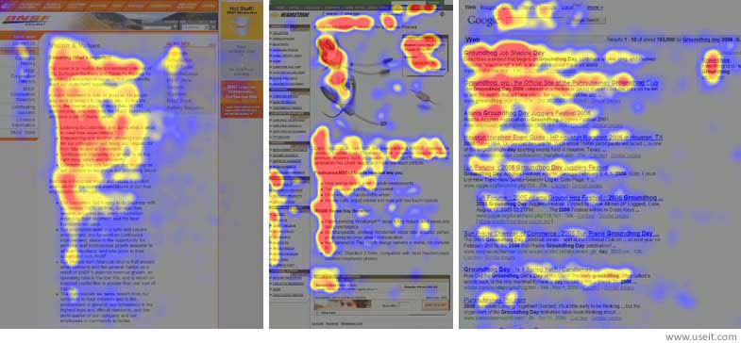

These images depict heat maps revealing the focal points of user attention during online browsing. The most viewed areas, represented as the "hottest" zones, tend to cluster around the middle of sentences, which aligns with the typical scanning behaviour of web users. A user’s impatience and the pursuit of instant gratification drive users to satisfice, opting for the first reasonable choice instead of the optimal one. Optimization is a lot harder and takes a lot more time, so satisficing is generally the more efficient approach. Users rely on their intuition and seek control in their interactions.

A fundamental principle in creating a user-friendly interface is to minimize cognitive effort, following Krug's first law of usability. Webpages should be clear, self-explanatory, and have clear structure, with moderate visual cues and easily recognizable links. By reducing cognitive load, you make it easier for visitors to grasp the idea behind the system. Recognizing users' limited patience, designers should strive to keep user requirements minimal, the less action is required from users to test a service, the more likely a random visitor is to try it out.

Effective management of users' attention is crucial. Web-users can instantly recognize edges, patterns and motions, a webpage should guide attention to specific areas through use of visual elements. This approach can help your visitors to get from point A to point B without thinking of how it is supposed to be done. Guidelines are extremely effective as they lead the visitors through the site content in a very simple and user-friendly way. The less confusion and questions a user have about the page, the better the sense of orientation and provides an overall improved user experience. (11)

Mental Models in HCI:

* Mental models are based on users' beliefs about the system they are interacting with.
* They are crucial for predicting user actions and interactions with the system.
* A key challenge in HCI is aligning the designer’s mental model with that of the users.

The computer:

In Human-Computer Interaction (HCI), the model of the computer refers to the mental framework users construct about how a computer system operates. This conceptual model is a crucial aspect of designing interfaces that are intuitive and user-friendly. Users form mental models based on their interactions with other computers and systems. This system should align with the users’ expectations, and this is achieved through clear affordances, providing visible feedback, maintaining consistency in design, and ensuring effective error handling. The mapping between controls and system functions, along with the visibility of system status and options, contributes to a coherent mental model. Furthermore, a system's learnability and adaptability over time influence the users evolving conceptual model of computer systems.

* Input and output modalities: Computers receive inputs through various means, such as keyboards, touch screens, and voice commands. Outputs can be presented visually, audibly, or through haptic feedback. Interfaces should match input and output modalities to user preferences and task requirements.
* Input and output modalities: Computers receive inputs through various means, such as keyboards, touch screens, and voice commands. Outputs can be presented visually, audibly, or through haptic feedback. Interfaces should match input and output modalities to user preferences and task requirements.

Colour Theory: Colour is a very effective way of influencing a user, here are some of the ways it can be used to enhance the interaction between humans and computers.

* Use complementary colours to create contrast. They create the strongest contrast, which can be used to make important elements stand out.
* Use analogous colours to create harmony They create a sense of harmony and unity, which can be used to create a calm and relaxing atmosphere.
* Use triadic colours to create balance. Triadic colours are colours that are evenly spaced around the colour wheel. They create a sense of balance and stability, which can be used to create a professional and sophisticated look.
* Use tetradic colours to create interest. Tetradic colours are made up of two complementary colours and two analogous colours. They create a sense of interest and excitement, which can be used to grab users' attention.
* Different types of audiences are attracted to different colours.
* Fewer colours are generally more powerful and less overwhelming.

Nielsen's usability heuristics are a set of principles that can be used to design more usable user interfaces (UIs). They are based on the idea that users should be able to easily learn, use, and remember how to use a system. The heuristics are designed to help designers avoid common usability problems. (12)

1. Visibility of system status: The system should always keep users informed about what is going on, through appropriate feedback within a reasonable amount of time.
2. Match between system and the real world: The system’s language, terminology, and concepts should align with what users already know from their real-world experiences.
3. User control and freedom: Users should be able to backtrack or undo actions easily, offering them the freedom to correct mistakes.
4. Consistency and standards: Follow platform conventions and be consistent in your use of terminology and design.
5. Error prevention: Careful design that prevents a problem from occurring. Double-check user input and provide clear instructions to avoid mistakes.
6. Recognition rather than recall: Minimize the amount of information that users must remember by providing appropriate defaults or making information easily retrievable.
7. Efficiency and flexibility: Efficiency features and shortcuts should be available for power users without overwhelming beginners. Accommodate both users by providing clear navigation options and the ability to customize frequent actions.
8. Aesthetic and minimalist design: Clutter-free, aesthetically pleasing designs are more user-friendly.
9. Help users recognize, diagnose, and recover from errors: Error messages should be clear, concise, and constructive. They should tell users what the problem is, and how to fix it.
10. Help and documentation: Provide easy access to help and documentation, and make sure it is clear, concise, and up to date.

# 4.2 Literature review:

**Human-Computer Interaction (3rd Edition), Alan Dix, Gregory D Abowd, Janet E Finlay and Russell Beale (1)**:

Introduces the core concepts and scope of HCI, defines HCI and its importance in the modern world. It is a foundational text that offers comprehensive insights into HCI principles, design considerations, and user experience. The book's focus on user-centred design, iterative development, and robust evaluation techniques makes it invaluable in the HCI field. Specific chapters and pages, such as Chapter 5 (Pages 3, 4, 8, 10, 14), Chapter 6 (Pages 38, 48), Chapter 8, and Chapter 10, provide detailed insights into these topics, contributing significantly to the understanding and advancement of human-computer interaction.

Human-Computer Interaction (3rd Edition) by Alan Dix, Gregory D Abowd, Janet E Finlay, and Russell Beale is a comprehensive textbook that covers a wide range of topics related to HCI. The book is divided into 12 chapters, each covering a different aspect of HCI. The authors provide a good balance between theory and practice, and they use many examples and case studies to illustrate the concepts covered in the book.

In the first three chapters, the authors provide an overview of the human and computer aspects of HCI, as well as the interaction between humans and computers. The next few chapters cover the design process for interactive systems, different interaction styles, navigation and wayfinding, input and output devices, software architectures, and the Model-View-Controller (MVC) architecture. The authors also cover evaluation techniques for interactive systems, universal access, and rich interaction.

Overall, Human-Computer Interaction (3rd Edition) is an excellent resource for anyone interested in HCI. The book is well-written and provides a good balance between theory and practice. The authors provide many examples and case studies to illustrate the concepts covered in the book, making it easy to understand and apply the material.

**Designing the User Interface: Strategies for Effective Human-Computer Interaction (6th Edition) by Ben Shneiderman (5):**

Talks about design principles and strategies for effective HCI. It emphasizes on the usability of interactive systems, guidelines, principles, and theories for designing user interfaces, and the management of design processes. This book presents a broad survey of designing, implementing, managing, maintaining, training, and refining the user interface of interactive systems​​. It emphasizes direct manipulation, menu selection, command languages, interaction devices, and collaboration​​.

this book is a comprehensive guide to the field of human-computer interaction (HCI) and user experience (UX) design. It covers topics such as design paradigms, design methods, prototyping, and evaluation techniques. The book also provides practical principles and guidelines for developing high-quality interface designs that users can understand, predict, and control. The authors use many examples and case studies to illustrate the concepts covered in the book, making it easy to understand and apply the material.

Designing the User Interface: Strategies for Effective Human-Computer Interaction (6th Edition) is authored by Ben Shneiderman, Catherine Plaisant, Maxine Cohen, and Steven Jacobs. The book is divided into 12 chapters, each covering a different aspect of HCI. The first three chapters provide an overview of the human and computer aspects of HCI, as well as the interaction between humans and computers. The next few chapters cover the design process for interactive systems, different interaction styles, navigation and wayfinding, input and output devices, software architectures, and the Model-View-Controller (MVC) architecture. The authors also cover evaluation techniques for interactive systems, universal access, and rich interaction.

**Empirical Research in HCI (Human-Computer Interaction: An Empirical Research Perspective by I. Scott MacKenzie) (6):**

MacKenzie's book discusses the empirical methods in HCI research. It highlights the importance of historical context, the human factor, interaction elements, scientific foundations, designing HCI experiments, hypothesis testing, modelling interaction, and the process of writing and publishing a research paper in the field of HCI​​.

Human-Computer Interaction: An Empirical Research Perspective by I. Scott MacKenzie is a comprehensive guide to empirical research in HCI. The book begins with foundational topics including historical context, the human factor, interaction elements, and the fundamentals of science and research. After that I learned about the methods for conducting an experiment to evaluate a new computer interface or interaction technique. There are detailed discussions and how-to analyses on models of interaction, focusing on descriptive models and predictive models. Writing and publishing a research paper is explored with helpful tips for success.

The book is divided into 12 chapters, each covering a different aspect of HCI. The first three chapters provide an overview of the human and computer aspects of HCI, as well as the interaction between humans and computers. The authors also cover evaluation techniques for interactive systems, universal access, and rich interaction.

5. My Progress so far

# 5.1 Work completed:

I dedicated a significant portion of this term to conducting a thorough literature review on HCI principles, methodologies and theory. This involved learning various design techniques and theoretical foundations so I can have a solid groundwork for the subsequent design and implementation of my UI’s. Notably, reading Alan Dix's book [1] was a milestone, enriching my understanding of HCI and providing valuable techniques for designing user interfaces. I focused particularly on the chapter’s most relevant to my project, documenting these chapters in my diary and making notes on everything ii could use for my designs.

In addition to this I learned practical methodologies through Scott Klemmer's lectures, focusing on design heuristics and visual design [4]. The I read research papers on the topic, including one by Sinha, Shahi, and Shankar on Human-Computer Interaction [3], and thoroughly reviewed and noted key points from articles such as "10 Principles of Effective Web Design" and "Designing for the Web: An Introduction to Human-Computer Interaction" by Jakob Nielsen.

As I was doing this, I developed my detailed project plan which was a crucial step in organizing my tasks and ensuring a systematic approach. Three user interfaces were also designed, each tailored to cater to different user groups and tasks so I could apply different aspects of HCI. Despite the challenges of balancing extensive literature review with development efforts, I maintained my diary to record mistakes, challenges, and track my progress, ensuring I have everything I will need for my final report.

As part of my design strategy, I adopted a greyscale layout for all UIs based on insights from Scott Klemmer's lectures. This approach, avoiding the use of colour for visual distinctions between components, has facilitated a clearer differentiation of elements on each page, with varying shades of grey indicating the importance of different items. Next term I will implement colour using principles from colour theory. After each iteration of my UIs, I have tested their usability with actual people which I have recorded in my diary. For the html programs I have not linked each page together yet as they are all still in progress and the paths are changing.

**Shopping website:**

I have begun this website by first using Canva to make a design for this website including all the HCI principles I had learnt. I previously planned to have this website targeted towards students but after more research and discussion with my supervisor I changed it to be targeted towards any user with visual difficulties. This is because I can use many different HCI principles that would be different from my other UIs whereas the previous version would be too like the other UI’s. I started by creating a navigation bar using bootstrap and adding the essential features of the website on it by taking inspiration from other popular websites like amazon.co.uk. I also added components/widgets like buttons, labels, text fields, and more to the website window. I then added Empty cards where I have put placeholder items that are being sold. Currently I am designing a few different product pages and a cart which will help me demonstrate how an average user could use this website. I then created another page which will act as the homepage of the website and will direct the user to wherever they need to go.

I first had to learn how to use bootstrap. I have made this webpage using bootstraps grid system as it was the most efficient way to have all the elements and components on the page in a symmetrical and centred position. Alignment guides the eye, reducing clutter. I had some issues learning how to use bootstrap and especially how to control and manipulate the columns and rows, but this video really sped up my progress: <https://www.youtube.com/watch?v=-qfEOE4vtxE>. I have had to redesign the website a couple of times a as I kept improving and building on the previous prototype using the knowledge I have acquired during my research.

After developing the shopping websites layout and structure I applied styling using CSS. While Bootstrap accelerated the process, including my CSS files in IntelliJ proved troublesome as they would not connect to the main html file, this prompted a switch to VS Code which seemed to instantly fix the issue. The decision to not use a framework or React for the website was a strategic one, based on the project's specific needs and my comfort with the technologies. I originally began learning and using react, but I did not continue for the reasons I mentioned previously. After all of this I did user testing with visually impaired people and used the insights I got to create a settings page with functionality for dark mode, high-contrast mode, and larger text mode. These all have functionality and apply to all the pages. I then created a screen reader button which also has functionality but only on the cover page at the moment.

Next, I will begin adding functionality like saving items in the basket and being able to buy items and error prevention functionality to prevent users performing actions they did not mean. This will include setting up event handlers to respond to user interactions (e.g., button clicks) for website. I will also create many more pages for this website like a help page (Learnability/Usability) and a menu bar that shows the user which stage of the buying process they are on (Visibility and affordance). I will then focus on the design of the page and make it look cleaner and more visually appealing along with transitions when a user performs an action or moves to another page to grab the user’s attention.

**Notes application:**

I began by learning Java Swing using this course: https://www.youtube.com/watch?v=Kmgo00avvEw&t=3s. I first made a design of the application using Canva, as well as all the functions and buttons that the application will need. I designed the multiple navigation bars for different functions by taking inspiration from other word processors like Microsoft word. I have created a panel with a navbar and a page where users would write. This is all still in greyscale so I can design the layout properly without using colour as a crutch. I am currently creating the multiple navigation bars, but I have had problems switching between them, so I have just left them as three separate ones for now. After this I added components like buttons, labels, text fields to the window. After all of this I Set up event handlers to respond to user interactions (e.g., button clicks) but now they do not do anything they just output to the console what action has be done.

The development of the Java GUI for the note’s application required meticulous attention to HCI principles, ensuring both functionality and user-friendliness. Even though I will not have much backend functionality, I am designing my user interface to be mainly functional as it will be used by students who are likely to have a lot of technical expertise. I have also redesigned the inventory interface a few times for better visual appeal as I was learning and get more comfortable with swing and learning more about HCI which was very time-consuming. I have redesigned this one a few times, adding functionality for typing and changing fort colour and format. After this I gave this to students to test and added the feedback to the application. I created another side menu with undo and redo buttons that are easily visible (Error recovery), and also a full screen mode to facilitate focus. I also added a Touch screen mode to be used with touch screen computers/laptops, this brings up an onscreen keyboard which can be moved around (Flexibility- different ways of interacting with the system).

I will add more functionality to the components for example adding support for keyboard shortcuts. I will also add a functional menu where users can add their own functions which are most used and also change the colours and background of the interface (Efficiency, customizability, productivity). I will then work on the design and over all appeal of the interface to make it more suitable for students.

**Inventory management interface:**

I began this user interface by also designing it in Canva. For this one I was going to have an account system and a responsive design as it will be used by professionals and must be very efficient and meet at the requirements they would have. I first created the database where all the account information and users’ inventory would be stored. After a meeting with my supervisor, I was informed that I dint need that much functionality so I am going to uses the MySQL database just to store random information which can be used by the inventory system. I then begun making the UI using html/CSS/js and bootstrap. The was quite say as I already had experience with bootstrap from the first website UI. As with all the other user interfaces I created the frame of the interface and started by created a side navigation bar. I then added columns of inventory stock next to it where I just used placeholder information.

I began this UI using colour but after my research I redesigned it to have an upper navigation and a side navigation bar and to be in grayscale. This was all to cater towards my target user which my first design didn’t do as well. I made these changes after doing user testing with university students. I will explain all the aspects of my design below. I also redesigned the interface again moving around components and making it look more modern and visually appealing. After user testing, I added many more pages such as login, signup and two factor authentication (Security). I also added a help menu to the cover page (Help, learnability). I also added a button for voice control of the system, this will make it easier for users to interact with the system (Flexibility). I will the add all the functionality for these and add functionality to personalise the inventory by changing the picture and names of inventory items, I have already implemented the menus for this. I will also make a customizable homepage. A few more functions I will implement are a button to export to Excell and google sheets and loading bars to show the systems status.

# 5.2 My process of design:

This image describes how I have been designing my Ui’s. I began by finding my users requirements, then I analysed how I would fulfil those requirements. After I repeatedly designed and tested these uis and added all the feedback. When my UIs are at their best versions, I will deliver the final product.

# 

# 5.3 Designs and HCI principles:

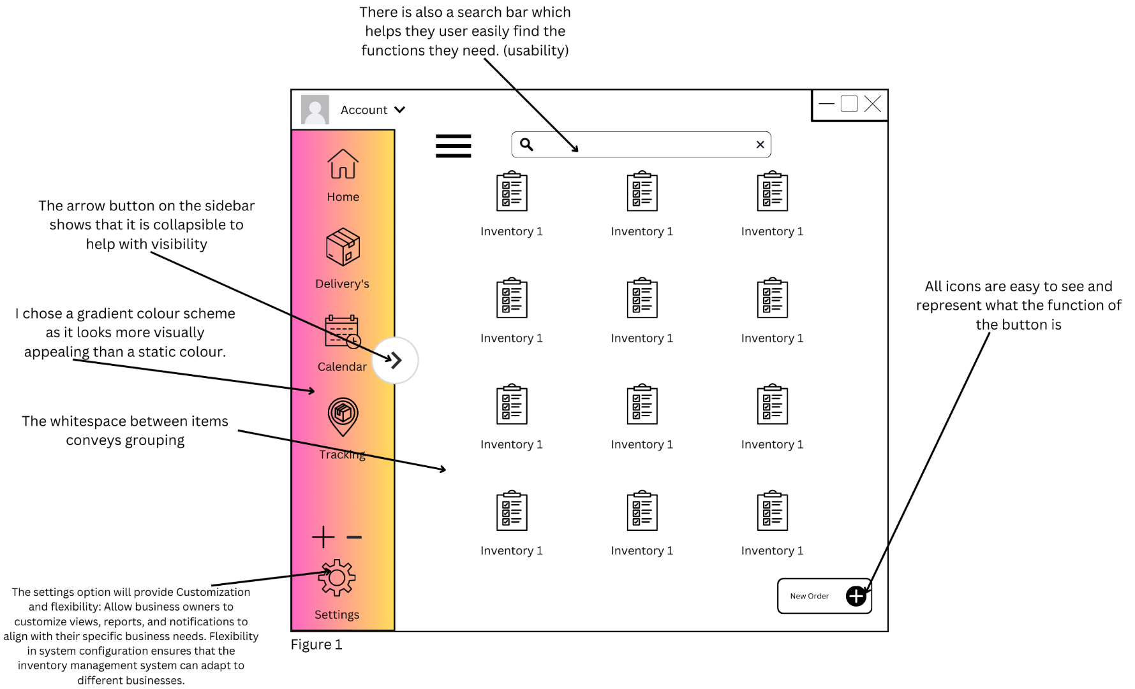Inventory management system:

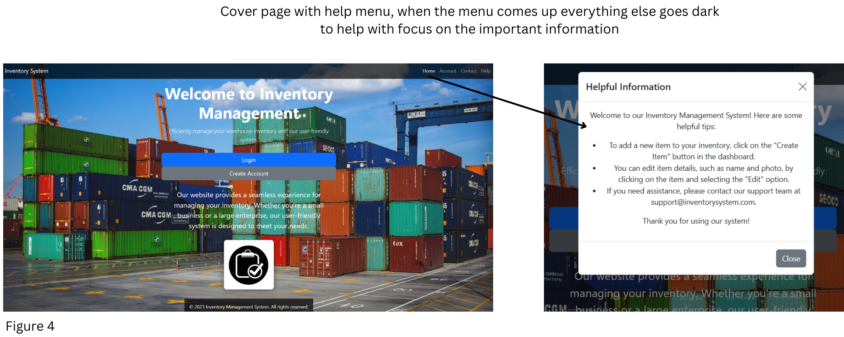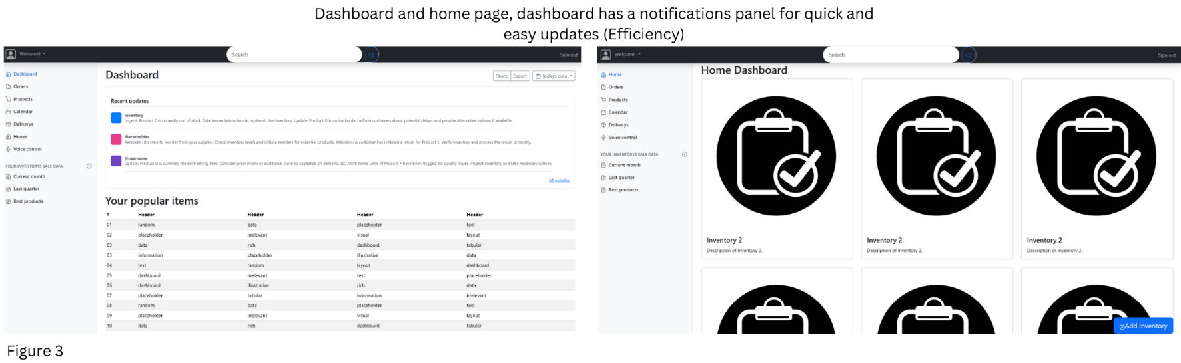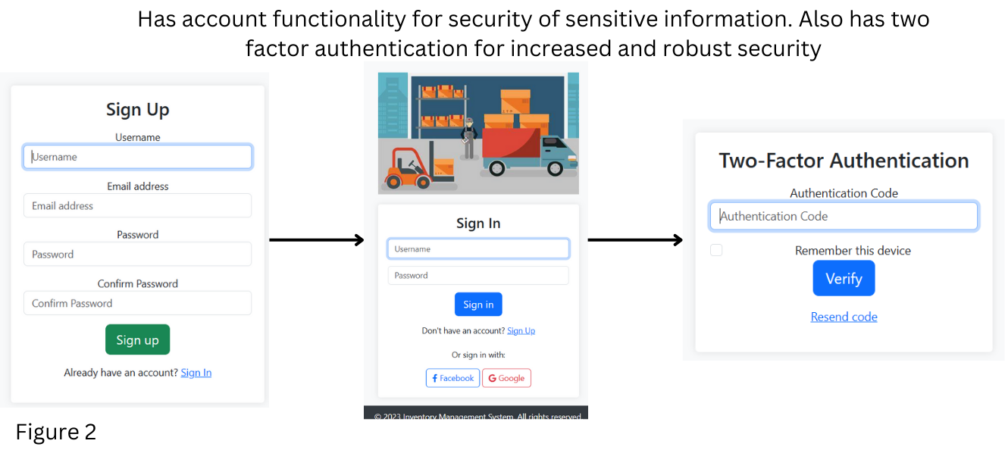

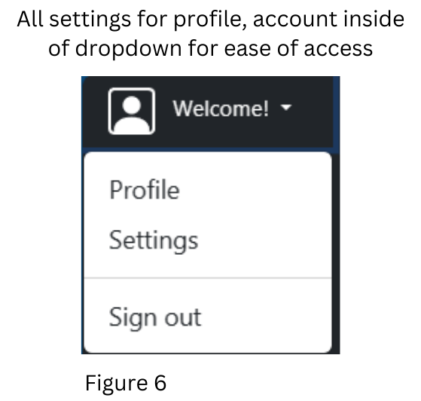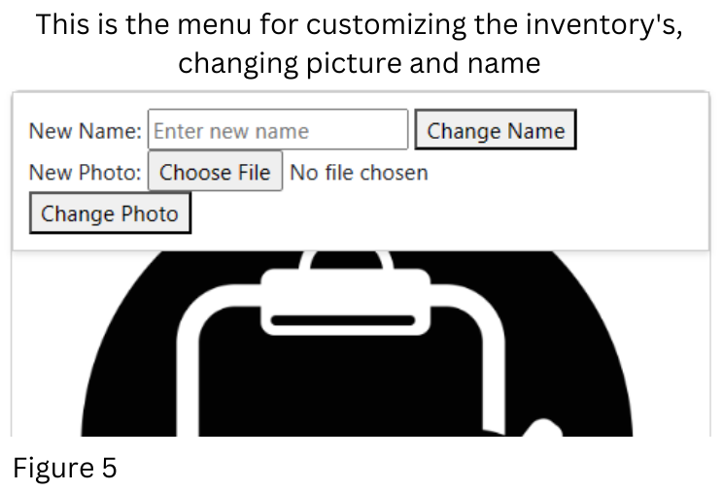

* This interface will have learnability integrated into a help system which will come up with tool tips and guidance on how to use the system. Will also have help and manual section.
* To promote efficiency, productivity, and flexibility, all the main functions and options are on the home screen and easily accessible. There will also be shortcuts for the most used functions.
* This should also be a memorable interface as it will always have the same layout on every page and on every device, it is used on.
* Security and privacy: Provide real-time feedback on inventory changes, updates, and system status. Timely notifications and alerts can help business owners stay informed about critical events affecting their inventory.
* There is a + - icon to increase and decrease the size of the Screen, these will have tooltips or name tags to explain what they do.
* To facilitate user control and freedom, there will be the options to undo/redo, delete, exit anything they have done.
* It has a very minimalist design reducing cognitive load.
* Will also have customizable home page as the system will be able to hold a lot of data so the user can put their most important data in the homepage.
* To show the systems tatus I will have a loading bar, so the user does not get frustrated thinking nothing is going on.

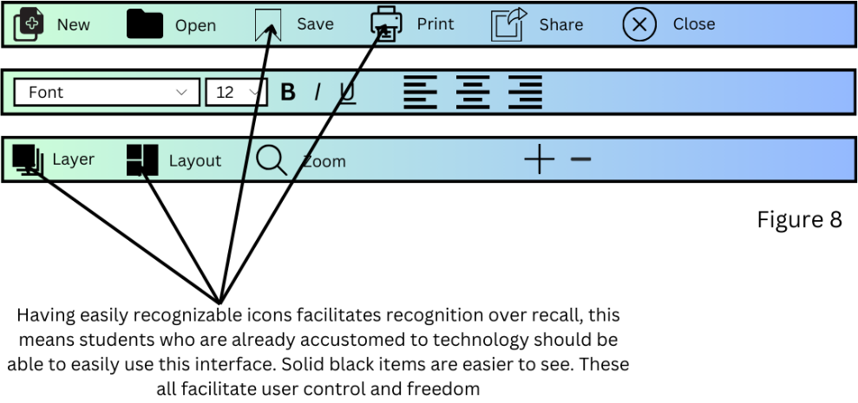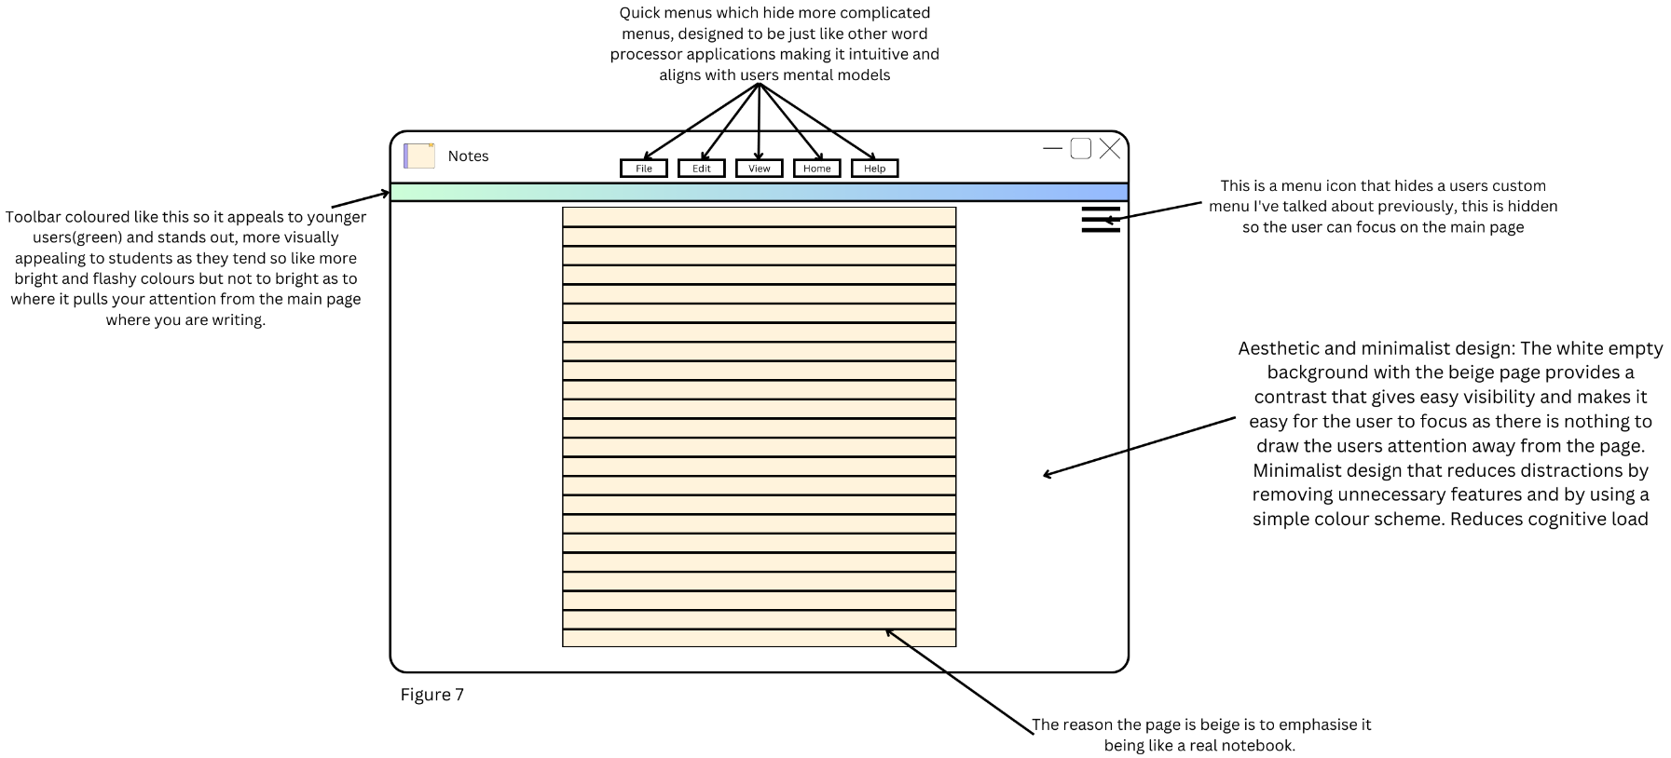Notes application:

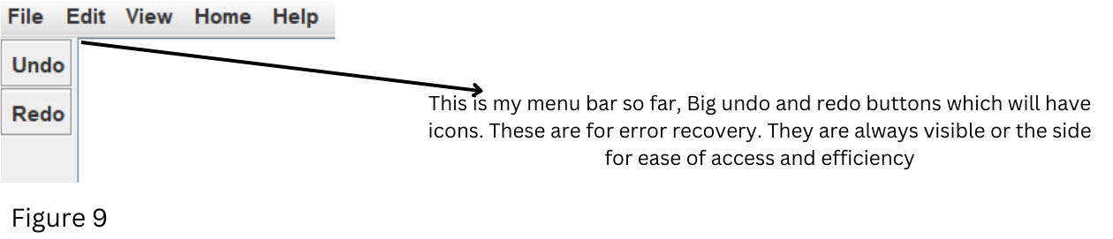

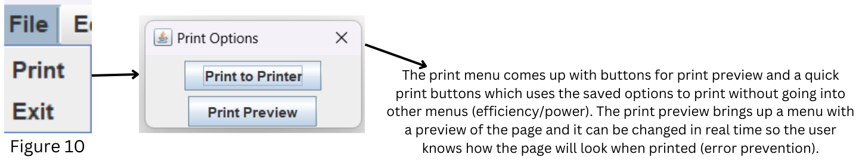

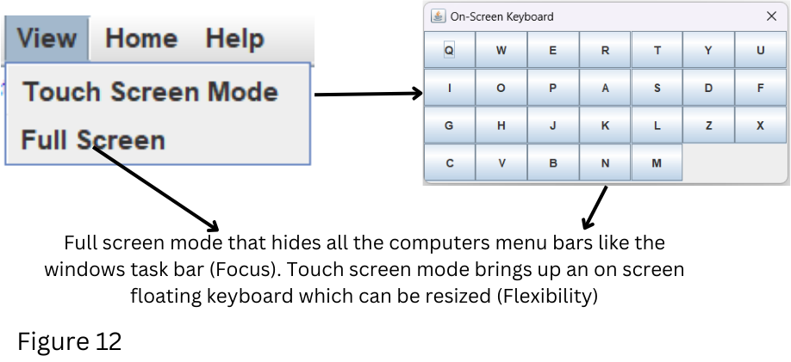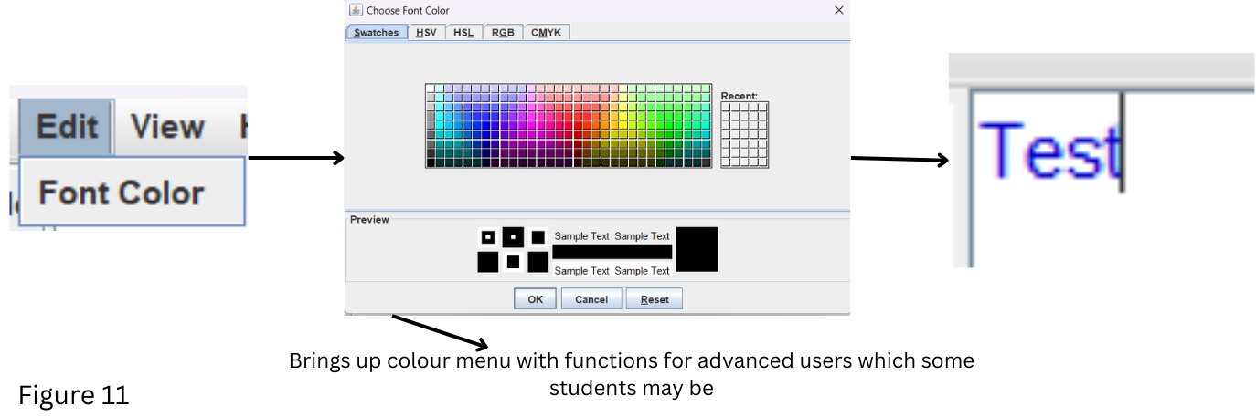

* Design is easy on the eyes and simple so students will pay attention and not get bored quickly (satisfaction).
* This will also give feedback about the storage of the system and feedback about any changes and actions made e.g., confirmation of change popup.
* The help section adds more usability to the application, The notepad application will have an integrated search feature to help users quickly locate specific notes and any functions they need.
* Error correction: One way this will be done is Spell checking: The notepad application will include spell checking to help users catch and correct mistakes.
* It is also robust as it provides many options and functions for the user.
* All components will have consistent names with other word processors to make them easy to recognize.
* It will also prevent errors, e.g., data loss from the computer closing abruptly, bad input.
* I will also have a language setting for different languages. Also has very simple and neutral language to be easily used by different user groups (internationalization).

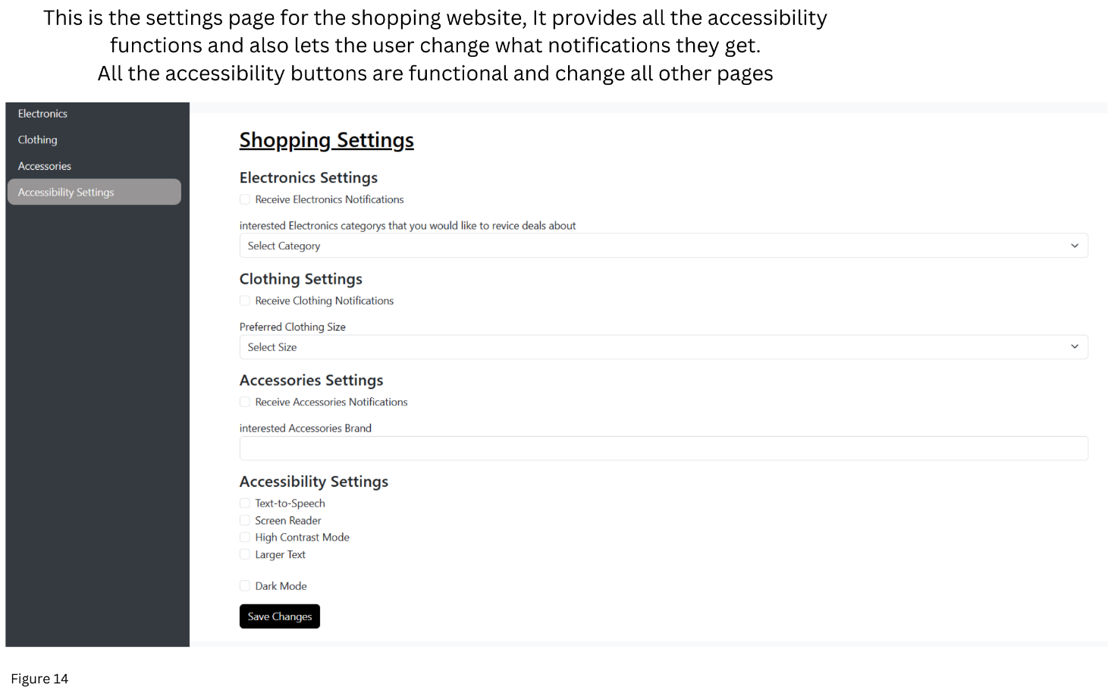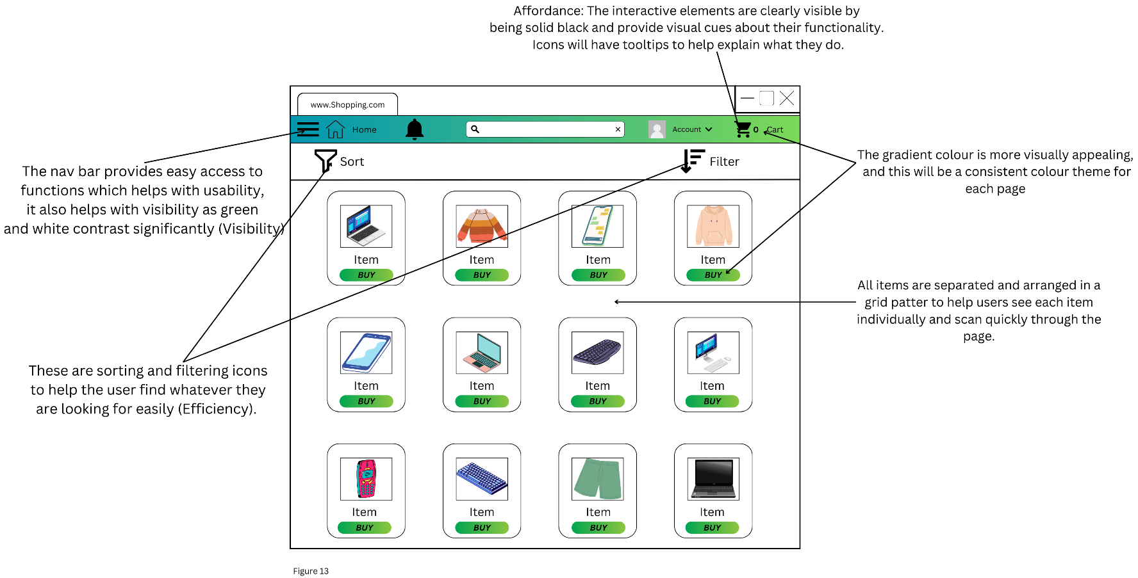Shopping website

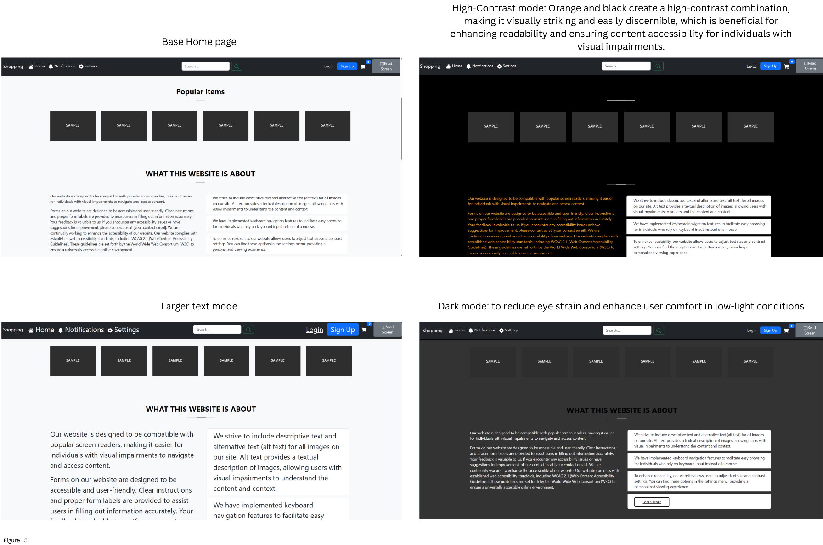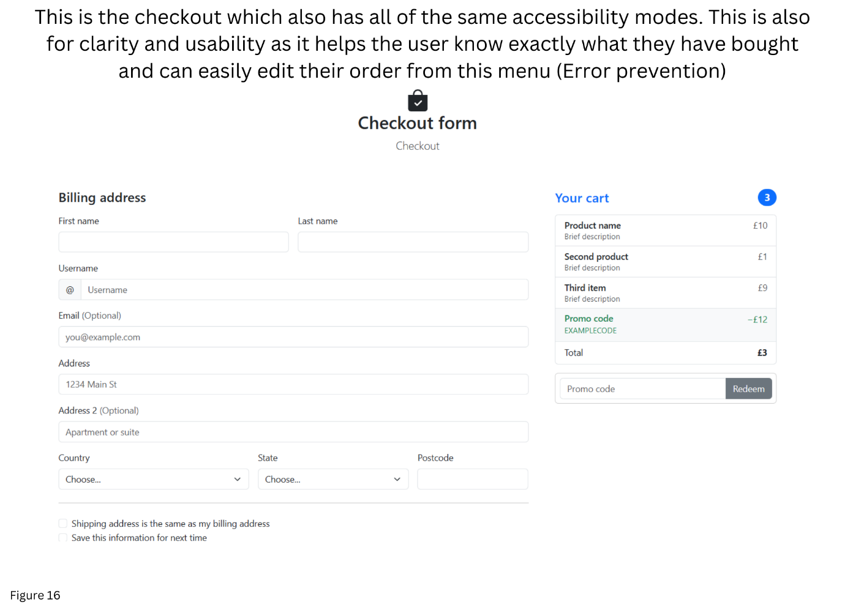

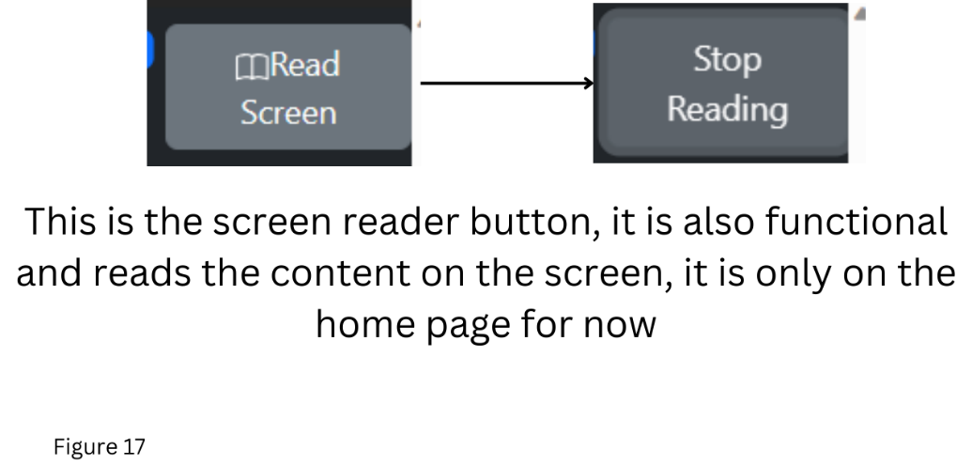

* This website provides clarity as it is simple and easy to understand, it also has a consistent styling for each page all this also helps with recognition rather than recall. Also aligns with users’ mental models of other websites.
* I will provide clear and concise feedback for every action the user does e.g. popup when something is added to the basket.
* It will also have audio feedback such as button clicks and error sounds for visually impaired people.
* It will have error prevention by making sure that the option a user is doing is what they want to do, e.g., buying something, before a user pays for their items, they will have to check the basket where they can remove items if needed.
* I will be providing accessibility by designing the website in a way where it is compatible with devices such as screen readers.
* Learnability is also included as it is very simple to use and therefore quickly learnt.
* There will also be a bar and a section of the page to show how far the user is in their buying process. User feedback
* The categories of items will be like items in other shops.
* It has a very minimalist design. (Clarity)
* The size of each element indicates its hierarchy.
* I created this using grid which can help to make designs more accessible to users with disabilities. For example, users with low vision may find it easier to scan and understand a grid-based layout. Additionally, grids are used for designs that are compatible with screen readers and other assistive technologies.

# 5.3.1 Other HCI methodologies I have included in my designs:

* Consistent Names, Clear choices
* Recognitions over recall
* Aesthetic and minimalist design
* Help clearly.
* whitespace in text to convey grouping.
* Use size contrast to indicate hierarchy, vary size and thickness.
* Uses a font that many people are familiar with and have a high X height (height of lower-case letters compared to capital): High x-height easier to read online.
* Mixed typed case is faster to read than all caps because you get greater vertical variation which gives your eye more information as its reading.
* tools like scale and layout as ways of distinguishing elements on the page instead of colour in the beginning
* Grids help to create a consistent visual experience for users.
* Generic Icons: they facilitate repeat recognition, you know what something looks like but not what it called.
* Design for glanceability
* Error popups or important information will be flashing or moving to draw the user’s attention.
* Menus:
  + less demanding of the user, relying on recognition rather than recall
  + still need to be meaningful and logically grouped to aid recognition.
  + naming of menu options then provides the only cue for the user to find the required option.
* Toolbars/navbars:
  + Most users do not want to spend time reading a manual, or even using online help to find out what each button does so I put the icons on the menus in the same way that accelerator keys are written there. So, in the ‘Edit’ menu one might find the option.
  + As the mouse drags down through the menu selections, each highlight in turn.
* Dialog boxes for important information

# 4.2 Software engineering:

Throughout the development of this project, I have been applying software engineering principles and methodologies to ensure that all my interfaces are not just user-friendly but also robust, reliable, and easy to understand and maintain.

**Use of Revision Control System**

I have been using a revision control system, specifically Git, to manage all the project's source code for all three user interfaces. This enables me to track changes and maintain a well-organized codebase. Git allows me to create branches for new features or fixes, merge changes, and roll back if necessary. One risk throughout the project is the potential for hardware failure, which could result in significant data loss and disruption to my project. This is not a very high risk but to address this concern, I am using GitLab, this is a version control system which hosts your repository online. This strategy involves regular code commits to ensure that all my project code and data are safely stored on git which I can access from anywhere. This means that even in the event of local hardware failure, no critical data will be lost. Additionally, this aids in managing various program versions which lets me retrieve older versions of my code in case of any issues, thus minimizing potential time and effort wastage. This ensures the integrity and traceability of my codebase.

**Test-Driven Development (TDD)**

I have been using Junit 5 tests to test my java swing classes. For testing the Swing applications actual GUI, I will be using a dedicated GUI testing library. One popular library for Swing GUI testing is AssertJ Swing.

I have adopted Test-Driven Development (TDD) as a key methodology in the software development process of my Java Swing notes taking application. TDD involves writing tests before implementing features. This approach helps me identify and address issues early in the development cycle, leading to a more robust and reliable software product. Another reason I am using TDD is that the test cases serve as executable documentation, and they provide examples of how your code is expected to behave which make it easier for others to understand my code.

**Agile Methodology**

I have used anagile methodology to develop these UIs as they are well-suited for projects with changing or evolving requirements. It also promotes, frequent feedback, and iterative development. This is all needed as this project involves heavily prototyping code and improving the user interface with HCI knowledge.

**User-Centred Design (UCD)**

UCD focuses on understanding the needs and preferences of users. It involves techniques like personas, user stories, and usability testing to create interfaces that align closely with user expectations. This is extremely relevant to my project as HCI is all about how a user interacts with the system and my UIs are designed around how a user would use them.

**Code Quality Tools**

I am using tools like prettier for vs code to keep my code style consistent. Another reason that this is very useful is that manually formatting code can be time-consuming. Prettier automates this process, saving me a lot of time and allowing me to focus on writing and understanding the logic of the code rather than its presentation. It also allows me to easily stick to my code standard for all my separate user interfaces. I have also used svgs for icons so nothing else has to be installed such as special FontAwsome icons.

5.Timeline with changes

**Term 1**

Week 1-2 starting 18/09/23:

* Start research, [**Human-Computer Interaction (3rd Edition)**](http://www.amazon.com/gp/product/0130461091?ie=UTF8&tag=hci01-20&linkCode=as2&camp=1789&creative=9325&creativeASIN=0130461091)**, Alan Dix, Gregory D Abowd, Janet E Finlay and Russell Beale**
  + **Read chapter 1, The Human, 2.3 Positioning, pointing and drawing, 2.4 Display devices, 2.10 Summary.**
* Work on the project plan, draft should be finished by the 27th of September and sent to supervisor.
* -Meeting with my project supervisor on Wednesday the 25th of September
* -Set up Eclipse and GitLab

Week 3:

* Read Paper: **Sinha, Gaurav, Rahul Shahi, and Mani Shankar. Human computer interaction**
* Finish Timeline, Bibliography and risk assessment by the 4th of October, then I will submit on the 5th.
* Plan and design all 3 UIs using Canva [10], using [7] as a design guide.
* Start creating a database with no information stored first plan database schema.
* Alan dix. Chapter 3, 4.3 Summary

Week 4:

* Continue Database with MySQL, Begin website interface for DBMS.
* Continue [**Human-Computer Interaction (3rd Edition)**](http://www.amazon.com/gp/product/0130461091?ie=UTF8&tag=hci01-20&linkCode=as2&camp=1789&creative=9325&creativeASIN=0130461091)**, Part 2: Design processes**
* Finish basic website layout.
* 5.4 User focus, 5.6 Navigation design, 5.7 Screen design and layout, 5.8 Iteration and prototyping.
* 6.3 Usability engineering, 6.5 Design rationale, 7.2 Principles to support usability, 7.5 Golden rules and heuristics, 7.6 HCI patterns, 7.7 Summary.

Week 5:

* Add components/widgets like buttons, labels, text fields, and more to the website window.
* Set up event handlers to respond to user interactions (e.g., button clicks) for website.
* Begin learning Swing [9] for Java desktop application.
* 8.5 User interface management systems, 8.6 Summary, 9.6 Summary, 10.2 Universal design principles, 10.3 Multi-modal interaction, 10.4 Designing for diversity.
* Finish SQL database, Use spring boot for the backend of the DBMS interface.
* Read: Designing for the Web: An Introduction to Human-Computer Interaction by Jakob Nielsen

Week 6:

* Begin desktop interface with swing.
* 10.5 Summary, 11.2 Requirements of user support, 11.3 Approaches to user support, 11.5 Designing user support systems.
* Watched and made notes on Scott Klemmers lectures. Design Heuristics parts 1 and 2, Visual Design
* Watched and made notes on Scott Klemmers lectures. Typography, Grids and Alignment, Reading and Navigation, Designing Studies
* Continue working on backend of website to add functionality.
* Start writing interim report.
* Continue DBMS interface, Website using html/CSS/js.
* Continue [**Human-Computer Interaction (3rd Edition)**](http://www.amazon.com/gp/product/0130461091?ie=UTF8&tag=hci01-20&linkCode=as2&camp=1789&creative=9325&creativeASIN=0130461091)**, Part 3: Models and theories**. This talks about a user’s cognitive and problem-solving abilities: 12.7 Summary, 13.4 Summary, 14.6 Summary, 16.2 Dialog design notations, 16.3 Diagrammatic notations, 16.6 Dialog analysis and design, 16.7 Summary.
* Interim Report: aims, objectives and literature survey.

week 7 – week 8:

* Continue application and database interfaces.
* 17.5 Summary, 18.5 Summary, 19.8 Summary, 20.4 Information and data visualization, 20.5 Summary, 21.2 Understanding hypertext, 21.7 Summary.
* Start presentation: explain the aims and objectives clearly, explain the background/relevance/importance of the project and set it in the wider context, I’ve made a broad description of the project - i.e. how parts of the project fit together to form a coherent whole.
* Continue [**Human-Computer Interaction (3rd Edition)**](http://www.amazon.com/gp/product/0130461091?ie=UTF8&tag=hci01-20&linkCode=as2&camp=1789&creative=9325&creativeASIN=0130461091)**, Part 4:Outside the box**
* Finish Report Draft
* Interim Report: summary of completed work.
* bibliography and citations.
* Background Theory
* Software Engineering

Week 9 – Week 10:

* Week 9 submit report draft.
* Conduct user testing on the three implemented interfaces. (Beginning of Week 9)
* Continue presentation and report.
* Presentation: briefly explain the theory underpinning the individual parts of the project (for example how algorithms work, or which architectural options existed including their benefits/ drawbacks), defend and justify decisions made during the project.
* Interim report due 1st December
* Presentation to be submitted 2nd December.

Week 11:

* Presentation on 4th December

Conclusion

This interim report has provided an overview of the progress that has been made on the HCI Project so far. The project is on track to be completed successfully by the deadline.

The research and planning phase has been completed, and the design phase is well underway. A basic website layout has been created, a database has been created for the inventory management system, and a basic shopping website has been created and styled. Swing has also been learned and used to create a basic GUI for the note’s application

The upcoming phases of the project involve a focused continuation of the development process for all three user interfaces (UIs). This entails advancing and refining each UI, ensuring that they align with the established design principles and respond to the diverse needs of their respective user groups.

In parallel, a critical step involves the initiation of usability testing for both the shopping website and notepad application. This testing phase is instrumental in assessing the effectiveness, efficiency, and overall user satisfaction with the interfaces. User feedback obtained through usability testing will serve as a valuable source of insights, offering a real-world perspective on the usability and functionality of the UIs.

Following the usability testing phase, the next critical task is to implement necessary changes to the UIs based on the feedback received. This iterative process is pivotal in refining the interfaces, addressing potential pain points, and enhancing the overall user experience. The adjustments made will be informed by a user-centric approach, ensuring that the UIs are not only functional but also user-friendly and aligned with the preferences and expectations of the target audience.

By systematically progressing through these steps, the project aims to deliver user interfaces that not only meet design objectives but also resonate with users, fostering a positive and effective interaction with the implemented applications.

I am confident that I am on track to complete the project successfully by the deadline. I am looking forward to continuing to work on the project and to learning more about HCI principles and their application to the design of interactive systems.

Bibliography and citations

Resources that have helped me prepare this plan:

* [1]. [*Human-Computer Interaction (3rd Edition)*](http://www.amazon.com/gp/product/0130461091?ie=UTF8&tag=hci01-20&linkCode=as2&camp=1789&creative=9325&creativeASIN=0130461091)*, Alan Dix, Gregory D Abowd, Janet E Finlay and Russell Beale***,** this book provides a comprehensive overview of the field of HCI.
* [2].[*https://www.techtarget.com/searchapparchitecture/definition/user-interface-UI#:~:text=Types%20of%20user%20interfaces&text=graphical%20user%20interface%20(GUI),touch%20user%20interface*](https://www.techtarget.com/searchapparchitecture/definition/user-interface-UI#:~:text=Types%20of%20user%20interfaces&text=graphical%20user%20interface%20(GUI),touch%20user%20interface). This article helped me decide which Interfaces I was going to make so I could plan how to make them.
* [3]. *Sinha, Gaurav, Rahul Shahi, and Mani Shankar. "Human computer interaction." 2010 3rd International Conference on Emerging Trends in Engineering and Technology. IEEE, 2010*. This paper is a basic introduction to HCI and talks about the history and how the field has evolved, and what the future of HCI could be.

[4]. [*https://youtu.be/WW1g3UT2zww?si=lgXaFbYio-kMyJAt*](https://youtu.be/WW1g3UT2zww?si=lgXaFbYio-kMyJAt)

* This is a playlist of lectures by Scott Klemmer and is a full course on HCI offered by Stanford University

[5]. [*Designing the User Interface: Strategies for Effective Human-Computer Interaction (6th Edition)*](https://www.amazon.com/Designing-User-Interface-Human-Computer-Interaction/dp/013438038X/)*,*

* This is atextbook on user interface (UI) design. create UIs that are easy to use and pleasurable.

[6]. *MacKenzie, I. S. (2012). Human-computer interaction: An empirical research perspective*. This is a book by I. Scott MacKenzie that provides a comprehensive overview of empirical research in human-computer interaction (HCI). The book is divided into two parts:

* Part 1: Foundations: This part covers the basics of HCI research, including the history of HCI, the human factor, interaction elements, and the fundamentals of science and research.
* Part 2: Methods and Applications: This part covers the different methods used to conduct HCI research, as well as how to apply HCI research findings to the design of new computer systems and interfaces.

[7].[*https://www.creativebloq.com/features/ui-design*](https://www.creativebloq.com/features/ui-design)

* This article provides a comprehensive overview of UI design, covering everything from the basics to advanced techniques. I will use this when designing my UI.

8. [*https://www.youtube.com/watch?v=He-1O8Pa4SE&list=PLlGZc17KPrVCGRKtgbdvnGshN8AePlqpd*](https://www.youtube.com/watch?v=He-1O8Pa4SE&list=PLlGZc17KPrVCGRKtgbdvnGshN8AePlqpd)

* This is a playlist that guides you thorough java swing and how to use it to create a good-looking GUI.

9.[*https://docs.oracle.com/javase/tutorial/uiswing/*](https://docs.oracle.com/javase/tutorial/uiswing/)*.*

* This is the Swing manual and documentation.

10. [*https://www.canva.com/*](https://www.canva.com/)

* This is a website which allows you to design anything you need.

11. [*https://www.smashingmagazine.com/2008/01/10-principles-of-effective-web-design/*](https://www.smashingmagazine.com/2008/01/10-principles-of-effective-web-design/)

*12. https://www.interaction-design.org/literature/article/user-interface-design-guidelines-10-rules-of-thumb*

Appendix

# Diary

Week 2, 25/09/23 - 01/09/23:

Project meeting:

- Talked about my project plan, I need to consider who is going to use my Interfaces. Also, which HCI principles I will use in each Interface. Talk about likelihood of each risk in project plan.

- I have read chapters 1 and 2 of Human computer interaction by Alan Dix.

- I have also created my Project Plan

- Next Week I will begin creating the website interface

- Finished reading paper: Sinha, Gaurav, Rahul Shahi, and Mani Shankar. Human computer interaction

Week 3, 02/10/23 - 08/10/23

- I have read chapters 3 and 4 of Human-Computer Interaction by Alan Dix

- Next week I will begin Part 2 of Human-Computer Interaction by Alan Dix

- I will also add CSS to my website, I may use Bootstrap as just CSS would take very long.

- I have created the designs of all 3 UI's using Canva

- I have Created basic website layout

Week 4, 09/10/23 - 15/10/23

- I have created a basic shopping website and included the styling

- I have also read Part 2 of Human-Computer Interaction by Alan Dix, chapters 5 to 7

- I had some issue learning how to use bootstrap but this video really sped up my progress: https://www.youtube.com/watch?v=-qfEOE4vtxE

- There was difficulty using intellij as my own CSS files would not load into my html website, to fix this I moved all my code to vs code. This seems like a problem with the intellij editor.

- Next week I will begin my database interface, I will first make an empty database using MySQL

- Begun reading and making notes on Designing the User Interface: Strategies for Effective Human-Computer Interaction (6th Edition)

Week 5, 16/10/23 - 22/10/22

- I have begun Learning Swing using this course: https://www.youtube.com/watch?v=Kmgo00avvEw&t=3s

- I have created the database for my inventory management system, as well as the schema for the database

- I have also read chapters 8-10 of Human-Computer interaction

- Next week I will begin the interface for the database and have my meeting

- I have also read and made notes on articles and other resources about: Designing for the Web: An Introduction to Human-Computer Interaction by Jakob Nielsen, https://santhosh-adiga-u.medium.com/jakob-nielsens-heuristics-for-interaction-design-guidelines-for-user-centered-excellence-609b270c7e6a, https://www.heurio.co/nielsens-10-usability-heuristics

- Completed testing for all 3 UIs with users and made notes to implement changes

Week 6, 23/10/23 - 29/10/23

- I have read 10 and 11 of Human-Computer Interaction

25/10/23

Project meeting:

-Explain and justify in my report why I did not use a framework for my websites, or use react

-Justify the modern technologies I have used, e.g. Swing

-Add more to my diary - a few lines everyday

-Look at who’s going to use inventory application and on what devices

- I have begun work on the interim project report

24/10/23

-Watched and made notes on Scott Klemmers lectures. Design Heuristics parts 1 and 2, Visual Design

- I have read chapters 12.7, 13.4, 14.6 of Human Computer Interaction by Alan Dix

- Continued Spring tutorial, parts 7 to 10

25/10/23

-Watched and made notes on Scott Klemmers lectures. Typography, Grids and Alignment, Reading and Navigation, Designing Studies

-Read Summary of chapter 15 of Human-Computer Interaction

-Continued spring tutorial, parts 10 to 15

- Created contents page of report, finalized sections it will include

26/10/23

- I have read chapters 16.2, 16.3, 16.6, 16.7 of Human-computer interaction by Alan Dix

- I will focus on the interim report Next week and make sure I have a draft ready to show to my supervisor before our meeting

-Created draft of introduction and abstract for interim report

Week 7, 30/10/23 - 05/11/23

30/10/23

- Read and made notes on https://www.smashingmagazine.com/2008/01/10-principles-of-effective-web-design/

31/10/23

- Read and made notes on Designing for the Web: An Introduction to Human-Computer Interaction by Jakob Nielsen: https://santhosh-adiga-u.medium.com/jakob-nielsens-heuristics-for-interaction-design-guidelines-for-user-centered-excellence-609b270c7e6a

and https://www.interaction-design.org/literature/article/user-interface-design-guidelines-10-rules-of-thumb

- Begun Home page for Shopping website

- I have also completed HCI by Alan dix

- I have been continuing my interim report

- I have finished the Swing GUI course

- Next week I will continue the report and begin my java Gui for the note’s application

- Finished abstract draft

- Finished introduction draft

- Completed testing for all 3 UIs with users and made notes to implement changes

Week 8, 06/11/23 - 12/11/23

- Created template for GUI application

- Created draft of project specification

- Continued Notes application by adding page and navbar, and making it more visually appealing than first prototype

- Completed draft of literature review

- Completed draft of Aims, objectives

- Made notes for theory section of report

- Remade inventory interface by making new sidebar and navbar more visually appealing, taken away colour from first prototype

- Next week I plan to Complete a draft of the report to give to my supervisor before the end of the week

- I will complete the inventory interface

- Add new front page for shopping website showing preview of items

- Continue notes application, adding toolbar and Tooltips, then adding more hci principles

Week 9, 13/11/23 - 19/11/23

- Created separate shopping basket page for shopping website

- Added placeholder items for inventory system UI

14/11/23

- Completed HCI goals for uis in report

- Finished Target audience section for report

- Completed Section on HCI theory draft for report

16/11/23

- Finished Work completed section draft of report

- Written conclusion for report

- Finished homepage for shopping website

- Begun presentation, decided which sections I am going to have

-Next week I plan to finish my report

- I also plan to remake the homepage basted on feedback from testing

- I will also create the settings page

Week 10, 20/11/23 - 26/11/23

- Created basic structure and layout for Presentation to show to supervisor

- Added new footer section to all pages that has quick links for website

Project meeting

- Add timescale section to report with how I have deviated from the original plan

- Talk more about the theory HCI and change the section with HCI principles to reference back to the theory

- Add more functionality to the websites

- Completed testing for all 3 UIs with users and made notes to implement changes

- I have created the settings page with all of the accessibility options

- I have Added a homepage to the inventory management system

- I have completed the Abstract, aims and objectives, motivation, my progress, work completed, HCI theory and principles, software engineering section for the project report

- Written conclusion and literature review

- Created drafts for presentation, aims and objectives section, background importance of HCI, description of the project

- Next week I plan to add more pages for the shopping website

- Also, I plan to add functionality to the note’s application, e.g. ability to type

- Then I will add functionality to the inventory interface by adding the ability to add and customize inventory’s,

Also adding setting and other extra pages for users where I can implement different HCI principles and methodologies.

Week 11, 27/11/23 - 03/12/23

- Created conclusion, section explain the individual parts of the project, defend and justify decisions, and summary sections of the PowerPoint

- Moved project report to Latex template

- Worked on Notes application by Adding more components such as save, edit etc

- Completed presentation and submitted

- Encountered problems with TDD testing as I was not able to find the buttons that are embedded within menus to test using the robot finder, so I have skipped a few tests for now

- I had problems with assertj for swing testing tdd, so I had to restart the whole notes application using maven and a pom file where I could then put the dependencies for junit 5 and assertj.

- I was unable to activate Junit 5 testing for this project after installing the java extension pack, it would only work in a different project so had to move code to new project.

- For the test where I used robot: https://www.tabnine.com/code/java/methods/org.assertj.swing.core.Robot/finder

- Added more components to the application such as font colour changing and Listeners for all buttons

- Next week I will continue to add more components

- Add screen reading functionality to shopping website, only the interface options

- Add account management for DBMS interface

- And finalise my report to submit next week

Week 12, 04/12/23 - 10/12/23

- I have added a touch screen mode option for notes application and keyboard popup

- I have finalises the theory section of my report

- I have practiced my presentation and made a script

- I have given my presentation at university

- I have had to fix my notes application code as none of the TDD tests would pass, this is because I had used constructors to make the 2 menu bars so the tdd test could not access them. To fix this I

moved the format Menu into the home menu as when it had 2 separate menus the robot. finder could not differentiate between them and test each one.

- Notes app:

Added touch screen mode with mock keyboard.

Added side menu with undo and redo buttons.

Added full screen mode with functionality.

- Database interface:

Made login and signup pages.

Made two factor authentication pages.

Made Cover page.

Changed main dashboard to have inventory items and made submenu for customizing the menus.

Added simple help button and popup in home page.