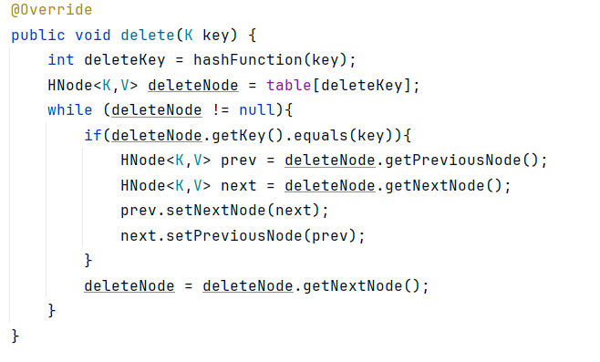

public void delete(K key) {  
 int deleteKey = hashFunction(key);  
 HNode<K,V> deleteNode = table[deleteKey];  
 while (deleteNode != null){  
 if(deleteNode.getKey().equals(key)){  
 HNode<K,V> prev = deleteNode.getPreviousNode();  
 HNode<K,V> next = deleteNode.getNextNode();  
 prev.setNextNode(next);  
 next.setPreviousNode(prev);  
 }  
 deleteNode = deleteNode.getNextNode();  
 }  
}

public void modifyTask(int key,int attribute,String value){  
 String oldvalue="";  
 Task taskToModify= hashTableChaining.search(key);  
 if (taskToModify==null){  
 JOptionPane.*showMessageDialog*(null,"Couldn't find the task associated to that ID");  
 }else {  
  
  
 switch (attribute) {  
 case 0:  
 oldvalue += taskToModify.getTitle();  
 taskToModify.setTitle(value);  
 break;  
 case 1:  
 oldvalue += taskToModify.getDescription();  
 taskToModify.setDescription(value);  
 break;  
 case 2:  
 oldvalue += taskToModify.getDeadline();  
 taskToModify.setDeadline(value);  
 break;  
 }  
 JOptionPane.*showMessageDialog*(null, "The attribute with value : " + oldvalue + " is now :" + value);  
 saveState();  
 }

