

**LA GRANDEE INTERNATIONAL COLLEGE**

**Simalchaur, Pokhara, Nepal**

A Final Report

on

**AttendifyPlus**

**Submitted to**

La Grandee International College

Bachelor of Computer Application (BCA) Program

In partial fulfillment of the requirements for the degree of Program Name under

Pokhara University

**Submitted by**

|  |  |  |  |
| --- | --- | --- | --- |
| **Name:** | **Course** | **Semester** | **P.U. Registration Number** |
| Namrata Bastola | BCA | 6th | 2022-1-53-0129 |
| R.a.mohan Tiwari | BCA | 6th | 2022-1-53-0136 |
| Rikita Gharti | BCA | 6th | 2022-1-53-0138 |
| Subash Gurung | BCA | 6th | 2022-1-53-0147 |

**Date: 28 April 2024**

# Acknowledgement

We would like to express our gratitude to our BCA coordinator Mr. Kundan Chaudhary, Project supervisor Mr. Nabin Pandey and LA Grandee International College for their support and contributions to the development of our Attendance Management System. This project is done for the in partial fulfilment of the requirements for BCA (Bachelor of Computer Application) program under Pokhara University. Our project was made possible by the effort and dedication of our team members. We thank our dedicated team for their hard work and contributions to the game. We are grateful for the guidance and mentorship provided by our respected sir Mr. Nabin Pandey.

Sincerely,

Namrata Bastola

R.a.mohan Tiwari

Rikita Gharti

Subash Gurung

**Declaration for “AttendifyPlus”**

# Student’s Declaration

We, **Namrata Bastola, R.a.mohan Tiwari, Rikita Gharti, Subash Gurung**, hereby declare that the project report entitled “**AttendifyPlus”** is uniquely prepared by us. This report is submitted in partial fulfillment of the requirements for the degree of Bachelor of Computer Application (BCA) under Pokhara University.

We confirm that this report is prepared solely for academic purposes, under the guidance of the BCA department of LA GRANDEE International College. It has not been, and will not be used elsewhere for any other purposes or submitted for the award of any other degree, diploma, or certificate.

We take full responsibility for the authenticity and originality of the content of this report.

|  |  |  |  |  |
| --- | --- | --- | --- | --- |
| ……………………  Namrata Bastola  BCA 6th Semester  ………………………  Subash Gurung  BCA 6th Semester |  | …………………...  R.a.mohan Tiwari  BCA 6th Semester |  | ……………………  Rikita Gharti  BCA 6th Semester |

**Date: 27 July, 2025**

# Supervisor's Declaration

I hereby recommend that the project entitled “**AttendifyPlus”** done under my supervision by **Namrata Bastola, R.a.mohan Tiwari, Rikita Gharti, Subash Gurung** during their **sixth** semester in partial fulfillment of the requirement for the degree of **Bachelor of Computer Application (BCA)** under affiliation of **Pokhara University** is completed to my satisfaction and be processed for final evaluation.

**Mr. Nabin Pandey**

Supervisor

Date: 27 July, 2025



# Letter of Approval

We hereby certify that we have carefully reviewed the project report titled **“AttendifyPlus”** and are satisfied with both the content and the project defense presented. We find the work to be of acceptable quality and scope, and consider it suitable to be submitted as partial fulfillment of the requirements for the degree of Bachelor of Computer Applications (BCA) under Pokhara University.

|  |  |  |
| --- | --- | --- |
| _____________________  Supervisor  Mr. Nabin Pandey | _________________  Examiner  Er. Ashmit Nepali  Date: 30/07/2025 | ______________________  Program Coordinator  Mr. Kundan Chaudhary |

# Abstract

AttendifyPlus is a secure, real-time attendance tracking system built to eliminate the common flaws of traditional and manual attendance methods especially proxy attendance and slow, inefficient processes. AttendifyPlus is designed specifically for educational institutions, it modernizes the way classrooms manage attendance, bringing speed, accuracy, and integrity into the learning environment. Using a dynamic QR code system and device fingerprinting, AttendifyPlus ensures that only physically present students can mark themselves present. It also offers flexibility without compromising security. Unlike other systems, this one allows students to mark their own attendance by scanning the QR. For educators, AttendifyPlus simplifies the teaching experience, teachers can take attendance in real time, upload learning materials, assign coursework, and instantly generate detailed attendance reports. Students can view their own attendance records, submit assignments, and track their progress with ease all through a unified, web-based platform. What sets AttendifyPlus apart is its focus on accountability, transparency, and usability. With advanced analytics and reporting features, it not only strengthens attendance integrity but also helps institutions make informed decisions to improve classroom engagement. In doing so, AttendifyPlus bridges the gap between outdated systems and the modern classroom making attendance smarter, faster, and fairer for everyone.

**Table of Content**

Acknowledgement ii

Student’s Declaration iii

Supervisor's Declaration iv

Letter of Approval v

Abstract vi

List of Figures ix

List of Tables 1

Abbreviations 2

1. Introduction 3

2. Problem Statement 5

3. Objectives 6

4. Background Study 7

5. Feasibility Analysis 9

5.1 Technical Feasibility 9

5.2 Operational Feasibility 9

5.3 Economic Feasibility 10

6. Requirement Documentations 12

6.1 Functional Requirements 12

6.2 Non-Functional Requirements 13

6.3 Technical Requirements 15

6.4 Requirements Matrix 17

7. System Design 19

7.1 ER Diagram 19

7.2 Dataflow Diagram 22

7.3 Flowchart 29

7.4 Use Case 32

8. Development 33

8.1 Development Methodology 33

8.2 Project Gantt Chart / Timeline Chart 35

8.3 Tools Used 36

9. Testing 38

9.1 Test Case 39

10. Project Results 42

11. Future Enhancements 43

12. Conclusion 45

13. Annexures 46

14. References 51

# List of Figures

7.1.1: ER-Diagram 18

Fig 7.2.1: DFD 0 18

Fig 7.2.2: Level-1 DFD for Admin 20

Fig 7.2.3: Level-1 DFD for Student 21

Fig 7.2.4: Level-1 DFD for Teacher 22

Fig 7.2.5: Level-2 DFD for Admin 23

Fig 7.2.6: Level-2 DFD for Student 24

Fig 7.2.7: Level-2 DFD for Teacher 25

Fig 7.3.1: Flowchart for Admin 29

Fig 7.3.2: Flowchart for Teacher 30

Fig 7.3.3: Flowchart for Student 31

Fig 7.4.1: Use Case 32

Fig 8.1.1: Methodology 27

Fig 8.2.1: Project Gantt Chart 29

Fig 13.1: Login Page 42

Fig 13.2: Student Dashboard 43

Fig 13.3: Admin Dashboard 43

Fig 13.4: Teacher Dashboard 44

Fig 13.5: Analytics Dashboard 44

Fig 13.6: Add New Student Section 45

Fig 13.7: Teacher Management Dashboard 45

Fig 13.8: Subject Management Dashboard 46

Fig 13.9: QR Generation 46

# List of Tables

Table 6. 1: AttendifyPlus Requirements Matrix 16

Table 8.1.1: Scrum Lifecycle Phases 27

Table 8.3.1: Tools Used 30

Table 9.1.1: Test case for login page 33

Table 9.1. 2: Test case for admin 34

Table 9.1. 3: Test case for teacher 35

Table 9.1. 4: Test case for student 35

# Abbreviations

|  |  |
| --- | --- |
| BCA | Bachelor of Computer Applications |
| QR | Quick Response |
| PHP | Hypertext Preprocessor |
| MySQL | My Structured Query Language |
| HTML | HyperText Markup Language |
| CSS | Cascading Style Sheets |
| CSRF | Cross-Site Request Forgery |
| XAMPP | Cross-platform, Apache, MariaDB, PHP, and Perl |
| XSS | Cross-Site Scripting |
| SQL | Structured Query Language |
| GB | Gigabyte |
| CPU | Central Processing Unit |
| SSD | Solid State Drive |
| RAM | Random Access Memory |
| UI/UX | User Interface / User Experience |
| ER | Entity-Relationship |
| AJAX | Asynchronous JavaScript and XML |

# 1. Introduction

In today's rapidly evolving education landscape, traditional attendance tracking methods like paper registers and basic biometric systems fall short of modern requirements. These outdated approaches are vulnerable to proxy attendance, suffer from poor data management, and create administrative bottlenecks that waste valuable time and resources.

AttendifyPlus emerges as a comprehensive solution to these challenges, offering an advanced, secure, and real-time attendance management system specifically designed for educational institutions. At its core, the system leverages QR code scanning technology to ensure authentic, tamper-proof attendance records while providing a seamless user experience across all devices.

The platform operates through a three-tier architecture that serves the distinct needs of students, teachers, and administrators.

Students benefit from a mobile-optimized interface where they can scan QR codes to mark attendance, view their attendance statistics, submit assignments with file uploads, and access course materials.

Teachers gain powerful tools for generating QR codes, managing attendance sessions, creating and tracking assignments, and uploading educational resources.

Administrators enjoy comprehensive user management capabilities, advanced analytics showing registration trends and department distributions, and a real-time notification system that keeps them informed of all system activities.

Built with modern web technologies including PHP 8.0+, MySQL, HTML5, CSS3, JavaScript ES6+, and Bootstrap 5.3.0, AttendifyPlus delivers a responsive, mobile-first experience with interactive data visualization through Chart.js.

The system incorporates essential security features like session management, input sanitization, and CSRF protection, while offering user-friendly touches such as dark/light theme support and real-time notifications.

What sets AttendifyPlus apart is its focus on real-world usability - it's not just about tracking attendance, but about creating an ecosystem that promotes academic accountability and institutional efficiency.

The system's scalability ensures it can grow with an institution's needs, whether deployed locally or in the cloud, making it an ideal choice for schools and universities looking to modernize their attendance management while maintaining the human touch that education requires.

# 2. Problem Statement

With increasing modernization of educational institutions, traditional methods of taking attendance are proving to be less efficient. Paper-based traditional registers and simple biometric systems have several drawbacks:

1. **Proxy Attendance:**

It is simple for students to fake attendance records by marking absent students as present, disrupting the integrity of information.

1. **Manual Mistakes and Loss of Data:**

Semi-digital or paper-based systems are prone to manual mistakes, physical loss of documents, and an inability to maintain past records.

1. **Ineffective Session Monitoring:**

Legacy systems do not monitor attendance for out-of-the-box sessions like workshops, seminars, and events effectively, nor do they capture engagement length.

1. **Inadequate Real-Time Insights:**

Administrators have no real-time visibility into attendance patterns, thus slowing down decision-making and data-driven strategies.

To address these problems of utmost importance, AttendifyPlus presents a complete-scale, real-time attendance management system with cutting-edge technologies like QR code scanning, location verification, entry and exit tracking of events, and solid analytics for admins.

# 3. Objectives

1. **Reliable Attendance Recording:**

To provide a reliable platform for electronic recording of student attendance, eliminating human errors and minimizing manual intervention.

1. **Prevent Proxy Attendance:**

To contribute to the authenticity of attendance records through the use of QR code scanning and device verification procedures.

1. **Event-Based Attendance Tracking:**

To facilitate entry and exit QR scanning for workshops, seminars, and special sessions to properly monitor participation and engagement time.

1. **Real-Time Analytics Dashboard:**

To enable administrators to have real-time insights into attendance behaviors, session participation, and student engagement through dynamic dashboards and reporting interfaces.

1. **Flexible Deployment Options:**

To design the system for local network deployment as well as optional cloud-based analytics for flexibility in accommodating institutional needs.

1. **Secure and Scalable System Architecture:**

To build a secure, scalable PHP, MySQL, HTML, CSS, and Bootstrap platform that will scale with the future needs of an institution.

# 4. Background Study

Background Study The rapid evolution of digital technologies has compelled educational institutions to seek more efficient, secure, and real-time attendance management solutions. Traditional methods such as paper registers, manual sign-ins, and basic biometric systems are increasingly seen as inadequate due to their susceptibility to errors, inefficiency, and vulnerability to fraudulent practices such as proxy attendance (Kumar et al., 2019).

**Literature Review:**

Recent years have witnessed a surge in the adoption of digital attendance systems across educational settings. Many institutions have implemented RFID-based systems, which use radio-frequency identification cards to automate attendance marking (Patel & Doshi, 2017). While these systems reduce manual effort, they are still prone to misuse, such as card swapping among students.

Biometric systems, particularly those using fingerprint or facial recognition, have also gained popularity for their higher accuracy and security (Saini & Sharma, 2013). However, these systems often require expensive hardware and can raise privacy concerns among users.

A significant trend in the literature is the use of QR code-based attendance systems. QR codes offer a cost-effective, scalable, and user-friendly solution for attendance tracking. In such systems, students scan a dynamically generated QR code using their smartphones to register their presence (Sharma et al., 2020). This approach minimizes the risk of proxy attendance, especially when combined with additional verification methods such as geolocation or device fingerprinting (Rahman et al., 2021). Some systems further enhance security by integrating real-time face capture or requiring students to be physically present within a specific location range (e.g., within the classroom or campus).

For example, Sharma et al. (2020) describe a QR code-based attendance system that generates unique codes for each session, ensuring that only students present at the time can mark their attendance. Similarly, Rahman et al. (2021) propose a hybrid system combining QR codes with geofencing to further reduce fraudulent attendance.

Despite these advancements, many existing systems focus primarily on classroom attendance and lack the flexibility to monitor participation in extracurricular activities, seminars, or workshops. There is also a growing need for real-time analytics and reporting to provide educators with actionable insights into student engagement and participation patterns (Patel & Doshi, 2017).

AttendifyPlus was developed in response to these evolving requirements. Leveraging modern web technologies (PHP, MySQL, HTML, CSS, and Bootstrap), AttendifyPlus provides a scalable, secure, and user-friendly platform for attendance management. The system integrates advanced verification methods—including QR code scanning, geolocation, and device fingerprinting—to enhance data integrity and minimize proxy attendance. Furthermore, AttendifyPlus is designed to support attendance tracking beyond traditional classrooms, enabling comprehensive monitoring of student involvement across various academic activities.

In summary, the development of AttendifyPlus is grounded in the need to address the limitations of existing attendance systems by embracing intelligent, secure, and flexible digital solutions. By incorporating best practices and innovations from recent research, AttendifyPlus aims to foster a culture of accountability, transparency, and active engagement within educational institutions.

# 5. Feasibility Analysis

A feasibility analysis for AttendifyPlus explores the technical, operational, and economic practicality of implementing a secure, real-time attendance tracking system in educational institutions. It ensures that the project is realistic, sustainable, and ready for real-world use.

## 5.1 Technical Feasibility

* **Hardware and Software:**

AttendifyPlus runs on standard web hosting servers using PHP 8.0+ for the backend and modern web technologies (HTML5, CSS3, JavaScript) for the frontend. It uses MySQL as the database and works perfectly with development tools like XAMPP. Since it's web-based, there's no need for a mobile app - users can access it from any device through their browser.

* **System Capabilities:**

The system uses QR code scanning for attendance tracking, with students scanning codes through their device cameras. It includes real-time notifications, responsive design that works on all screen sizes, and role-based access for security. The dashboard features interactive charts using Chart.js to show attendance trends and analytics.

* **Technical Team Expertise:**

Our team has strong skills in full-stack development, database design, and web security. The code is well-structured and modular, making it easy to maintain and expand. We use proven, well-documented technologies that have strong community support.

## 5.2 Operational Feasibility

* **Ease of Use:**

Teachers can easily generate QR codes, upload materials, create assignments, and view reports through a simple dashboard. Students just scan QR codes with their phones, check their attendance stats, and submit assignments - no app downloads needed.

* **Adoption and Integration:**

Since it works through web browsers with minimal setup, schools can start using AttendifyPlus right away without major technical changes. It fits naturally into daily classroom routines and makes administrative tasks more efficient.

* **Impact on Daily Operations:**

The system eliminates manual attendance tracking and reduces proxy attendance through secure QR verification. It provides real-time data and analytics, saves administrative time, and creates a more accountable learning environment. The notification system keeps everyone informed, while assignment features streamline the submission process.

## 5.3 Economic Feasibility

* **Resource Feasibility:**

AttendifyPlus is developed with open-source tools and runs on widely available infrastructure, minimizing development and deployment costs. By avoiding the need for dedicated apps or expensive hardware, the system ensures maximum resource efficiency.

* **Scalability:**

AttendifyPlus is built to be scalable. As more institutions adopt the platform, it can be upgraded to support higher user volumes, integrate additional modules (e.g., biometric systems in the future), and provide institution-wise customization. The web-based approach also allows cost-effective scaling without needing platform-specific app development.

* **Growth Potential:**

AttendifyPlus is scalable and can support increasing user numbers with minimal upgrades. Its flexible architecture makes it suitable for different types of educational institutions—from small colleges to large universities.

# 6. Requirement Documentations

Requirements analysis is the process of identifying, gathering, and defining user needs for the AttendifyPlus platform. This ensures the system meets practical expectations for functionality, security, performance, and usability. Below is the detailed requirement documentation for AttendifyPlus.

## 6.1 Functional Requirements

* **User Management:**
* Role-based login system for Admin, Teacher, and Student with secure authentication
* User registration and profile management with fields: name, email, gender, date of birth, phone number, and password
* Secure session management and authorization controls
* **Attendance Management:**
* Teachers can generate dynamic QR codes for attendance sessions with configurable time limits
* Students scan QR codes using their device cameras to mark attendance in real-time
* Admin and teachers can view, filter, and generate attendance reports by class, date, or individual student
* Export functionality for attendance data in various formats
* **Assignment Management:**
* Teachers can create assignments with descriptions, file attachments, and due dates
* Students can submit assignments with file uploads and track their submission status
* Teachers can view submissions, provide feedback, and manage assignment statuses
* Assignment analytics showing submission rates and completion statistics
* **Study Materials:**
* Teachers can upload and organize course materials (lectures, notes, resources)
* Students can access and download materials from their dashboard
* Material access tracking and organization by subject
* **Reporting & Dashboard:**
* Real-time dashboards for all user types with role-specific analytics
* Interactive charts showing attendance trends, registration data, and performance metrics
* Students can view their attendance records, assignment statuses, and academic progress
* Admin and teachers can generate comprehensive reports on various metrics
* **Admin Controls:**
* Complete user management (add, edit, delete students, teachers, and admins)
* Department and subject management with organizational structure
* System-wide monitoring and activity tracking
* Global settings and configuration management
* **Search Functionality:**
* Search capabilities across students, subjects, dates, and teachers
* Quick record retrieval and filtering options
* **Security Functions:**
* Login-based access control with session management
* Role-based permissions and feature access
* Input sanitization and CSRF protection
* Secure file upload handling and validation

## 6.2 Non-Functional Requirements

* **Performance:**
* Fast loading times for all pages and features
* Efficient QR code generation and scanning with minimal latency
* Quick dashboard updates and real-time notification delivery
* Optimized database queries and responsive UI interactions
* **Security:**
* Secure authentication and session management
* Input validation and sanitization to prevent XSS and SQL injection
* Role-based access control to protect sensitive features
* Secure file upload handling with size and type validation
* **Scalability:**
* Modular architecture supporting easy feature additions
* Efficient database design for handling increasing user loads
* Responsive design that works across all device types and screen sizes
* Extensible codebase for future enhancements
* **Reliability:**
* Stable application performance with error handling
* Data integrity through proper database constraints and validation
* Graceful error handling and user-friendly error messages
* Consistent functionality across different browsers and devices
* **Usability:**
* Clean, intuitive interface requiring minimal training
* Mobile-responsive design optimized for smartphone usage
* Consistent navigation and user experience across all pages
* Accessibility features for inclusive design
* **Maintainability:**
* Modular code structure with separate files for different functionalities
* Clear documentation and code comments
* Consistent coding standards and naming conventions
* Easy-to-understand architecture for future development and debugging

## 6.3 Technical Requirements

**6.3.1 Hardware Requirements**

* **Development Environment:**
* Processor: Intel Core i3 (or equivalent, 64-bit)
* RAM: 8 GB minimum (8 GB recommended)
* Storage: 50 GB available space for project files and development tools
* GPU: Not required for web development
* **Production Server (Future Deployment):**
* Processor: 2-core CPU minimum for small to medium institutions
* RAM: 4 GB minimum, 8 GB recommended
* Storage: 100 GB SSD for application files, database, and uploaded content
* Network: Stable internet connection for web hosting
* **Client Devices:**
* Browser: Modern browsers (Chrome 90+, Firefox 88+, Safari 14+, Edge 90+)
* RAM: 2 GB minimum for smooth web application usage
* OS: Windows 10+, macOS 10.14+, or Linux (any modern distribution)
* Mobile: iOS 12+ or Android 8+ for QR scanning functionality

**6.3.2 Software Requirements**

* **Backend:**
* PHP (v8.0+), XAMPP/WAMP stack, MySQL 5.7+
* Built-in PHP functions for file uploads and processing
* MySQL database for data storage and management
* **Frontend:**
* JavaScript (ES6+), HTML5, CSS3, Bootstrap 5.3.0
* HTML5 QR Code Scanner for mobile QR code scanning
* Chart.js for data visualization and analytics
* **Development Tools:**
* Git for version control and collaboration
* Code editor (VS Code, Sublime Text, etc.)
* phpMyAdmin for database management

**6.3.3 Deployment Requirements**

* **Web Server:**
* Apache (with PHP 8.0+ support)
* MySQL v5.7+ or MariaDB 10.2+
* **Development Environment:**
* Local development setup with XAMPP/WAMP
* No hosting requirements for current development phase

**6.3.4 Dependencies**

* Frontend Libraries:
* Bootstrap 5.3.0: CSS framework for responsive design
* Chart.js: JavaScript library for interactive charts
* Lucide Icons: SVG icon library
* HTML5 QR Code Scanner: Browser-based QR code scanning
* jQuery 3.6.0: JavaScript library for DOM manipulation
* Mermaid.js: For generating diagrams and flowcharts
* Backend Dependencies:
* PHP: Core language with built-in functions
* MySQL: Database management system
* Composer: PHP dependency management (if needed for future enhancements)

**6.3.5 Network Requirements**

* **Development:**
* Local network access for development and testing
* No internet required for local development

## 6.4 Requirements Matrix

|  |  |  |  |
| --- | --- | --- | --- |
| SN | Module / Feature | Description | Priority |
| 1 | Login and Role Security | Secure login with role-based access control | High |
| 2 | User Registration | Form with name, photo, email, phone, etc. | High |
| 3 | QR Attendance System | Teacher-generated QR codes for student check-in | High |
| 4 | Device Fingerprinting | Ensure same device usage for scan authenticity | High |
| 5 | Assignment Upload & Review | Assignment submission and feedback system | High |
| 6 | Study Materials Upload | Teachers can upload slides and resources | High |
| 7 | Reporting Tools | Generate attendance reports and submission status | High |
| 8 | Search Functionality | Search by student name, date, or subject | Moderate |
| 9 | Admin Panel | Manage users and platform settings | High |
| 10 | Responsive UI/UX | Clean and mobile-friendly interface | High |

Table 6. 1: AttendifyPlus Requirements Matrix

# 7. System Design

ER diagrams, data flow diagrams, algorithms, and flowcharts are essential tools for understanding a system’s design and functionality. They play a vital role in creating clear and effective documentation throughout the development process.

## 7.1 ER Diagram

An Entity-Relationship (ER) diagram is a visual representation used to design and understand the structure of a database. It illustrates the main entities, their attributes, and the relationships between them. This helps in organizing data clearly and identifying how different parts of the database are connected.

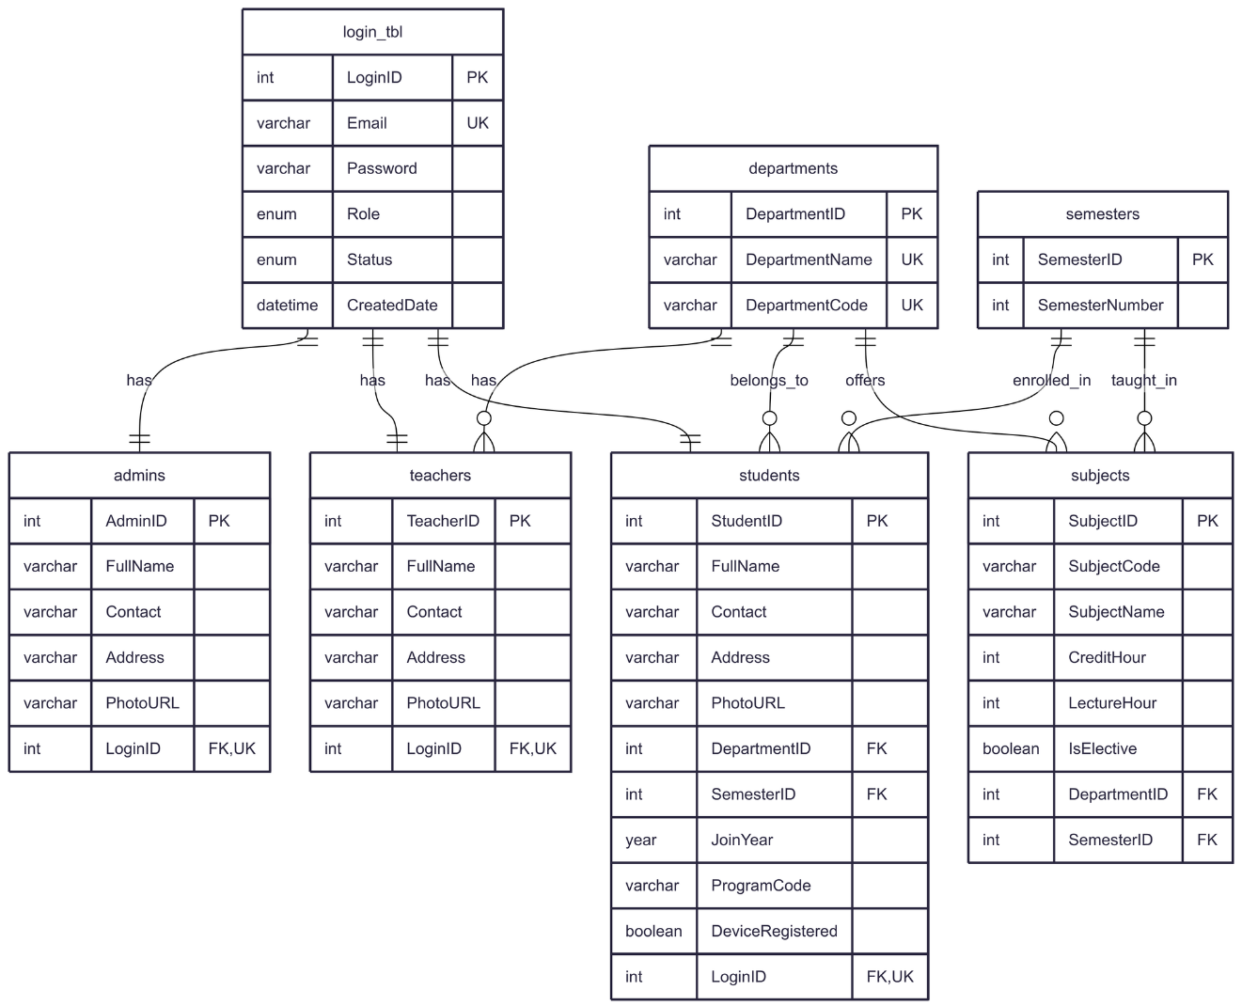

7.1.1: ER-Diagram for User

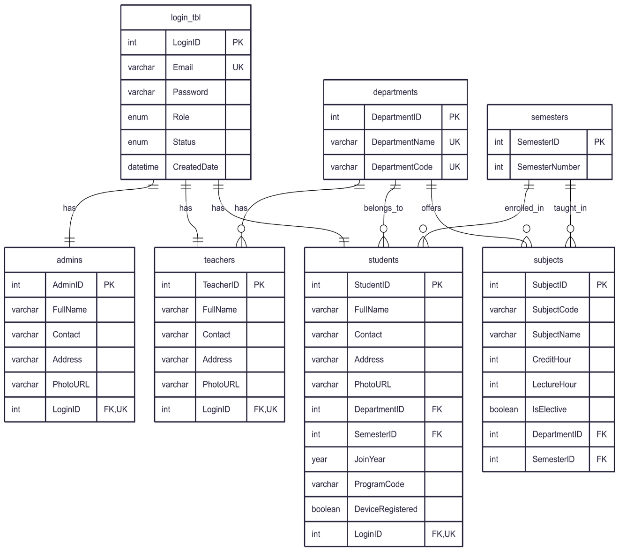

7.1.2: ER-Diagram for Attendance and Device Management

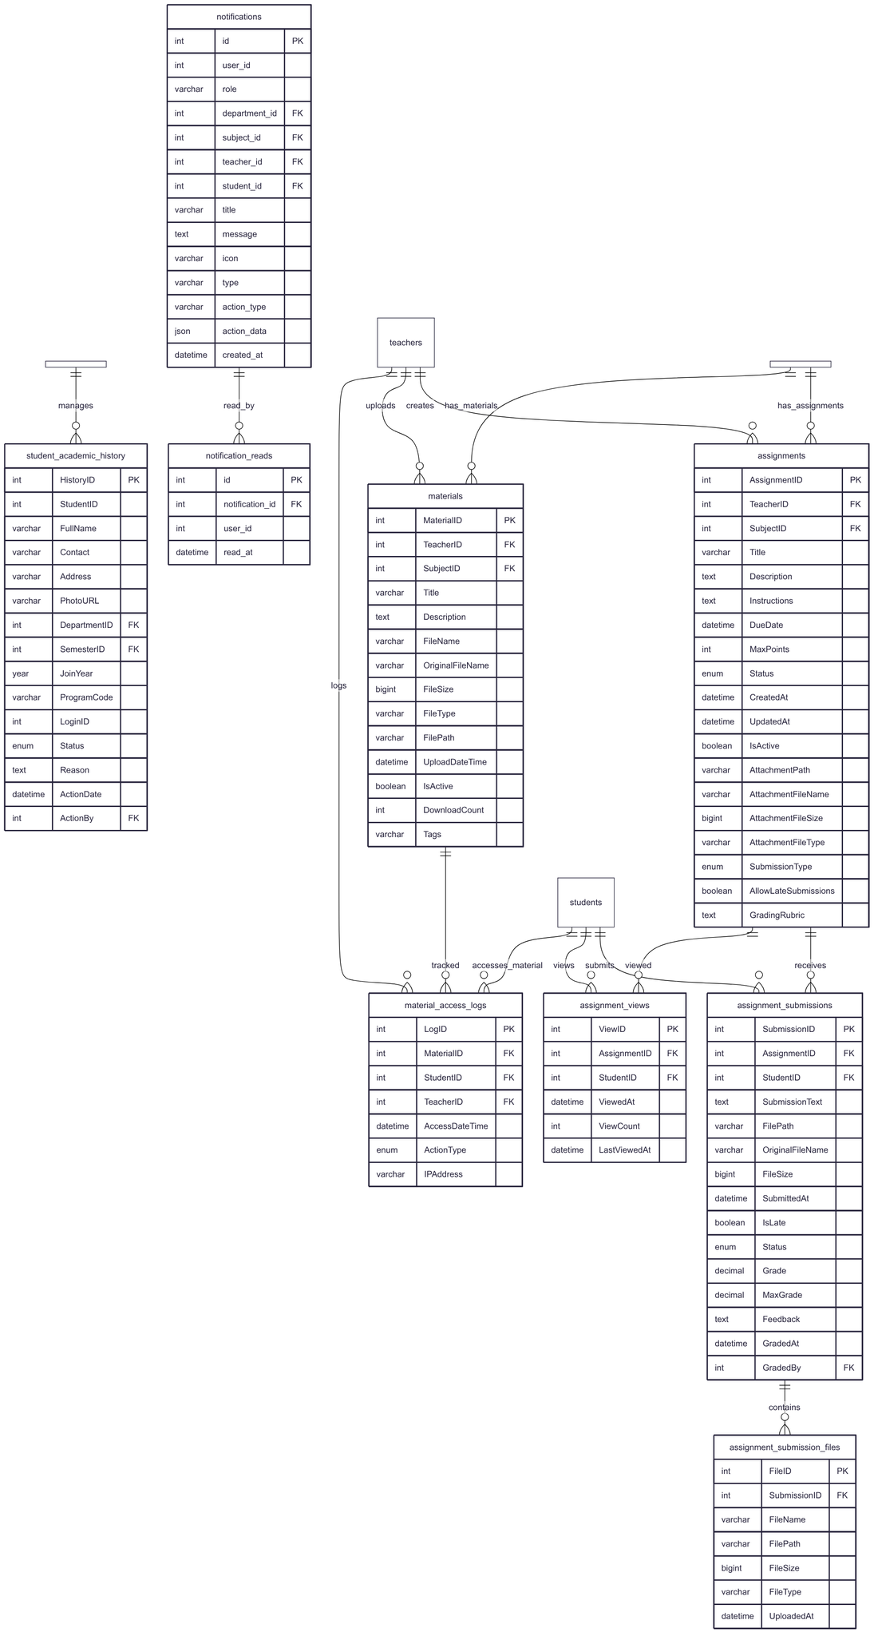

7.1.3: ER- Diagram for Academic, Assignments, Notification

## 7.2 Dataflow Diagram

A Data Flow Diagram (DFD) is a simple visual tool that shows how data moves through a system. It illustrates processes, data inputs and outputs, data stores, and the flow of information between them. It helps communicates the general data flow structure of a proposed system to the system designer, programmer, and end-users.

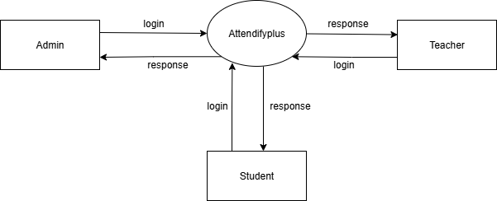

Fig 7.2.1: DFD 0

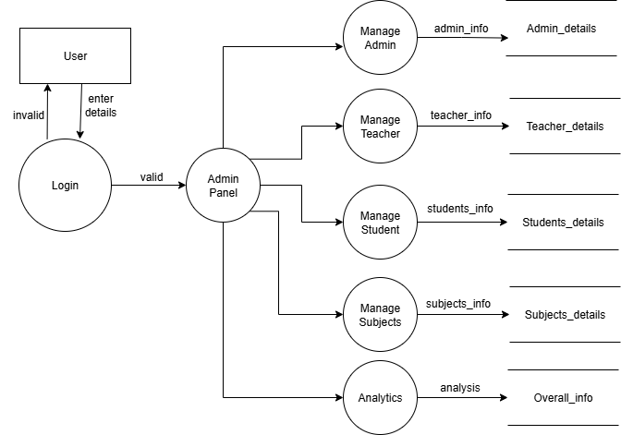

Fig 7.2.2: Level-1 DFD for Admin

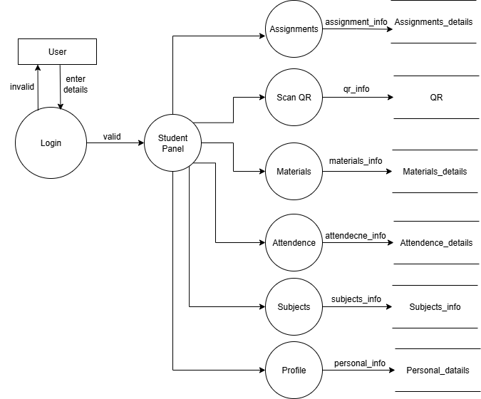

Fig 7.2.3: Level-1 DFD for Student

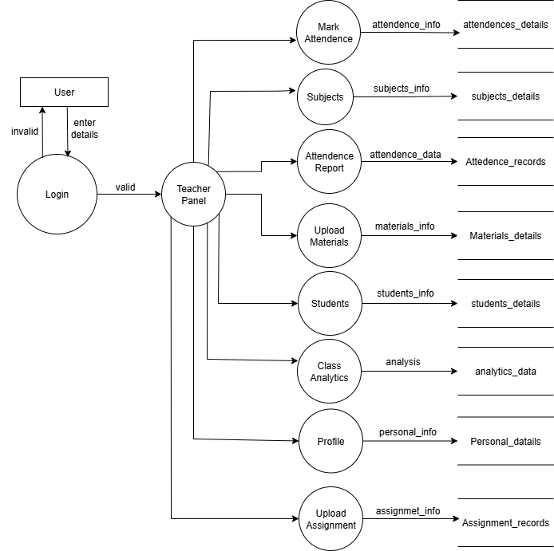

Fig 7.2.4: Level-1 DFD for Teacher

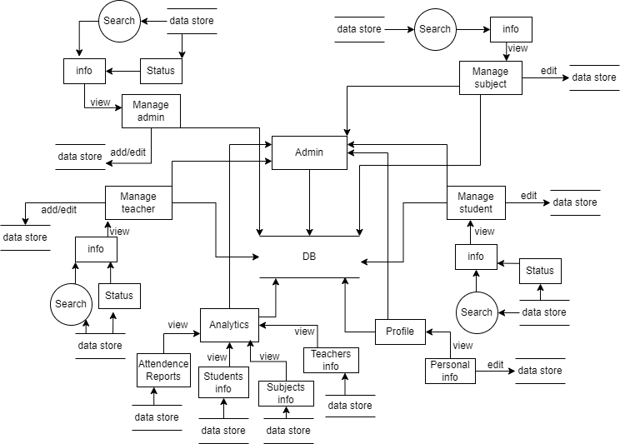

Fig 7.2.5: Level-2 DFD for Admin

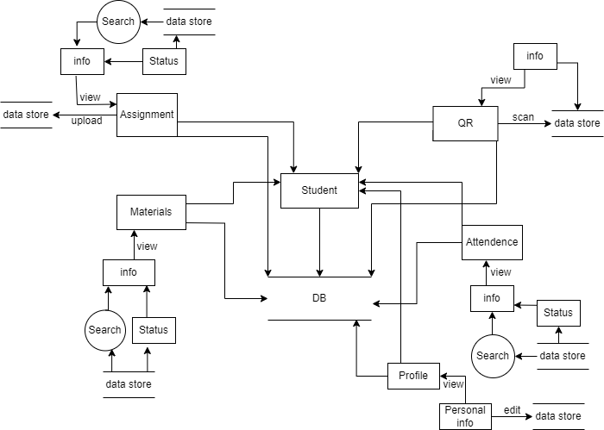

Fig 7.2.6: Level-2 DFD for Student

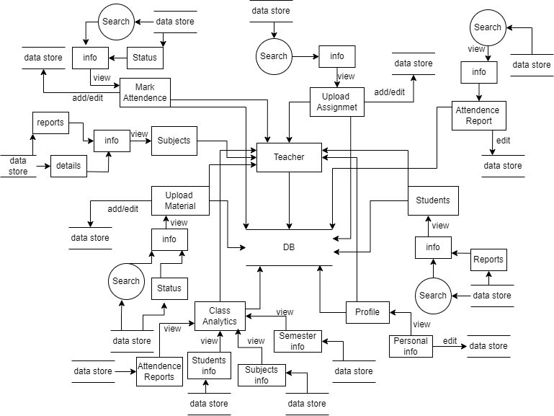

Fig 7.2.7: Level-2 DFD for Teacher

## 7.3 Flowchart

A flowchart is a visual tool that outlines the sequence of steps in a process using standard symbols like ovals, rectangles, and diamonds. It helps to clearly show the flow of actions, decisions, and inputs/outputs in a system. Flowcharts are widely used in system design and programming to simplify complex logic. They make it easier to understand and communicate how a process works.

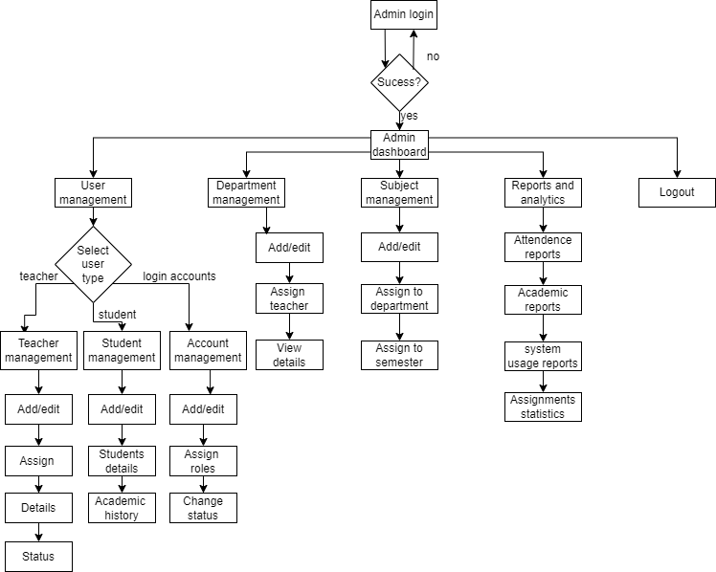

Fig 7.3.1: Flowchart for Admin

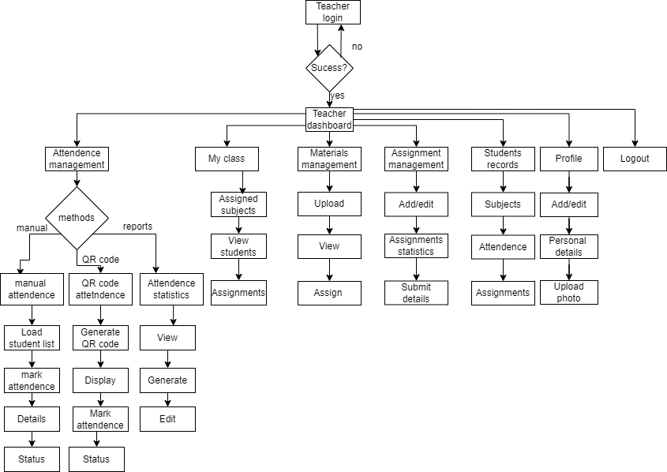

Fig 7.3.2: Flowchart for Teacher

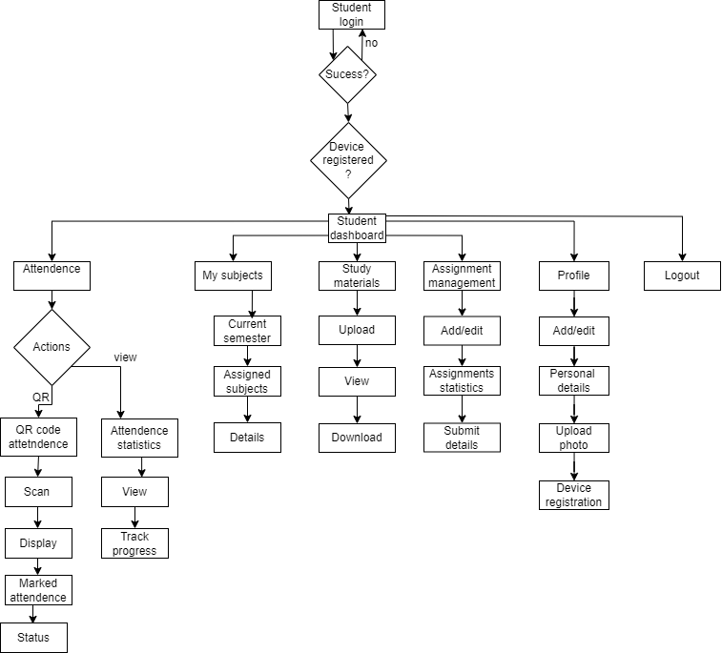

Fig 7.3.3: Flowchart for Student

## 7.4 Use Case

A Use Case Diagram is a visual representation of how users (called actors) interact with a system to achieve specific goals (use cases). It shows the system’s functionality from the user’s perspective. It’s main purpose is to understand system requirements, identify main functionalities, and visualize user-system interactions.

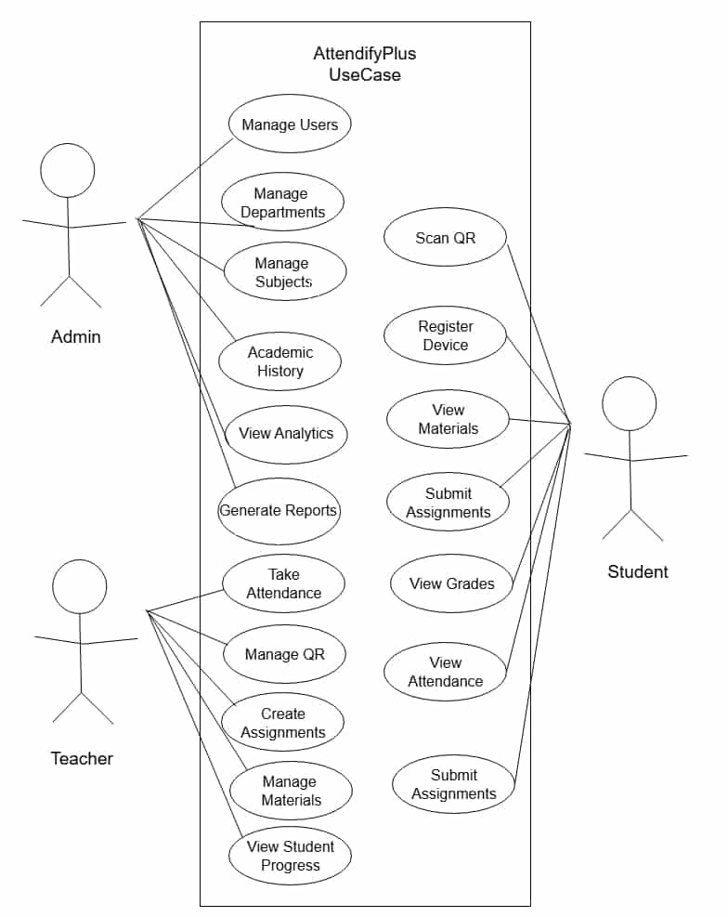

Fig 7.4.1: Use Case

# 8. Development

## 8.1 Development Methodology

AttendifyPlus uses the Agile Scrum Methodology, which is a flexible and team-focused way to develop software. Work is done in short, focused sprints (usually 1–2 weeks), allowing the team to build, test, and get feedback quickly. This approach fits well with AttendifyPlus since it has different modules like QR attendance, fingerprint validation, and role-based dashboards. Agile makes it easy to adapt to changes, improve with user feedback, and keep everyone (developers, testers, and stakeholders) closely involved throughout the process.

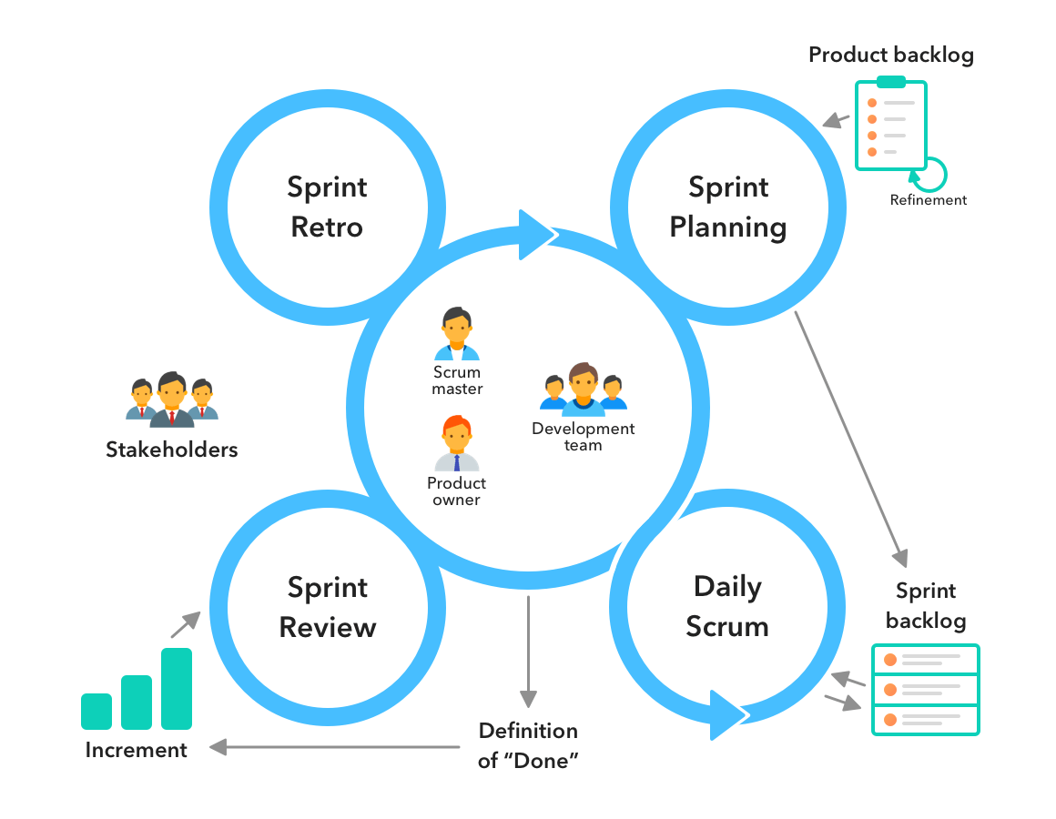

Fig 8.1.1: Methodology

**Scrum Lifecycle Phases:**

**Phase Description:**

|  |  |
| --- | --- |
| Phase | Description |
| Product Backlog | A list of all desired features such as QR scanning, assignments, and reports. |
| Sprint Planning | The team selects specific tasks from the backlog to work on in the upcoming sprint. |
| Sprint Execution | Developers work on implementing the selected features during a 1-2 week sprint. |
| Daily Stand-ups | Short, daily meetings to share updates, discuss blockers, and plan next steps. |
| Sprint Review | A demonstration of completed features to stakeholders to gather feedback. |
| Sprint Retrospective | A team reflection to identify successes and areas for improvement. |

Table 8.1.1: Scrum Lifecycle Phases

## 8.2 Project Gantt Chart / Timeline Chart

Using a Gantt Chart in the development of the AttendifyPlus system enables effective project planning, task scheduling, and progress tracking. Each phase of the project from requirement analysis to final deployment is visually mapped with specific timelines, allowing the team to monitor deadlines and dependencies clearly.

The Gantt Chart approach facilitates a structured workflow by breaking down the entire system development into manageable tasks, ensuring that activities such as core attendance module creation, QR code integration, location verification, and analytics dashboard development are systematically prioritized and completed on time.

By regularly updating the Gantt Chart, the team can assess project status, identify potential delays early, and adjust plans accordingly to maintain smooth progression throughout the Agile Scrum development cycles.

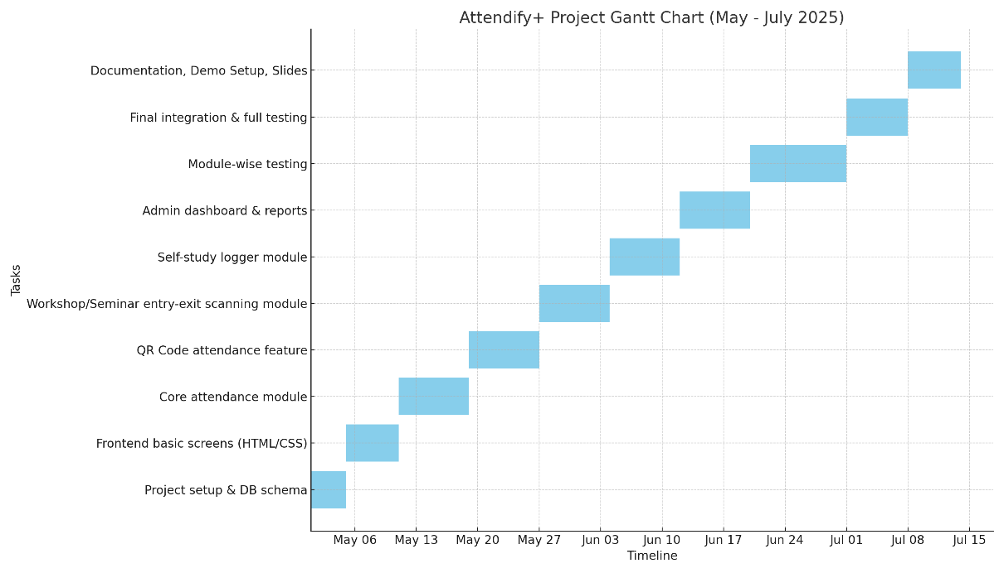

Fig 8.2.1: Project Gantt Chart

## 8.3 Tools Used

AttendifyPlus is built using robust and modern web technology stack. The tools ensure reliability, performance, and real-time data handling.

|  |  |  |
| --- | --- | --- |
| Component | Technology Used | Description |
| Backend Development | PHP 8.0+, MySQL | For server-side logic, attendance processing, user management, and reporting |
| Local Server | XAMPP (Apache + MySQL) | For local development and testing environment |
| Frontend Development | HTML5, CSS3, JavaScript ES6+, Bootstrap 5.3.0 | For responsive and theme-based dashboard UI with mobile optimization |
| Device Registration | Token-based device registration system | Students register their devices with tokens before QR code scanning |
| QR Code System | HTML5 QR Code Scanner library | Used for secure, time-sensitive student check-ins via mobile camera |
| Admin Panel | PHP + Bootstrap + Chart.js dashboard | To manage students, teachers, generate reports, and monitor system activity |
| Real-time Features | JavaScript + AJAX | For live notifications, dashboard updates, and instant attendance confirmation |
| Data Visualization | Chart.js | For interactive charts showing attendance trends, analytics, and reports |
| Icons and UI | Lucide Icons | Modern SVG icon library for consistent UI design |
| Version Control | Git | For source code tracking and collaboration |
| Documentation | Markdown | For project documentation and setup instructions |
| Diagrams | Mermaid.js | For generating ERDs, flowcharts, and system diagrams |
| File Management | PHP file upload system | For assignment submissions, material uploads, and file handling |
| Theme System | CSS variables + JavaScript | Dark/light mode toggle with persistent user preferences |

Table 8.3.1: Tools Used

# 9. Testing

Testing is a critical part of the Software Testing Life Cycle (STLC) to ensure AttendifyPlus is secure, error-free, and efficient before deployment.

**STLC Phases for AttendifyPlus:**

* **Requirement Analysis:**

Understand what functionalities are to be tested: QR attendance Device-based checks Assignment module Teacher/admin reports Clarify the logic for QR expiration, location matching (if applicable), and duplicate check prevention.

* **Test Planning:**

Determine resources, testing tools, and team members. Define test objectives like performance under load, real-time processing accuracy, and role-based access control.

* **Test Case Development:**

Write test cases for: Valid QR scanning Invalid/expired QR attempts Assignment upload & download Report generation accuracy Fingerprint mismatch or bypass attempts.

* **Test Environment Setup:**

Local server environment using XAMPP Simulated student and teacher accounts Multiple device/browser combinations to ensure compatibility.

* **Test Execution:**

Manual testing across all modules Unit testing of PHP backend functions Browser/device testing for frontend Edge cases: Multiple scans, wrong IP, expired QR.

* **Test Closure:**

Prepare final test report with: Number of passed/failed cases Bug list and resolution status Lessons learned and suggestions for deployment.

## 9.1 Test Case

**9.1.1 Test case for login page:**

|  |  |  |  |  |
| --- | --- | --- | --- | --- |
| Test Case ID | Test Case | Input | Expected Result | Test Result |
| 001 | Verify login with valid inputs | Enter valid email and password | User logged in and redirected to home page | Successful |
| 002 | Verify login with invalid inputs | Enter incorrect email and password | Error message | Successful |

Table 9.1.1: Test case for login page

**9.1.2 Test case for admin:**

|  |  |  |  |  |
| --- | --- | --- | --- | --- |
| Test Case ID | Test Case | Input | Expected Result | Test Result |
| 003 | Add teacher | Enter all the requirements (like name, address, faculty, subject, etc) | Teacher details are added | Successful |
| 004 | Add student | Enter all the requirements (like personal details, batch, faculty, etc) | Student details are added | Successful |
| 005 | Add admin | Enter all the requirements | Administrator details are added | Successful |
| 006 | Add subject | Enter all the required subject information | Subject details are added | Successful |
| 007 | Enter log out | Clicking on log out button | Goes back to log in page | Successful |

Table 9.1. 2: Test case for admin

**9.1.3 Test case for teacher:**

|  |  |  |  |  |
| --- | --- | --- | --- | --- |
| Test Case ID | Test Case | Input | Expected Result | Test Result |
| 008 | Check the assigned subject | Enter “My Subjects” button | Show the details of subjects that is assign to the particular teacher | Successful |
| 009 | Take attendance | Enter “Quick Attendance” button | Show the list of students and can mark “present” or “absent” | Successful |
| 010 | Upload study materials | Enter “Upload Materials” button | Able to upload the files | Successful |

Table 9.1. 3: Test case for teacher

**9.1.4 Test case for student:**

|  |  |  |  |  |
| --- | --- | --- | --- | --- |
| Test Case ID | Test Case | Input | Expected Result | Test Result |
| 011 | QR Scan | Scan the QR | Able to do attendance by scanning QR | Successful |
| 012 | Access study materials | Click o the files provided by teachers | Able to access the files provided by teachers | Successful |

Table 9.1. 4: Test case for student

# 10. Project Results

AttendifyPlus has brought meaningful improvements to the traditional attendance process in educational institutions by introducing a faster, more secure, and tamper-proof system. With its real-time QR code scanning and device registration validation, the platform has successfully addressed major challenges such as proxy attendance, manual delays, and inaccuracies in record keeping.

The system allows teachers to focus more on instruction rather than administrative tasks by simplifying attendance marking, report generation, and assignment distribution. On the student side, the ability to self-scan QR codes, submit assignments online, and track their attendance status in real time has empowered them to take ownership of their academic participation.

The admin module has centralized the oversight of academic operations enabling higher-level users to monitor data, generate reports for departments, and ensure institutional accountability. By eliminating the need for paper-based attendance and disconnected Excel sheets, AttendifyPlus also supports environmentally friendly practices and streamlined digital management.

Furthermore, the platform's modular and scalable structure ensures that additional features like separate dashboards for different institutions, or push notifications can be added without compromising existing performance. This positions AttendifyPlus as a future-ready solution capable of serving a broader range of academic organizations, including colleges, schools, and training centers.

In essence, AttendifyPlus demonstrates how technology can solve deeply rooted inefficiencies in classroom environments. It not only secures the attendance process through token-based device registration but also fosters a culture of transparency, efficiency, and accountability making it a valuable asset for academic institutions aiming to modernize their administrative and learning operations.

# 11. Future Enhancements

As AttendifyPlus continues to evolve, several potential enhancements have been identified to further improve its effectiveness, security, and user experience. These future features aim to make the system more robust, intelligent, and adaptable for diverse academic environments.

1. **GPS Integration for Location Verification**

To strengthen the security of the attendance process, GPS-based location tracking will be integrated in future versions. This will help verify whether a student is physically present in or near the classroom premises when scanning the QR code, thereby minimizing location spoofing and ensuring attendance authenticity.

1. **Device Fingerprinting Upgrade**

Although the current device fingerprinting is functional, future updates will enhance its accuracy using more advanced techniques, such as detecting emulator use, IP location mismatches, and browser fingerprint behavior to better prevent fake attendance.

1. **AI-Powered Attendance Anomaly Detection**

An AI module will be implemented to detect patterns of irregular attendance behavior—such as bulk scans from the same location or unusual time patterns—and flag suspicious entries for administrative review. This will help ensure integrity in attendance records.

1. **Push Notification System**

A notification system will be added to keep students and teachers updated on attendance submission windows, class schedule changes, assignment deadlines, and system alerts in real-time via mobile or web.

1. **Role-Based Mobile App Development**

A dedicated mobile app for teachers, students, and admins will be developed with role-specific interfaces. The app will provide access to features such as QR scanning, slide uploads, assignment views, and instant status updates in a more compact and user-friendly format.

1. **Multi-Institution Support (Cloud-Based Version)**

AttendifyPlus will be extended into a multi-tenant, cloud-based system allowing multiple institutions (schools, colleges, or departments) to operate independently under a single hosted platform. This will improve scalability and broaden adoption.

1. **Chatbot Integration**

To provide quick assistance, an AI-based chatbot will be integrated to answer common user queries, guide users through the platform, and provide live support—minimizing the need for manual help desks.

# 12. Conclusion

AttendifyPlus is a smart and secure attendance system designed to solve the problems of traditional methods. By using QR codes and device validation, it helps ensure real-time, accurate, and proxy-free attendance. The system is easy to use for both teachers and students, making attendance faster and more reliable. With features like class material access and report generation, AttendifyPlus improves classroom management and saves time. Though GPS tracking is not yet added, future updates are planned to make the system even better. Overall, AttendifyPlus is a modern and efficient solution for today’s academic needs.

# 13. Annexures

The AttendifyPlus allows admins to manage users, subjects, and records, while teachers can view student lists, generate attendance reports, upload study materials, etc. Students mark their attendance by scanning a QR code through the system, which records their presence in real time. The system ensures secure login for all users, accurate attendance tracking, and automatic report generation, making the entire process fast, reliable, and easy to manage.

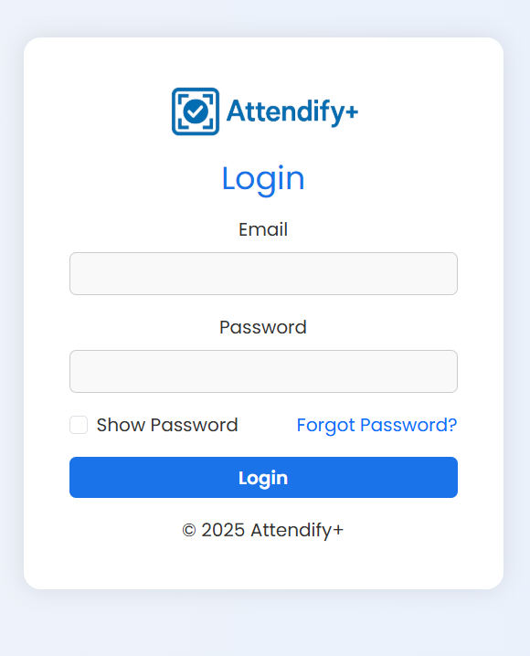

Fig 13.1: Login Page

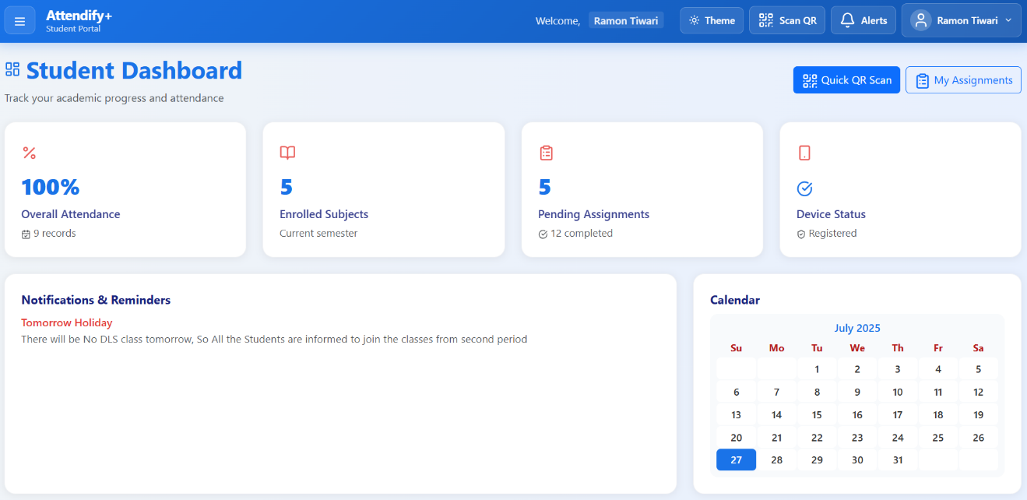

Fig 13.2: Student Dashboard

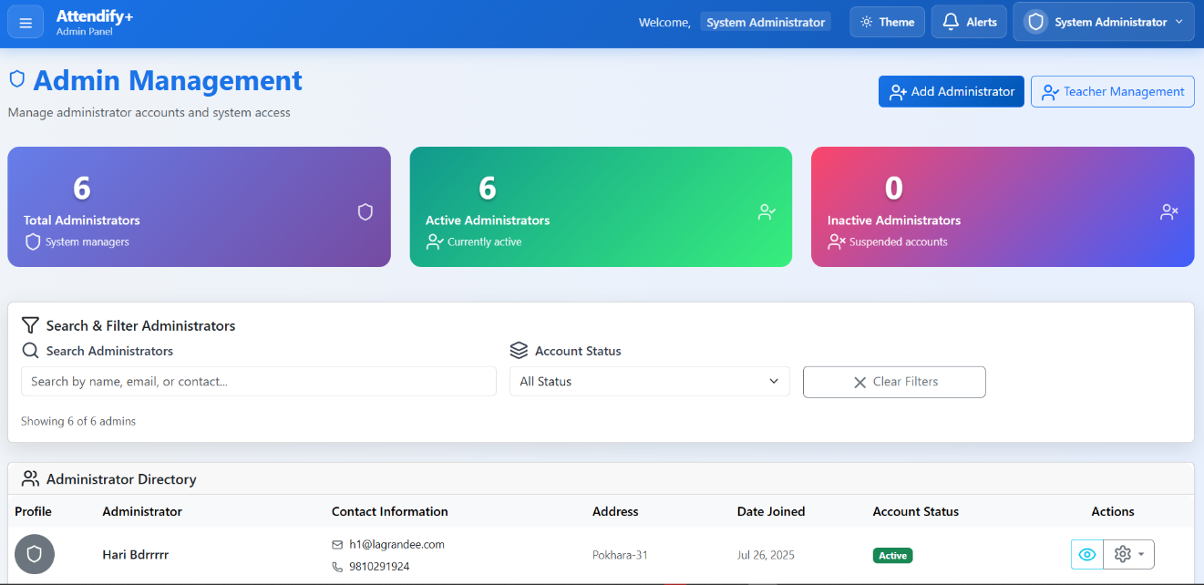

Fig 13.3: Admin Dashboard

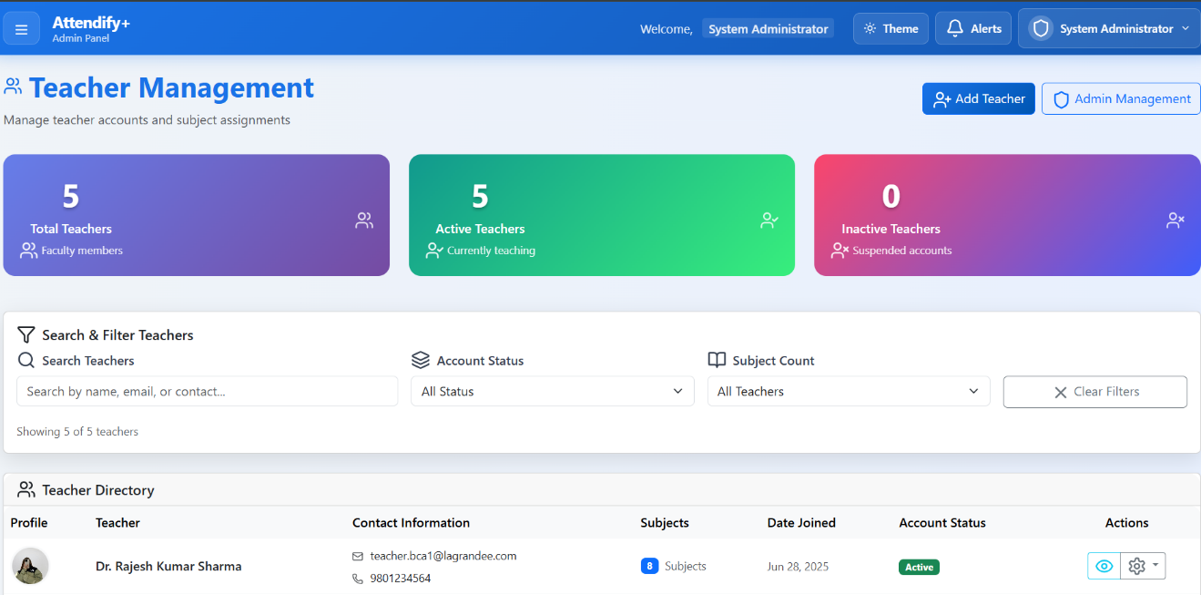

Fig 13.4: Teacher Dashboard

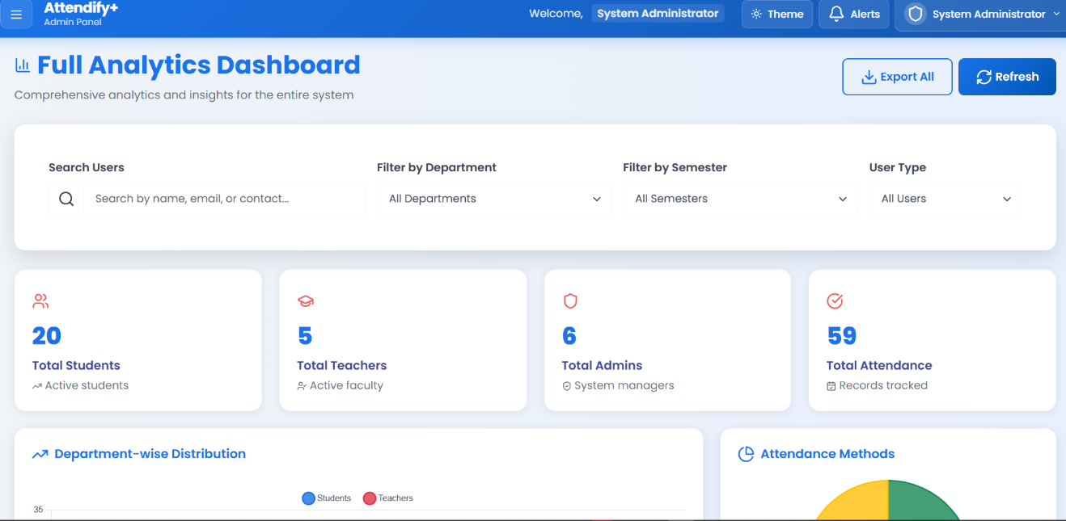

Fig 13.5: Analytics Dashboard

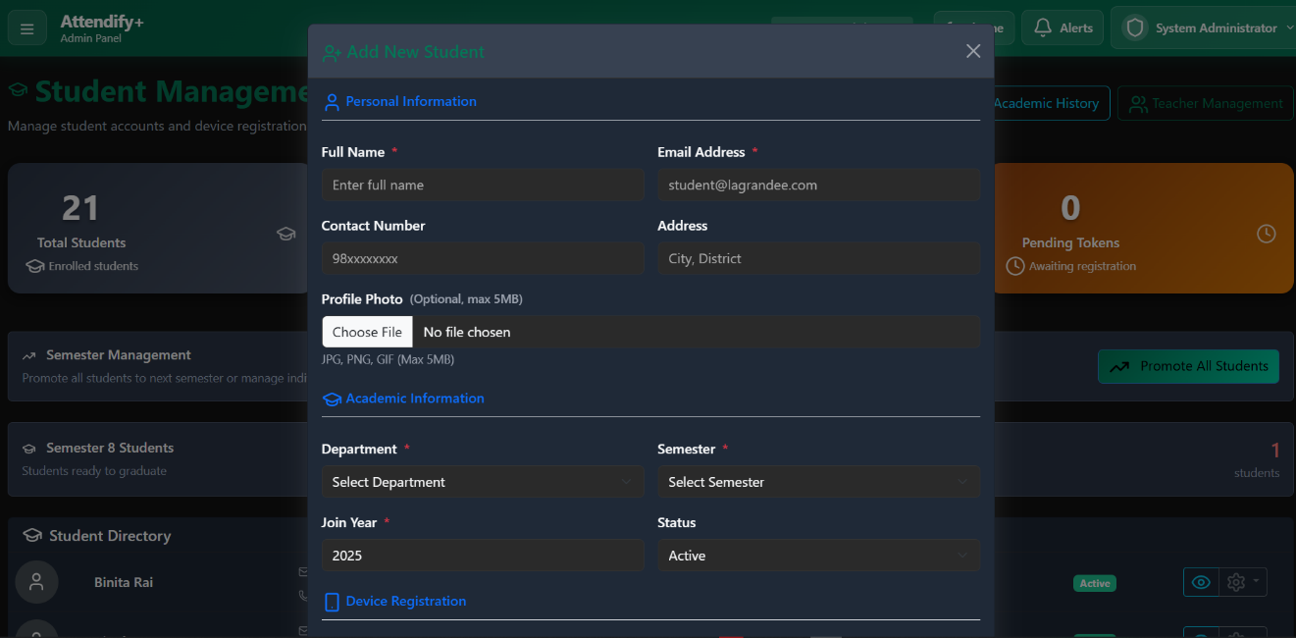

Fig 13.6: Add New Student Section



Fig 13.7: Teacher Management Dashboard

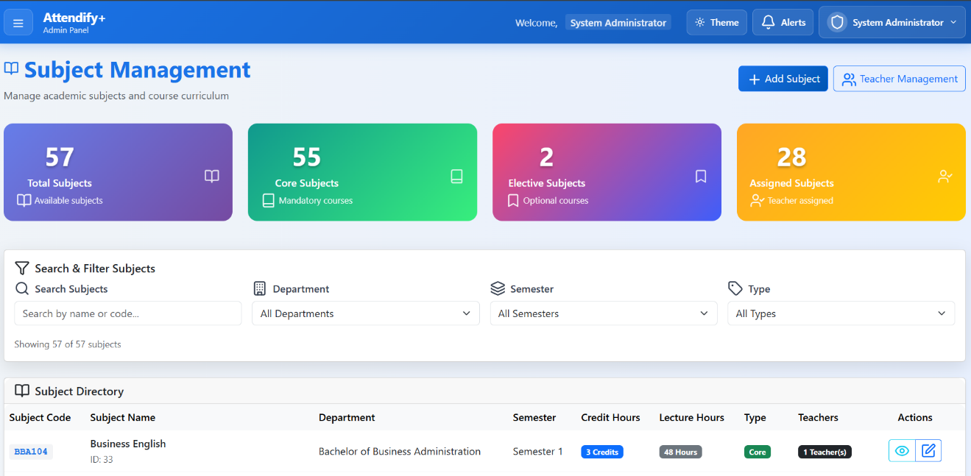

Fig 13.8: Subject Management Dashboard

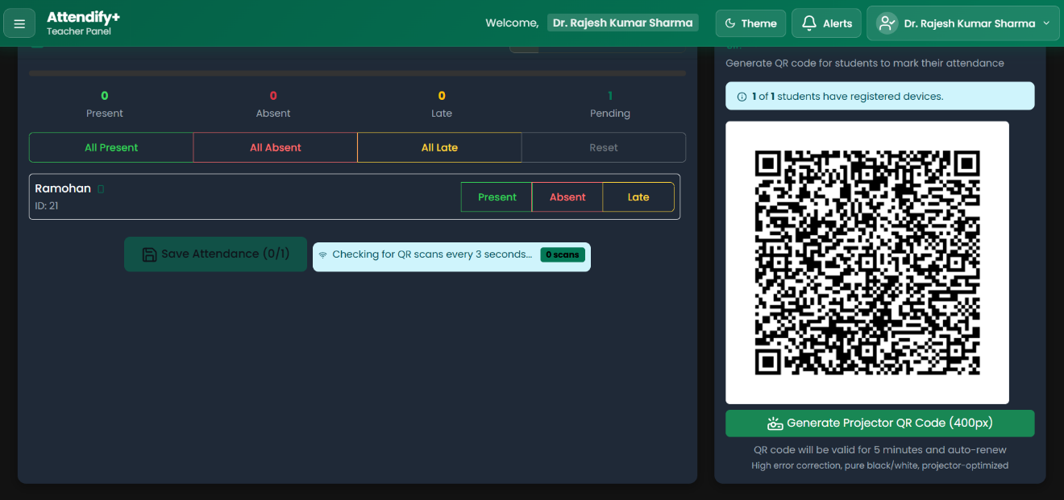

Fig 13.9: QR Generation

# 14. References

* Clappia. (n.d.). QR code attendance tracking. ClappiaBlog. Retrieved July 26, 2025, from <https://www.clappia.com/blog/qr-code-attendance-tracking>
* Attendezz. (n.d.). Attendezz *–* Attendance App. Retrieved July 26, 2025, from <https://attendezz.com>
* Zoho People. (n.d.). Attendance management system. Retrieved July 26, 2025, from <https://www.zoho.com/people/attendance-management-system.html>
* **Kumar et al. (2019)** reviewed automated attendance systems that use RFID and facial recognition technologies. They highlighted that while these systems improve efficiency, they still face issues related to accuracy and cost.
* **Patel & Doshi (2017)** discussed the use of RFID and IoT in attendance management systems. Their study showed that RFID can reduce manual efforts but is vulnerable to card swapping and lacks strict identity verification.
* **Saini & Sharma (2013)** explored the use of biometric methods, such as fingerprint and facial recognition, in attendance systems. They noted that biometric systems offer high accuracy but are costly and may raise privacy concerns.
* **Sharma et al. (2020)** introduced a QR code-based attendance system where students scan dynamically generated codes. Their solution was cost-effective and reduced proxy attendance by requiring real-time scanning.
* **Rahman et al. (2021)** proposed a smart system that combines QR code scanning with geofencing. This hybrid method added an extra layer of security by verifying the student’s location when marking attendance.

# 